**Control System Laboratory Report-lab10**

**Name and ID no. of the Student: Raghuram C S 2019A3PS0357H**

**Controller Design for DC -DC Converter**

**Model/Simulation: PID control of DC to DC Converter**

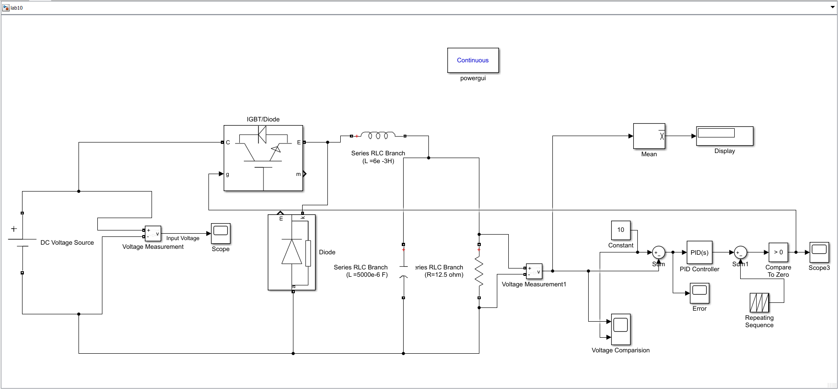

**Results: Desired Output vs Actual PID Tuned Voltage (Zoomed in )**

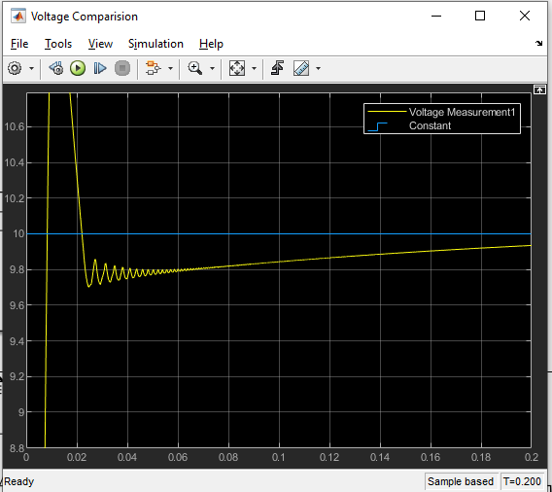

**Error between the reference (desired) output Voltage and the Actual output voltage : Minimised to “ZERO” with time Using PID controller**

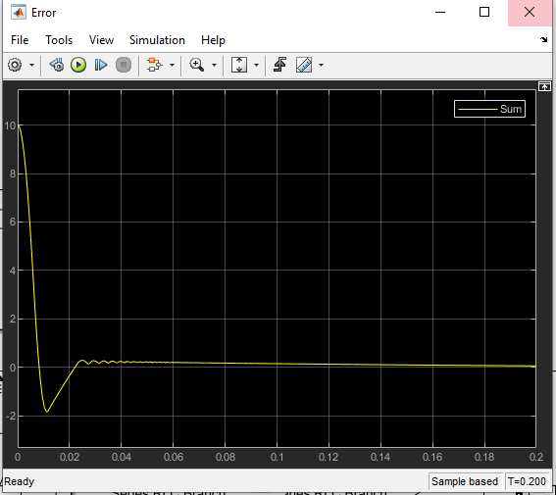

**The final Volatge after passing though PID minimised to zero oscillating from 0 to 1**

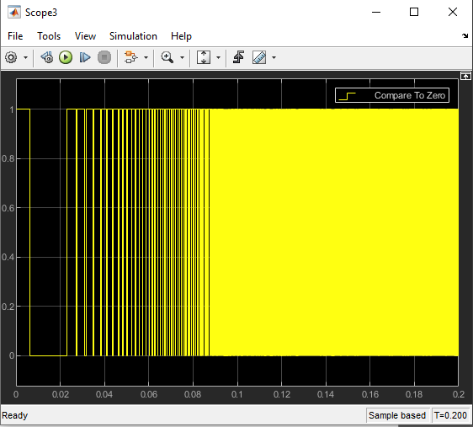

**Conclusive remarks:**

1. **In the exp we are modelling a step down DC to DC Converter using a PID controller by also passing thorugh a IGBT(Controllable switch).**
2. **The Outpus reaches a Maximum after which it oscillates with values which are less than the desired output before finally reaching a values less than the desired voltage with minimum error.**
3. **The error between the Desired Volatge and Actual Voltage varies from** 
   1. **-2 < error < 2**
4. **The ripples that are obtained due to PID controller are removed using the Series L and C circuits.**
5. **The mean of the all the values at a frequency of 60hz is displayed ~9.55 less than desired voltage.**
6. **A PWN Techinque is used as ripples slowly fade out in the Volatge graph.**
7. **The voltage is Being Stepped down from 12 V DC to ~10V DC.**