**Control System Laboratory Report**

**Name and ID no. of the Student: RAGHURAM C S, 2019A3PS0357H**

**Title of the Experiment:** Mathematical modelling of Physical Systems

**Model/Simulation:** 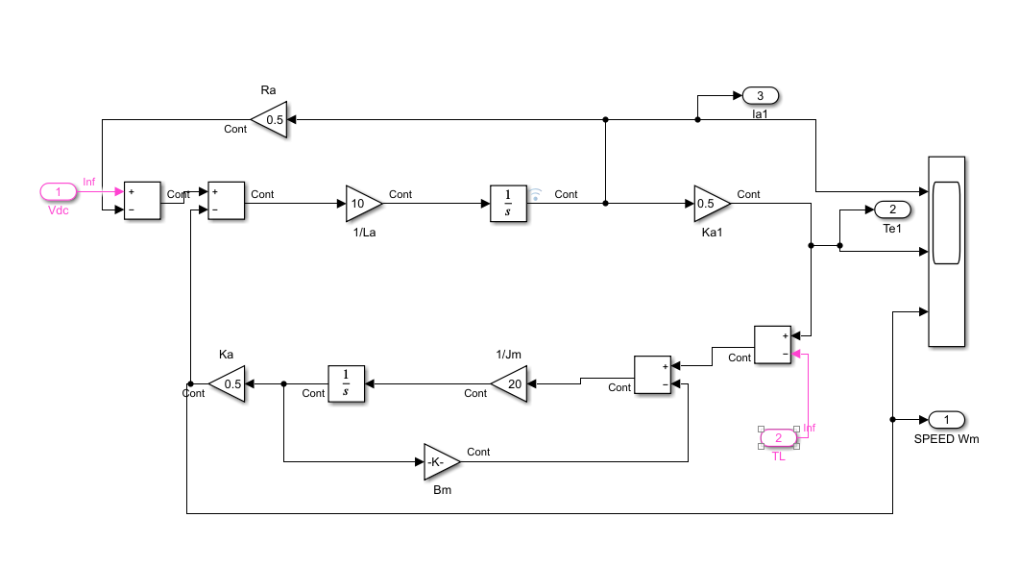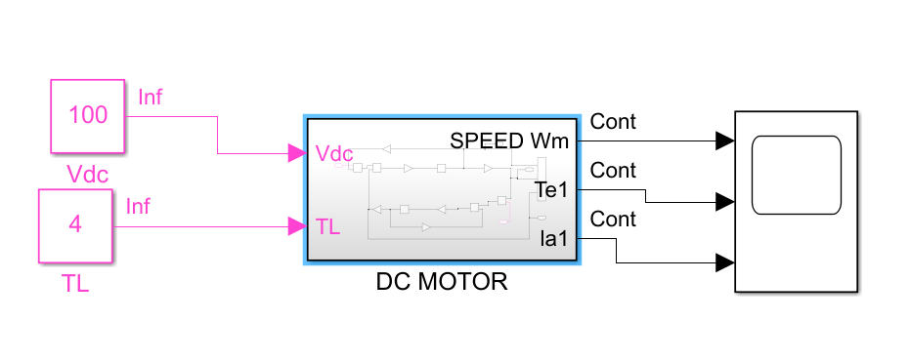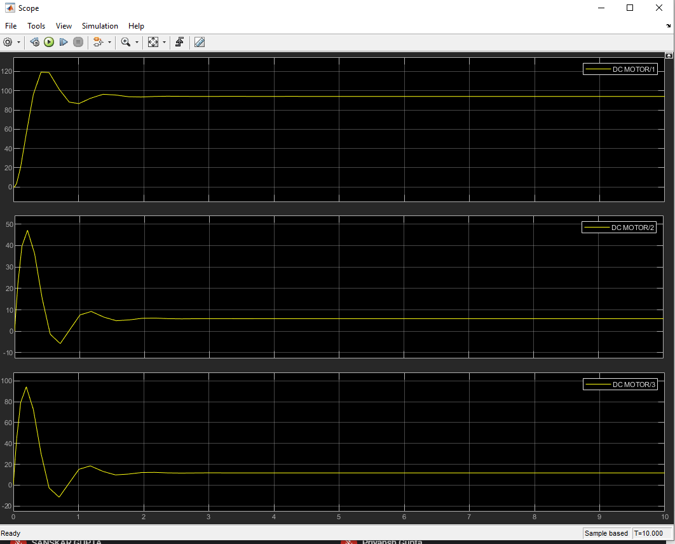

**Results: The graph shows the response given by dc motor**

**Conclusive remarks:**

1. **Modelled a DC motor with the given values in Simulink**
2. **Modelled a transfer function subsystem of DC motor which consisted of negative feedback loops for a positive gain and stability.**
3. **When supplied a constant input voltage of 100V (Vdc) and a load torque (TL) of 4-N-m is added to a subsystem. In the subsystem:**
   1. **Speed (Wm) reaches a final steady state value of 94.12rpm denoted by the yellow line in the first graph.**
   2. **Armature current (Ia1) reaches a steady state value of 11.76A denoted by the yellow line in third graph.**
   3. **Effective torque (Te1) reaches steady-state value of 5.88N-m denoted by second graph.**
4. **There is a deviation in speed from that of ideal motor as the speed obtained is less than ideal motor .**