**Control System Laboratory Report**

**Name and ID no. of the Student: 2019A3PS0357H, RAGHURAM C S**

**Title of the Experiment:**  Bump Test Modelling

**Model/Simulation:**

**Simulink Model**

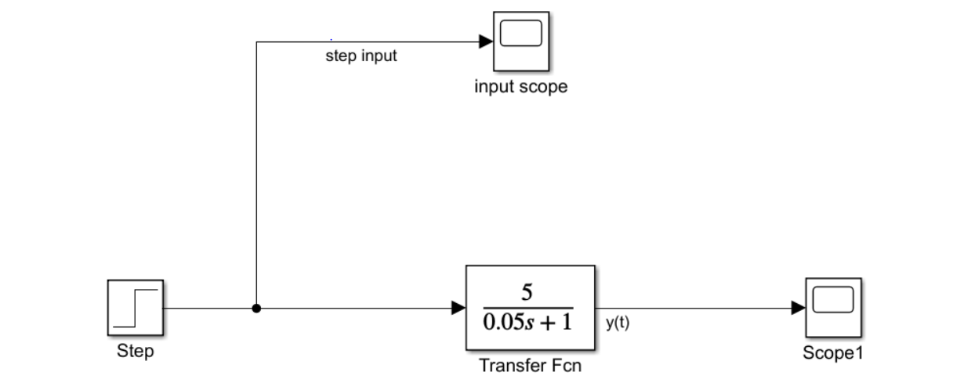

**MATLAB Code**

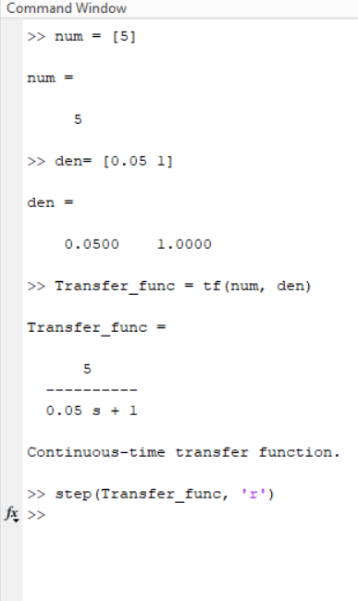

**Results:**

**1)Simulink**

**Step Input**

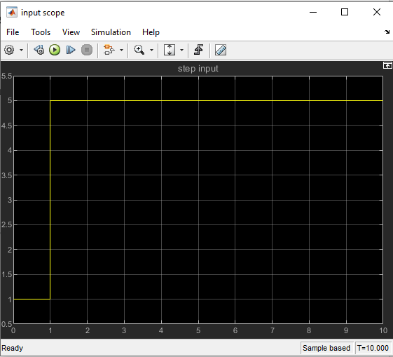

Transfer function Output

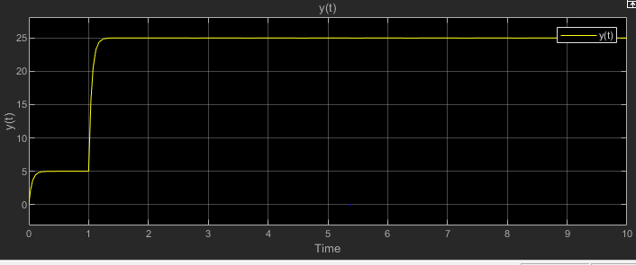

**Step response of code.**

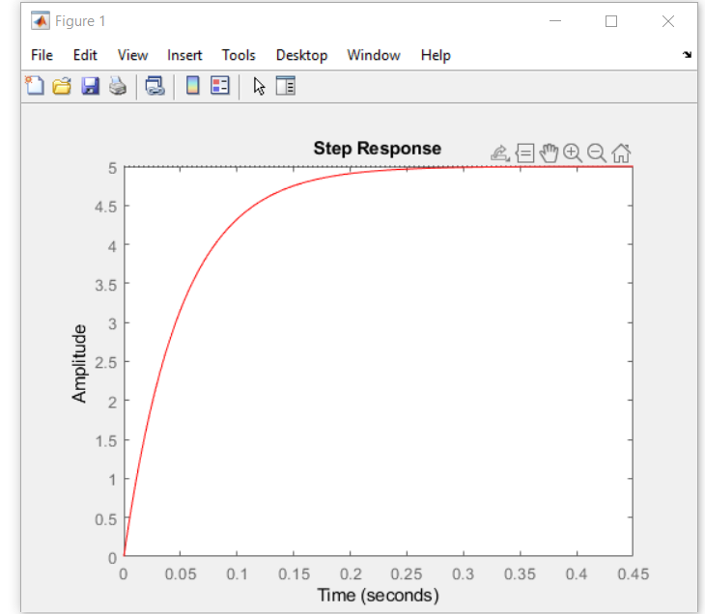

**Conclusive remarks:**

**1)Simulated Step response of a Fist Order system i.e. in denominator s has a maximum power of 1.**

**2) time constant of the system = 0.05(time taken to reach 63.2% out output)**

**Gain (K)= 5**

**3) The poles of a first order system are located at (1/t), as the farther the pole the faster it reaches transient response hence we took such a small value for t.**

**4) the larger the time constant the system is more unstable and takes more time to reach a stable state.**