**Control System Laboratory Report**

**Name and ID no. of the Student: RAGHURAM C S 2019A3PS0357H**

**Title of the Experiment: Second order Dynamic systems**

**Model/Simulation:**

1. **Under-damped Second Order System**

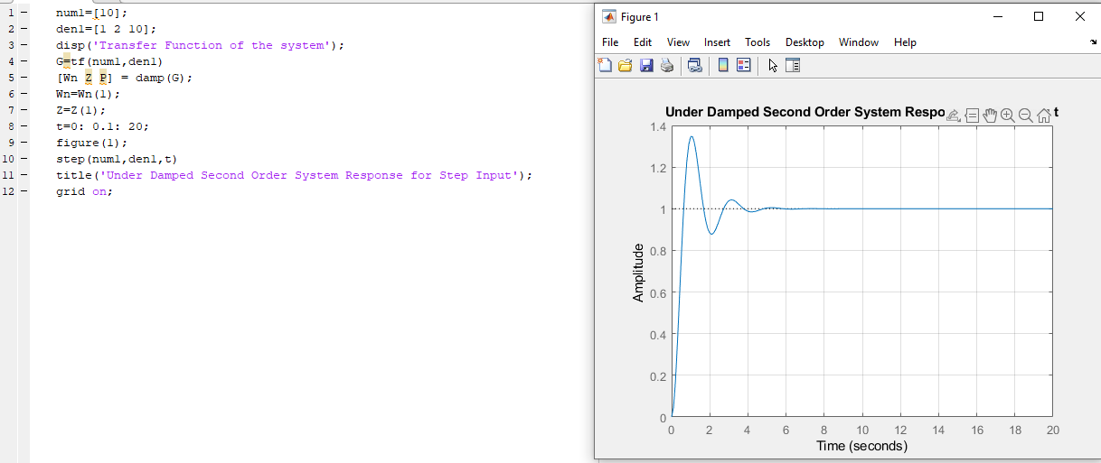

1. **Un-Damped Second order System**

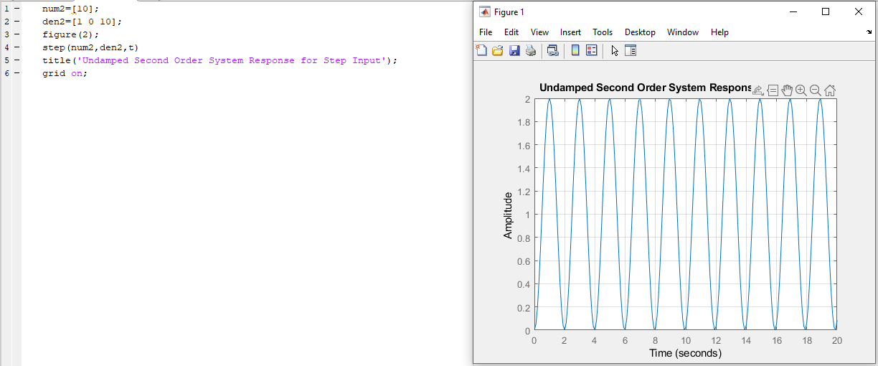

1. **Critically Damped Second Order System**

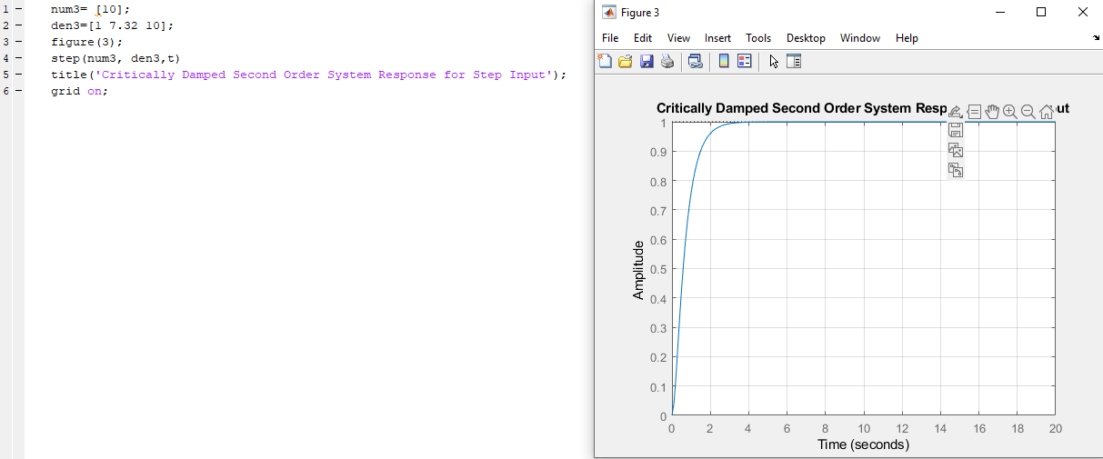

1. **Over-Damped Second Order System**

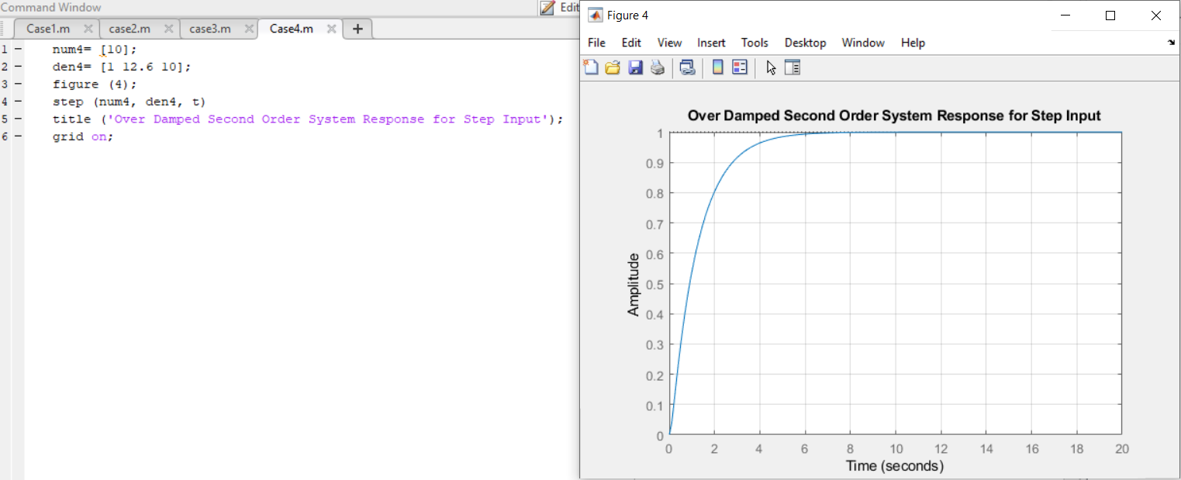

**B)**

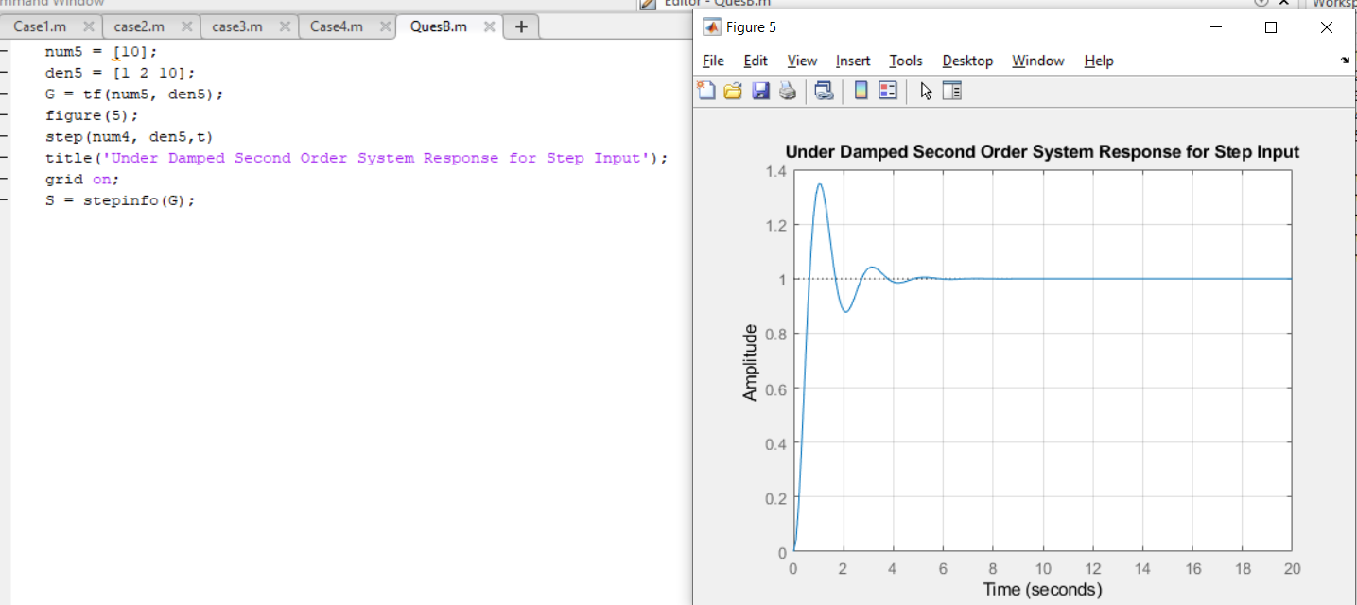

**Results: Calculated steady state and Transient response vales**

**1)under-damped:**

* **Maximum(percentage ) overshoot (Mp) = 35.0670%**
* **Peak time (tp) = 1.0592sec**
* **Delay time(td) = 0.4259sec**
* **Rise time (tr) = 0.429sec**
* **Settling time (ts) = 3.5359sec**
* **Damping ratio =0**

**2)un-damped:**

* + **Maximum(percentage ) overshoot (Mp) = Na**
  + **Peak time (tp) = inf**
  + **Delay time(td) = Na**
  + **Rise time (tr) = Na**
  + **Settling time (ts) = Na**

**3)Critically-damped:**

* + **Maximum(percentage ) overshoot (Mp) = 0%**
  + **Peak time (tp) = 4.3351sec**
  + **Delay time(td) = 0.578sec**
  + **Rise time (tr) = 1.3140sec**
  + **Settling time (ts) = 2.3733sec**
  + **Damping Ratio = 1**

**4)Over-damped:**

* + **Maximum(percentage ) overshoot (Mp) = 0%**
  + **Peak time (tp) = 8.6028sec**
  + **Delay time(td) = 0.902sec**
  + **Rise time (tr) = 2.5913sec**
  + **Settling time (ts) = 4.6848sec**
  + **Damping Factor(dr) = 1.992**
* **From Graph**

**1)under-damped:**

* + 1. **Maximum(percentage ) overshoot (Mp) = 35.0670%**
    2. **Peak time (tp) = 1.0592sec**

**2) Analytically:**

* **Wn= sqrt(10)**
* **Damping ratio(dr) = 1/sqrt(10)**
* **Mp = 100 x e^(-pi/sqrt(1 –(dr^2) )) = 36.479%**
* **Peak time (tp) = pi/Wn*sqrt(1- (dr^2)) = 1.04719sec**

**Conclusion Remarks:**

* **Designed a second order system using MATLAB code and tabulated graphical and analytical results of various damped systems (Under, Un, Critically, Over).**
* **Found the parameters of the system that give us relative information of Stability, time taken to for the system to settle to stability by how much the system overshoots its maximum value.**
* **By knowing how much the system overshoots we can design in it such that it settles much faster by altering the damping ratio and frequency of the transfer function.**
* **The damping ratio determined the type of damped system it is such as:**
  1. **Dr = 0 (Un-damped)**
  2. **Dr = 1 (Critically damped)**
  3. **0 < Dr < 1 (Under-damped)**
  4. **Dr > 1 (Over-Damped)**