**Control System Laboratory Report**

**Name and ID no. of the Student: Raghuram C S 2019A3PS0357H**

**Title of the Experiment: PD Control**

**Model/Simulation:**

1. DC Motor as a SubSystem of the Model

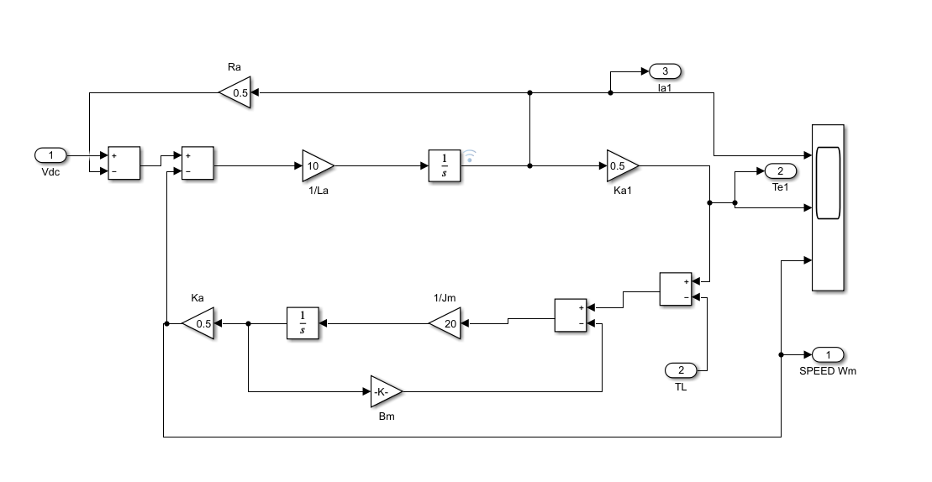

1. DC motor with a PID controller

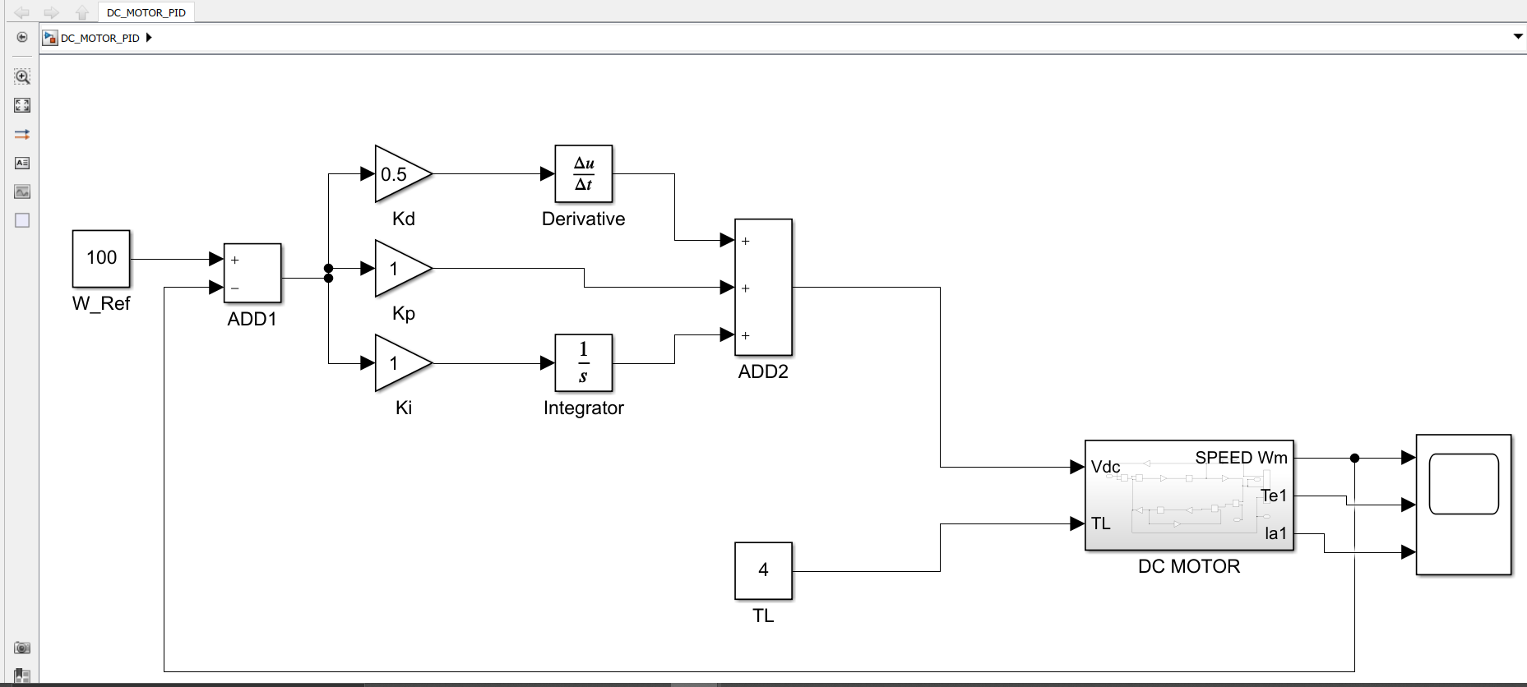

**Results:**

**Simulation graph of the PID controller with DC Motor**

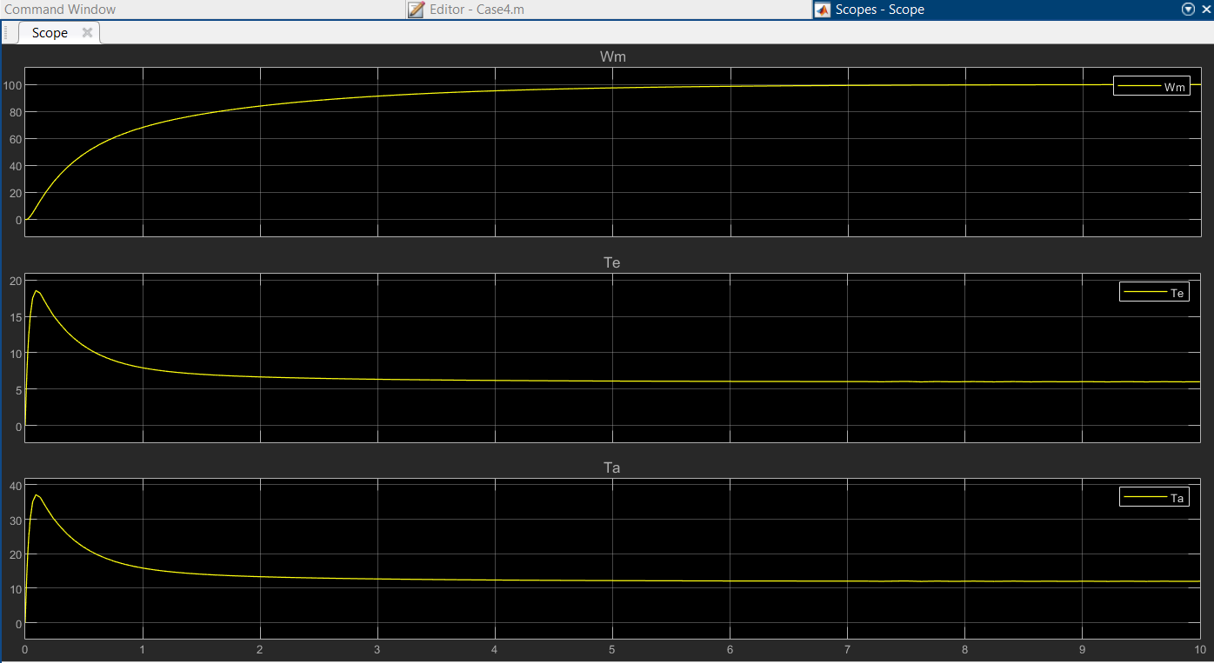

**Conclusive remarks:**

1. **As observed in correspondence with a DC motor without PID control this system reaches steady state or stability in a much smoother curve or reduces oscillations at steady state.**
2. **As the oscillations before reaching steady state are reduced the system operates much smoothly and does not give in error in applications when it constantly overshooting and undershooting it values between tasks.**