**Control System Laboratory Report**

**Name and ID no. of the Student: Raghuram C S 2019A3PS0357H**

**Title of the Experiment:** Root Locus for Stability

**Model/Simulation:**

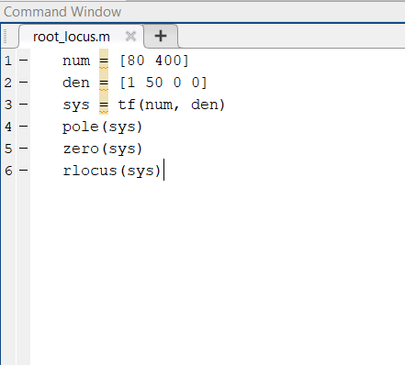

**Results:**

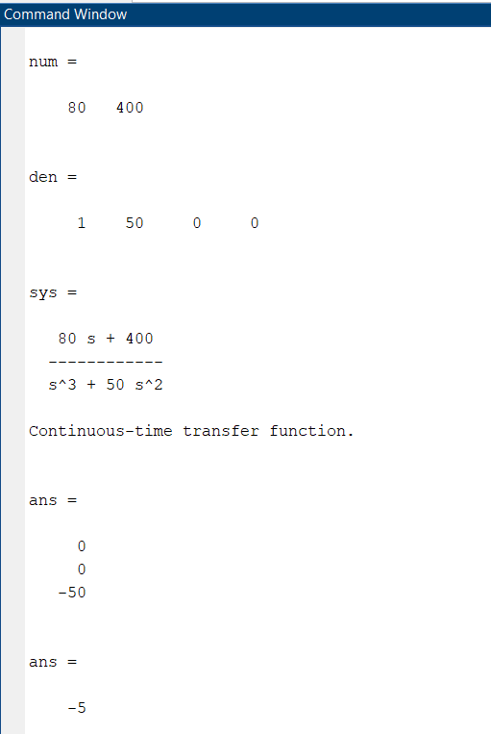

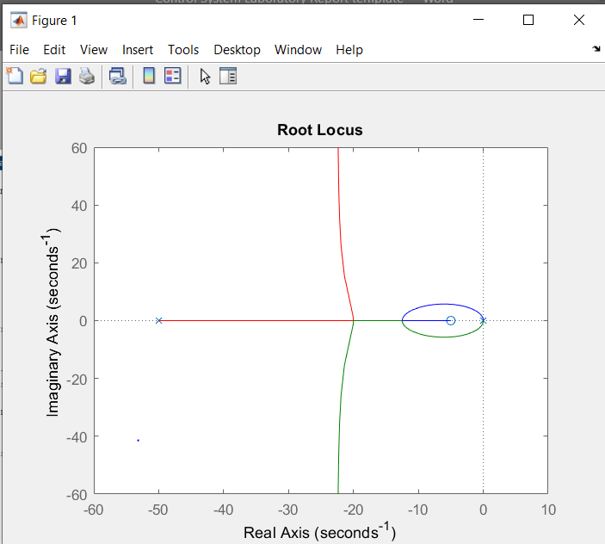

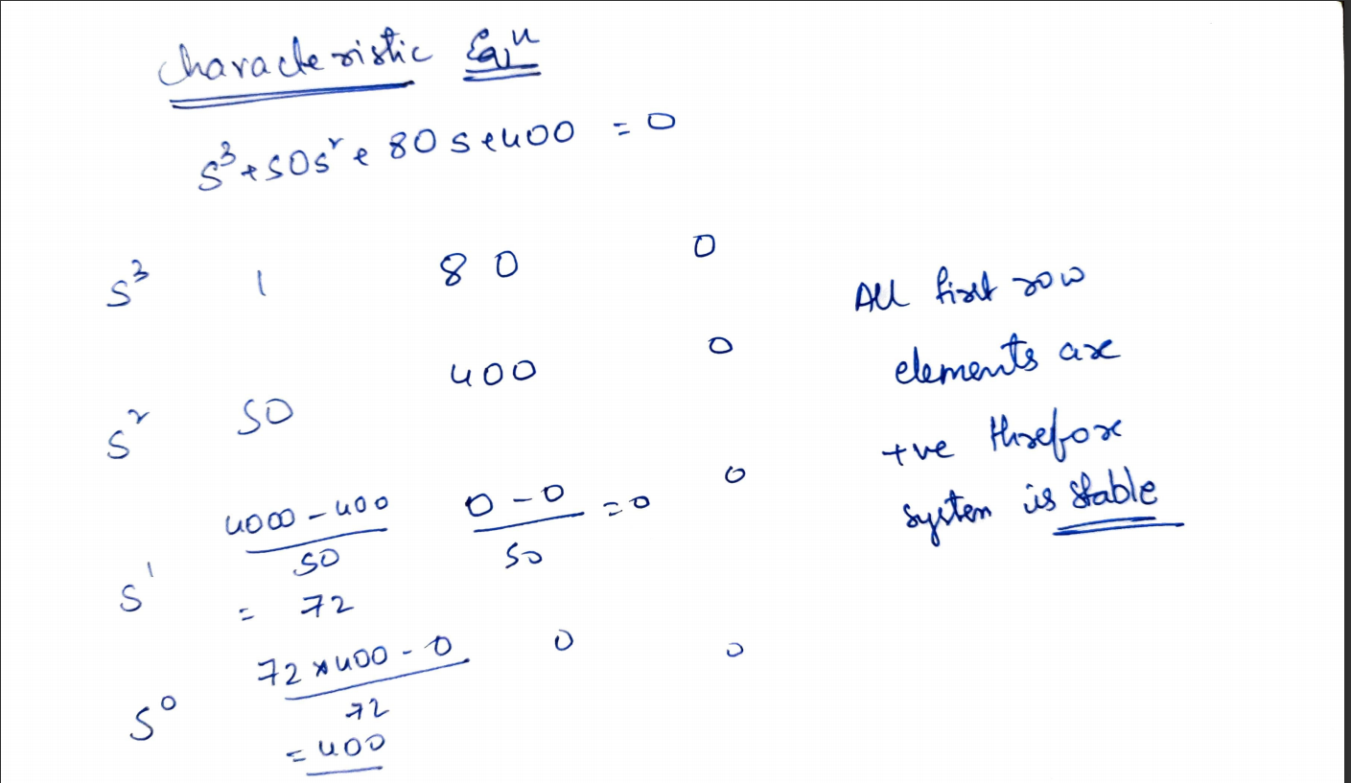

**Conclusive remarks:**

1. **The system is marginally stable(pole on imaginary axis) as all poles are on left side of real axis and all first-row elements of routh table are positive and there is no sign change.**
2. **The break-in and break-away points are 0,-12.5,-20.**
3. **The angle of departure is also N,A,**
4. **The root locus does not intersect the imaginary axis as there are no complex poles**
5. **The angle of the asymptotes is 90 and 270.**