**Control System Laboratory Report**

**Name and ID no. of the Student: Raghuram C S 2019A3PS0357H**

**Measurement of servo speed and pendulum moment of inertial**

**Model/Simulation:**

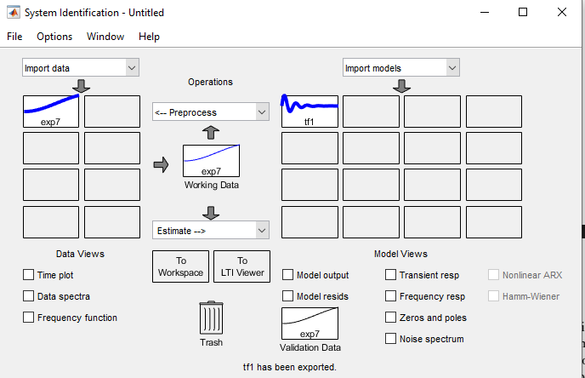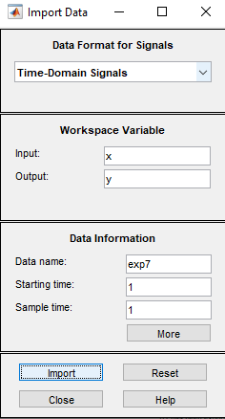

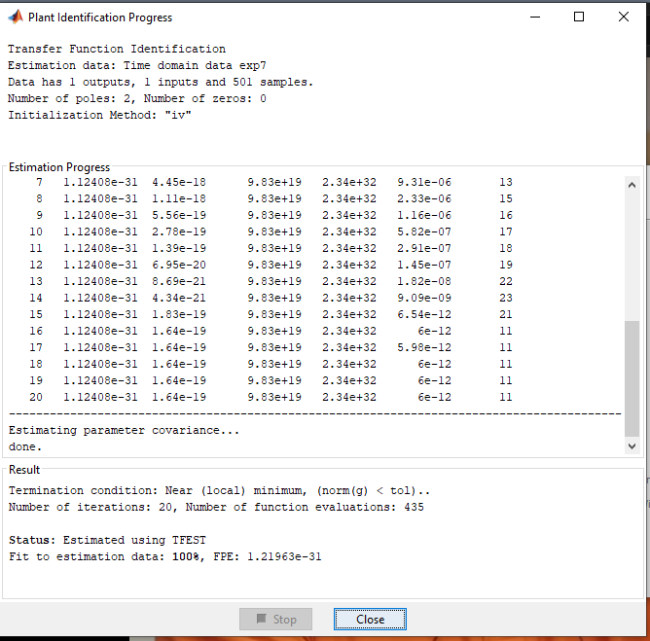

**Results:**

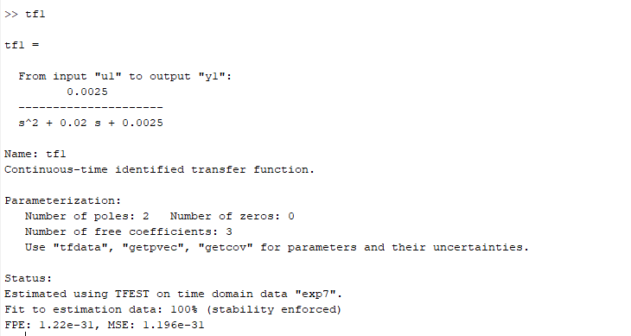

**Conclusive remarks:**

1. **We are using the System Identification Toolbox to Analyse the given time domain Values to generate a transfer function.**
2. **The final trnafer function comes out to be** 
   1. **0.0025/(s^2 + 0.02s + 0/0025)**
3. **Comparing with given transfer function H(s) = (K/J)/(s^2 + (B/J)s + K/J)**
   1. **Given (B/J) = 0.02 from comparing**
   2. **Given friction coefficient B = 1.2M-m-s/rad**
   3. **Hence J = 1.2/0.02 = 60**
4. **The final moment of inertia (J) of the Pendulum is 60 kg-m^2**