**Control System Laboratory Report**

**Name and ID no. of the Student: Raghuram C S 2019A3PS0357H**

**Title of the Experiment:**

**Sec A. LINEARIZED 1ST ORDER DYNAMIC MODEL OF DC SERVO AND PENDULUM**

**Sec. B. STABILITY ANALYSIS**

**Model/Simulation:**

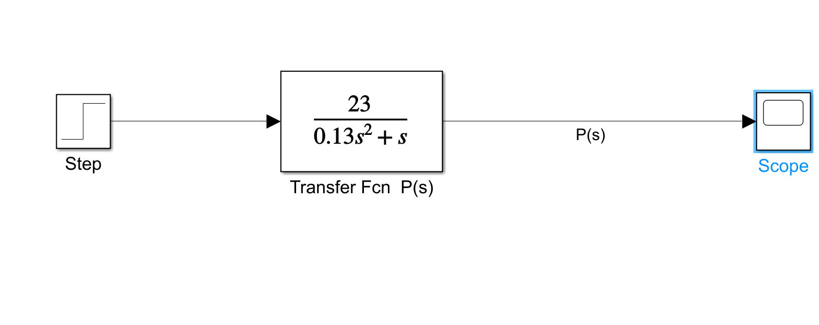

**Results:**

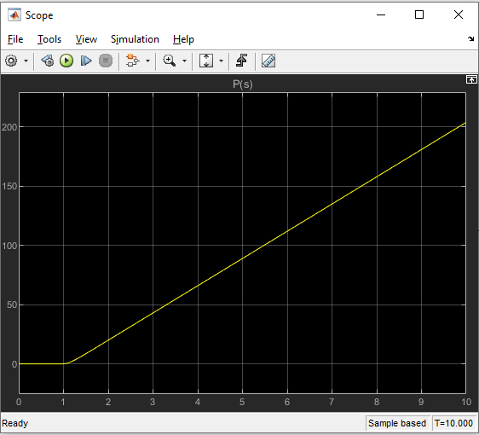

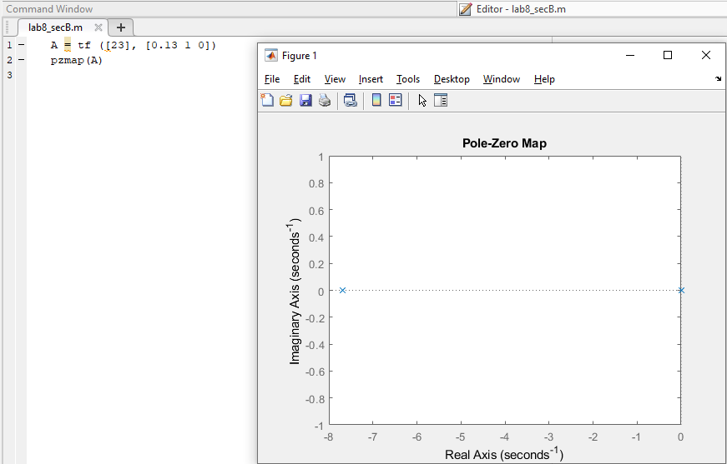

**Conclusive remarks:**

1. **System is stable for sec B as both poles are on the left side of the real axis and on the imaginary axis**
2. **In system for sec A is stable as it has poles negative real axis and frequency response is constantly increasing .**