Community Technical Orientation and Linguistic Register in AI Reddit Communities: A Cluster-Aware Exploratory Reanalysis
Abstract
Online discussions of artificial intelligence span communities with different intended audiences and technical norms, but posts within a subreddit are not independent observations of community orientation. This exploratory reanalysis revisits 1,778 posts from nine Reddit communities originally grouped into three orientation tiers. The revision treats subreddit, rather than individual post, as the tier-level inferential unit; audits AI relevance; controls for topic and post length; corrects for multiple testing; and evaluates classifiers only on held-out communities. Two external raters also independently classified the nine communities. They agreed on 8 of 9 assignments (88.9%; Cohen's kappa = .82), but their mappings differed from the original author coding for several communities; sensitivity analyses therefore repeated cluster-level tests under both external mappings. A conservative AI/ML screen retained 1,299 posts (73.1%). Exact cluster-level permutation tests found that none of ten planned linguistic outcomes survived Benjamini-Hochberg false-discovery-rate correction under the original mapping, and no outcome survived FDR correction under either external-rater mapping. Average syllables per word produced the smallest unadjusted p-value under the original mapping (p = .0536; q = .5357) and weakened after topic and length adjustment (p = .4286; q = .8482). Leave-one-subreddit-out logistic regression achieved balanced accuracy = .3336 and macro-F1 = .3355; random forest performance was lower, and subreddit-label permutation baselines did not support reliable generalization. The corrected evidence therefore does not support robust three-tier linguistic separation in this nine-community sample. Instead, it documents descriptive heterogeneity and shows how post-level inference can overstate precision when the explanatory construct is defined at the community level.
Keywords: Reddit; computational sociolinguistics; register variation; clustered inference; community technical orientation; artificial intelligence

1. Introduction
A software engineer explaining a machine-learning model to a colleague may use terms such as regressors, classifiers, or model architecture without stopping to define them. The same idea presented to a non-specialist is likely to be expressed differently. Artificial intelligence is therefore an unusually useful domain for studying register because it is discussed by machine-learning researchers, developers, hobbyists, students, and casual users within the same broad technological ecosystem.
Reddit makes those differences visible because its communities are organized not only around topics, but also around norms. Each subreddit develops expectations about what counts as a useful explanation, an impressive contribution, an acceptable question, or the right amount of technical detail. Prior work has shown that online communities develop distinctive linguistic conventions and that community reception is related to style and local norms (Danescu-Niculescu-Mizil et al., 2013; Liimatta, 2019; Tran & Ostendorf, 2016). Computational sociolinguistics provides a framework for treating those patterns as socially structured language variation rather than merely as noise in text data (Nguyen et al., 2016).
Audience-design theory offers one possible interpretation of such variation. Bell (1984) and Clark and Murphy (1982) argue that speakers and writers shape language in relation to what an audience is expected to know. Communities of practice similarly develop shared linguistic resources as participation becomes routinized (Lave & Wenger, 1991). In an AI-focused technical community, expressions such as reinforcement learning from human feedback, quantization, inference latency, or retrieval-augmented generation may require little explanation; in a general-audience setting, those same expressions may need unpacking or replacement. These theories motivate examining whether communities oriented toward different levels of technical discussion display different registers.
The original version of this study attempted to test that question with 1,778 highly scored posts from nine subreddits organized into low-, medium-, and high-expertise tiers. It compared readability, sentence length, syllable-based lexical complexity, lexical diversity, hedging, causal connectives, sentiment, and machine-learning classification. The original post-level analyses suggested several statistically significant differences, with average syllables per word appearing especially prominent.
The desk review identified a fundamental problem with that interpretation. The explanatory label was assigned at the subreddit level, yet the main inferential tests treated individual posts as independent observations. Two hundred posts from one subreddit do not represent two hundred independently sampled communities: they share moderation rules, recurring topics, local history, reward structures, and potentially overlapping users. The effective evidence for a community-level orientation claim therefore comes from the number of communities, not simply from the number of posts. With only nine subreddits, post-level p-values can substantially overstate precision.
The review also identified three related problems. First, the original tier assignment was qualitative and partly informed by typical technical language, raising a risk of circularity because lexical register was itself an outcome. Second, r/explainlikeimfive and r/Futurology were not exclusively AI communities, creating topic mismatch. Third, the original classifier split individual posts at random, allowing the same subreddit to appear in both training and test data. During revision, two external raters independently reclassified the nine communities into low-, medium-, and high-complexity categories. Their strong but imperfect agreement, and their departures from the author's original mapping, motivated an explicit tier-mapping sensitivity analysis rather than a claim that the original tier structure had been fully validated.
The present revision therefore changes both the statistical unit and the strength of the claim. The original categories are retained only as exploratory community technical-orientation or intended-audience labels. They are not treated as verified measurements of individual author expertise. The analysis asks a narrower question: what descriptive linguistic differences remain across the nine sampled AI-related communities when subreddit is treated as the tier-level inferential unit, AI relevance and topic composition are audited, post length is controlled, multiple testing is corrected, and prediction is evaluated only on communities excluded from training?
This reframing has an important consequence. The revision is not designed to rescue the original findings. It tests whether the original substantive story survives a more appropriate analysis. A non-significant cluster-level result is therefore informative: it indicates that the original corpus does not contain enough independent community-level evidence to support the earlier strength of inference. The contribution becomes partly methodological, illustrating how large platform datasets can create a false sense of sample size when a theoretically important variable is defined at a higher level than the individual text observation.

2. Methodology

2.1 Corpus and original sampling frame
The source corpus contains 1,778 posts from nine Reddit communities. The original low tier comprised r/Futurology, r/GenerativeAI, and r/explainlikeimfive; the medium tier comprised r/ChatGPT, r/OpenAI, and r/learnmachinelearning; and the high tier comprised r/LocalLLaMA, r/MachineLearning, and r/deeplearning. The original study aimed for approximately 200 posts per community and retained between 192 and 200 per subreddit.
Data were collected through a public web-scraping workflow rather than through official Reddit API credentials. The historical collection prioritized highly scored posts across overlapping recency windows between April 2025 and April 2026, deduplicated overlapping retrievals, removed deleted or removed material and likely bot content, cleaned Reddit formatting, and excluded posts shorter than 50 cleaned words. Because score was used in the original sampling process, the corpus is best interpreted as a sample of community-rewarded discourse rather than typical or randomly sampled subreddit language.
That distinction matters for the revised interpretation. High-scoring posts can exaggerate local community norms because different communities may reward different things: technical precision, accessibility, novelty, humor, emotional resonance, or practical usefulness. The present reanalysis therefore makes no claim that the corpus estimates average language use within a subreddit. It asks only whether the language of the sampled, highly rewarded posts provides robust evidence for the original community-orientation comparison.
The original preprocessing removed URLs, markdown markers, repeated whitespace, and repeated line breaks before linguistic measurement. Titles were retained as metadata but were excluded from linguistic feature calculations. The current revision preserves the existing analysis outputs and their provenance; it does not represent unavailable body-text transformations as newly recomputed.

2.2 Community-orientation labels and construct boundary
The original tiers were assigned qualitatively at the subreddit level. They were intended to approximate the technical orientation and expected background knowledge of each community rather than the verified expertise of individual authors. The original low tier contained r/Futurology, r/GenerativeAI, and r/explainlikeimfive; the medium tier contained r/ChatGPT, r/OpenAI, and r/learnmachinelearning; and the high tier contained r/LocalLLaMA, r/MachineLearning, and r/deeplearning. Because any Reddit user can post in any community, these labels are treated throughout the revision as coarse community-orientation categories.
The original classification procedure drew partly on community norms and typical discussion style, including whether conversation was intuitive, application-oriented, or implementation-focused. That creates a construct-validity concern because the language used to help identify a tier may overlap conceptually with the linguistic outcomes being studied. The revised paper therefore does not treat the original mapping as a validated measurement of expertise. Instead, it asks whether the corrected conclusions remain stable when the community mapping itself is changed.
For a future confirmatory design, orientation should be coded before outcome inspection using only external community metadata such as About text, stated audience, prerequisite expectations, beginner-content policy, and research or professional orientation. The prospective 24-community protocol described later adopts exactly this outcome-independent approach.

2.2.1 External rating check and tier-mapping sensitivity
Two external raters independently assigned the same nine subreddits to low-, medium-, or high-complexity categories. Rater 1 placed r/explainlikeimfive and r/ChatGPT in low; r/Futurology, r/GenerativeAI, r/OpenAI, and r/learnmachinelearning in medium; and r/LocalLLaMA, r/MachineLearning, and r/deeplearning in high. Rater 2 placed only r/explainlikeimfive in low; r/ChatGPT, r/Futurology, r/GenerativeAI, r/OpenAI, and r/learnmachinelearning in medium; and the same three technical communities in high. The two external raters agreed on 8 of 9 communities (88.9%), yielding Cohen's kappa = .82. Across the author and both external raters, Fleiss' kappa was .654.
The external ratings do not reproduce the author's original 3/3/3 mapping exactly: both external raters move r/Futurology and r/GenerativeAI from the original low tier to medium, and they disagree with each other only about r/ChatGPT. Accordingly, the external ratings are used as a sensitivity check rather than as evidence of perfect validation. The available records preserve the assignments but not a fully prespecified coding manual, so the agreement statistics should be read as supportive construct evidence, not as a substitute for a prospective outcome-blind reliability study.
To test whether the inferential conclusion depends on the author's original tier boundaries, the exact cluster-level permutation analysis was repeated under each external mapping while preserving its observed group sizes (2/4/3 for Rater 1 and 1/5/3 for Rater 2). Benjamini-Hochberg correction was again applied across the same ten linguistic outcomes. The topic- and length-adjusted residual analysis was also repeated under both external mappings.

2.3 Linguistic measures
The preserved feature set spans several dimensions that could plausibly vary with community register. Readability was represented by Flesch-Kincaid Grade Level, Gunning Fog, and SMOG. Average sentence length was retained separately so that syntactic length could be distinguished from broader readability formulas. Average syllables per word was treated as a narrow lexical-register measure rather than as a direct measure of cognitive difficulty or author expertise.
Flesch-Kincaid combines sentence length and syllables per word to estimate grade level. Gunning Fog incorporates sentence length and the proportion of polysyllabic words, while SMOG is based primarily on polysyllabic-word density. These formulas were developed for more conventional prose, so their application to Reddit requires caution: fragments, code, bullet lists, ellipses, and irregular punctuation can distort sentence segmentation and therefore the resulting scores.
Lexical diversity was represented by Moving Average Type-Token Ratio (MATTR) using a 25-word window. MATTR is preferable to raw type-token ratio for texts of unequal length because it computes diversity over local windows rather than allowing the measure to decline mechanically as text length increases. Even so, lexical diversity in short, informal posts remains sensitive to topic and repeated technical terminology.
Hedging was operationalized as occurrences per 100 words of a predefined list of expressions such as maybe, perhaps, might, could, possibly, likely, probably, seem, appear, tend, generally, roughly, and approximately. The measure captures common informal uncertainty markers but is context-blind. It can count non-epistemic uses of words such as could or appear and can miss formal multi-word hedging constructions used in technical writing.
Causal connectives were counted per 100 words using words and phrases including because, therefore, since, thus, hence, consequently, as a result, due to, which means, this means, so that, in order to, leads to, caused by, and results in. This is an approximate measure of explicit causal explanation because several expressions, especially since, can have non-causal meanings.
Sentiment was measured with VADER, a rule-based sentiment system designed for social-media language (Hutto & Gilbert, 2014). The revision retains compound sentiment and negative sentiment as exploratory outcomes. VADER is not specialized for technical AI discourse, so expressions such as model failure, failed to converge, or error rate can receive affective interpretations that are not intended by the writer. Sentiment therefore receives less theoretical weight than the register measures.

2.4 AI-relevance audit
Topic comparability was a central concern in the desk review. The revised evidence package therefore uses a conservative pre-existing content screen that marked posts as clearly AI/ML-related or not. The screen covered terms associated with artificial intelligence, machine learning, deep learning, large language models, major model families, prompting, embeddings, fine-tuning, inference, computer vision, NLP, reinforcement learning, and related concepts. The decisions were produced when the historical text content was available and are preserved in the revision package.
The current retained handoff does not include the complete post bodies/selftext, so those binary decisions cannot be independently re-adjudicated from titles alone. They are therefore described as a conservative audit and sensitivity filter rather than as gold-standard human semantic annotations. The primary corrected analysis uses the 1,299 posts retained by this screen while preserving the full 1,778-post corpus as historical context.

2.5 Topic representation and overlap
The saved AI-screened subset was represented with TF-IDF unigram and bigram features and decomposed into eight non-negative matrix factorization topics. The topics were operationally labeled from their highest-weighted terms as: general ChatGPT use; ML learning and education; model training and open-source implementation; AI video and generation; social, work, and human impacts; OpenAI and company/product news; quoted or web-style fragments; and image prompting and generation.
Seven of the eight topics were represented in all three orientation tiers. Topic 6, the quoted/web-style fragment cluster, had no low-tier observations. Topic indicators were used as nuisance controls in the adjusted analysis rather than as measures of expertise. The topic model does not eliminate content confounding, but it provides a direct sensitivity test for whether the main cluster-level patterns become stronger or weaker after accounting for broad topic composition.

2.6 Cluster-level inference
The central statistical correction is to move tier-level inference from posts to subreddits. For each planned linguistic outcome in the AI-screened subset, post-level values were averaged within each subreddit. The resulting nine community means, rather than 1,299 individual posts, were treated as the independent observations for the tier comparison.
Exact balanced permutation inference was then used. With nine communities and three labels per tier, the analysis enumerated all 1,680 balanced assignments of three communities to low, three to medium, and three to high orientation. For each assignment, a between-tier dispersion statistic was calculated and compared with the observed labeling. This produces an exact randomization-style p-value at the level on which the explanatory label is defined.
Ten planned outcomes were tested: Flesch-Kincaid grade, Gunning Fog, SMOG, mean sentence length, mean syllables per word, MATTR, hedges per 100 words, causal terms per 100 words, VADER compound sentiment, and VADER negative sentiment. Benjamini-Hochberg false-discovery-rate correction was applied across this planned family. The corrected q-values are used to distinguish descriptive patterns from evidence that survives multiplicity control.

2.7 Topic- and length-adjusted sensitivity analysis
Post length and topic are plausible nuisance variables because communities differed in how much people wrote and what they discussed. For the adjusted analysis, each outcome was residualized against log word count and the saved topic indicators without including orientation tier in that residualization model. Residuals were then averaged within subreddit and tested with the same exact balanced cluster-label permutation procedure.
This two-stage sensitivity analysis does not turn the observational design into a causal model. It asks a narrower robustness question: after removing variation associated with broad topic and length, is the remaining between-community pattern more consistent with the original orientation categories than would be expected under balanced relabeling of the nine communities?

2.8 Grouped predictive validation
The original classifier evaluation randomly split posts into training and test sets. Because all posts from a subreddit share the same tier label, that procedure allowed the model to learn from one part of a community and then be tested on another part of the same community. Such a split cannot establish generalization to new communities.
The revised analysis therefore uses leave-one-subreddit-out validation. Logistic regression and random forest models are trained on eight communities and evaluated on the ninth, repeating the process until every subreddit serves as the held-out community. Performance is summarized with accuracy, balanced accuracy, and macro-F1 from pooled held-out predictions. Null baselines shuffle the labels at the subreddit level, never independently across posts, so the permutation structure respects the level at which the label is defined.

2.9 Reproducibility boundary
The public reproducibility package preserves the AI-relevance decisions, subreddit-level descriptive and inferential outputs, grouped classifier predictions, topic-overlap files, figures, random seeds, and analysis documentation. Complete Reddit post bodies and the original post-level linguistic-feature matrix are not publicly redistributed because public text can remain searchable or identifying even after direct identifiers are removed. The cluster-aware reanalysis and external-tier sensitivity checks were conducted against the historical working data, while the public repository provides the derived outputs needed to audit the manuscript-facing results.
Accordingly, a fresh public clone cannot regenerate body-level feature extraction from raw Reddit text, but it can validate the canonical aggregate outputs and regenerate the manuscript figures. The manuscript distinguishes this public-release boundary from the statistical analysis itself rather than presenting unavailable raw text as openly reproducible.

3. Results

3.1 Corpus integrity and AI relevance
The existing corpus contains 1,778 posts from nine subreddits, with three communities in each original orientation tier. The retained handoff reports no missing titles and one duplicate subreddit-title pair. The conservative AI relevance screen retained 1,299 posts, or 73.1% of the corpus. Retention was strongly uneven across communities, which confirms that topic comparability was not a minor issue in the original sampling frame.
Table 1. Existing-corpus composition and conservative AI-relevance retention.
Orientation | Subreddit | Posts | AI-screened N | Retention
Low | Futurology | 200 | 81 | 40.5%
Low | GenerativeAI | 198 | 172 | 86.9%
Low | explainlikeimfive | 200 | 4 | 2.0%
Medium | ChatGPT | 200 | 182 | 91.0%
Medium | OpenAI | 192 | 181 | 94.3%
Medium | learnmachinelearning | 200 | 188 | 94.0%
High | LocalLLaMA | 197 | 172 | 87.3%
High | MachineLearning | 198 | 154 | 77.8%
High | deeplearning | 193 | 165 | 85.5%
The contrast is especially large in the original low tier. r/explainlikeimfive retained only 4 of 200 sampled posts (2.0%), and r/Futurology retained 81 of 200 (40.5%). Most dedicated AI communities retained between 77.8% and 94.3%. The original low-tier comparison therefore included a much larger amount of non-AI material than the medium- and high-tier comparisons. This is consequential because broad topic differences can influence readability, sentiment, and vocabulary independently of community technical orientation.
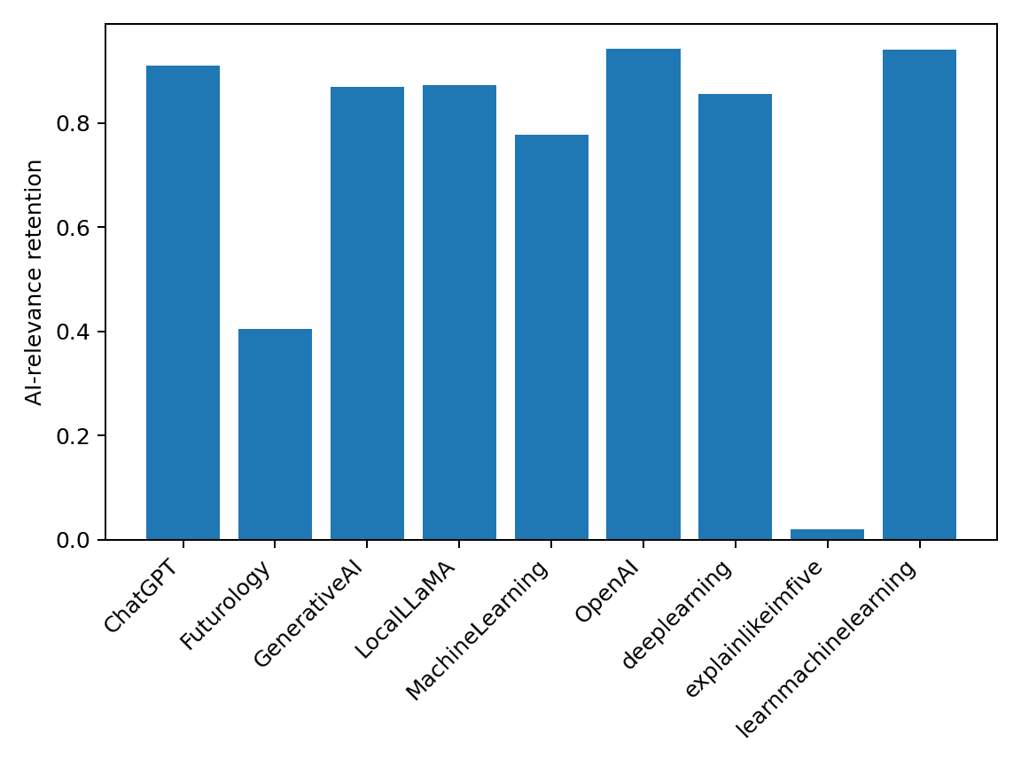
Figure 1. Conservative AI-relevance retention by subreddit. The low retention in r/explainlikeimfive and r/Futurology illustrates the topic-equivalence problem in the original low-tier sample.

3.2 Cluster-aware linguistic results
No planned linguistic outcome survived Benjamini-Hochberg correction when subreddit was treated as the independent tier-level unit. Average syllables per word produced the smallest unadjusted exact p-value. Its unweighted mean of subreddit means was 1.581 in the low tier, 1.540 in the medium tier, and 1.638 in the high tier. The exact p-value was .0536, but the corresponding FDR-adjusted q-value was .5357. The other nine outcomes had exact p-values from .2857 to .6679 and q-values of .6679 or higher.
Table 2. Subreddit-level descriptive means and exact permutation results for the AI-screened subset. Adjusted columns control for topic and log post length before subreddit aggregation.
Outcome | Low | Medium | High | Exact p | BH q | Adj. p | Adj. BH q
FK grade | 11.025 | 9.952 | 10.834 | .6071 | .6679 | .5250 | .8482
Gunning Fog | 13.444 | 12.292 | 13.186 | .6107 | .6679 | .5536 | .8482
SMOG | 12.699 | 11.778 | 12.612 | .3321 | .6679 | .5393 | .8482
Mean sentence length | 20.410 | 18.897 | 18.194 | .6679 | .6679 | .5179 | .8482
Mean syllables/word | 1.581 | 1.540 | 1.638 | .0536 | .5357 | .4286 | .8482
MATTR | .9207 | .9119 | .9149 | .2857 | .6679 | .6786 | .8482
Hedges/100 | .3925 | .3904 | .3413 | .6429 | .6679 | .8893 | .8893
Causal terms/100 | .3278 | .3201 | .2163 | .5214 | .6679 | .8821 | .8893
Sentiment compound | .5828 | .4406 | .6304 | .6143 | .6679 | .6179 | .8482
Negative sentiment | .0421 | .0569 | .0394 | .5286 | .6679 | .6536 | .8482
The corrected result therefore differs sharply from the original post-level analysis. The historical corpus still shows descriptive variation, but the available community-level evidence does not support calling any planned linguistic measure a robust tier effect. In particular, the original claim that syllable-based lexical complexity reliably separated the tiers is not sustained after the inferential unit is corrected and multiplicity is accounted for.
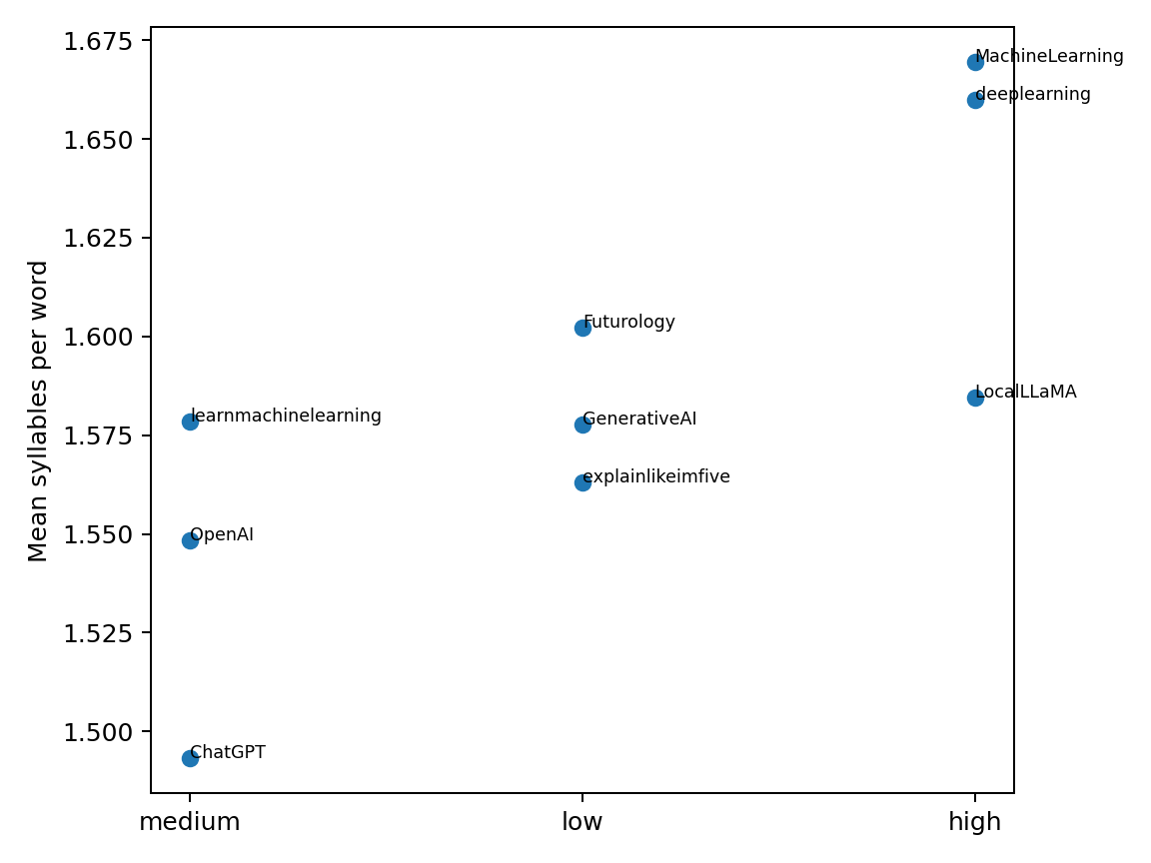
Figure 2. Subreddit means for average syllables per word, the smallest unadjusted exact cluster-level p-value. Individual community points show substantial within-tier heterogeneity.

3.2.1 Readability and sentence-level measures
The cluster-level results change the interpretation of the readability measures most sharply. In the AI-screened subset, the unweighted mean Flesch-Kincaid grade across low-tier communities was 11.025, compared with 9.952 for medium and 10.834 for high. Gunning Fog followed a similar non-monotonic pattern (13.444, 12.292, and 13.186), and SMOG was 12.699, 11.778, and 12.612. None approached cluster-level significance after correction. The descriptive ordering therefore does not support a simple claim that communities with higher technical orientation consistently use text with a higher general reading grade.
Mean sentence length was also inconsistent with a straightforward complexity gradient. The low-tier community mean was 20.410 words per sentence, compared with 18.897 in the medium tier and 18.194 in the high tier. The exact p-value was .6679. This result is important because sentence length is one of the main ingredients in conventional readability formulas. The higher technical-orientation communities were not descriptively distinguished by longer sentences in the corrected AI-screened sample.
Taken together, these measures suggest that the original post-level readability differences were partly driven by within-community sample size and composition rather than by a stable between-community orientation gradient. They also reinforce a measurement caution: broad grade-level formulas combine multiple surface characteristics that may behave differently in informal technical discourse. A single readability score can therefore obscure rather than clarify which aspect of language is changing.

3.2.2 Lexical register and diversity
Average syllables per word remains the closest thing to a directional lexical pattern. The high-tier mean of 1.638 exceeded both the low-tier mean of 1.581 and the medium-tier mean of 1.540. Yet the community-level scatter shows that this ordering is not uniform: r/LocalLLaMA sits near several low- and medium-tier communities, while r/MachineLearning and r/deeplearning account for the upper end of the distribution. With only three communities in each category, those differences matter greatly to the apparent tier mean.
MATTR showed even less separation. The low-, medium-, and high-tier means were .9207, .9119, and .9149, with an exact p-value of .2857 and q = .6679. The descriptive values are so close that the corrected analysis offers little support for lexical diversity as a distinguishing feature of community orientation. This contrasts with the intuitive expectation that more technically oriented communities necessarily use a more diverse vocabulary. Repetition of a specialized technical lexicon can coexist with high expertise, while general-audience explanations can draw on varied everyday vocabulary and analogy.
The corrected lexical results therefore favor a narrower conclusion than the original manuscript. Individual communities differ in vocabulary profile, but the present sample does not establish a general three-level orientation effect. Average syllables per word may still be useful as a descriptive indicator of technical-register density, but its inferential status is exploratory until replicated across substantially more communities.

3.2.3 Discourse markers and sentiment
Neither hedging nor causal-connective frequency produced convincing cluster-level evidence. Hedges per 100 words averaged .3925, .3904, and .3413 across low, medium, and high tiers, respectively (p = .6429; q = .6679). Causal terms per 100 words averaged .3278, .3201, and .2163 (p = .5214; q = .6679). The small descriptive decline toward the high tier is therefore not distinguishable from between-community variation in this sample.
Sentiment likewise remains descriptive rather than inferential. Compound sentiment averaged .5828 in the low tier, .4406 in the medium tier, and .6304 in the high tier (p = .6143; q = .6679). Negative sentiment averaged .0421, .0569, and .0394 (p = .5286; q = .6679). These values do not reproduce the strong tier-level affective interpretation suggested by the original post-level tests. Because topic distributions differ sharply across communities, the corrected result is more consistent with sentiment being community- and topic-specific than with a stable orientation gradient.
This is especially important for r/Futurology, where public discussion can center on social consequences, uncertainty, or risk, and for technical subreddits in which apparently negative words may describe model errors rather than emotional stance. The cluster-aware results provide no basis for inferring that expertise or technical orientation itself causes a more positive tone.

3.2.4 Full-corpus cluster-level sensitivity
A parallel exact cluster-level analysis of the unfiltered 1,778-post corpus leads to the same broad conclusion. No planned outcome survives FDR correction; all q-values are .75. Average syllables per word has an exact p-value of .2071 in the full corpus, while hedge frequency has the smallest full-corpus p-value at .0821. Flesch-Kincaid, Gunning Fog, SMOG, sentence length, MATTR, causal connectives, and the two sentiment measures are all further from conventional significance.
The AI relevance filter therefore does not create the lack of cluster-level significance. Instead, the sensitivity comparison shows that both the full historical sample and the AI-focused subset contain substantial between-community heterogeneity that cannot be summarized confidently as a three-tier effect with only nine clusters. The AI-screened subset is preferable for topical interpretation, but the inferential conclusion is similar in both versions.

3.2.5 External-rater tier sensitivity
The external-rater sensitivity analysis directly tests whether the corrected conclusion is an artifact of the author's original tier boundaries. The two external raters agreed strongly with each other (88.9%; Cohen's kappa = .82) but both reclassified r/Futurology and r/GenerativeAI into the middle tier. Across the author and both external raters, Fleiss' kappa = .654, indicating meaningful but non-identical classification of the nine communities.
Under Rater 1's 2/4/3 mapping, the smallest unadjusted exact p-value was for causal-connective frequency (p = .0206; q = .2063), while average syllables per word yielded p = .0429 and q = .2143. Under Rater 2's 1/5/3 mapping, causal-connective frequency again produced the smallest raw p-value (p = .0496; q = .3836), and average syllables per word yielded p = .1052 and q = .3836. Thus, neither external mapping produced an FDR-significant linguistic outcome.
Table 3. Sensitivity of cluster-level inference to the original and two external community-tier mappings. Adjusted entries report the strongest topic- and length-adjusted result under each mapping.
Mapping | Tier sizes | Strongest unadjusted | p / q | Syllables p / q | Strongest adjusted | FDR sig.?
Original author | 3/3/3 | Mean syllables/word | .0536 / .5357 | .0536 / .5357 | Syllables: .4286 / .8482 | No
External Rater 1 | 2/4/3 | Causal terms/100 | .0206 / .2063 | .0429 / .2143 | Causal: .0754 / .7540 | No
External Rater 2 | 1/5/3 | Causal terms/100 | .0496 / .3836 | .1052 / .3836 | Neg. sentiment: .0575 / .2249 | No
The adjusted analyses lead to the same conclusion. Under Rater 1's mapping, the strongest adjusted result was causal-connective frequency (p = .0754; q = .7540). Under Rater 2's mapping, the strongest adjusted result was negative sentiment (p = .0575; q = .2249). No adjusted outcome survived FDR correction under either mapping. The main inferential conclusion is therefore robust to the two independently supplied alternative tier structures.

3.3 Topic overlap and adjusted analysis
Seven of the eight saved broad topics were represented in all three orientation tiers. Topic 6, operationally labeled as quoted or web-style discussion fragments, had no low-tier observations. This means the corpus has substantial but incomplete topic overlap. The topic representation does not make the communities directly comparable, but it permits a sensitivity test for whether broad content composition explains the apparent linguistic ordering.
Table 4. Saved broad topic representation and cross-tier overlap.
Topic | Operational label | Overlap all tiers
0 | ChatGPT and general use discussion | Yes
1 | ML learning and education | Yes
2 | Model training and open-source implementation | Yes
3 | AI video and generation | Yes
4 | AI society, work, and human impacts | Yes
5 | OpenAI and company/product news | Yes
6 | Quoted/web-style discussion fragments | No
7 | Image prompting and generation | Yes
After residualizing each linguistic measure for log post length and topic, no outcome survived FDR correction. The adjusted p-value for average syllables per word was .4286 with q = .8482. All adjusted q-values were .8482 or higher. Adjustment therefore weakened rather than strengthened the most prominent unadjusted descriptive pattern. The corrected evidence does not support the interpretation that topic and length were merely suppressing a strong underlying tier effect.
The adjustment results are also useful for interpreting the original concern about post length. In the old post-level analysis, several measures changed materially when word count was controlled. The revised cluster procedure takes a different approach: it first removes variation associated with log word count and topic at the post level, then asks whether the average residuals of the nine communities align with the original orientation labels. That test does not reveal a hidden tier pattern. Instead, the adjusted p-values for the readability and lexical measures range from .4286 to .6786, while the discourse-marker outcomes are .8821 and .8893.
This matters because a confound can operate in either direction. If topic and length were masking a genuine orientation effect, adjustment might strengthen the separation. If they were contributing to the apparent difference, adjustment should weaken it. The latter pattern is closer to what occurs here for mean syllables per word. The revised analysis therefore treats post length and topic not as minor nuisances around a stable finding, but as important parts of why the original communities appeared different.

3.4 Generalization to unseen communities
Grouped validation also substantially weakened the original predictive story. Leave-one-subreddit-out logistic regression achieved accuracy of .3549, balanced accuracy of .3336, and macro-F1 of .3355. In a three-class problem, the balanced-accuracy result is effectively at the chance benchmark. Random forest performed worse, with accuracy .2394, balanced accuracy .1998, and macro-F1 .1880.
Table 5. Leave-one-subreddit-out classifier performance and subreddit-level permutation baselines.
Model | Accuracy | Balanced acc. | Macro-F1 | Perm. p acc. | Perm. p bal. | Perm. p F1
Logistic regression | .3549 | .3336 | .3355 | .353 | .529 | .477
Random forest | .2394 | .1998 | .1880 | .950 | .999 | .987
The subreddit-label permutation baselines do not support reliable unseen-community prediction. For logistic regression, the permutation p-values were .353 for accuracy, .529 for balanced accuracy, and .477 for macro-F1. For random forest they were .950, .999, and .987. The corrected classifier evaluation therefore provides no evidence that the measured linguistic features generalize reliably from the original communities to an unseen subreddit with the same orientation label.
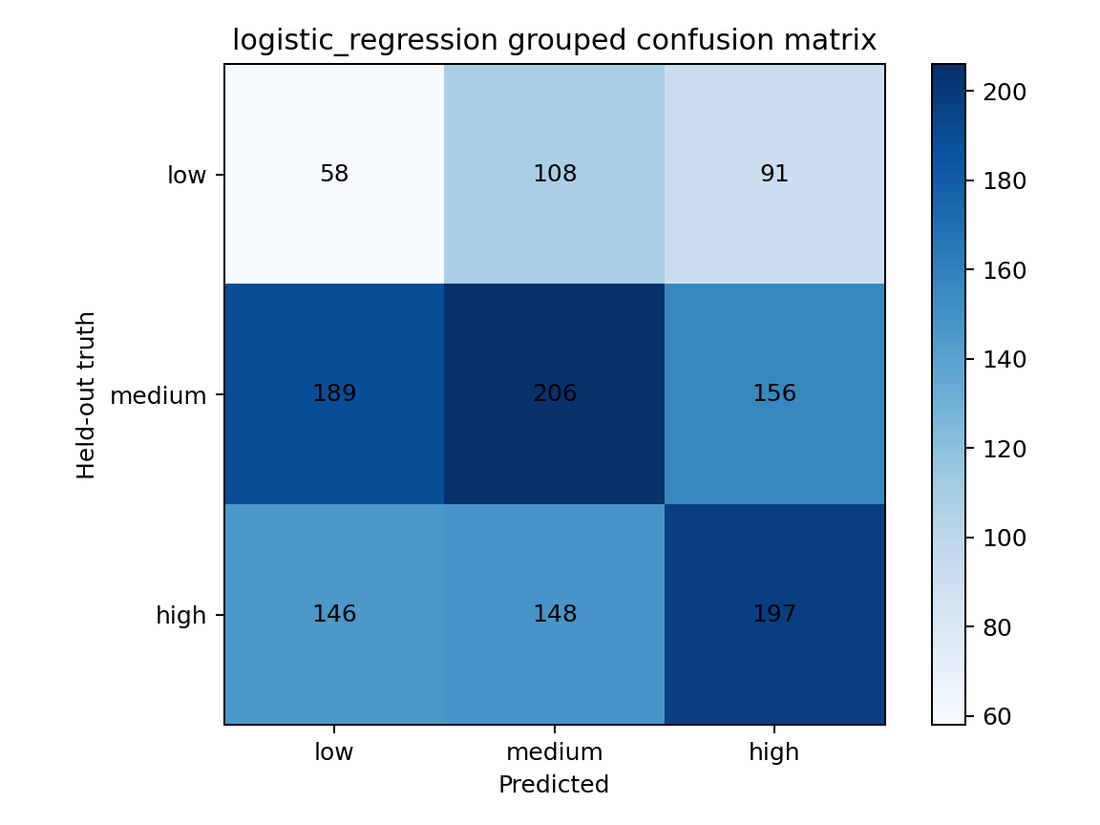
Figure 3. Logistic-regression confusion matrix under leave-one-subreddit-out validation. Prediction errors are broadly distributed across all three orientation classes, consistent with near-chance balanced accuracy.

3.4.1 Variation across held-out communities
Performance varied substantially depending on which subreddit was held out. In logistic regression, held-out accuracy was approximately .48 for r/ChatGPT, .21 for r/Futurology, .23 for r/GenerativeAI, .39 for r/LocalLLaMA, .37 for r/MachineLearning, .46 for r/OpenAI, .44 for r/deeplearning, .50 for r/explainlikeimfive, and .19 for r/learnmachinelearning. This instability is exactly what would be expected if the model were learning patterns tied to particular communities rather than a transferable three-tier register.
A classifier that genuinely captured a general orientation signal should perform with some consistency across unseen communities that share the same nominal tier. Instead, communities within the same tier differ markedly. The result reinforces the statistical analysis: the tier labels summarize heterogeneous subreddits, and within-tier similarity is not strong enough to support reliable out-of-community prediction.
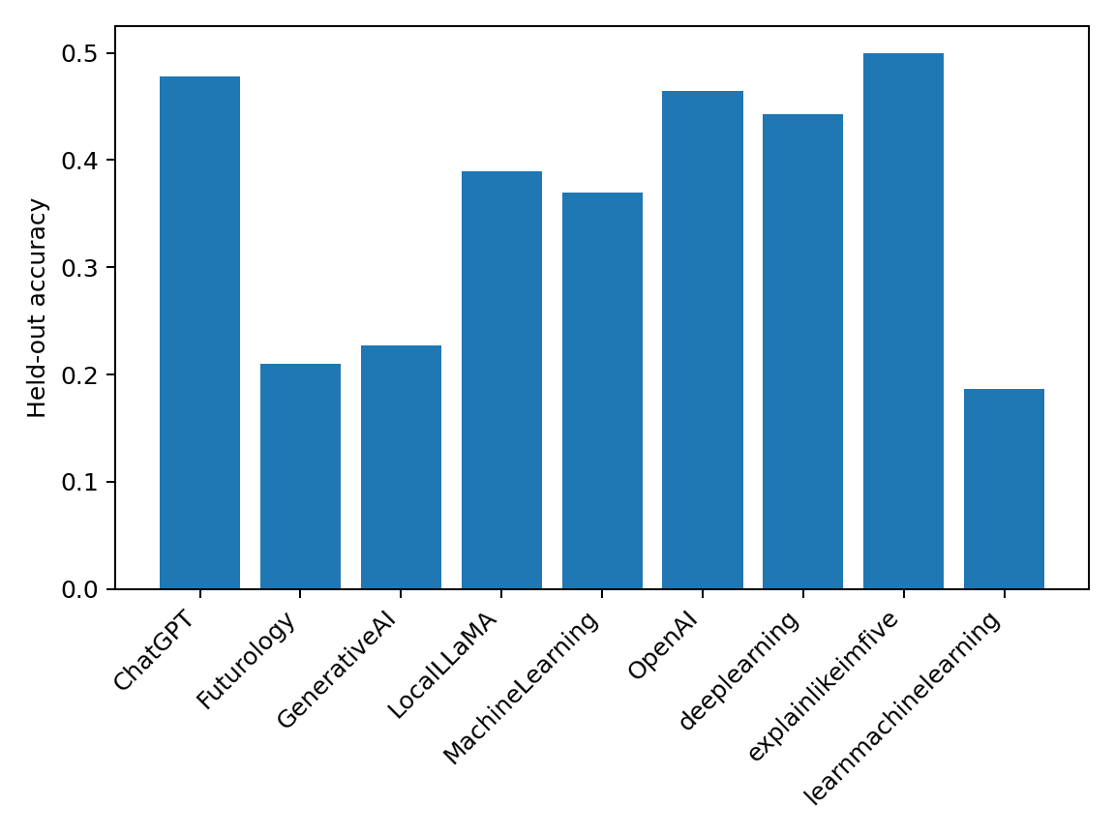
Figure 4. Logistic-regression held-out accuracy by subreddit. The wide community-to-community variation illustrates the instability hidden by a single pooled accuracy value.

3.5 What remains descriptively visible
The absence of FDR-significant cluster-level effects does not mean the communities are linguistically identical. Figure 2 shows visible cross-subreddit differences in mean syllables per word, and the descriptive means in Table 2 vary across readability, sentiment, and discourse-marker measures. What changes is the level at which those differences can be generalized. With only three communities per tier, within-tier heterogeneity is large relative to the information available for estimating a tier effect.
Average syllables per word remains the most descriptively suggestive measure because the high tier contains the two highest community means, r/MachineLearning and r/deeplearning. At the same time, r/LocalLLaMA is closer to several low- and medium-tier communities, and the medium tier spans the lowest observed mean in r/ChatGPT and higher values in r/learnmachinelearning. The tier labels therefore compress substantial community-specific variation.
The corrected results also separate statistical uncertainty from substantive absence. An exact p-value of .0536 with only nine clusters does not prove that lexical register is unrelated to community orientation. It indicates that this dataset cannot support the earlier strength of claim. A larger sample of independently selected communities is needed to distinguish a genuine orientation effect from idiosyncratic subreddit composition.

4. Discussion
The central finding of the revision is methodological: the strength of the original evidence depended heavily on treating posts as if they were independent observations of a community-level construct. Once subreddit is allowed to carry the inferential weight, the apparent certainty largely disappears. None of the ten planned outcomes survives FDR correction, topic and length adjustment does not recover a robust effect, and grouped classifiers do not generalize reliably to unseen communities.
This change in inference is not a technicality. Posts from the same subreddit share moderation policies, topic distributions, recurring users, cultural norms, ranking systems, and collective histories. These common influences make within-subreddit posts correlated in ways that matter for a tier label attached to the subreddit itself. A very large number of posts can therefore coexist with a very small effective sample for a community-level hypothesis. In the present study, the relevant number for the three-tier claim is nine communities, not 1,778 posts.
The AI-relevance audit further shows why the original community composition was difficult to interpret. r/explainlikeimfive contributed only four clearly AI-related posts under the conservative screen, while r/Futurology retained less than half of its sampled posts. Those communities were originally intended to anchor the low-orientation tier, yet much of their sampled material was not directly comparable with dedicated AI communities. This creates a confound between technical orientation and topic domain. Sentiment is particularly vulnerable: a community discussing societal risks or speculative futures can differ in affect from one discussing model releases or implementation even when audience orientation is held constant.
Average syllables per word remains descriptively interesting but no longer supports the original headline claim. Its high-tier mean is larger than the low- and medium-tier means, and r/MachineLearning and r/deeplearning occupy the top of the community-level distribution. However, the exact cluster-level p-value is .0536 and the FDR q-value is .5357. After topic and length adjustment, the evidence becomes weaker. The appropriate wording is therefore that lexical register varies descriptively across the sampled communities, not that a stable three-tier technical-orientation effect has been established.
This distinction also changes how audience-design theory should be used. Bell's (1984) framework remains a useful motivation for why language might vary with expected audience knowledge, but the present design cannot demonstrate audience adaptation. It does not track the same writers across communities, randomly assign audiences, verify individual expertise, or hold topic constant. The data are consistent with several mechanisms: audience expectations, community gatekeeping, topic specialization, self-selection of authors, moderation rules, and reward structures. The revision therefore treats audience design as a theoretical lens rather than as a causal conclusion.
Communities-of-practice theory remains relevant for a different reason. Technical communities can normalize vocabulary and discourse conventions that become routine for participants (Lave & Wenger, 1991). Such local norms can create real linguistic differences without implying that every member has the same expertise or that any one lexical measure tracks expertise directly. The descriptive heterogeneity observed here is compatible with community-specific register formation even though the three-tier grouping is too coarse to produce robust inferential separation.
The grouped classifier results reinforce this interpretation. A random post split can reward a model for learning patterns specific to communities that appear in both training and test data. Leave-one-subreddit-out validation asks the more meaningful question: if the model has never seen a particular community, can it infer that community's orientation from the linguistic features of its posts? In this dataset, the answer is no. Logistic regression is essentially at chance in balanced accuracy, and random forest performs worse. This suggests that the features encode substantial community-specific information that does not transfer cleanly to another subreddit within the same nominal tier.
The revised analysis therefore highlights a broader issue for computational social science. Hierarchical online data can make statistical samples look much larger than the number of independent social contexts they actually contain. When the explanatory construct is defined at the group level, post-level significance can be misleading even when the feature extraction is technically correct. Robust inference requires either many more groups, an explicitly exploratory group-level analysis, or a design that introduces independent variation at the level of the construct.
The null corrected result should also be interpreted carefully. With only three communities per tier, exact cluster-level tests have limited power and coarse p-value resolution. Failure to reject a null does not establish that technical orientation has no effect on register. It establishes that this particular corpus does not provide sufficiently strong independent evidence for the effect. The distinction matters because the most productive next step is not to defend the old p-values, but to improve the sampling design.
A stronger confirmatory study would select a substantially larger set of AI-related communities before examining linguistic outcomes, classify community orientation from outcome-independent metadata, verify AI relevance for every retained post, use a common score-independent sampling rule, ensure topic overlap, and fit models that respect posts nested within communities. Grouped prediction should continue to hold out entire communities, and permutation procedures should operate on community labels rather than individual posts. Such a design would test whether the descriptive pattern observed here generalizes beyond the idiosyncrasies of the original nine subreddits.

4.1 Why the original result looked stronger
The contrast between the original and revised analyses is instructive. Post-level tests answered a question of the form: do thousands of texts carrying different subreddit labels have different feature distributions? Because posts within a community share many contextual influences, that question can produce extremely small p-values even when the number of independent communities is tiny. The revised test asks the question implied by the theoretical claim: do communities assigned different orientation labels differ in their community-level linguistic profiles? The second question has only nine independent units and therefore much wider uncertainty.
This is a common hierarchical-data problem rather than a peculiarity of Reddit. Students nested within schools, patients nested within hospitals, users nested within platforms, and posts nested within communities all create dependence. If an explanatory variable is defined at the higher level, increasing the number of lower-level observations improves estimation of each group but does not create new independent groups. The present revision makes that structure explicit.
The result also explains why leave-one-subreddit-out robustness in the old analysis was not sufficient. Removing one subreddit at a time can show that a post-level association is not produced entirely by a single community, but the remaining posts are still nested in only eight communities and are still analyzed as thousands of observations if the inferential model is unchanged. A sensitivity analysis can therefore be stable while the underlying level of inference remains inappropriate.

4.2 Tier-label sensitivity and construct validity
The external ratings strengthen the revision in a way the original manuscript could not. They show that the broad distinction between the three most technical communities and the rest is not unique to the author's judgment, while also revealing that the lower and middle boundary is genuinely ambiguous. Both external raters placed r/Futurology and r/GenerativeAI in the middle category, and they disagreed only about r/ChatGPT. This is precisely the kind of ambiguity that should be visible rather than hidden inside a single researcher-defined tier structure.
Crucially, changing the tier boundaries does not restore the original statistical story. Neither external mapping produces an FDR-significant result, before or after topic and length adjustment. This makes the revised conclusion stronger: the absence of robust tier-level evidence is not dependent on preserving the author's original categorization. At the same time, the imperfect agreement shows why future work should define orientation prospectively from outcome-independent metadata and retain the complete coding records.

4.3 Interpreting the apparent lexical pattern
The lexical pattern deserves particular care because it is both theoretically plausible and statistically uncertain. Technical communities often normalize long domain-specific terms, and the highest subreddit means in Figure 2 occur in r/MachineLearning and r/deeplearning. That descriptive observation is compatible with an audience-orientation account. It is equally compatible, however, with subfield topic composition, community-specific author populations, or moderation norms that are not captured by the three-tier label.
The revised evidence therefore supports treating mean syllables per word as a hypothesis generator rather than a confirmed marker. A future sample with eight or ten independent communities per orientation category could test whether the high-tier tendency repeats across different technical subfields instead of depending on a small number of communities. Direct measures of domain terminology could also distinguish technical vocabulary from generic polysyllabic words more cleanly than a syllable average.

4.4 Topic as a substantive variable, not only a nuisance
Topic is not merely statistical noise in online discourse. Communities partly exist because they select different subjects, and those subjects shape vocabulary, affect, sentence form, and explanation style. The desk review correctly identified that comparing AI risk discussions in a broad futures community with model-release discussions in a technical implementation community can generate linguistic differences even if audience orientation plays no role.
A stronger design should therefore decide in advance whether topic is something to control, match, or study jointly with orientation. Matched-event designs could compare discussion of the same model release, regulation, safety incident, or technical breakthrough across communities. A larger observational design could model topic and orientation simultaneously, allowing the analysis to ask whether the same broad topic is expressed differently in communities with different intended audiences.

4.5 Implications for interpreting online linguistic data
The revised results caution against treating surface linguistic metrics as direct proxies for social constructs. Readability scores, lexical diversity, hedging counts, sentiment, and syllable-based complexity each capture different properties of text. None directly measures expertise. Their interpretation depends on topic, genre, text length, community norms, and the assumptions built into the underlying algorithms.
Readability formulas are especially vulnerable in informal technical discourse. They combine sentence and word-level features developed for conventional prose, while Reddit posts may contain fragments, code snippets, equations, list structures, and unusual punctuation. A high readability grade can reflect formatting artifacts or terminology rather than conceptual difficulty. Similarly, a high syllable count may reflect technical names or domain vocabulary that is efficient for insiders rather than intrinsically harder language.
The same principle applies to sentiment. A negative VADER score may reflect genuinely negative affect, but it may also reflect technical phrases containing words such as failure, error, loss, or risk. Without matched topics or domain-specific sentiment validation, affective differences across technical communities should remain secondary and exploratory.

5. Limitations and Future Work
The most important limitation is the number of independent communities. Although the corpus contains 1,778 posts, only nine subreddits define the orientation comparison, with three communities per tier. Exact cluster-level inference appropriately reflects this small effective sample, but the resulting tests have limited power. The absence of FDR-significant effects should not be interpreted as proof of no relationship; it indicates that the current design cannot estimate a general tier effect with confidence.
Second, community orientation remains an imperfect construct. Two external raters independently classified the same nine communities and agreed with each other on 8 of 9 assignments (Cohen's kappa = .82), while agreement across the author and both external raters yielded Fleiss' kappa = .654. The external ratings therefore provide useful evidence that some community distinctions are reproducible, but they also show that the low-versus-medium boundary is unstable: both raters moved r/Futurology and r/GenerativeAI into the middle category, and they differed on r/ChatGPT. The available records preserve the assignments but not a fully prespecified coding manual. For that reason, the external ratings are treated as a sensitivity check rather than definitive validation. Importantly, no linguistic outcome survives FDR correction under either external mapping.
Third, topic equivalence is incomplete. The AI-relevance screen retained only four r/explainlikeimfive posts and 81 r/Futurology posts, compared with much higher retention in dedicated AI communities. The saved topic model shows broad overlap, but topic modeling cannot fully recover comparability after the original sample has been collected. A confirmatory design should verify AI relevance before feature analysis and either match topics across communities or include topic controls in a larger multilevel model.
Fourth, the original sampling procedure prioritized highly scored posts. This design was motivated by interest in community-rewarded language, but it does not represent typical discourse and can amplify local norms. Score itself is also not comparable across communities of different sizes and activity levels. Future work should use a common time-bounded chronological rule as the primary sample and, if desired, analyze highly rewarded posts as a separate secondary subset.
Fifth, several linguistic measures have construct-validity limitations. Readability formulas were developed for formal prose; keyword-based hedging and causal-connective counts cannot disambiguate context; VADER is not specialized for AI discourse; and average syllables per word conflates ordinary lexical complexity with technical names and domain vocabulary. These measures are useful as reproducible surface indicators but should not be interpreted as direct measurements of expertise, cognitive load, or communicative quality.
Sixth, public reproducibility is necessarily partial because the complete historical Reddit post bodies and original post-level linguistic-feature matrix are not redistributed. The corrected analyses, including the external-tier sensitivity checks, were conducted against the historical working data. The public repository therefore supports auditing of manuscript-facing aggregate outputs and regeneration of figures, but not end-to-end reconstruction of body-level feature extraction from a fresh clone. This boundary is a data-release limitation rather than an unreported analytical substitution.
Seventh, the current topic representation is statistical rather than a human-validated substantive coding scheme. Topic 6 lacks low-tier observations, and the eight-topic NMF solution may divide or merge themes differently from a human taxonomy. Future work should validate topic labels and test matched-topic subsets in which each topic is well represented across community orientations.
Eighth, the study concerns one platform, one broad technological domain, one historical sampling period, and English-language discourse. Reddit's demographics, moderation structures, and voting mechanisms differ from other platforms. AI discussion also changes rapidly over time. Generalization to other domains, languages, and platforms therefore requires independent replication.
Finally, the prospective redesign prepared during revision remains unexecuted in the present evidence base. A balanced 24-community frame, outcome-blind tiering rubric, common time window, score-independent sampling rule, AI-relevance gate, topic controls, hierarchical analysis plan, and grouped classifier validation were specified before outcome inspection. Technical access limitations prevented collection of a valid fresh corpus in the available environment, and the resulting zero-row collection attempt was explicitly excluded from analysis. No observation from that prospective design is used in the present results.

5.1 Prospectively specified confirmatory design
The revision process produced a prospective design intended to address the four desk-review concerns directly. The planned frame contains 24 AI-related communities, balanced at eight communities per orientation category. Community labels are assigned before linguistic outcomes are examined and use only public metadata such as community purpose, intended audience, prerequisite expectations, rules, and beginner-content policy. Linguistic difficulty, jargon density, readability, or observed post vocabulary are explicitly prohibited from the tiering decision.
The prospective sampling rule also differs from the historical corpus. Rather than selecting highly scored posts, it uses a common time window and chronological discovery followed by timestamp-systematic selection. Score and comment count are not used for selection. The protocol targets 100 to 150 eligible AI-related posts per community, retains communities with 80 to 99 posts as reduced-N rather than replacing them merely for balance, and requires review of communities below 80 before any outcome analysis. These decisions were frozen before linguistic outcomes were inspected.
Every retained post in the prospective design must receive an explicit AI-relevance decision. Broad topics are to be coded or modeled before outcome testing, with sensitivity analyses restricted to topics represented across orientation categories. The primary inferential model is hierarchical, with posts nested within subreddit and orientation represented at the community level. Cluster-level permutation and bootstrap procedures are planned as sensitivity analyses rather than relying on conventional post-level p-values.
Predictive evaluation is also grouped by community. Entire subreddits must be absent from training, and label permutations operate at the subreddit level. This design tests whether linguistic patterns generalize to social contexts that were not seen during model fitting rather than whether a classifier can recognize more posts from communities it already knows.
A compliant attempt to collect the prospective corpus was made in a public-browser environment, but the automated pages exposed zero retrievable post cards across all frozen communities. The failure was documented as a technical rendering or selector-access problem, not as evidence of content scarcity. The zero-row output was excluded from all cleaning and analysis. Because no valid fresh corpus was obtained, the prospective design remains a replication protocol and does not contribute observations to the present manuscript.
Although unexecuted, the protocol clarifies what evidence would be needed to move beyond the present exploratory result. The key improvement is not simply more posts. It is more independent communities selected and categorized without reference to the linguistic outcomes, combined with stronger control of topic and community-level validation. That design would allow a future study to estimate whether the suggestive lexical pattern in Figure 2 is a reproducible orientation effect or a property of the particular subreddits sampled here.

6. Conclusion
This cluster-aware reanalysis materially changes the interpretation of the original study. Across 1,299 AI-screened posts from nine Reddit communities, no planned linguistic outcome survives exact subreddit-level permutation testing with FDR correction, topic and length adjustment does not recover a robust effect, and grouped classifiers do not generalize reliably to unseen communities. The same inferential conclusion holds under both external-rater tier mappings: despite strong agreement between the two external raters (88.9%; Cohen's kappa = .82), neither alternative mapping produces an FDR-significant linguistic outcome. The corrected evidence therefore does not support a general three-tier register effect in this nine-community sample.
The corpus nevertheless shows substantial linguistic heterogeneity across individual subreddits. The corrected conclusion is therefore not that online communities are linguistically identical, but that the original three-tier structure is not supported strongly enough by nine communities to justify the earlier claims. Large numbers of posts cannot substitute for independent communities when the explanatory construct exists at the community level.
The broader contribution is methodological. Studies of online discourse should align the inferential unit with the level at which theoretical constructs are defined, distinguish descriptive variation from generalizable group effects, control topic composition explicitly, and evaluate prediction on genuinely unseen social contexts. A larger, independently coded, AI-specific, topic-controlled community sample is needed before strong claims about technical orientation and linguistic register can be made.

7. References
Banerjee, T. (2022). textstat (Version 0.7.13) [Computer software]. https://pypi.org/project/textstat/
Bell, A. (1984). Language style as audience design. Language in Society, 13(2), 145-204. https://doi.org/10.1017/S004740450001037X
Chandrasekharan, E., Samory, M., Jhaver, S., Charvat, H., Bruckman, A., Lampe, C., Eisenstein, J., & Gilbert, E. (2018). The Internet's hidden rules: An empirical study of Reddit norm violations at micro, meso, and macro scales. Proceedings of the ACM on Human-Computer Interaction, 2(CSCW), Article 32, 1-25. https://doi.org/10.1145/3274301
Clark, H. H., & Murphy, G. L. (1982). Audience design in meaning and reference. Advances in Psychology, 9, 287-299. https://doi.org/10.1016/S0166-4115(09)60059-5
Danescu-Niculescu-Mizil, C., West, R., Jurafsky, D., Leskovec, J., & Potts, C. (2013). No country for old members: User lifecycle and linguistic change in online communities. In Proceedings of the 22nd International Conference on World Wide Web (pp. 307-318). Association for Computing Machinery. https://doi.org/10.1145/2488388.2488416
Hutto, C. J., & Gilbert, E. (2014). VADER: A parsimonious rule-based model for sentiment analysis of social media text. In Proceedings of the Eighth International AAAI Conference on Weblogs and Social Media (pp. 216-225). AAAI Press. https://ojs.aaai.org/index.php/ICWSM/article/view/14550
Lave, J., & Wenger, E. (1991). Situated learning: Legitimate peripheral participation. Cambridge University Press.
Liimatta, A. (2019). Exploring register variation on Reddit. Register Studies, 1(2), 233-264. https://doi.org/10.1075/rs.18005.lii
Nguyen, D., Doğruöz, A. S., Rosé, C. P., & de Jong, F. (2016). Computational sociolinguistics: A survey. Computational Linguistics, 42(3), 537-593. https://doi.org/10.1162/COLI_a_00258
Strukova, S., Ruipérez-Valiente, J. A., & Gómez Mármol, F. (2024). Computational approaches to detect experts in distributed online communities: A case study on Reddit. Cluster Computing, 27, 2181-2201. https://doi.org/10.1007/s10586-023-04076-w
Sweller, J. (1988). Cognitive load during problem solving: Effects on learning. Cognitive Science, 12(2), 257-285. https://doi.org/10.1207/s15516709cog1202_4
Tan, C., Niculae, V., Danescu-Niculescu-Mizil, C., & Lee, L. (2016). Winning arguments: Interaction dynamics and persuasion strategies in good-faith online discussions. In Proceedings of the 25th International Conference on World Wide Web (pp. 613-624). International World Wide Web Conferences Steering Committee. https://doi.org/10.1145/2872427.2883081
Tran, T., & Ostendorf, M. (2016). Characterizing the language of online communities and its relation to community reception. In Proceedings of the 2016 Conference on Empirical Methods in Natural Language Processing (pp. 1030-1035). Association for Computational Linguistics. https://doi.org/10.18653/v1/D16-1108
Data & Code Availability Statement
The revised analysis package contains the exploratory reanalysis scripts, AI-relevance decisions, subreddit-level descriptive and inferential outputs, grouped classifier predictions, topic-overlap files, figures, environment information, external-rater tier assignments and sensitivity outputs, and the prospective replication protocol. Complete historical Reddit post bodies and the original post-level feature matrix are not publicly redistributed.
The anonymized repository associated with this submission is available at the following address. The repository should contain the same revision outputs used for the submitted manuscript.
https://anonymous.4open.science/r/reddit-expertise-register-analysis-EBE6/README.md
Acknowledgements
The author thanks a close friend and a cousin for their encouragement and support throughout the research process.
Author Biography
The author is a high school senior and independent researcher interested in the intersection of computer science, psychology, language, and human behavior. Their research focuses on how artificial-intelligence systems behave across linguistic, cultural, and social contexts, with particular interests in multilingual evaluation, moral reasoning, computational social science, and human-centered AI. Their work uses reproducible computational experiments, statistical analysis, and human validation to study variation in model behavior and communication. They aspire to combine research and system design to develop technology that is not only technically capable, but also socially responsible and genuinely useful to the people and communities it is meant to serve.
Mentor Contribution Statement
This research was conducted independently. No mentor contributed to the study design, data collection, analysis, interpretation, or writing of the manuscript.

