Community Technical Orientation and Linguistic Register in AI Reddit Communities: A Cluster-Aware Exploratory Reanalysis
Abstract
Online discussions of artificial intelligence span communities with very different intended audiences and technical norms, but posts within a subreddit are not independent observations of community expertise. This exploratory reanalysis revisits 1,778 posts from nine Reddit communities originally grouped into three community-orientation tiers. The revision treats subreddit, rather than individual post, as the tier-level inferential unit; audits AI relevance; controls for topic and post length; corrects for multiple testing; and evaluates classifiers only on held-out communities. A conservative AI/ML screen retained 1,299 posts (73.1%), with large cross-community differences in retention, including 4/200 posts in r/explainlikeimfive and 81/200 in r/Futurology. Exact cluster-level permutation tests found that none of ten planned linguistic outcomes survived Benjamini-Hochberg false-discovery-rate correction. Average syllables per word produced the smallest unadjusted p-value (p=.0536; q=.5357), but its topic- and length-adjusted result was weaker (p=.4286; q=.8482). Leave-one-subreddit-out logistic regression achieved balanced accuracy=.3336 and macro-F1=.3355; random forest performance was lower, and subreddit-label permutation baselines did not support reliable generalization. The corrected analysis therefore does not support robust tier-level linguistic separation in the original nine-community sample. Instead, it shows descriptive heterogeneity across communities and illustrates how post-level inference can overstate precision when the explanatory variable is defined at the community level. The findings are best treated as exploratory evidence motivating larger, independently coded and topic-controlled community samples.
Keywords: Reddit; computational linguistics; register variation; online communities; clustered inference; community technical orientation

1. Introduction
Artificial intelligence is discussed on Reddit by casual users, learners, developers, hobbyists, and researchers. These communities differ not only in topic but also in norms: what counts as a useful explanation, an impressive contribution, or an appropriate level of technical detail can vary substantially across subreddits. Such variation makes Reddit a natural setting for studying linguistic register across online communities.
Audience-design theory proposes that language varies with expectations about listeners or readers (Bell, 1984; Clark & Murphy, 1982). Related work has shown that online communities develop distinctive linguistic norms and that language changes with community participation, social position, and interactional goals (Danescu-Niculescu-Mizil et al., 2013; Liimatta, 2019; Tan et al., 2016). Computational work has also examined expertise detection in Reddit communities (Lim & Hachigian, 2023). These literatures motivate asking whether communities oriented toward different levels of technical discussion show different linguistic profiles.
The original version of this study analyzed 1,778 posts from nine subreddits and reported several post-level differences across low-, medium-, and high-expertise tiers. The desk review identified a fundamental statistical problem with that interpretation: the tier label was assigned at the subreddit level, whereas the inferential tests treated individual posts as independent evidence about tier. Two hundred posts from one subreddit do not provide two hundred independent observations of a community-level exposure. The review also identified three related concerns: possible circularity in the original tier assignments, topic mismatch across communities, and classifier leakage caused by random post-level train/test splitting.
This revision therefore changes both the statistical unit and the strength of the claims. The original categories are retained only as exploratory labels for community technical orientation or intended-audience orientation. They are not treated as verified measures of individual author expertise. The revised analysis asks: What descriptive linguistic differences remain across these nine AI-related communities when subreddit is treated as the tier-level inferential unit, topic and length are considered explicitly, multiple testing is controlled, and prediction is evaluated only on unseen communities?
This narrower framing matters. The goal is no longer to establish causal audience adaptation or to claim that the language of individual writers reveals their expertise. Instead, the study evaluates whether the originally observed register differences are robust to a cluster-aware reanalysis of the existing corpus.

2. Methods

2.1 Corpus and original sampling frame
The source corpus contains 1,778 posts from nine subreddits: r/Futurology, r/GenerativeAI, and r/explainlikeimfive in the original low tier; r/ChatGPT, r/OpenAI, and r/learnmachinelearning in the medium tier; and r/LocalLLaMA, r/MachineLearning, and r/deeplearning in the high tier. The original study sampled highly scored posts through a public web-scraping workflow rather than the official Reddit API. Posts were drawn from overlapping recency windows and deduplicated. Because that strategy preferentially samples community-rewarded content, the present reanalysis does not interpret the corpus as representative of typical posting behavior.
The revision preserves the original community labels only to audit the claims made from the original design. These labels should be read as coarse subreddit-level technical-orientation categories, not verified expertise measurements. No individual-level expertise is inferred.

2.2 Linguistic features
The preserved feature set includes Flesch-Kincaid grade level, Gunning Fog, SMOG, average sentence length, average syllables per word, MATTR, hedging frequency per 100 words, causal-connective frequency per 100 words, VADER compound sentiment, and VADER negative sentiment. Readability measures were computed with standard formula-based tooling, and sentiment was derived using VADER (Hutto & Gilbert, 2014). Average syllables per word is treated only as a syllable-based lexical-register indicator; it is not assumed to be a direct measure of cognitive difficulty or author expertise.

2.3 AI-relevance audit
A conservative content screen was used to identify clearly AI/ML-related posts using terms covering artificial intelligence, machine learning, deep learning, large language models, major model families, prompting, embeddings, fine-tuning, inference, computer vision, NLP, reinforcement learning, and related concepts. The screen functions as an audit and sensitivity filter rather than as a gold-standard semantic annotation. The retained analysis package preserves the original content-screen decisions; it does not reconstruct body-level semantic judgments from titles alone.
Orientation | Subreddit | Posts | AI-screened N | Retention
Low | Futurology | 200 | 81 | 40.5%
Low | GenerativeAI | 198 | 172 | 86.9%
Low | explainlikeimfive | 200 | 4 | 2.0%
Medium | ChatGPT | 200 | 182 | 91.0%
Medium | OpenAI | 192 | 181 | 94.3%
Medium | learnmachinelearning | 200 | 188 | 94.0%
High | LocalLLaMA | 197 | 172 | 87.3%
High | MachineLearning | 198 | 154 | 77.8%
High | deeplearning | 193 | 165 | 85.5%
Table 1. Existing-corpus composition and conservative AI-relevance retention.

2.4 Topic representation and overlap
The saved AI-screened subset was represented using TF-IDF unigrams and bigrams and decomposed with an eight-topic non-negative matrix factorization model. The resulting operational topics covered general ChatGPT use, ML learning, model training/open-source implementation, AI video generation, societal and work impacts, OpenAI/company news, quoted or web-style fragments, and image prompting/generation. Seven of the eight topics were represented in all three tiers; Topic 6 had no low-tier observations. Topic indicators were used as nuisance controls in the adjusted analysis.

2.5 Cluster-level inference
For each planned linguistic outcome, post-level values in the AI-screened subset were averaged within subreddit. The nine subreddit means were then treated as the independent tier-level observations. Exact balanced permutation inference enumerated all 1,680 assignments of nine subreddit clusters into three groups of three and compared the observed between-tier dispersion with the resulting null distribution. Benjamini-Hochberg false-discovery-rate correction was applied across the ten planned linguistic outcomes.

2.6 Topic- and length-adjusted sensitivity analysis
For the adjusted exploratory analysis, each linguistic outcome was residualized against log post length and the saved topic indicators without including tier in the residualization model. Residuals were then averaged within subreddit and tested using the same exact cluster-label permutation procedure. This approach asks whether the descriptive tier pattern remains after removing variation associated with topic and post length while keeping the inferential unit at the community level.

2.7 Grouped predictive validation
The original random 80/20 post split was removed because it allowed posts from the same subreddit to appear in both training and test data. The revised analysis uses leave-one-subreddit-out validation. Logistic regression and random forest classifiers are trained on eight communities and evaluated on the ninth, repeated until every subreddit serves as the held-out community. Accuracy, balanced accuracy, and macro-F1 are computed from pooled held-out predictions. Null baselines permute tier labels at the subreddit level rather than independently across posts.

2.8 Reproducibility boundary
The revision package preserves the cluster-aware result files and provenance from the original feature pipeline. The retained handoff used for this reanalysis does not contain complete post bodies/selftext or the original post-level linguistic-feature matrix. Consequently, body-based feature extraction, acronym normalization, new topic modeling, cluster bootstrap, and alternative outcome refits were not represented as newly recomputed from titles. Where such analyses could not be rerun honestly from retained inputs, the revision records that limitation rather than silently reconstructing them.

3. Results

3.1 AI relevance varies sharply by community
The conservative screen retained 1,299 of 1,778 posts (73.1%). Retention varied substantially by subreddit. r/explainlikeimfive retained only 4 of 200 posts (2.0%) and r/Futurology retained 81 of 200 (40.5%), whereas most dedicated AI communities retained between 77.8% and 94.3% of their posts. This confirms that topic equivalence was a material weakness of the original sampling frame, especially in the low tier.
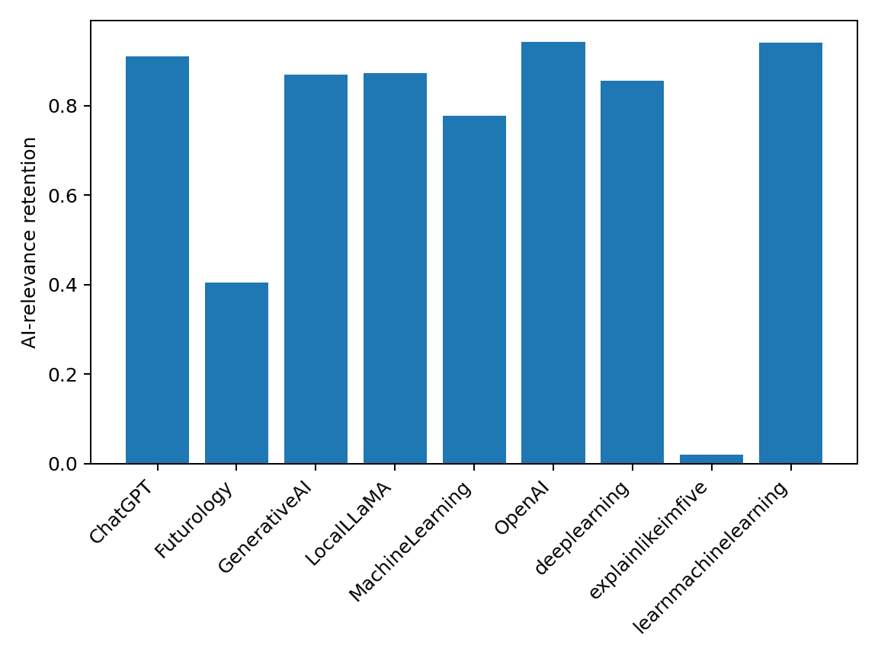
Figure 1. Conservative AI-relevance retention by subreddit.

3.2 Cluster-aware linguistic differences
No planned linguistic outcome survived BH false-discovery-rate correction in the AI-screened subset. Average syllables per word produced the smallest exact cluster-level p-value, with low, medium, and high tier means of 1.581, 1.540, and 1.638 respectively (p=.0536; q=.5357). All remaining outcomes had exact p-values between .2857 and .6679, with q-values of .6679 or higher. Thus, the strong post-level significance reported in the original manuscript does not translate into robust tier-level evidence when the subreddit is treated as the independent unit.
Outcome | Low | Medium | High | Exact p | BH q | Adj. p | Adj. q
FK grade | 11.025 | 9.952 | 10.834 | .6071 | .6679 | .5250 | .8482
Gunning fog | 13.444 | 12.292 | 13.186 | .6107 | .6679 | .5536 | .8482
SMOG | 12.699 | 11.778 | 12.612 | .3321 | .6679 | .5393 | .8482
Mean sentence length | 20.410 | 18.897 | 18.194 | .6679 | .6679 | .5179 | .8482
Mean syllables/word | 1.581 | 1.540 | 1.638 | .0536 | .5357 | .4286 | .8482
MATTR | .9207 | .9119 | .9149 | .2857 | .6679 | .6786 | .8482
Hedges/100 | .3925 | .3904 | .3413 | .6429 | .6679 | .8893 | .8893
Causal terms/100 | .3278 | .3201 | .2163 | .5214 | .6679 | .8821 | .8893
Sentiment compound | .5828 | .4406 | .6304 | .6143 | .6679 | .6179 | .8482
Negative sentiment | .0421 | .0569 | .0394 | .5286 | .6679 | .6536 | .8482
Table 2. Subreddit-level descriptive means and exact permutation results for the AI-screened subset. Adjusted columns control for topic and log post length before subreddit aggregation.
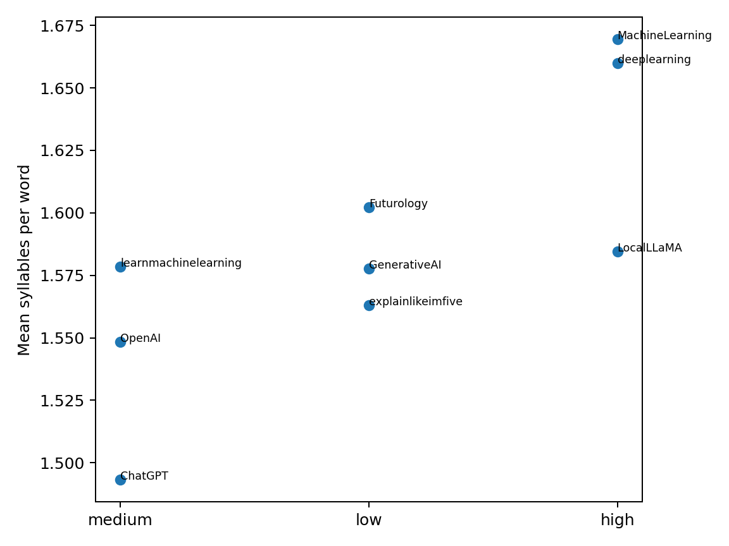
Figure 2. Subreddit means for average syllables per word, the smallest unadjusted cluster-level p-value.
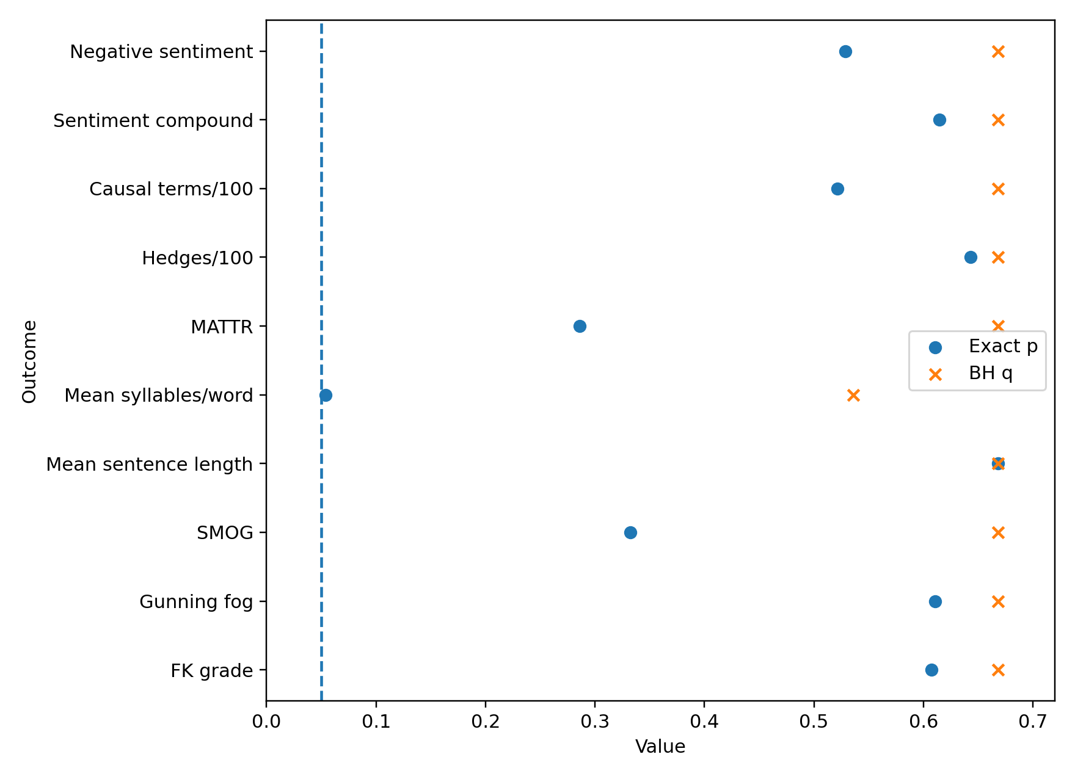
Figure 3. Exact cluster-level p-values and BH-adjusted q-values across planned outcomes.

3.3 Topic- and length-adjusted results
Adjustment for topic and log post length did not strengthen the evidence. The average-syllables result weakened from p=.0536 to p=.4286, and its adjusted q-value was .8482. Across all ten outcomes, adjusted q-values were .8482 or .8893. Therefore, no topic- and length-adjusted outcome provided FDR-significant evidence of differences across the original community-orientation tiers.
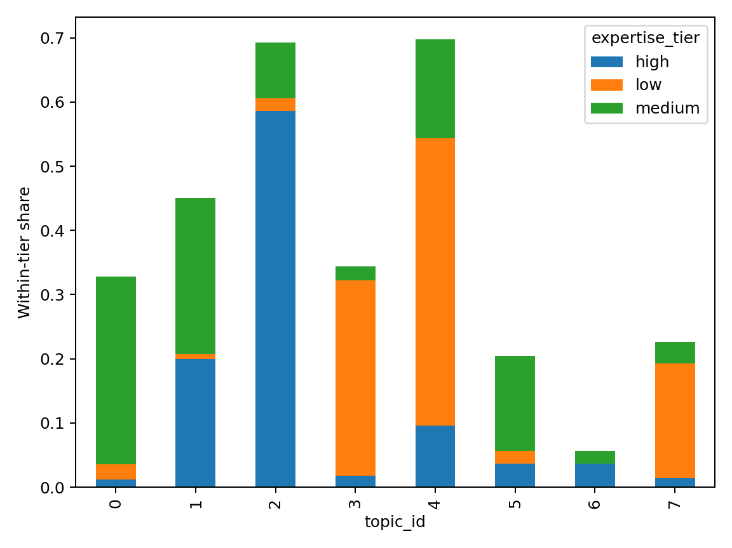
Figure 4. Saved broad-topic distribution across the three original community-orientation tiers. Seven of eight topics overlap all tiers.

3.4 Prediction does not generalize reliably to unseen communities
Grouped validation produced weak performance. Logistic regression achieved accuracy=.3549, balanced accuracy=.3336, and macro-F1=.3355. Random forest performance was lower: accuracy=.2394, balanced accuracy=.1998, and macro-F1=.1880. Subreddit-label permutation p-values did not support reliable performance above a community-level null. For logistic regression, permutation p-values were .353 for accuracy, .529 for balanced accuracy, and .477 for macro-F1; for random forest they were .950, .999, and .987 respectively.
Model | Accuracy | Balanced acc. | Macro F1 | Perm. p (acc.) | Perm. p (bal.) | Perm. p (F1)
Logistic regression | .3549 | .3336 | .3355 | .353 | .529 | .477
Random forest | .2394 | .1998 | .1880 | .950 | .999 | .987
Table 3. Leave-one-subreddit-out classifier performance and subreddit-label permutation baselines.
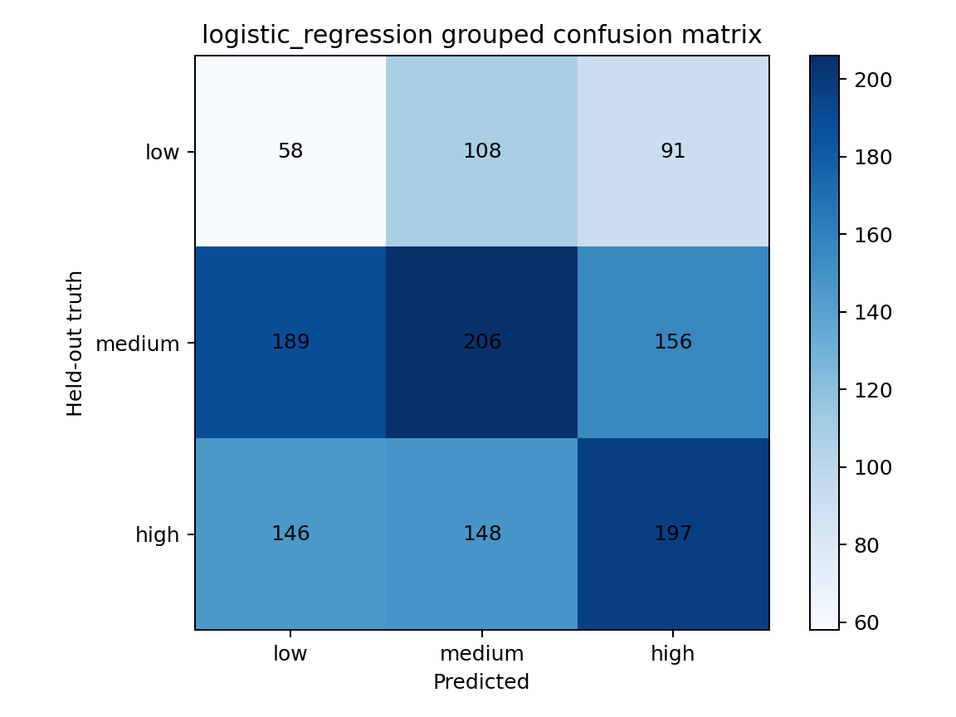
Figure 5. Logistic-regression confusion matrix under leave-one-subreddit-out validation.
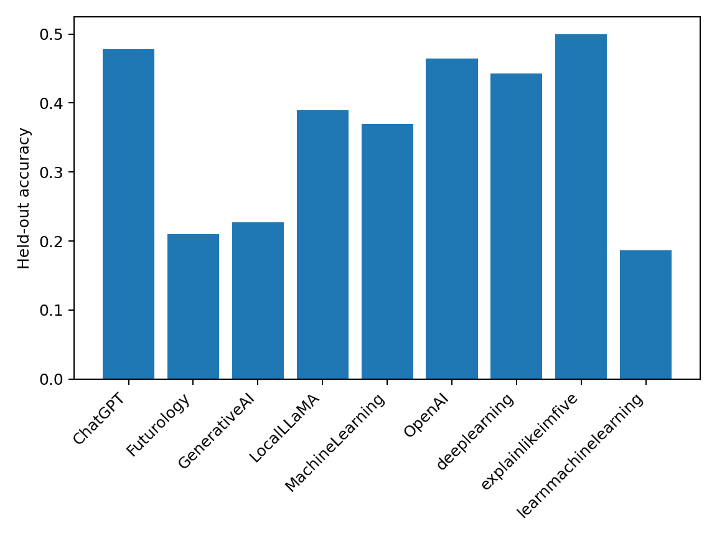
Figure 6. Held-out accuracy by subreddit for logistic regression.

4. Discussion
The corrected analysis materially changes the interpretation of the study. The original corpus contains genuine descriptive heterogeneity, including visible differences in lexical measures across communities. However, once tier is recognized as a subreddit-level variable, the evidence is much less precise than the original post-level tests suggested. None of the ten planned linguistic outcomes survives FDR correction, the strongest lexical signal falls just above the conventional unadjusted .05 threshold, and that signal weakens substantially after topic and post-length adjustment.
This distinction is important because the unit of measurement and the unit of inference are not the same. Linguistic features are measured on individual posts, but the community-orientation label is attached to the subreddit. Posts from the same subreddit share moderation rules, recurring topics, community history, platform norms, and potentially overlapping users. Treating those posts as independent evidence about the tier label inflates the apparent amount of information available for tier-level inference. The cluster-aware reanalysis avoids that interpretation by allowing the nine communities, rather than the 1,778 posts, to carry the inferential weight.
The AI-relevance audit also clarifies why the original low tier was especially difficult to interpret. r/explainlikeimfive contributed only four clearly AI-related posts under the conservative screen, and r/Futurology retained less than half of its sampled posts. The original comparison therefore mixed AI discourse with substantial quantities of unrelated explanatory or futures content. This is particularly consequential for sentiment and readability, both of which can vary strongly with topic. The topic-adjusted analysis provides no evidence that controlling for these differences recovers a robust tier effect.
Average syllables per word remains descriptively interesting because the high-tier communities include the two highest subreddit means in the corpus. Yet the corrected evidence does not justify calling this a robust tier marker. The exact p-value of .0536 and FDR q-value of .5357 indicate that, with only three communities per tier, the observed ordering is compatible with substantial between-community uncertainty. After topic and length adjustment, the result becomes weaker rather than stronger. The appropriate interpretation is therefore descriptive: lexical register differs across communities, but the current nine-community sample cannot establish a general technical-orientation effect.
The grouped classifiers tell a similar story. A random post split can appear encouraging because the model sees training examples from the same communities that later appear in the test set. Leave-one-subreddit-out validation asks a harder and more substantively relevant question: do these linguistic features generalize to a community the model has never seen? In this corpus, they do not. Logistic regression is essentially at chance in balanced accuracy, and the random forest performs worse. The community-level permutation baselines reinforce the conclusion that the apparent post-level signal does not generalize reliably across communities.
These corrected results do not imply that community norms are linguistically irrelevant. Prior work on online communities provides strong reasons to expect register differentiation (Danescu-Niculescu-Mizil et al., 2013; Liimatta, 2019), and the descriptive plots here show substantial heterogeneity. Rather, the present reanalysis demonstrates that nine communities are insufficient for strong claims about a three-level community-orientation construct, especially when the communities differ in topic and sampling conditions. The methodological lesson is therefore as important as the substantive one: large numbers of posts do not substitute for large numbers of independent communities when the explanatory variable exists at the community level.

5. Limitations and Future Work
The most important limitation is the small number of independent communities. Although the corpus contains 1,778 posts, only nine subreddits define the tier-level comparison. With three communities per tier, exact cluster-level tests necessarily have limited resolution and power. The absence of FDR-significant effects should therefore not be read as proof that no community-orientation effect exists; it means that this dataset does not provide sufficiently strong evidence for one.
Second, the original tier labels were assigned qualitatively and are retained here only as exploratory community-orientation categories. They do not establish individual expertise, and the revised manuscript does not treat them as such. A stronger design should assign tiers using outcome-independent metadata such as community purpose, intended audience, prerequisite expectations, and beginner-content policy, with independent outcome-blind coders and agreement reporting.
Third, the original sampling frame contains strong topic imbalance. The AI-relevance audit shows that r/explainlikeimfive and r/Futurology are not comparable to dedicated AI communities in the proportion of clearly AI-related sampled posts. The saved topic model reduces but cannot eliminate this concern. Future work should use only AI-relevant posts and either match topics across communities or model topic directly in a larger hierarchical design.
Fourth, the original sample emphasized highly scored posts. This captures community-rewarded language rather than typical language and can amplify subreddit-specific norms. A confirmatory study should use a common time-bounded, score-independent sampling rule across communities.
Fifth, the original feature set has measurement limitations. Traditional readability formulas were developed for formal prose and may behave unpredictably on Reddit text containing fragments, code, lists, and unconventional punctuation. Hedging keyword counts cannot distinguish epistemic from non-epistemic uses, and sentiment models may confound affect with technical vocabulary or topic. These measures should therefore be interpreted as surface indicators rather than definitive linguistic constructs.
Finally, the retained revision handoff does not include the full post bodies or original post-level feature matrix, so certain robustness analyses cannot be newly reconstructed from the retained inputs. The revision therefore preserves the provenance of existing cluster-aware outputs and explicitly avoids presenting unavailable recomputations as newly performed. A future confirmatory corpus should preserve immutable raw text, derived features, and analysis-ready records together under a reproducible data-management plan.
To address these issues prospectively, a balanced 24-community replication protocol (eight communities per orientation tier) was specified before outcome analysis. The protocol uses outcome-blind metadata tiering, a common time window, score-independent chronological sampling, AI-relevance decisions for every post, topic controls, hierarchical models, and grouped validation. That prospective design contributes no observations to the present results and is presented only as a roadmap for confirmatory work.

6. Conclusion
This cluster-aware reanalysis does not support the strong tier-level conclusions of the original post-level analysis. Across 1,299 AI-screened posts from nine subreddits, no planned linguistic outcome survives exact community-level permutation testing with FDR correction, topic and length adjustment does not recover a robust effect, and grouped classifiers fail to generalize reliably to unseen communities. The corpus nevertheless shows substantial descriptive heterogeneity across subreddits, underscoring that online communities can differ linguistically even when a general three-tier effect cannot be established from this design. The central contribution of the revision is therefore methodological as well as substantive: when a construct is assigned at the community level, inference must respect the community as the independent unit. Larger, independently coded, topic-controlled samples are required before making general claims about technical orientation and linguistic register in AI discourse.

Data and Code Availability
The revision package contains the analysis script, post-level AI-relevance decisions, subreddit-level descriptive and inferential outputs, grouped classifier predictions, topic-overlap files, figures, environment information, and a frozen prospective replication protocol. The current reanalysis package does not contain the complete original post bodies/selftext or original post-level linguistic-feature matrix; analyses that require those inputs are therefore not represented as newly recomputed. The prospective 24-community protocol is not part of the present empirical sample.

References
Banerjee, T. (2022). textstat (Version 0.7.13) [Software]. https://pypi.org/project/textstat/
Bell, A. (1984). Language style as audience design. Language in Society, 13(2), 145-204. https://doi.org/10.1017/S004740450001037X
Clark, H. H., & Murphy, G. L. (1982). Audience design in meaning and reference. Advances in Psychology, 9, 287-299. https://doi.org/10.1016/S0166-4115(09)60059-5
Danescu-Niculescu-Mizil, C., West, R., Jurafsky, D., Leskovec, J., & Potts, C. (2013). No country for old members: User lifecycle and linguistic change in online communities. Proceedings of the 22nd International Conference on World Wide Web, 307-318. https://doi.org/10.1145/2488388.2488416
Hutto, C. J., & Gilbert, E. (2014). VADER: A parsimonious rule-based model for sentiment analysis of social media text. Proceedings of the Eighth International Conference on Weblogs and Social Media.
Lave, J., & Wenger, E. (1991). Situated learning: Legitimate peripheral participation. Cambridge University Press.
Lim, S., & Hachigian, C. (2023). Computational approaches to detect experts in distributed online communities: A case study on Reddit. Cluster Computing. https://doi.org/10.1007/s10586-023-04076-w
Liimatta, A. (2019). Exploring register variation on Reddit. Register Studies, 1(2), 233-264. https://doi.org/10.1075/rs.18005.lii
Sweller, J. (1988). Cognitive load during problem solving: Effects on learning. Cognitive Science, 12(2), 257-285. https://doi.org/10.1207/s15516709cog1202_4
Tan, C., Niculae, V., Danescu-Niculescu-Mizil, C., & Lee, L. (2016). Winning arguments: Interaction dynamics and persuasion strategies in good-faith online discussions. Proceedings of the 25th International Conference on World Wide Web, 613-624. https://doi.org/10.1145/2872427.2883081

