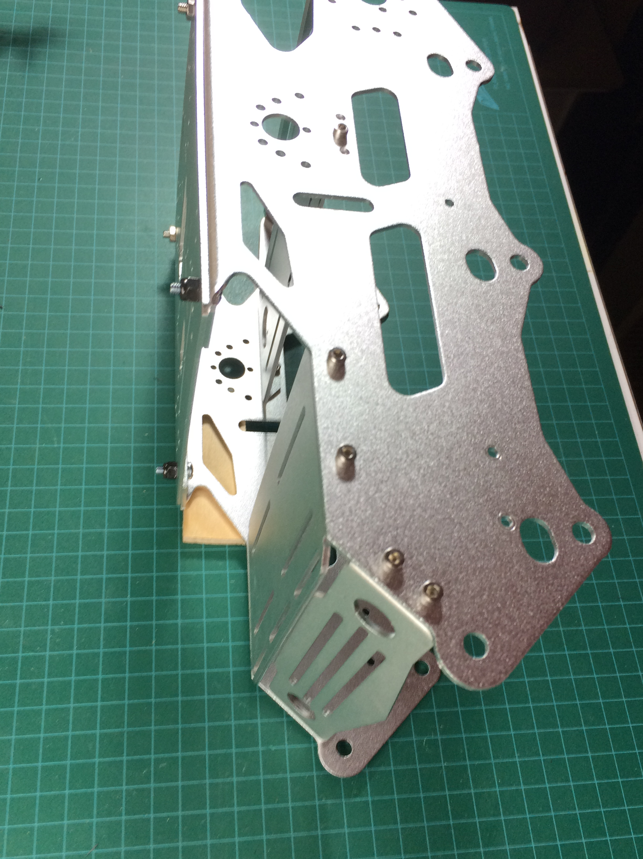
Left view
Left Bulkhead
FP
Front Plate
F
Deck
D
Deck
Right Bulkhead
B
Deck

Forward Aft

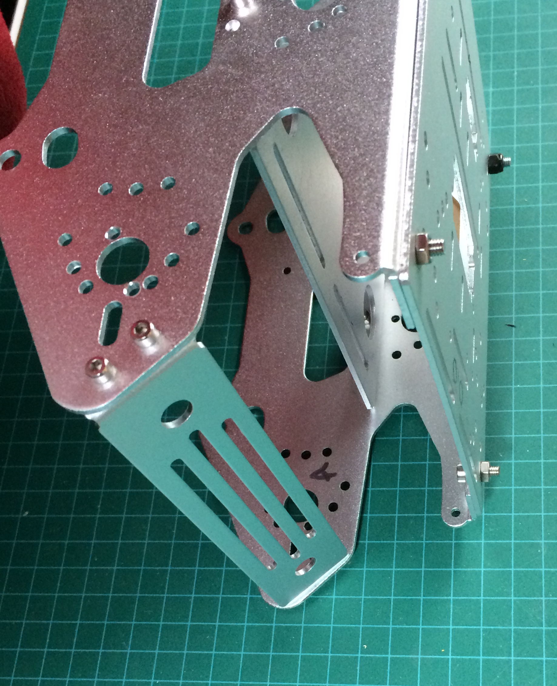
Left View
AP
Aft Plate
B
Deck
a
Deck
F
Deck
e
Deck
Forward Aft

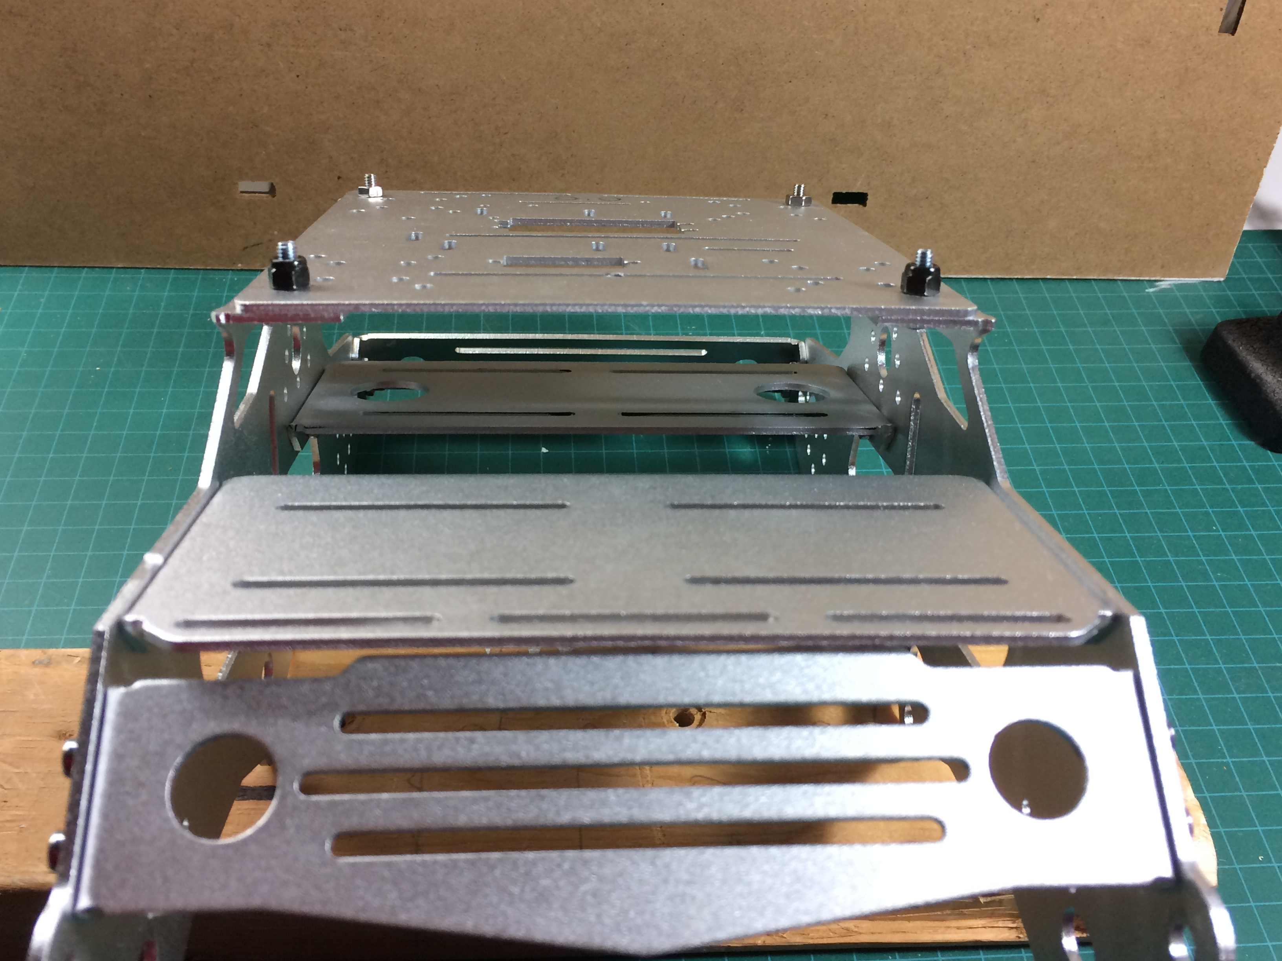
Front View

FP
Front Plate
B
Deck
D
Deck
F
Deck
e
Deck

Right Left

Aft View
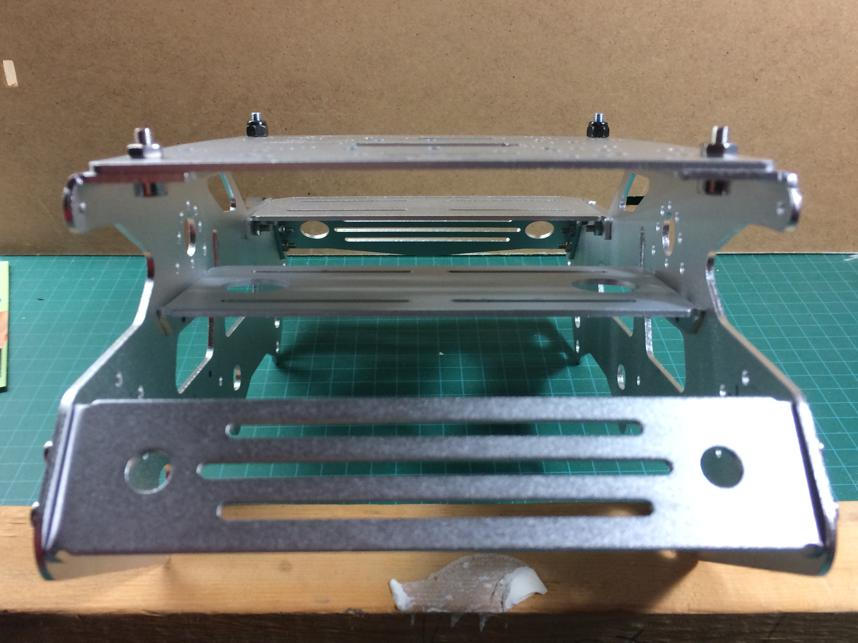
AP
Aft Plate
B
Deck
F
Deck
D
Deck
a
Deck
c
Deck
e
Deck
Left Right
Legend

a, c, e: bottom decks
B, D, F: top decks

