How to Commit from XCode (and skip committing certain files)

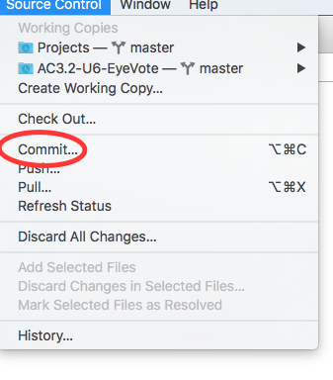

1. In your XCode Project, go to Source Code > Commit
2. 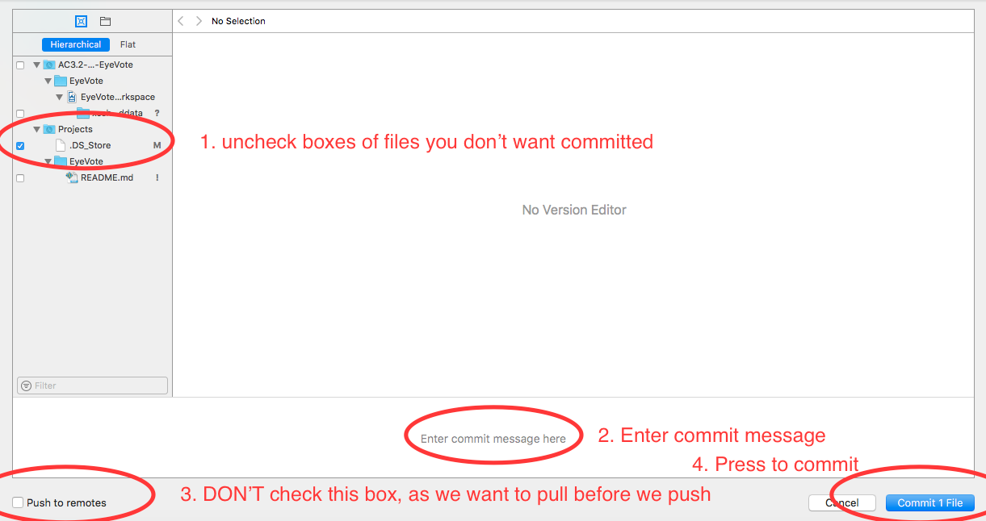
3. Follow the steps above to commit locally
4. PULL FROM MASTER
5. Check for merge issues
6. PUSH to Master
7. Make Pull Request
8. Simone or Mira will approve your pull request