**KNIFE LEGISLATION AND HANDLING AT AIRPORTS**

**IN**

**INDIA**

# Weapons Act

*1.1 Which knives are considered weapons under your local law?*

I note that Indian legislations do not have a precise definition for “weapon” per se.

Since knives are bladed objects, they fall within the category of arms. Under the Arms Act, 1959, Section 2(c) defines “arms” as follows:

*“arms” means articles of any description designed or adapted as weapons for offence or defence, and includes firearms, sharp edged and other deadly weapons, and parts of, and machinery for manufacturing, arms, but does not include articles designed solely for domestic or agricultural uses such as a lathi (which means as stick) or an ordinary walking stick and weapons incapable of being used otherwise than as toys or of being converted into serviceable weapons;*

Further, under the Arms Rules, 2016, Schedule I, Category V provides a detailed list of arms other than firearms, which is given below:

*“Sharp-edged and deadly weapons, namely: Swords (including swordsticks), daggers, bayonets, spears (including; lances and javelins), battle-axes, knives (including Kirpans and Khukries) and other such weapons with blades longer than 9” or wider than 2” other than those designed for domestic, agricultural, scientific or industrial purposes, steel batton, “Zipo” and other such, weapons called 'life preservers', machinery for making arms, other than category II, and any other arms which the Central Government may notify under Section 4 of the Act.”*

In view of the above, knives (including Kirpans, which is a short sword or knife with a curved blade, worn by individuals belonging to Sikh religion and Khukries, which is a knife and often appears in Nepalese and Indian Gorkha heraldry and is used in many traditional rites such as wedding ceremonies) and other such knives with blades longer than 9” or wider than 2” will be considered as weapons and/or deadly weapons. In addition to that, the Central Government may issue a notification to include any new instrument/object within the category of arms under the Arms Act.

Apart from the above, I note that the Indian legislation doesn’t specify any particular type or kind category of knives, which are designated as weapons.

In this regard, I perused through few cases and in the case of Ashfaq v. State (2004) 3 SCC 116, wherein the Supreme Court had approved the findings of the lower Court and held that “a knife is equally a deadly weapon, for purposes of Section 394 IPC[1]”.

Furthermore, in the case Mathai v. State of Kerala (2005) 3 SCC 260 the Hon’ble Supreme Court stated that the expression "any instrument which used as a weapon of offence is likely to cause death" has to be gauged taking note of the heading of the Indian Penal Code Section. What would constitute a 'dangerous weapon' would depend upon the facts of each case and no generalization can be made. In this particular regard, the Supreme Court observed that “The facts involved in a particular case, depending upon various factors like size, sharpness, would throw light on the question whether the weapon was a dangerous or deadly weapon or not.”

In view thereof, whether a particular knife would be considered a weapon or a deadly weapon would depend upon the facts and circumstances of each case.

*1.2 Is there a legal requirement to have a legitimate/justifiable reason for carrying and/or transporting a knife in the public? If so, for what kind of knives (lock knife, folding knife (depending on a special blade length or not?), fixed knife or any knife)?*

As per the provisions of Section 4 of the Arms Act, there is no complete embargo with respect to acquisition/ possession/carrying of arms/sharp edged objects. The relevant legal provision states that:

If the Central Government is of opinion that having regard to the circumstances prevailing in any area it is necessary or expedient in the public interest that the acquisition, possession or carrying of arms other than firearms should also be regulated, it may, by notification in the Official Gazette, direct that this section shall apply to the area specified in the notification, and thereupon no person shall acquire, have in his possession or carry in that area arms of such class or description as may be specified in that notification unless he holds in this behalf a license issued in accordance with the provisions of this Act and the rules made thereunder.

In view thereof, the Central Government may regulate acquisition/ possession/carrying of arms by issuing an official notification in the prescribed manner, in public interest.

Further, as per the provisions enshrined under the Constitution of India, only the Central Government can legislate in matters relating to arms, firearms, ammunition and explosives, as the same fall under the Union List, which comes under the Seventh Schedule under Article 246 of the Constitution of India. However, as per the provisions of Section 43 (Power to delegate) of the Arms Act, the Central Government may delegate this power to the State Government in the public interest.

In this regard, I came across a notification issued by the State Government of Madhya Pradesh vide Notification No. 6312-6552-II-B(i) dated November 22, 1974, wherein acquisition, possession or carrying of sharp edged weapons with a blade of more than 6 inches and 2 inches wide and spring actuated knives with a blade of any size in public places requires a license as per the provisions Section 4 of the Arms Act. Reference is being made to below:

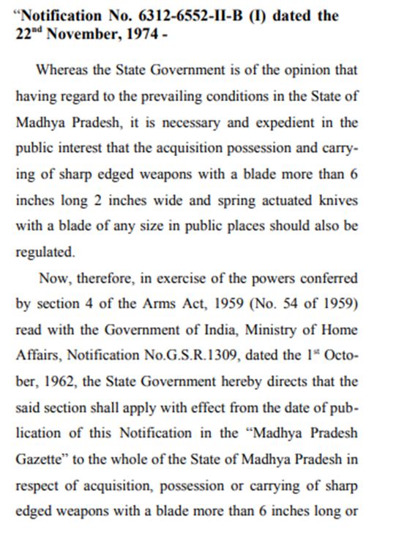

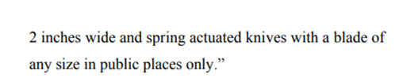

<https://taxguru.in/wp-content/uploads/2017/04/Ajeet-Singh-Anand-alias-Mange-Sardar-Vs-State-of-M.P.-And-others-Madhya-Pradesh-High-Court.pdf>

Furthermore, I came across a case law, wherein a notification bearing no. S.O.127/C.A.54/59/S.4/78 dated 15.9.1978 has been issued by the State Government of Haryana, whereby all persons in the State of Haryana are prohibited from having in their possession spring actuated knife.

In view of the above findings, I would suggest that we should file a request under the Right to Information Act, 2005 before the respective State Governments and before concerned authorities of the Union Territories of India to provide copies of all notifications issued under the provisions of Section 4 of the Arms Act, in order to ascertain if any state has in particular issued any notification with respect to possession/carrying of arms/bladed objects in the respective state and/or Union Territory as the case may be.

*1.3 How must these concerned knives of point 1.2 be carried or transported in the public (e.g. in a closed or locked container)?*

At the outset, I note that the provisions of Arms Rules, 2016 with respect to ‘transport’ include movement of arms or ammunition intercity and the definition of the same does not include intra-city movement.

In general, Rule 96 of the Arms Act, 2016 provides that any arms (knives with blades longer than 9” or wider than 2” other than those designed for domestic, agricultural, scientific or industrial purposes,) specified under Schedule I, Category V[2] shall be transported only with a license in Form XII. Unless, the knives are:

* transported personally or as personal luggage, in reasonable quantities for his own use, by a person lawfully entitled to possess or carry such arms or ammunition;
* transported by a person licensed to manufacture such articles, for proof testing, in a case or package legibly addressed to a Government establishment or an establishment licensed under these rules, or re-transported by such establishment to such person;
* transported through an area where the Central Government has, by notification in the Official Gazette, applied section 4, or from such area to an area where section 4 does not apply, provided that the arms are properly packed and labeled, showing clearly the description of these articles and the name and address of the consignee;
* transported by a licensed manufacturer or dealer for export or after import, in accordance with a license for their export or import,

(i) from the place of despatch to the port or other place of export, or

(ii) from the port or other place of import to the place of destination, or

(iii) by trans-shipment in the port of import for re-export;

This is subject to obtaining a certificate of no objection from the licensing authority at the destination of the articles;

* transported

(i) by a person lawfully entitled to possess such articles, in reasonable quantities for his own use from the premises of a licensed manufacturer or dealer, or for purposes of examination or repair or test to or from any such premises, or to the address of any other person lawfully entitled to possess such articles; or

(ii) by a licensed manufacturer or a dealer, in a case or package legibly addressed to a person lawfully entitled to possess such articles, in compliance with an order given by such person for the supply of such articles, in reasonable quantities, for his own use or after carrying out necessary repairs thereto;

(iii) by a dealer to another dealer under trade transfer, within the same State against a sale invoice;

This is subject to obtaining a certificate of no objection from the licensing authority at the destination of the articles.

*1.4 Are there any public places which may be restricted by an authority (on certain days or at certain times) for carrying any knives or other dangerous tools (e.g. railway station, airport, market places, football stadium, event halls etc.)?*

AIRPORT:

The Airport Authority of India has banned carriage of knives of any length and type in hand baggage, on board flights operating from civil airports in India and Indian registered aircrafts from foreign airports. The only exception is of round-bladed, butter, and plastic cutlery, which could be carried in checked- in baggage.

Reference: <https://www.aai.aero/en/airports/security-info/kullu>

RAILWAYS (interstate intrastate):

I perused through Indian Railways luggage rules and note that knives have not been specifically mentioned as a restricted item. The Luggage Rules states that “offensive articles, explosive, dangerous, inflammable articles and empty gas cylinders, dead poultry, and game, acids and other corrosive substance are not permitted to be booked as luggage.”

Reference: <https://wcr.indianrailways.gov.in/uploads/files/1387190151089-luggege3.pdf>

In view thereof, knives could be carried in Indian railways, unless the dimensions of such knives are such, which may require a License as per the provisions Section 4 of the Arms Act. In this regard, as per the general provisions knives with blades longer than 9” or wider than 2” will be considered as weapons and may indeed be considered as dangerous articles, which cannot be carried as part of the luggage, if travelling through Indian railways.

However, as mentioned above, notifications have been issued by few State Governments, wherein different dimensions of knives have been regulated, therefore, it is imperative to get all the notifications from the respective State Government before I conclusively advise in this regard.

Further, intrastate metro railways in cities like Kolkata, Delhi, Chennai, Bengaluru, Hyderabad, Jaipur, Gurgaon, Mumbai, Kochi and Lucknow have in general banned carriage of knives of any length and type, except round-bladed, butter and plastic cutlery.

However, I came across a 2017 news article, wherein Delhi Metro Corporation has stated that the ban on carrying knives aboard Metro coaches was lifted two months back in November, 2016, as many women carry small knives to cut fruits in their tiffin-boxes and it shows up in the scan machine while going through checks at the stations. Therefore, in order to save the time that goes into physical checks, DMRC decided to let go of the prohibition completely.

Reference: <https://www.ndtv.com/delhi-news/have-allowed-knives-but-not-for-self-defence-delhi-metro-1646038>

Practically speaking, the officials who frisk passengers at the metro stations decide whether to allow a passenger possessing any sharp edged object on case to case basis. Therefore, at times the officials may not allow passengers who are carrying sharp objects/knives with blades which are not longer than 9” or wider than 2”, as these people may not be aware the prescribed dimensions as per law.

*1.5 How is the blade length measured (only the cutting blade or including the blade shank)?*

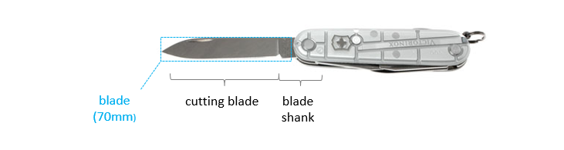

The legislations do not provide for a specific way to measure the blade. However, common practice suggests that the entirety of the blade is measured, starting from the highest point of the tip to where the knife meets the handle.

*1.6 Are there any further dangerous objects which also fall under the Weapons Act?*

In addition to knives (including Kirpans and Khukries) and other such weapons with blades longer than 9” or wider than 2”, following sharp edged objects categorized under Schedule I, Category V of the Arms Rules, 2016 fall under the category of deadly weapons:

* Swords (including swordsticks),
* daggers,
* bayonets,
* spears (including lances and javelins),
* battle-axes

*1.7 Are there any exceptions?*

Yes, ‘KIRPAN’ which can be termed to be a sword or dagger is an important religious symbol of Sikhism. As per provisions of the Constitution of India, people belonging to Sikh religion are allowed to carry Kirpan in public places. In this regard, Sikh passengers travelling on flights with point of origin and destination both being within India, on an Indian registered aircraft are permitted to carry a 'Kirpan' in person. The dimensions of the 'Kirpan' must not exceed a total maximum length of 9 inches (22.86 cms.), including the length of the blade not exceeding 6 inches (15.24 cms.) and the length of the handle not exceeding 3 inches (7.62 cms).

Carriage of ‘Kirpan’ shall not be permitted in the cabin of an aircraft on an International flight and the same shall be carried by the Passenger in his check-in baggage only.

*1.8 What are the consequences for a legal offense?*

As per the provisions of Rule 4 of the Arms Rules, 2016, no license is required for manufacture, sale, possession for sale or test, of arms falling under Schedule I Category V, except in areas notified under Section 4 of the Arms Act.

Further, Section 4 of the Arms Act, 1959 gives the Central Government the power to make a license mandatory in certain areas for acquisition, possession and carrying of arms based on necessity and public interest.

However, if any person in contravention to the aforementioned provisions or notifications issued by the Central Government or the State Government acquires, has in his possession or carries in any place any arms, then the person shall be punished with imprisonment for a term not less than one year but which may extend up to three years and shall also be liable to fine under Section 25(1B)(b).

Also, if the aforesaid contravention takes place in a disturbed area (which has been notified by the Central Government or the State Government), the person may be imprisoned with a period of not less than three years which may extend to seven years and shall also be liable to fine.

*1.9 Are there any legislative developments? If so what do they concern?*

During my search, I could not find any recent legislative developments in relation to blades and knives.

# Airports

* 1. *According to the Official Journal of the European Union laying down detailed measures for the implementation of the common basic standards in aviation security, any pointed or sharp objects which may cause serious injury, including a knife with a blade more than 6cm are not allowed to be taken into the security restricted areas or on board of an aircraft.* 
     1. *Are there any further national regulations to be considered in this respect?*

Our country is outside the European Union.

* + 1. *If your country is outside the EU, what are the corresponding local regulations?*

In India, Bureau of Civil Aviation Security (BCAS), is the regulatory authority for civil aviation security in India.

BCAS lays down Aviation Security Standards in accordance with Annex 17 to Chicago Convention of ICAO for airport operators, airlines operators, and their security agencies responsible for implementing AVSEC measures. It also monitors the implementation of security rules. The BCAS has issued a list of restricted articles which are not allowed to be carried in baggage or in person and the said list is strictly complied by the airport security administration in India. I have attached the said list in the e-mail for your ease of reference.

Apart from that, there are other legislations like Aircraft Act, 1934 and Aircraft Rules, 1937, however, the same doesn’t explicitly touch upon the subject of regulation of sharp edged objects/knives on board of an aircraft.

* 1. *May the airports/airlines in your country issue any further (stricter) regulations for forbidden items?*

Yes, the airports/airlines may issue stricter regulations for forbidden items depending on how sensitive the security situation is at that point of time. But they necessarily have to adhere to the Bureau of Civil Aviation Security (BCAS) guidelines. Here are a few articles, which covers situations when stricter norms were implemented:

<https://economictimes.indiatimes.com/industry/transportation/airlines-/-aviation/now-you-have-to-go-through-extra-hassle-at-indian-airports/articleshow/65588486.cms?from=mdr>

<https://www.hindustantimes.com/delhi/you-can-use-steel-knives-on-planes-not-in-airports/story-KMlsiEj9Y4mdAxsyNtfYrK.html>

<https://timesofindia.indiatimes.com/city/bengaluru/Scissor-chilli-powder-banned-on-domestic-flights/articleshow/21494699.cms>

* 1. *May a pair of scissors or a saw be included in a pocket knife with a blade of max. 6cm? If so, is the size of the pair of scissors or the length of the saw of relevance?*

At the outset, any sharp edged objects are prohibited to be carried at airports regardless of the length and type of the blade, and are included in the BCAS list of ‘restricted sharp objects’ along with scissors. This may cause hindrances if carried in hand-baggage. There is no specific reference to pocket knives, therefore, the same has to be carried only in the checked in baggage. Following links provide an insight regarding the Security Regulations followed by most airports/airlines in India:

[http://www.bengaluruairport.com/airportInformation/internationalDepartures.jspx?_afrLoop=1843253987224911_afrWindowMode=0_adf.ctrl-state=tyww3t6x4_4](http://www.bengaluruairport.com/airportInformation/internationalDepartures.jspx?_afrLoop=1843253987224911&_afrWindowMode=0&_adf.ctrl-state=tyww3t6x4_4)

<https://www.newdelhiairport.in/pdf/Prohibited-Items.pdf>

<https://www.csmia.aero/pdf/prohibited_item_list.pdf>

<http://www.airindia.in/Images/pdf/General-Rules.pdf>

* 1. *What is considered as a sharp object besides knives?*

The Bureau of Civil Aviation Security has released a document containing lists of Restricted Articles which specifies the following as sharp objects:

* Box Cutters
* Ice Axes/Ice Picks
* Knives of any length and type except round bladed, butter and plastic cutlery
* Meat Cleavers
* Razor-Type Blades such as box cutters, utility knives, razor blades not in a cartridge, but excluding safety razors
* Sabers
* Scissors – metal with pointed tips
* Sword
  1. *Are there any further aviation security regulations with respect to the Victorinox (pocket) knives to be observed?*

Prohibited items such as pocket knives or knives in general wherein the blades are not longer than 9” and wider than 2” may be carried in checked-in baggage. However, pocket knives cannot be carried in hand baggage and is a prohibited item. I found an article which through light on the fact that airport security officials confiscate the pocket knives carried in hand baggage at the time of security check:

<https://www.newindianexpress.com/cities/bengaluru/2018/aug/11/bengaluru-flyers-weep-row-to-carry-nandini-ghee-swiss-knives-1856067.html>

* 1. *Are there any changes intended in the near future? If so what do they concern?*

Upon a thorough search, I could not find indications of any changes to be brought about in the near future.

Ibach, Switzerland, 2 March 2020

* * *

1. Section 394 of Indian Penal Code:

   **Voluntarily causing hurt in committing robbery**: If any person, in committing or in attempting to commit robbery, voluntarily causes hurt, such person, and any other person jointly concerned in committing or attempting to commit such robbery, shall be punished with 1(imprisonment for life), or with rigorous imprisonment for a term which may extend to ten years, and shall also be liable to fine.
2. “Sharp-edged and deadly weapons, namely: Swords (including swordsticks), daggers, bayonets, spears (including; lances and javelins), battle-axes, knives (including Kirpans and Khukries) and other such weapons with blades longer than 9” or wider than 2” other than those designed for domestic, agricultural, scientific or industrial purposes, steel batton, “Zipo” and other such, weapons called 'life preservers', machinery for making arms, other than category II, and any other arms which the Central Government may notify under Section 4 of the Act.