**KNIFE LEGISLATION AND HANDLING AT AIRPORTS**

**IN**

**MEXICO**

# Weapons Act

*1.1 Which knives are considered weapons under your local law?*

Based on federal criminal legislation, they are the instruments that can only be used to attack and that have no application in work or recreational activities.

*1.2 Is there a legal requirement to have a legitimate/justifiable reason for carrying and/or transporting a knife in the public? If so, for what kind of knives (lock knife, folding knife [depending on a special blade length or not?], fixed knife or any knife)?*

The FEDERAL LAW OF FIRE WEAPONS AND EXPLOSIVES in Articles 12 and 13 refer to what is considered or not as prohibited weapons:

Article 12 - They are prohibited weapons, for the purposes of this Law, those already indicated in the Criminal Code for the Federal District in Matters of the Common Jurisdiction and for the whole Republic in Matters of the Federal Fuero.

Article 13 - Utensils, tools or instruments for fieldwork or any trade, art, profession or sport that have application known as such shall not be considered as prohibited weapons, but their use shall be limited to the place or place where the sport is worked or performed.

*1.3 How must these concerned knives of point 1.2 be carried or transported in the public (e.g. in a closed or locked container)?*

There is no special requirement for transportation, it is only required that the packaging be closed and sealed.

*1.4 Are there any public places which may be restricted by an authority (on certain days or at certain times) for carrying any knives or other dangerous tools (e.g. railway station, airport, market places, football stadium, event halls etc.)?*

In the case of pocket knives or recreational knives, no. There are some places such as government buildings or schools that do not allow access.

*1.5 How is the blade length measured (only the cutting blade or including the blade shank)?*

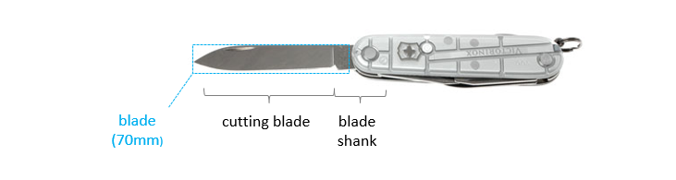

Only the blade. It should be it is necessary to emphasizethat pocket knives have a standard measurement on their grip. The blades whose edge does not exceed six centimeters long and 1.27 wide.

*1.6 Are there any further dangerous objects which also fall under the Weapons Act?*

Sharp or pointed objects.

*1.7 Are there any exceptions?*

Utensils, tools or instruments for fieldwork or any trade, art, profession or sport that have application known as such shall not be considered as prohibited weapons, but their use shall be limited to the place or place where the sport is worked or performed.

*1.8 What are the consequences for a legal offense?*

Based on federal criminal legislation three months to three years or 180 to 360 days fine and confiscation.

*1.9 Are there any legislative developments? If so what do they concern?*

No, there is not.

# Airports

* 1. *According to the Official Journal of the European Union laying down detailed measures for the implementation of the common basic standards in aviation security, any pointed or sharp objects which may cause serious injury, including a knife with a blade more than 6cm are not allowed to be taken into the security restricted areas or on board of an aircraft.*

According to the Official Journal of the European Union laying down detailed measures for the implementation of the common basic standards in aviation security, any pointed or sharp objects which may cause serious injury, including a knife with a blade more than 6cm are not allowed to be taken into the security restricted areas or on board of an aircraft.

* + 1. *Are there any further national regulations to be considered in this respect?*

In accordance with airline baggage regulations, storing dangerous items in carry-on and checked baggage on flights is prohibited, or subject to restrictions. However, these regulations vary by airport or airline. So it is recommended to keep pocket knives in checked luggage.

* + 1. *If your country is outside the EU, what are th**e corresponding local regulations?*

Federal penal code:

FEDERAL LAW OF FIRE WEAPONS AND EXPLOSIVES

* 1. *May the airports/airlines in your country issue any further (stricter) regulations for forbidden items?*

No, there is no special regulations for forbidden items.

* 1. *May a pair of scissors or a saw be included in a pocket knife with a blade of max. 6cm? If so, is the size of the pair of scissors or the length of the saw of relevance?*

Only the size of the blade.

* 1. *What is considered as a sharp object besides knives?*

Blades, scissors, removable blade knives.

* 1. *Are there any further aviation security regulations with respect to the Victorinox (pocket) knives to be observed?*

No, no changes are foreseen in the regulations

* 1. *Are there any changes intended in the near future? If so what do they concern?*

No, at this moment there is no intended changes.

Ibach, Switzerland, 28 July 2020

* * *