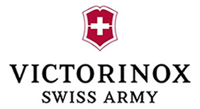**KNIFE LEGISLATION AND HANDLING AT AIRPORTS**

**IN**

**SWEDEN**

# Weapons Act

*1.1 Which knives are considered weapons under your local law?*

All knives except those that cannot be used as a weapon, i.e. table knives, butter knives etc., are covered by The Swedish Knife Act (Sw: lagen om förbud beträffande knivar och andra farliga föremål). The blade does not have to be of a certain length to be considered a knife under the law.

*1.2 Is there a legal requirement to have a legitimate/justifiable reason for carrying and/or transporting a knife in the public? If so, for what kind of knives (lock knife, folding knife [depending on a special blade length or not?], fixed knife or any knife)?*

Yes, the possession of a knife in a public place, in a school area or in a vehicle in a public place always needs to be justifiable. This applies to all knives covered by The Swedish Knife Act. However, it is justifiable to carry a small knife, such as a pen knife, unless there are circumstances implying that there is a considerable risk that the knife will be used as a weapon.

*1.3 How must these concerned knives of point 1.2 be carried or transported in the public (e.g. in a closed or locked container)?*

There is no legal requirement that a knife must be carried or transported in a certain way, but it will be of relevance when assessing if a possession was justifiable. For example, it may under some circumstances be justifiable to have a certain knife in a backpack but not in a coat pocket.

*1.4 Are there any public places which may be restricted by an authority (on certain days or at certain times) for carrying any knives or other dangerous tools (e.g. railway station, airport, market places, football stadium, event halls etc.)?*

Yes, such places may be restricted specifically. The requirement that carrying a knife in public places needs to be justifiable means however that it rarely would be legitimate to possess a knife in the mentioned places.

*1.5 How is the blade length measured (only the cutting blade or including the blade shank)?*

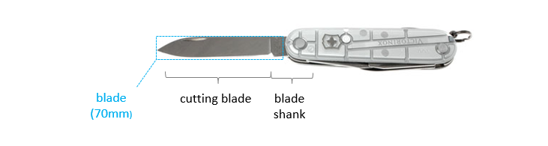

Only the cutting blade should be measured. However, as in the case you presented to us, the blade shank is often wrongly included.

*1.6 Are there any further dangerous objects which also fall under the Weapons Act?*

Not only knives but also objects like bayonets, swords and spears are covered by The Swedish Knife Act, as well as screwdrivers, brass knuckles and similar objects. Firearms, crossbows and similar weapons fall under The Swedish Weapons Act (Sw: vapenlagen), whereas hand grenades and other explosives fall under The Swedish Act on Flammable and Explosive Goods (Sw: lagen om brandfarliga och explosive varor).

*1.7 Are there any exceptions?*

Not except for the harmless types of knives mentioned under 1.1.

*1.8 What are the consequences for a legal offense?*

The standard sanction is a fine of 1 200 SEK or, when there is a considerable risk for a fight where the knife will be used, 50 day-fines (each day-fine based on the convicted person’s income). In minor cases, depending on e.g. the person’s intent, the nature of the object and the circumstances surrounding the carrying of the object, the person is not held responsible. If it is a gross offense, e.g. possession of several dangerous objects or carrying such object where there is a great risk that it will be used as a weapon, the punishment is imprisonment for at most one year

*1.9 Are there any legislative developments? If so what do they concern?*

The Swedish government as well as the opposition have expressed their view that the punishment for crimes against The Swedish Knife Act should be harsher. However, no committee has yet been appointed to issue a report on the matter.

# Airports

* 1. *According to the Official Journal of the European Union laying down detailed measures for the implementation of the common basic standards in aviation security, any pointed or sharp objects which may cause serious injury, including a knife with a blade more than 6cm are not allowed to be taken into the security restricted areas or on board of an aircraft.* 
     1. *Are there any further national regulations to be considered in this respect?*

No.

* + 1. *If your country is outside the EU, what are the corresponding local regulations?*

N/A

* 1. *May the airports/airlines in your country issue any further (stricter) regulations for forbidden items?*

Yes. For example, Finnair has regulated that the knife-edge needs to be rounded.

* 1. *May a pair of scissors or a saw be included in a pocket knife with a blade of max. 6cm? If so, is the size of the pair of scissors or the length of the saw of relevance?*

Yes, but the restriction for knives applies for scissors and saws as well, meaning that their blades cannot exceed 6 cm.

* 1. *What is considered as a sharp object besides knives?*

See answer under 1.6.

* 1. *Are there any further aviation security regulations with respect to the Victorinox (pocket) knives to be observed?*

No.

* 1. *Are there any changes intended in the near future? If so what do they concern?*

No such intention has been communicated.

Ibach, Switzerland, 25 February 2020

* * *