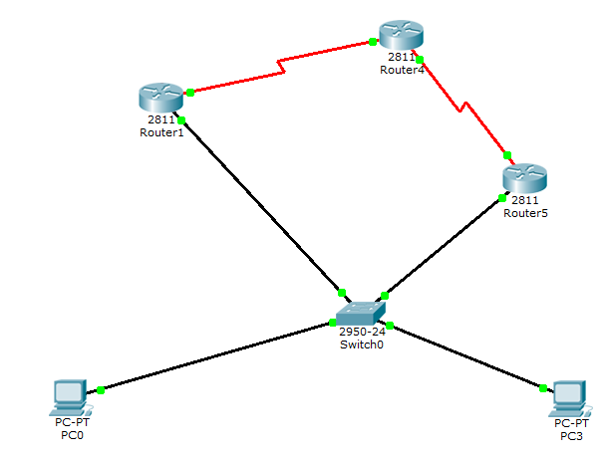

- 配置联通
Router1： 红 s0/2/1 192.168.70.1 黑 f0/0 192.168.10.2
Router2： 左 s0/2/0 192.168.70.2 右 s0/2/1 192.168.80.1
Router3: 红 s0/2/0 192.168.80.2 黑 f0/0 192.168.60.2
Pc0： 192.168.10.1 网关：192.168.10.2
Pc3： 192.168.60.1 网关：192.168.10.2（？）
交换机：f0/3连接pc0 f0/4连接pc3

代码：
Router1：
Ena
Conf t
Int s0/2/1
Ip address 192.168.70.1 255.255.255.0
No shut
Int f0/0
Ip address 192.168.10.2 255.255.255.0
No shut
End

Router2：
Ena
Conf t
Int s0/2/0
Ip address 192.168.70.2 255.255.255.0
No shut
Int s0/2/1
Ip address 192.168.80.1 255.255.255.0
No shut
End

Router3：
Ena
Conf t
Int s0/2/0
Ip address 192.168.80.2 255.255.255.0
No shut
Int f0/0
Ip address 192.168.60.2 255.255.255.0
No shut
End

检测：show ip route

二、配置动态路由
Router1:
Ena
Conf t
Router rip
Network 192.168.70.0
Network 192.168.10.0
End

Router2:
Ena
Conf t
Router rip
Network 192.168.70.0
Network 192.168.80.0
end

Router3:
Ena
Conf t
Router rip
Network 192.168.80.0
Network 192.168.60.0
end

检验：show ip route

三、vlan配置
switch#vlan database
switch(vlan)#vlan 2 name vlan2
switch(vlan)#exit
switch#config t
switch(config)#int f0/2
switch(config-if)#switchport access vlan 2//将f0／1划入vlan2
switch(config)#int f0/3
switch(config-if)#switchport access vlan 3//将f0／2划入vlan3

检测：show vlan

