**Advance Lane Finding Project**

The goals / steps of this project are the following:

* Compute the camera calibration matrix and distortion coefficients given a set of chessboard images for calibration
* Apply a distortion correction to raw images.
* Use colour transforms, gradients, etc., to create a thresholded binary image.
* Apply a perspective transform to rectify binary image ("birds-eye view").
* Detect lane pixels and fit to find the lane boundary.
* Determine the curvature of the lane and vehicle position with respect to center.
* Warp the detected lane boundaries back onto the original image.
* Output visual display of the lane boundaries and numerical estimation of lane curvature and vehicle position.

**Camera Calibration**

Code for this step is contained in **src/preprocessing.py** : **calibrate_camera()**

I started by initializing *obj_points* which are the 3D world co-ordinates for the chessboard corners it will have (x,y,z) values were z=0 as all the corner points lies on the same flat chessboard plane. This will be appended to *obj_points_list* after each successful detection of chessboard corners. I have used *cv2.findChessboardCorners to find NX*NY* chess board corners *NX* is the number of corners in x-direction, NY is the number of corners in y-direction NX=9 and NY=6 for given chessboard images.

If corners are successfully detected then I am appending the co-ordinates of these corners *img_points* to *img_points_list* .

These lists are used by *cv2.calibrateCamera* to fetch camera matrix and distortion co-efficient , I am storing this data to a pickle file. Next call to calibrate_camera will load this matrix and co-efficient from pickle file directly and skips the calculations.

**Distortion Correction**

Code for this step is contained in **src/preprocessing.py** : **undist_image()**

I used camera matrix and distortion co-efficient to undistort all the raw camera image, I have used cv2.undist function for the same. Obtained results can be seen in below images

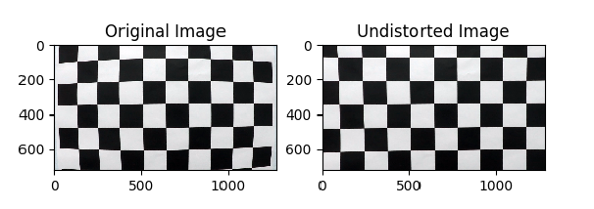

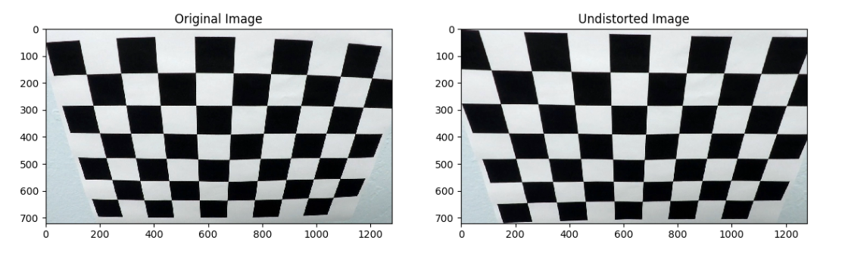

The same has been applied to raw test images, results are shown below:

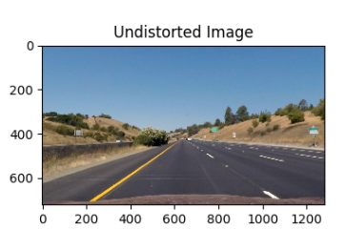 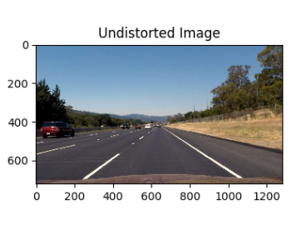

Perspective Transformation

Code for this step is contained in **src/preprocessing.py** : **perspective_transform (), get_perspective_transform_matrix()**

Perspective transformation has been used to the perspective of camera to bird eye view so the road and lane lines can be seen from the top and measurement of the curvature and vehicle position can be determined.

Perspective transformation matrix has been derived from below source points from the original test image and their corresponding destination points in the transformed image. These points has been chosen from the test images having straight lane lines.

|  |  |
| --- | --- |
| Source Points | Destination Points |
| (257, 685),  (1050, 685),  (583, 460),  (702, 460) | *(257, 685),*  *(1050, 685),*  *(257, 0),*  *(1050, 0)* |

*cv2.getPerspectiveTransform*  is being used to get the transformation matrix and the inverse transformation matrix , *cv2.warpPerspective* is used to transform the raw images, Results of the transformation can be seen from below images.

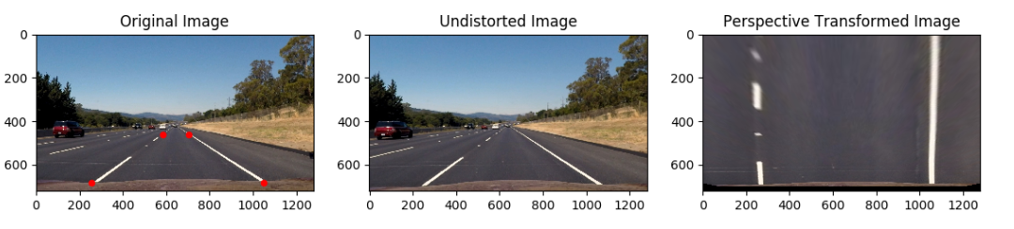

4 Red points in the original image represents the chosen source points, last image shows the bird eye view of the road.

Below images shows the results on curvy lane lines near the left turn

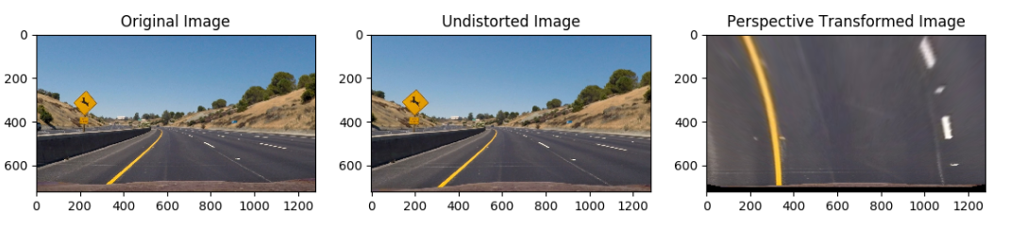

**Lane lines Detection**

For detecting the lane lines from the perspective transformed image I have used different thresholding techniques on colour channels and on gradient image which are described below

**Thresholding :**

Code for this step is contained in **src/thresholding.py**

1. **Colour Thresholding :**

Lane lines are of white or yellow colour, to detect the lane lines in different weather, lighting conditions, I have used filtering on HSL Colour space where I am using thresholding on saturation and hue channels, thresholds have been tuned to detect lane lines only

1. **Gradient Thresholding :**

Lane lines are having edge on both the side and this can be detected using edge detectors like canny and sobel, I have sobel edge detection with gradient in x, y direction, magnitude and direction of threshold. This 4 result have been combined to detect edge of the lane line

These both thresholding have been combined to form the final binary image showing the lane lines.

Results can be seen from the below images

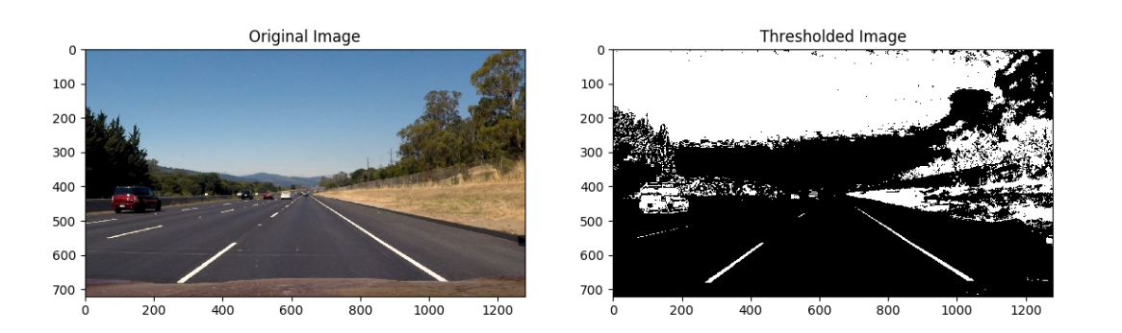

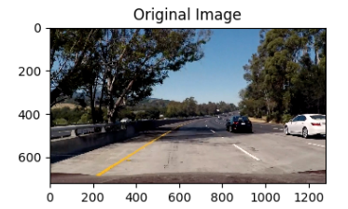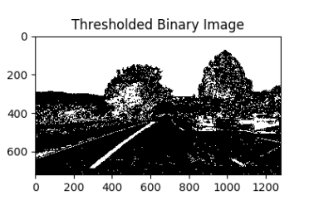

Thresholded image shows the final result after applying colour and gradient thresholding where lane lines are being identified in shadows as well.

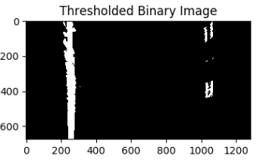

Above image shows the same thresholding applied on the bird eye view of lanes

**Sliding Window Search**

Code of this section is contained in **slidingwindowsearch.py**

This technique has been used to identify lane line pixels and fitting 2 curves for left and right lane lines, *search_lanes()* method of *LaneDetector* Class implements this logic. Where in the first pass a sliding window search start from the bottom of the image and identifies pixels of the lane portion and continue towards top of the image, then this pixels are fitted by 2nd degree polynomial.

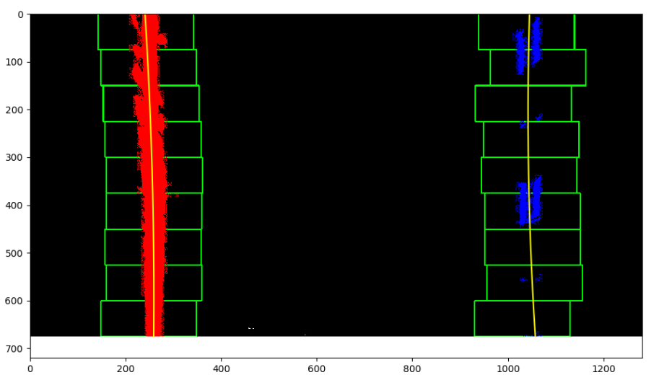

In the above image left line pixels are marked with Red colour, and right lane pixels are marked with blue colour, green rectangles shows the window used for detection. Fit curves are marked with yellow lines.

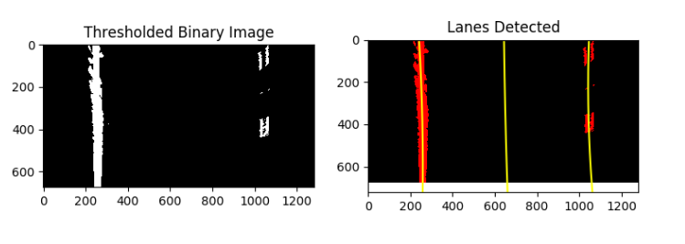

Here in the above image there are 3 fit , 1st and 3rd are left and right lane ,mid curve is used to calculate the vehicle position and radius of curvature.

Final output image and video overlays the lane portion in green, radius of curvature and vehicle position from the left lane assuming lanes are 3.7m wide and road length shown in video is approximately 30m

Code for Video pipeline is in **runner.py** which converts the videos to frame, process each frame and then compiles the output video.

Sample output video can be found with name : output.mp4