

Functional Safety Concept Lane Assistance

**Document Version: [Version]**

**Template Version 1.0, Released on 2017-06-21**



# Document history

|  |  |  |  |
| --- | --- | --- | --- |
| Date | Version | Editor | Description |
| 24-May-2018 | 1.0 | Nishant Katariya | Initial Draft |
|  |  |  |  |
|  |  |  |  |
|  |  |  |  |
|  |  |  |  |

# Table of Contents

Document history

Table of Contents

Purpose of the Functional Safety Concept

Inputs to the Functional Safety Analysis

Safety goals from the Hazard Analysis and Risk Assessment

Preliminary Architecture

Description of architecture elements

Functional Safety Concept

Functional Safety Analysis

Functional Safety Requirements

Refinement of the System Architecture

Allocation of Functional Safety Requirements to Architecture Elements

Warning and Degradation Concept

# Purpose of the Functional Safety Concept

The Main Purpose of the Functional Safety Concept is to derive functional safety requirement from the safety goals defined in HARA. To derive safety requirements Functional safety concept document identifies which sub systems actually responsible for the risk and relevant to safety goal. It documents system high level requirement these are allocated to different parts of the item which are then used to identify technical requirements.

# Inputs to the Functional Safety Concept

## Safety goals from the Hazard Analysis and Risk Assessment

**[Instructions:**

**REQUIRED:**

**Provide the lane departure warning and lane keeping assistance safety goals as discussed in the lessons and derived in the hazard analysis and risk assessment.**

**OPTIONAL:**

**If you expanded the hazard analysis and risk assessment to include other safety goals, include them here.**

**]**

|  |  |
| --- | --- |
| **ID** | **Safety Goal** |
| Safety_Goal_01 | The oscillating steering torque from the LDW (Lane departure Warning) function shall be limited. |
| Safety_Goal_02 | LKA (Lane Keeping Assistance)function shall be time limited and  the additional steering torque shall end  after a given timer period so that the  driver cannot misuse the system for fully autonomous driving. |

## Preliminary Architecture

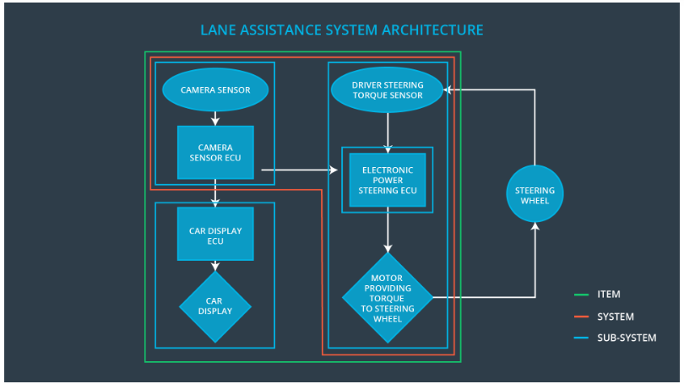

Fig 1.1

### Description of architecture elements

|  |  |
| --- | --- |
| **Element** | **Description** |
| Camera Sensor | Camera sensor perceives the vehicle leaving the lane; it sends the signal to the Electronic power steering system request to turn/vibrate the steering wheel.  ECU (Electronic Control Unit) is a microcomputer that contains software and hardware specific to vehicle’s functionality. |
| Camera Sensor ECU | The camera ECU have the hardware and software required for detecting lanes using computer vision techniques like machine learning or image processing. |
| Car Display | Displays the warning and status of the system on Display |
| Car Display ECU | ECU have the hardware and software required to display messages on Car display |
| Driver Steering Torque Sensor | It senses how much steering force is applied by the driver. |
| Electronic Power Steering ECU | It controls the Motor attached to Steering wheel |
| Motor | It is actuator to generate torque and rotate the steering wheel |

# Functional Safety Concept

The functional safety concept consists of:

* Functional safety analysis
* Functional safety requirements
* Functional safety architecture
* Warning and degradation concept

## Functional Safety Analysis

**[Instructions: Fill in the functional safety analysis table below.]**

|  |  |  |  |
| --- | --- | --- | --- |
| **Malfunction ID** | **Main Function of the Item Related to Safety Goal Violations** | **Guidewords (NO, WRONG, EARLY, LATE, MORE, LESS)** | **Resulting Malfunction** |
| Malfunction_01 | Lane Departure Warning (LDW) function shall apply an oscillating steering torque to provide the driver a haptic feedback | MORE | Lane Departure Warning (LDW) function applies high oscillating steering torque amplitude(above limit) as feedback |
| Malfunction_02 | Lane Departure Warning (LDW) function shall apply an oscillating steering torque to provide the driver a haptic feedback | MORE | Lane Departure Warning (LDW) function applies high oscillating steering torque with high frequency(above limit) as feedback |
| Malfunction_03 | Lane Keeping Assistance (LKA) function shall apply the steering torque when active in order to stay in ego lane | NO | The Lane Keeping  Assistance (LKA) function  is not limited in time  interval which lead  to misuse as an fully autonomous driving system |

## Functional Safety Requirements

Lane Departure Warning (LDW) Requirements:

|  |  |  |  |  |
| --- | --- | --- | --- | --- |
| **ID** | **Functional Safety Requirement** | **ASIL** | **Fault Tolerant Time Interval** | **Safe State** |
| Functional  Safety  Requirement  01-01 | The lane keeping item shall ensure that the lane departure oscillating torque amplitude is below Max_Torque_Amplitude | A |  | Steering torque  Amplitude is  below  Max_Torque_A  mplitude |
| Functional  Safety  Requirement  01-02 | The lane keeping item shall ensure that the lane departure oscillating torque frequency is below Max_Torque_Frequency | B |  | Oscillation  frequency is  below  Max_Torque_Fr  equency. |

Lane Departure Warning (LDW) Verification and Validation Acceptance Criteria:

|  |  |  |
| --- | --- | --- |
| **ID** | **Validation Acceptance**  **Criteria and Method** | **Verification Acceptance**  **Criteria and Method** |
| Functional  Safety  Requirement  01-01 |  |  |
| Functional  Safety  Requirement  01-02 |  |  |

**[Instructions: Fill in the functional safety requirements for the lane keeping assistance]**

Lane Keeping Assistance (LKA) Requirements:

|  |  |  |  |  |
| --- | --- | --- | --- | --- |
| **ID** | **Functional Safety Requirement** | **ASIL** | **Fault Tolerant Time Interval** | **Safe State** |
| Functional  Safety  Requirement  02-01 | the electronic power steering ECU shall ensure that the lane keeping assistance torque is applied for only Max_Duration |  |  |  |

Lane Keeping Assistance (LKA) Verification and Validation Acceptance Criteria:

|  |  |  |
| --- | --- | --- |
| **ID** | **Validation Acceptance**  **Criteria and Method** | **Verification Acceptance**  **Criteria and Method** |
| Functional  Safety  Requirement  02-01 |  |  |

## Refinement of the System Architecture

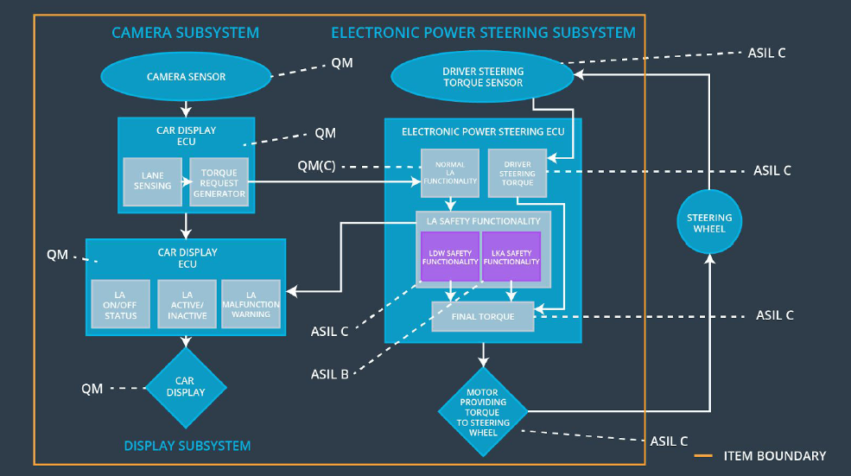

## Allocation of Functional Safety Requirements to Architecture Elements

|  |  |  |  |  |
| --- | --- | --- | --- | --- |
| **ID** | **Functional Safety Requirement** | **Electronic Power Steering ECU** | **Camera ECU** | **Car Display ECU** |
| Functional  Safety  Requirement  01-01 | The lane keeping item shall ensure that the lane departure oscillating torque amplitude is below Max_Torque_Amplitude | **X** |  |  |
| Functional  Safety  Requirement  01-02 | Lane Departure Warning (LDW) function shall apply an oscillating steering torque to provide the driver a haptic feedback | **X** |  |  |
| Functional  Safety  Requirement  02-01 | Lane Keeping Assistance (LKA) function shall apply the steering torque when active in order to stay in ego lane | **X** |  |  |

## Warning and Degradation Concept

**[Instructions: Fill in the warning and degradation concept.]**

|  |  |  |  |  |
| --- | --- | --- | --- | --- |
| **ID** | **Degradation Mode** | **Trigger for Degradation Mode** | **Safe State invoked?** | **Driver Warning** |
| WDC-01 |  |  |  |  |
| WDC-02 |  |  |  |  |