

Technical Safety Concept Lane Assistance

**Document Version: [Version]**

**Template Version 1.0, Released on 2017-06-21**



# Document history

|  |  |  |  |
| --- | --- | --- | --- |
| Date | Version | Editor | Description |
| 25-May-2018 | 1.0 | Nishant Katariya | Initial Draft |
|  |  |  |  |
|  |  |  |  |
|  |  |  |  |
|  |  |  |  |

# 

# Table of Contents

Document history

Table of Contents

Purpose of the Technical Safety Concept

Inputs to the Technical Safety Concept

Functional Safety Requirements

Refined System Architecture from Functional Safety Concept

Functional overview of architecture elements

Technical Safety Concept

Technical Safety Requirements

Refinement of the System Architecture

Allocation of Technical Safety Requirements to Architecture Elements

Warning and Degradation Concept

# Purpose of the Technical Safety Concept

**[Instructions: Answer what is the purpose of a technical safety concept?]**

# Inputs to the Technical Safety Concept

## Functional Safety Requirements

|  |  |  |  |  |
| --- | --- | --- | --- | --- |
| **ID** | **Functional Safety Requirement** | **ASIL** | **Fault Tolerant Time Interval** | **Safe State** |
| Functional  Safety  Requirement  01-01 | The lane keeping item shall ensure that the lane departure oscillating torque amplitude is below Max_Torque_Amplitude | C | 50ms | Steering torque  Amplitude is  below  Max_Torque_A  mplitude |
| Functional  Safety  Requirement  01-02 | The lane keeping item shall ensure that the lane departure oscillating torque frequency is below Max_Torque_Frequency | C | 50ms | Oscillation  frequency is  below  Max_Torque_Fr  equency. |
| Functional  Safety  Requirement  02-01 | The electronic power steering ECU shall ensure that the lane keeping assistance torque is applied for only Max_Duration | B | 500ms | Lane Assistance Functionality is Off |

## 

## Refined System Architecture from Functional Safety Concept

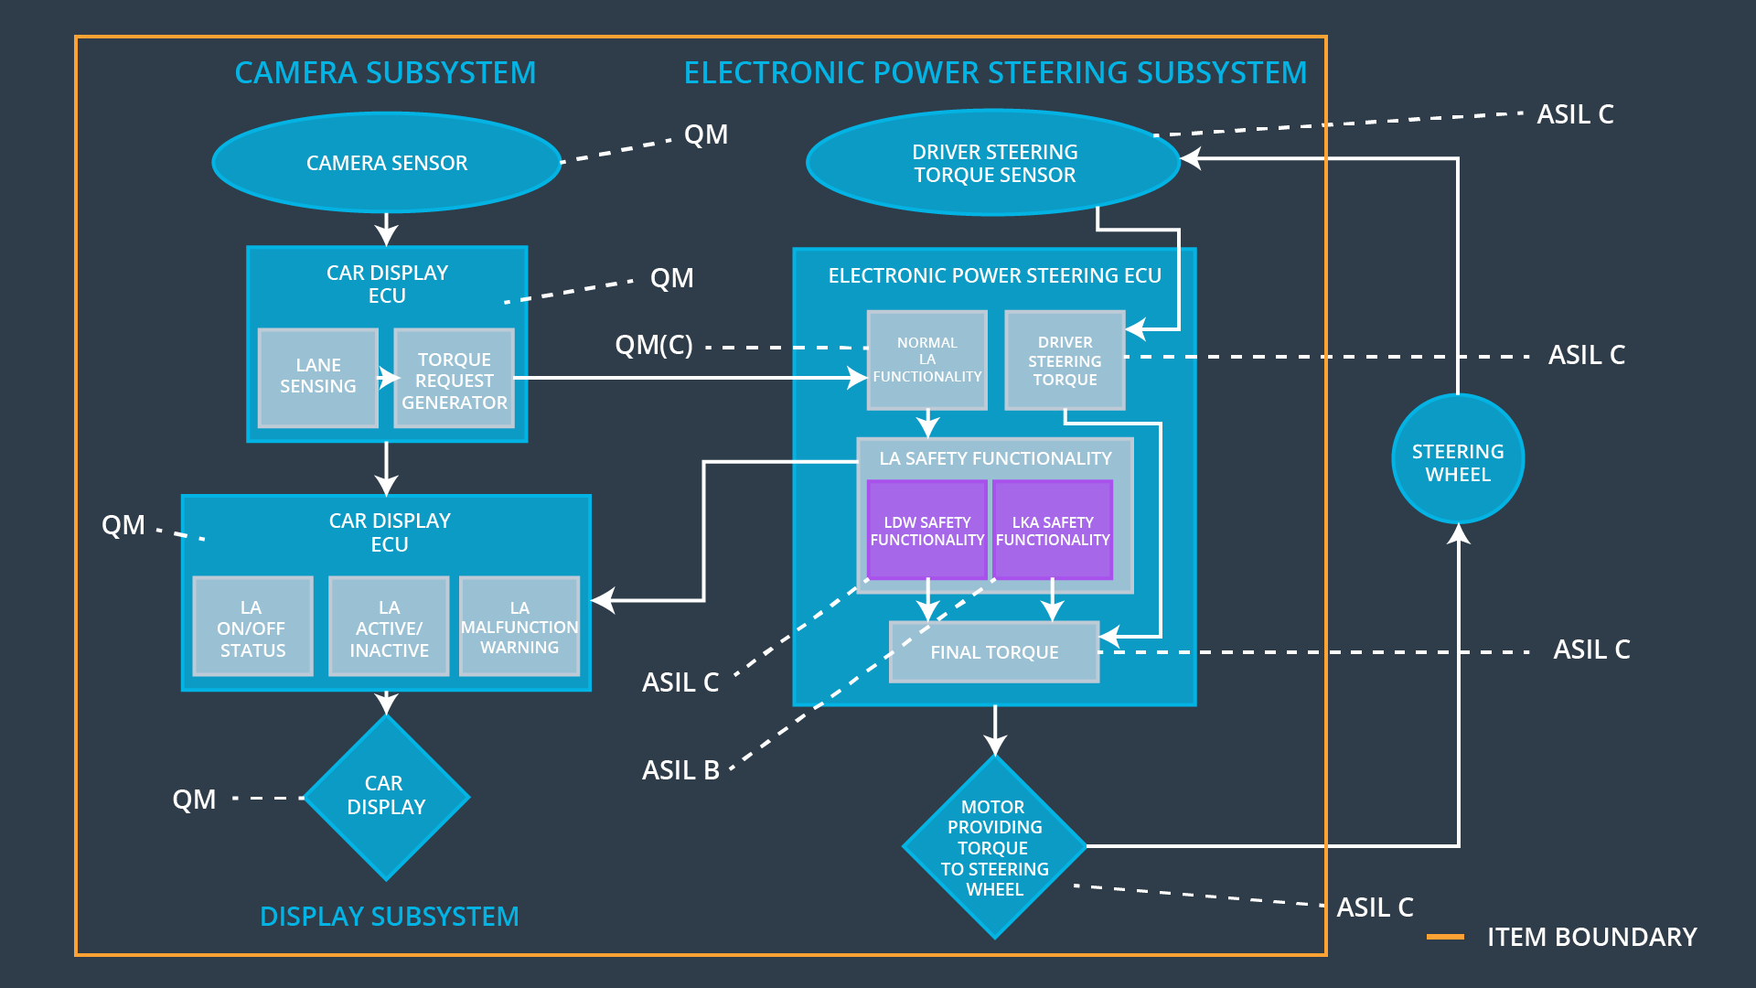

### 

### Functional overview of architecture elements

|  |  |
| --- | --- |
| **Element** | **Description** |
| Camera Sensor | Camera sensor perceives the vehicle leaving the lane; it sends the signal to the Electronic power steering system request to turn/vibrate the steering wheel.  ECU (Electronic Control Unit) is a microcomputer that contains software and hardware specific to vehicle’s functionality. |
| Camera Sensor ECU - Lane Sensing | Camera Sensor ECU has software block to detect lanes either using deep learning algorithm or sing image processing |
| Camera Sensor ECU - Torque request generator | Camera Sensor ECU has software block which generate torque request which will be sent to EPS ECU. |
| Car Display | Displays the warning and status of the system on Display |
| Car Display ECU - Lane Assistance On/Off Status | A Status light for showing the status on/off of LA |
| Car Display ECU - Lane Assistant Active/Inactive | A Status light for showing the status Active/Inactive of LA |
| Car Display ECU - Lane Assistance malfunction warning | A Warning light for showing malfunction in LA system |
| Driver Steering Torque Sensor | It senses how much steering force is applied by the driver. |
| Electronic Power Steering (EPS) ECU - Driver Steering Torque | ECU Block to process sensor measurement (Steering torque applied by driver) |
| EPS ECU - Normal Lane Assistance Functionality | Receives torque request from Camera sensor ECU and transfer it to safety lane assistance functionality |
| EPS ECU - Lane Departure Warning Safety Functionality | Checks malfunction of LDW and translates torque requests into final torque output. |
| EPS ECU - Lane Keeping Assistant Safety Functionality | Checks malfunction of LKA and translates torque requests into final torque output. |
| EPS ECU - Final Torque | Combine torque from LDW and LKA and send them to motor |
| Motor | It is actuator to generate torque and rotate the steering wheel |

# Technical Safety Concept

## Technical Safety Requirements

**Lane Departure Warning (LDW) Requirements:**

Functional Safety Requirement 01-01 with its associated system elements

(derived in the functional safety concept)

|  |  |  |  |  |
| --- | --- | --- | --- | --- |
| **ID** | **Functional Safety Requirement** | **Electronic Power Steering ECU** | **Camera ECU** | **Car Display ECU** |
| Functional  Safety  Requirement  01-01 | The lane keeping item shall ensure that the lane departure oscillating torque amplitude is below Max_Torque_Amplitude | X |  |  |

Technical Safety Requirements related to Functional Safety Requirement 01-01 are:

|  |  |  |  |  |  |
| --- | --- | --- | --- | --- | --- |
| **ID** | **Technical Safety Requirement** | **ASIL** | **Fault Tolerant Time Interval** | **Architecture Allocation** | **Safe State** |
| Technical  Safety  Requirement  01 | The LDW safety component shall ensure that the amplitude of the 'LDW_Torque_Request' sent to the 'Final electronic power steering Torque' component is below 'Max_Torque_Amplitude. | C | 50 ms | LDW Safety | LDW Torque request Amplitude shall be set to 0 |
| Technical  Safety  Requirement  02 | As soon as the LDW function deactivates the LDW feature, the 'LDW Safety' software block shall send a signal to the car display ECU to turn on a warning light. | C | 50 ms | LDW Safety | LDW Torque request Amplitude shall be set to 0 |
| Technical  Safety  Requirement  03 | As soon as a failure is detected by the LDW function, it shall deactivate the LDW feature and the 'LDW_Torque_Request' shall be set to zero. | C | 50 ms | LDW Safety | LDW Torque request Amplitude shall be set to 0 |
| Technical  Safety  Requirement  04 | The validity and integrity of the data transmission for 'LDW_Torque_Request' signal shall be ensured. | C | 50 ms | Data Transmission Integrity Check | LDW Torque request Amplitude shall be set to 0 |
| Technical  Safety  Requirement  05 | Memory test shall be conducted at startup of the EPS ECU to check for any faults in memory. | A | Ignition Cycle | Memory Test | LDW Torque request Amplitude shall be set to 0 |

Functional Safety Requirement 01-2 with its associated system elements

(derived in the functional safety concept)

|  |  |  |  |  |
| --- | --- | --- | --- | --- |
| **ID** | **Functional Safety Requirement** | **Electronic Power Steering ECU** | **Camera ECU** | **Car Display ECU** |
| Functional  Safety  Requirement  01-02 | The lane keeping item shall ensure that the lane departure oscillating torque frequency is below Max_Torque_Frequency | X |  |  |

Technical Safety Requirements related to Functional Safety Requirement 01-02 are:

|  |  |  |  |  |  |
| --- | --- | --- | --- | --- | --- |
| **ID** | **Technical Safety Requirement** | **ASIL** | **Fault Tolerant Time Interval** | **Architecture Allocation** | **Safe State** |
| Technical  Safety  Requirement  01 | The LDW safety component shall ensure that the amplitude of the 'LDW_Torque_Request' sent to the 'Final electronic power steering Torque' component is below 'Max_Torque_Frequency. | C | 50 ms | LDW Safety | LDW Torque request Frequency shall be set to 0 |
| Technical  Safety  Requirement  02 | As soon as the LDW function deactivates the LDW feature, the 'LDW Safety' software block shall send a signal to the car display ECU to turn on a warning light. | C | 50 ms | LDW Safety | LDW Torque request Frequency shall be set to 0 |
| Technical  Safety  Requirement  03 | As soon as a failure is detected by the LDW function, it shall deactivate the LDW feature and the 'LDW_Torque_Request' shall be set to zero. | C | 50 ms | LDW Safety | LDW Torque request Frequency shall be set to 0 |
| Technical  Safety  Requirement  04 | The validity and integrity of the data transmission for 'LDW_Torque_Request' signal shall be ensured. | C | 50 ms | Data Transmission Integrity Check | LDW Torque request Frequency shall be set to 0 |
| Technical  Safety  Requirement  05 | Memory test shall be conducted at startup of the EPS ECU to check for any faults in memory. | A | Ignition Cycle | Memory Test | LDW Torque request Frequency shall be set to 0 |

**Lane Departure Warning (LDW) Verification and Validation Acceptance Criteria:**

**[OPTIONAL]**

**Lane Keeping Assistance (LKA) Requirements:**

Functional Safety Requirement 02-1 with its associated system elements

(derived in the functional safety concept)

|  |  |  |  |  |
| --- | --- | --- | --- | --- |
| **ID** | **Functional Safety Requirement** | **Electronic Power Steering ECU** | **Camera ECU** | **Car Display ECU** |
| Functional  Safety  Requirement  02-01 | The lane keeping item shall ensure that the lane keeping assistance torque is applied for only Max_Duration | X |  |  |

Technical Safety Requirements related to Functional Safety Requirement 02-01 are:

|  |  |  |  |  |  |
| --- | --- | --- | --- | --- | --- |
| **ID** | **Technical Safety Requirement** | **ASIL** | **Fault Tolerant Time Interval** | **Architecture Allocation** | **Safe State** |
| Technical  Safety  Requirement  01 | The LKA safety component shall ensure that the of the 'LKA_Torque_Request' sent to the 'Final electronic power steering Torque' component for only 'Max_Duration’. | B | 500 ms | LKA Safety | LKA_Activation_Status shall be set to 0 |
| Technical  Safety  Requirement  02 | As soon as the LKA function deactivates the LKA feature, the 'LKA Safety' software block shall send a signal to the car display ECU to turn on a warning light. | B | 500 ms | LKA Safety | LKA_Activation_Status shall be set to 0 |
| Technical  Safety  Requirement  03 | As soon as a failure is detected by the LKA function, it shall deactivate the LKA feature and the 'LKA_Torque_Request' shall be set to zero. | B | 500 ms | LKA Safety | LKA_Activation_Status shall be set to 0 |
| Technical  Safety  Requirement  04 | The validity and integrity of the data transmission for 'LKA_Torque_Request' signal shall be ensured. | B | 500 ms | Data Transmission Integrity Check | LKA_Activation_Status shall be set to 0 |
| Technical  Safety  Requirement  05 | Memory test shall be conducted at startup of the EPS ECU to check for any faults in memory. | A | Ignition Cycle | Memory Test | LKA_Activation_Status shall be set to 0 |

**Lane Keeping Assistance (LKA) Verification and Validation Acceptance Criteria:**

**[OPTIONAL]**

## Refinement of the System Architecture

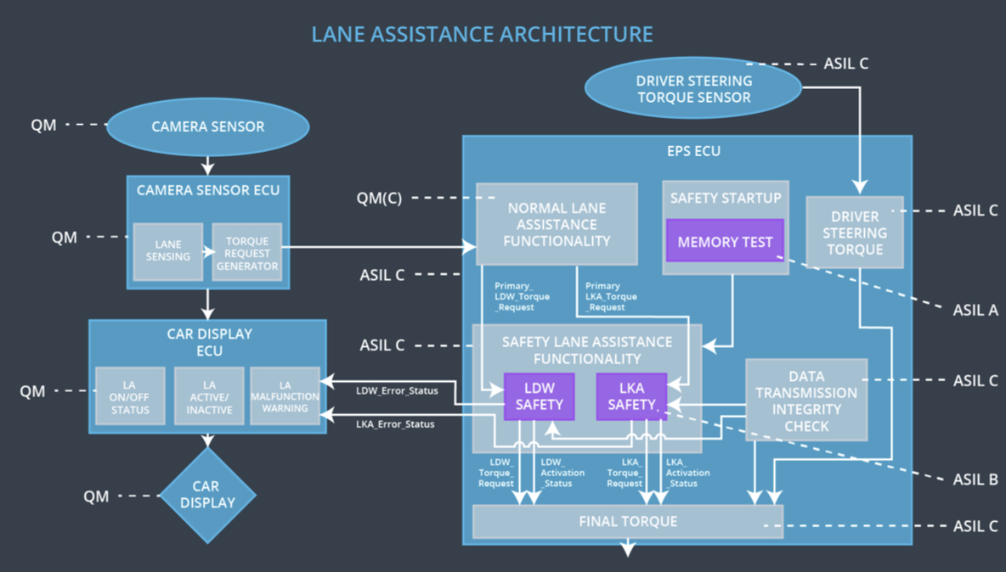

## Allocation of Technical Safety Requirements to Architecture Elements

All Technical safety requirements were allocated to the Electronic Power Steering ECU. For exact allocation check the technical requirements mentioned above.

## Warning and Degradation Concept

|  |  |  |  |  |
| --- | --- | --- | --- | --- |
| **ID** | **Degradation Mode** | **Trigger for Degradation Mode** | **Safe State invoked?** | **Driver Warning** |
| WDC-01 | Turn Off LDW functionality | Malfunction_01 | Yes | LDW malfunction warning on Car display |
| WDC-02 | Turn Off LDW functionality | Malfunction_02 | Yes | LDW malfunction warning on Car display |
| WDC-03 | Turn Off LKA functionality | Malfunction_03 | Yes | LKA malfunction warning on Car display |