This is a brief tutorial on how to get started with the Lightning game engine.

First, install the Lightning SDK by running the **SDKSetup.exe** that you downloaded**:**

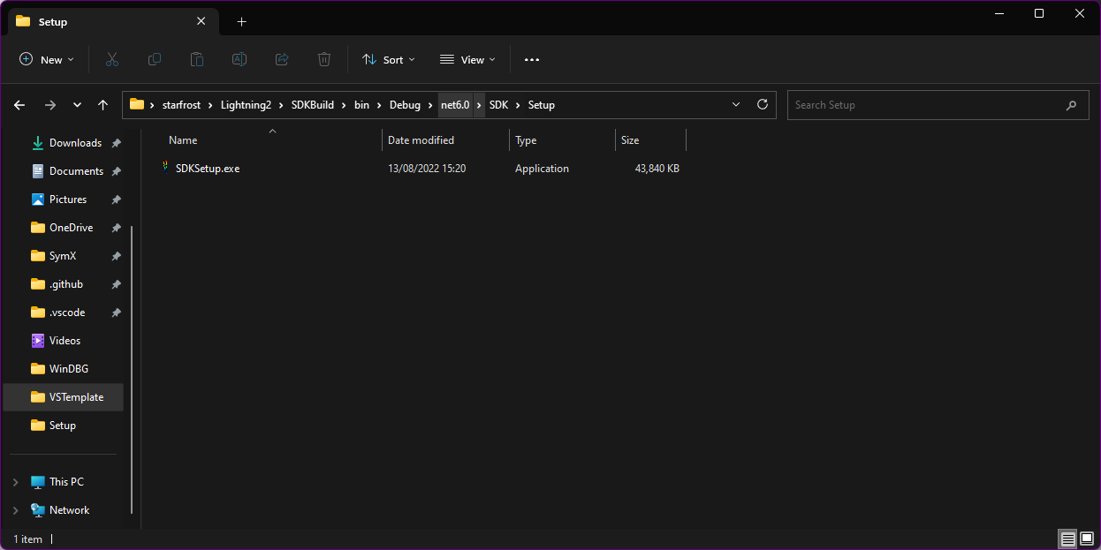

Now, open Visual Studio (2022 or later is required). A new project template will have been installed, called **Lightning Game Project.** Additionally, links to the example code and documentation are added to the Start Menu.

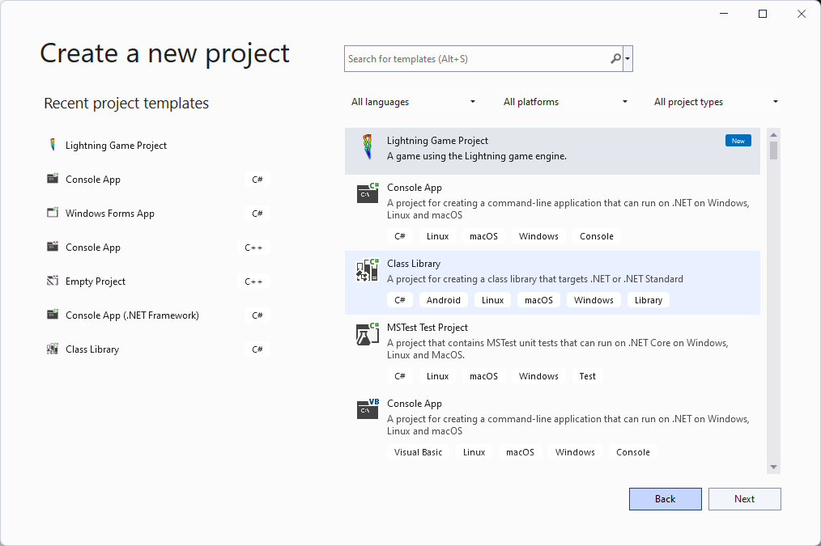

Select it and press **Next.**

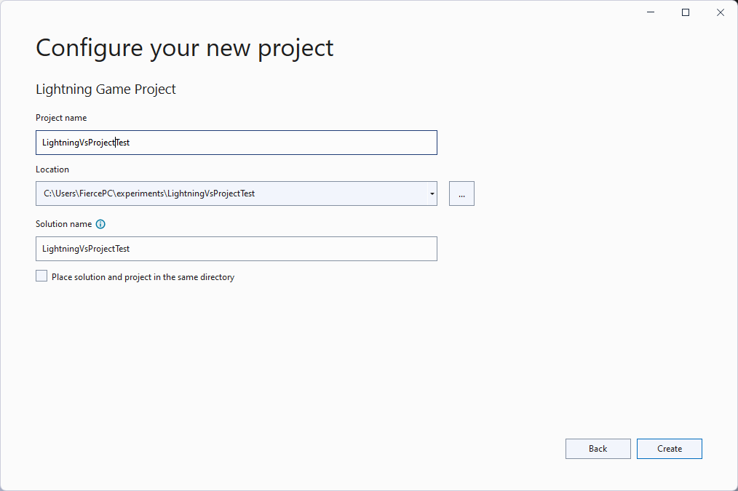

Select a project and folder name and press **Create**. Visual Studio will now create your project.

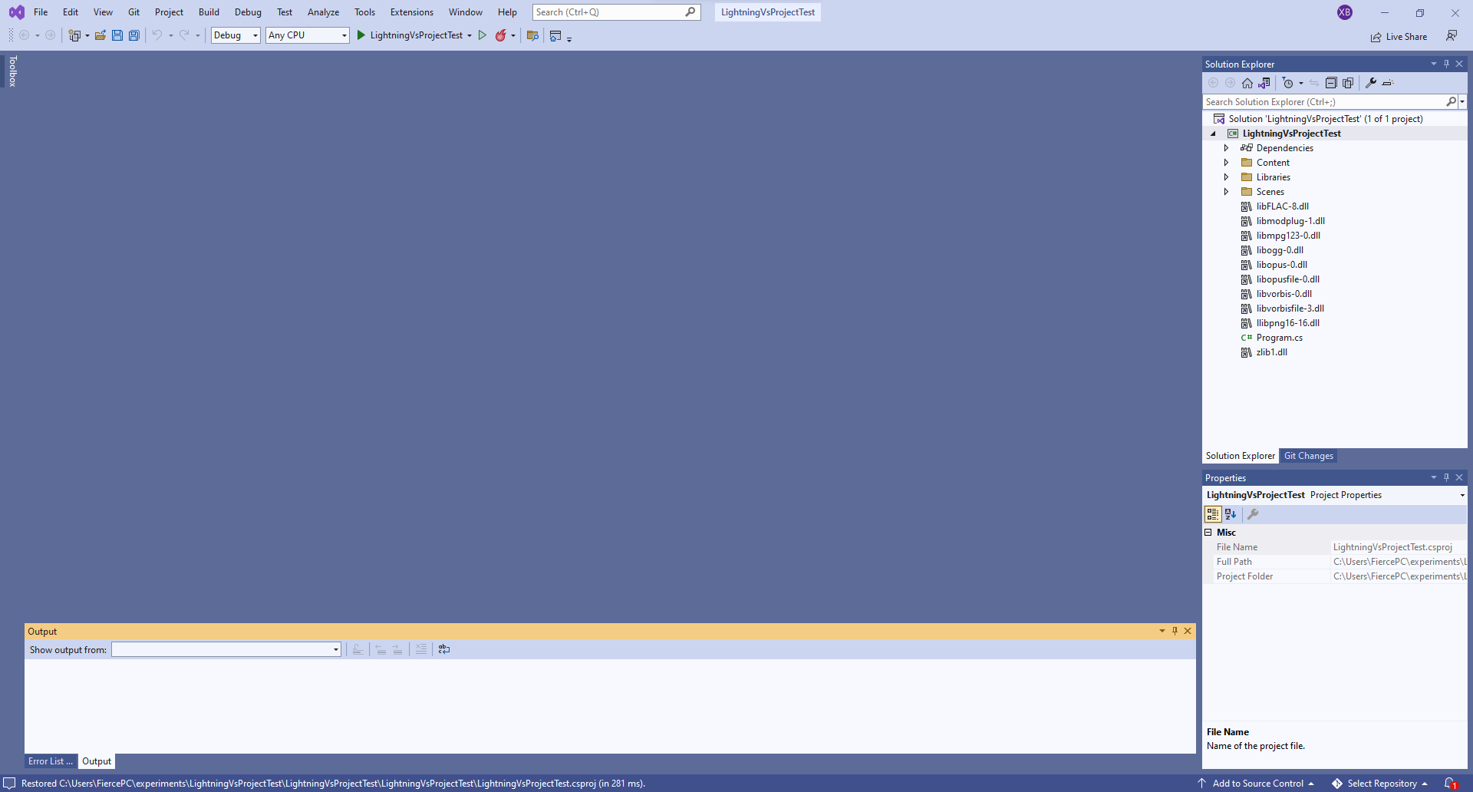

You will now see this view. Select **Scenes** to open the folder and view MainScene.cs, or view the launcher code by opening Program.cs.

To build the solution, press the green play button next to the name of your solution. The game will now build:

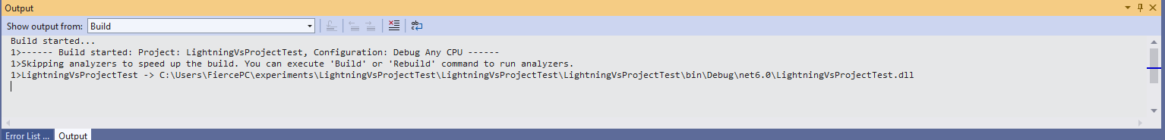

After some time, a window will appear on your screen:

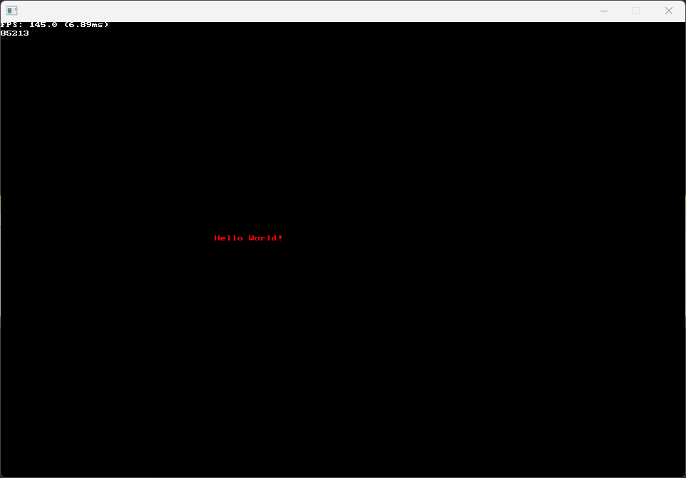

This is the Hello World project.

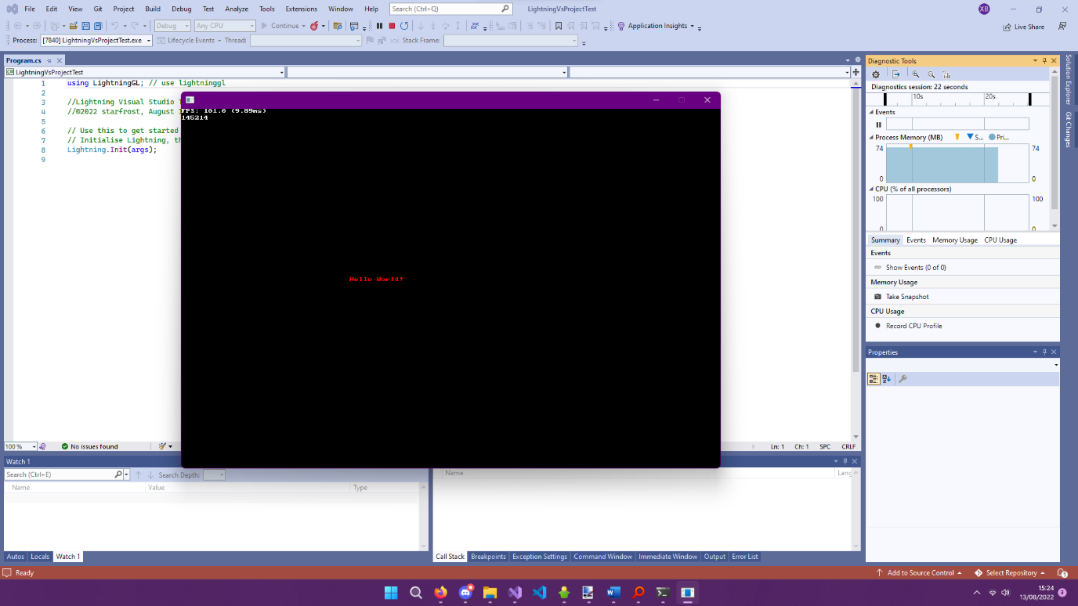

You can use Visual Studio’s built-in debugging features in order to debug, modify, and run the game code.

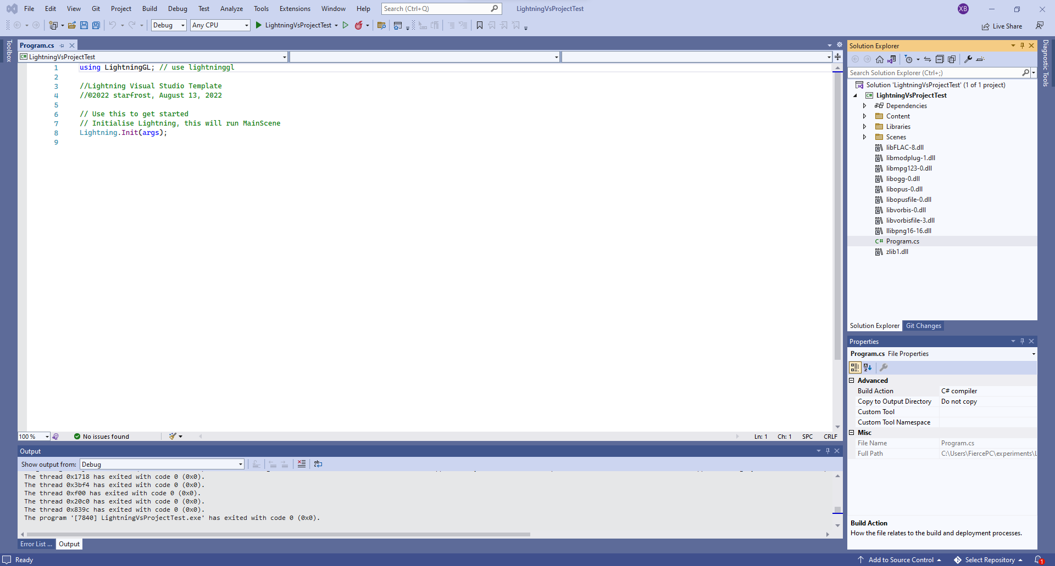

Close the game; you can now edit your code and develop with Lightning! Please make sure to peruse the API documentation and all the other documentation files!