Read Me File:

To run the Cascade Object Detector as is:

unzip the images folder as a directly inside your Matlab application's folder

(i.e. on my computer C:\Program Files\MATLAB\R2015b\ENSC424_Project)

Save the following codes in the same folder and have the Matlab command window point to that folder

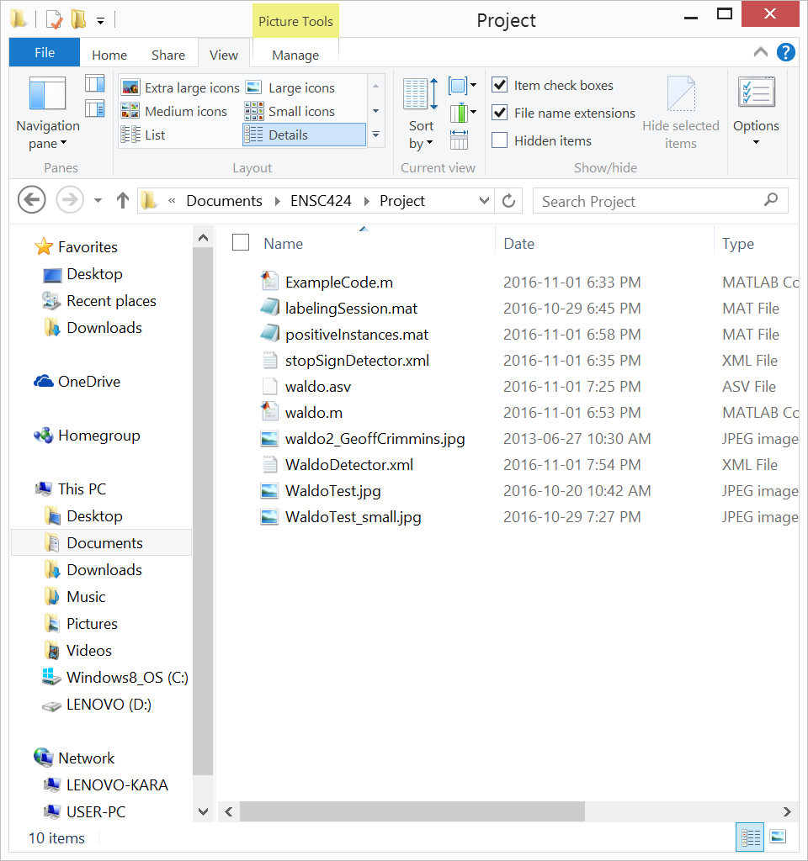

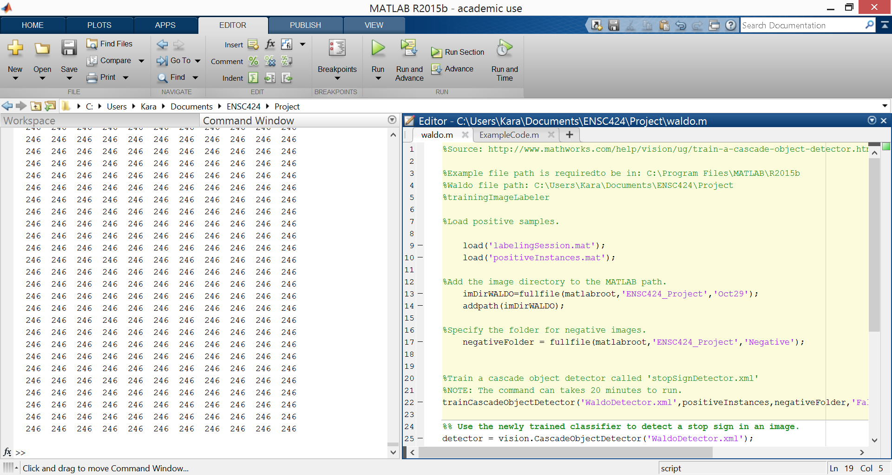

And run the second section of code as shown below (have your cursor highlighting the spot)

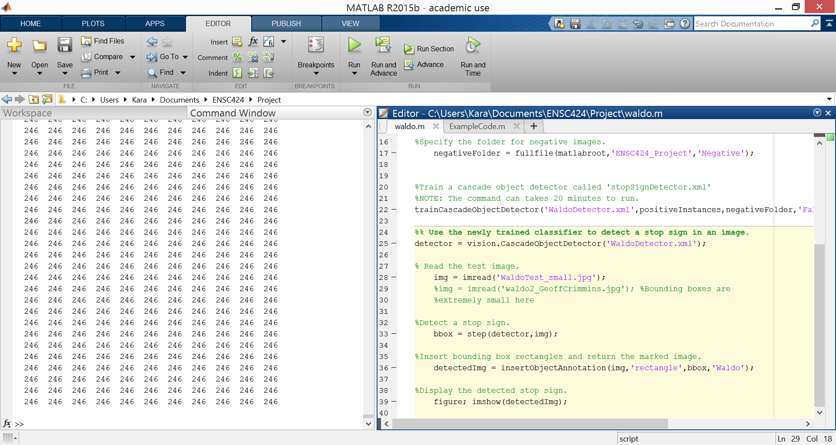

After a minute or two you should get this:

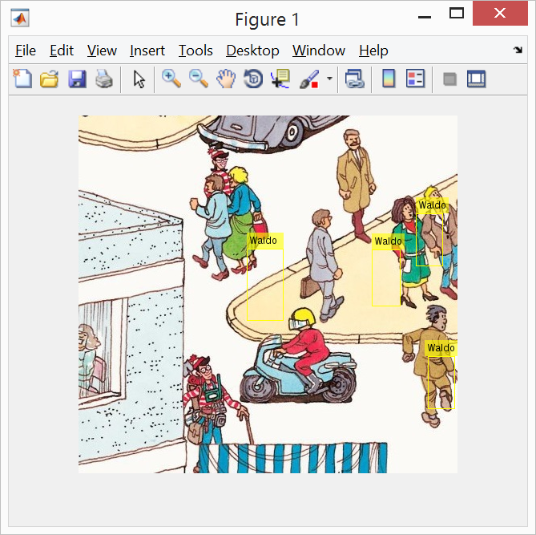

To Reset the Trainer:

Since the training function ran out of images before it could complete we need to increase the number of positive images, decrease the 'FalseAlarmRate', or decrease ‘NumCascadeStages'.

To reset the trainer merely run all the code again with the same folders as mentioned before.

Note: it took 20 minutes to build for me.