Step1: Extract the MINI_PROJECT file in a folder.

Step2: Install the requirements using following command:

pip install -r requirements.txt

Step3: Change **only** the ‘MAINPATH’ in the “mini-project.ipynb”, according to your directory(The directory in which you have extracted the project file)

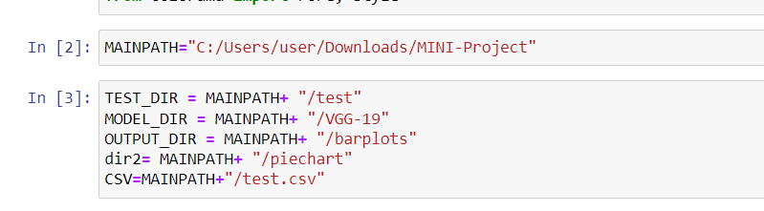

Step4: Place the test images in the ‘’/MINI-PROJECT/test’ folder which is already present in the project directory.

Step5: Run the “mini-project.ipynb” file in jupyter notebook.

Step6: Mark the center of the pie chart in the popup python window named “Mark_center_of_piechart”.