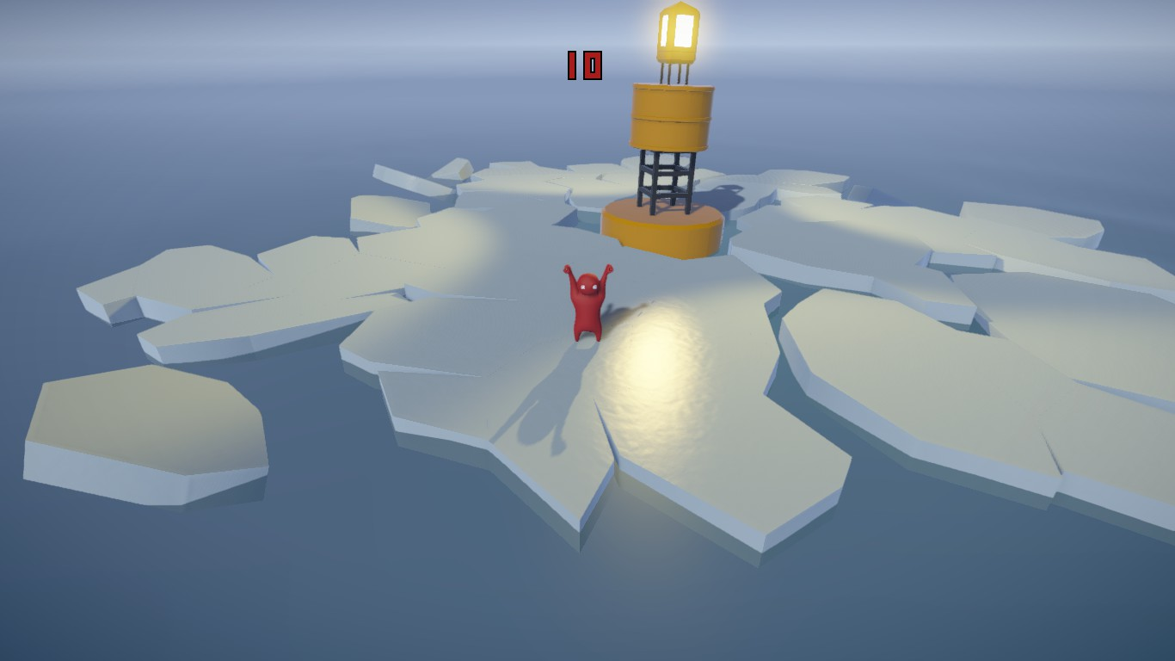
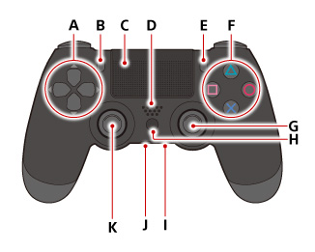
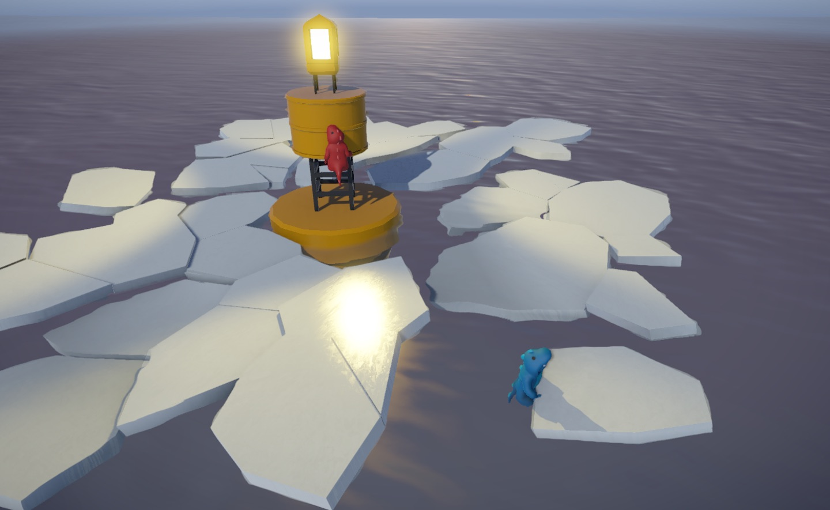
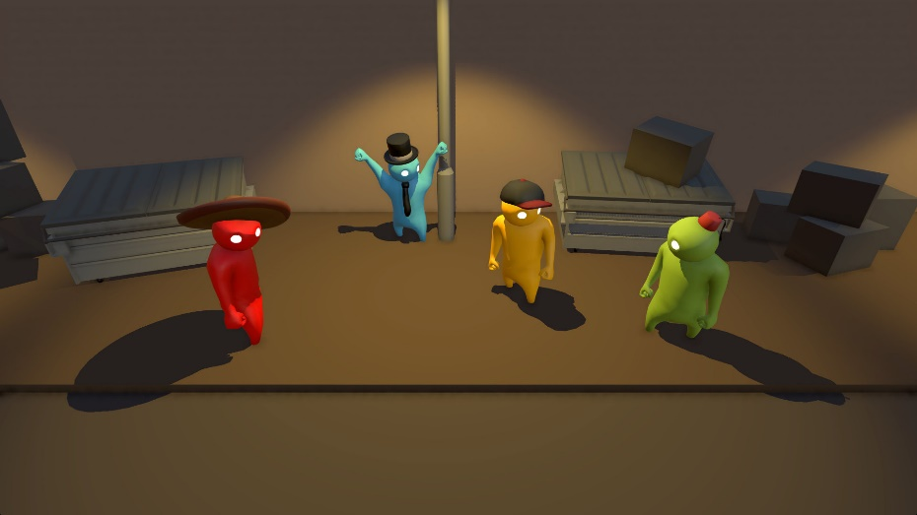
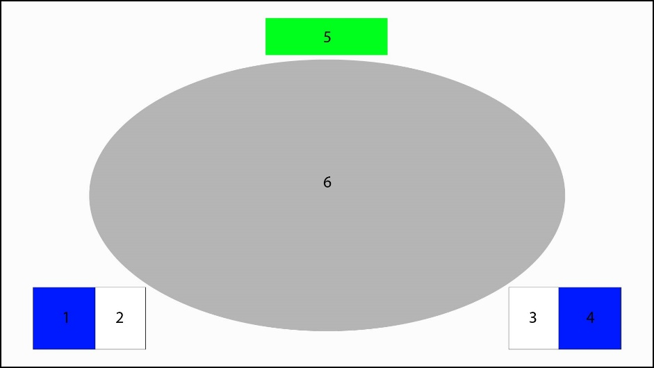
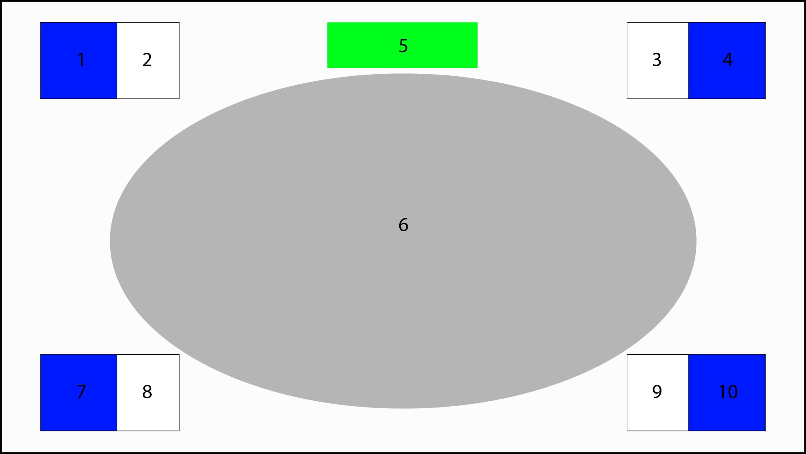
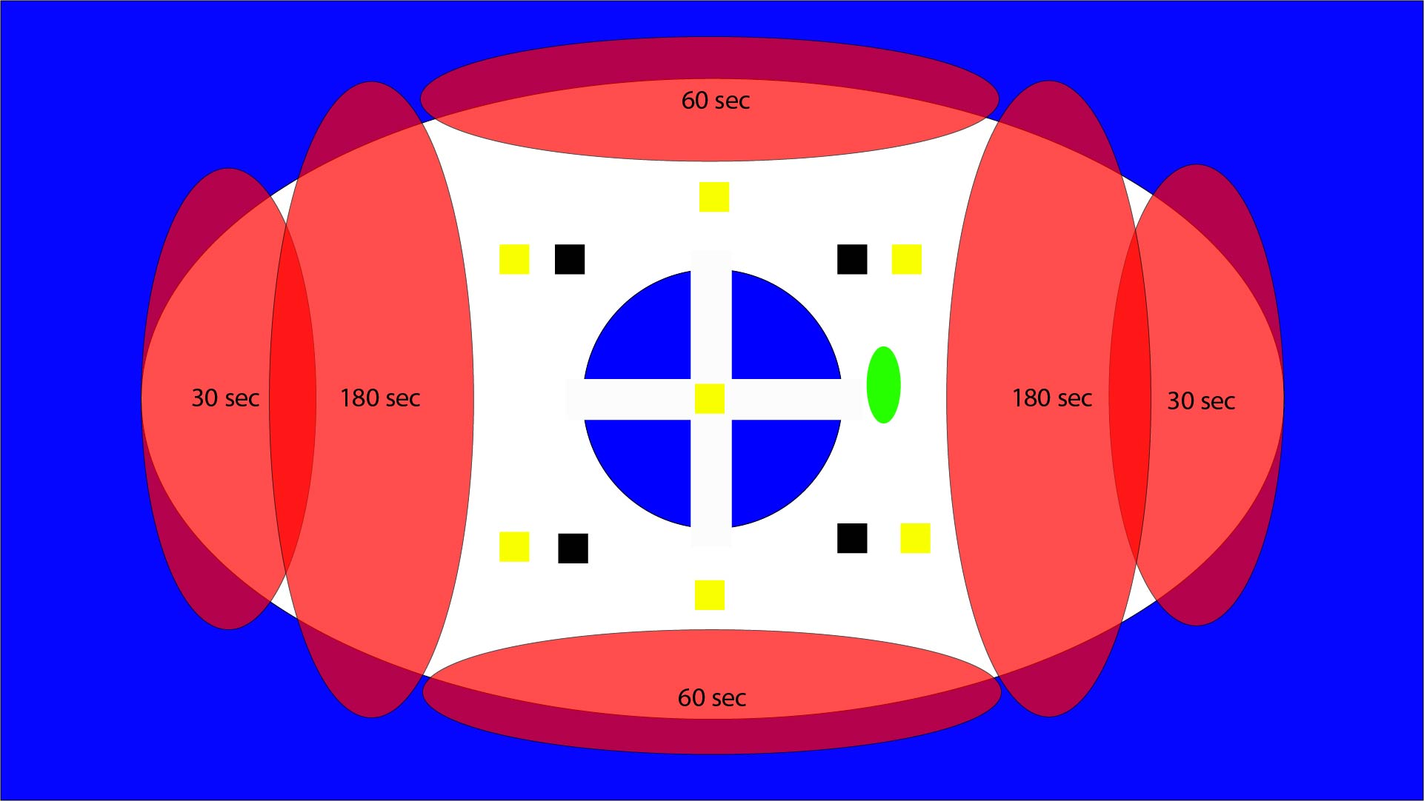
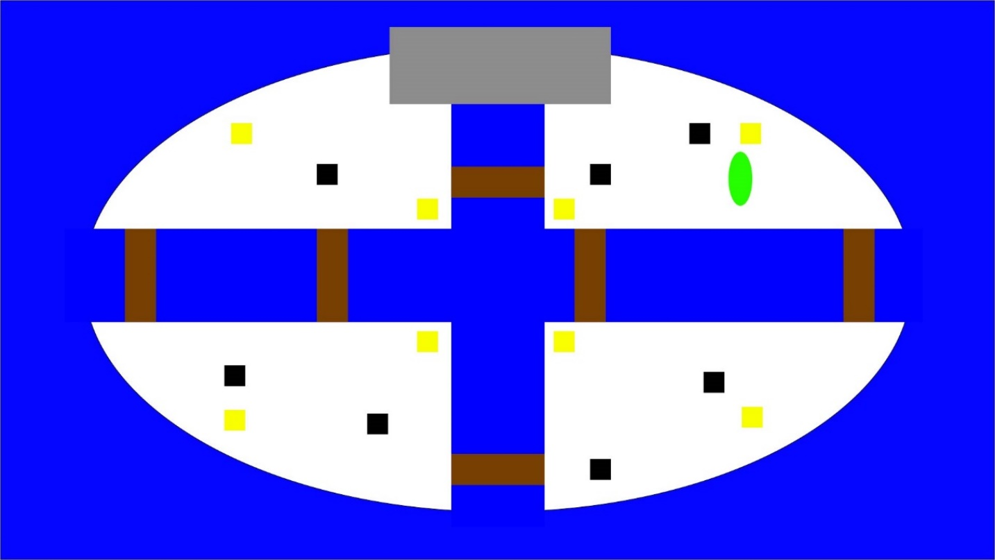
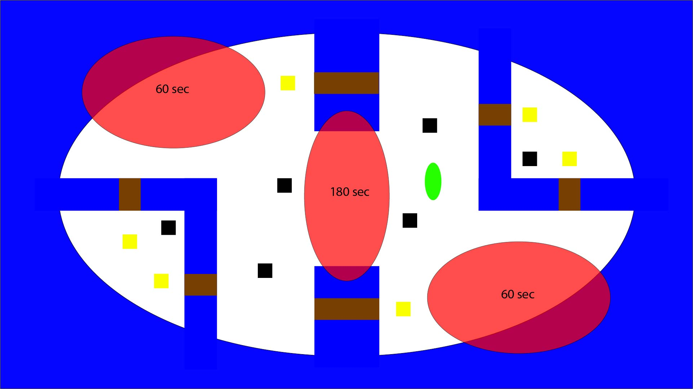

Penguin Water War

Game Design Document

Revision: 0.0.1

GDD written by Alex Lötscher

Index
Index 2
Overview 5
Summary 5
Aesthetics and style 5
Gameplay 6
Gameplay 6
Win/Lose Condition 6
Input 6
Rules 7
References and influences 7
Target audience 7
Targeted platforms 7
Monetization model 7
What sets this project apart? 7
Graphics & Art 8
General 8
Characters (Penguins) 9
Interface 9
Menu 9
Game 9
Music & Sound 11
Music 11
Sound 11
Story and Characters 11
Story 11
Characters 11
Generally 11
Emperor penguins 11
Chinstrap penguins 11
Rockhopper penguins 12
Jackass penguins 12
Game Elements 13
Penguin (Player) 13
Properties 13
Behaviors 13
Relationships 13
Water cannon 13
Properties 13
Behaviors 13
Relationships 13
Destroyable ice platforms 13
Properties 13
Behaviors 14
Relationships 14
Mechanical platforms 14
Properties 14
Behaviors 14
Relationships 14
Items (Powerups) 14
Properties 14
Behaviors 14
Maps 15
Map 1 (ice land) 15
Map 2 (research station factory) 15
Map 3 (Mixed) 16
Modes 16
Default 17
Speed mode 17
Mixed map 17
2vs2 17
Assets Needed 18
2D 18
3D 18
Sound 18
Code 19
Animation 19
Development milestones 19
Prototype 19
First playable 19
Content 19
Beta 19
Release 19

Overview

Summary
Penguin Water War is a multiplayer (Split Screen) action party game for 2-4 players.
The goal is to shoot the other players out of the map with help of a water cannon.

Aesthetics and style
The game plays in a friendly and playful fantasy South Pole region. There are also mechanical platforms from research stations which brings in some dynamics to the maps.
It’s a 3D game with low poly cartoony graphics, much like Gang Beasts:
(https://steamuserimages-a.akamaihd.net/ugc/448454842789805178/02A5EB99AB0243687F45FA9E9C7275AC1FD5B02B/)

Gameplay

Gameplay
Before the game starts, the players can choose the mode, maybe the map and their penguin.
While playing, the players can move on the map and shoot the other players. They also must look out for changes in the map (platforms and destroyable ice). While charging the water cannon, all players see the range of the impact. The range and power of the water cannon hit, increases while charging.
After a while, if the round not already ended, some powerups spawn. This powerups (e.g.: increased movement/reload speed) can be collected and are automatically activated to the player.
The players must pay attention to the following things: walk around & not falling of the map, shooting the other players and not get hit by other players.

Win/Lose Condition
Players who fall of the map are out of the current round. The last player standing on the map wins this round (last man standing) and gets a point. The player who get five points first wins the game.
On a draw (if more than one player survives after timer is on zero) nobody gets a point. But the players who already fell of, loses one point (minus points possible).

Input
There are not a lot of inputs options needed. The recommended input device is a gamepad.
The player can move around with an analog stick or the arrow keys. One button is needed to jump. With another button the water cannon can be charged (holding button down) and activated (release button). While charging, the direction can be changed but the player cannot move around.

A mapping of a DualShock Controller could look like this (see controller description below):

K (Left analog Stick): Move and rotate
G (Right analog stick): Could also be used for rotating, but not intended
F Cross (X): Jump
F Square or Circle: Charge and shoot water cannon
(https://manuals.playstation.net/document/de/ps4/basic/pn_controller.html)

Rules
- Players can’t move while charging the water cannon
- Players can’t move or rotate while in the air
- If a player falls of the map (by himself or by any players water cannon) he is out of the current round
- The last player who doesn’t fall of the map wins this round and gets a point
- The first player that gets five points wins the game
- Different types of powerups are stackable. But only one powerup per type

References and influences
- Super Mario Sunshine (water cannon)
- Lance A Lot
- Gang beasts

Target audience
The target audience are people who want to have fun or competition with/against their friends. The game is free, but gamepads are highly recommended (if player on PC). The game also fits to a younger audience as the game art is friendly. A game lasts about 15 to 30 minutes.

Targeted platforms
The targeted platforms are PC (highest priority), PS4 and Xbox One. The game is optimized to play with gamepads.

Monetization model
The game is free to play. The players can buy cosmetics with microtransaction.

What sets this project apart?
- Penguins fighting in the Antarctic
- Penguins fighting with water cannon

Graphics & Art

General
It’s a 3D game that plays in a fantasy South Pole / Antarctica setting. There is not only ice and water, but also different platforms from research stations.
The feeling and colors should be friendly and playful.
Most used colors are white (ice), blue (sky & water).
The platforms and research stations constructions are in a friendly bright brown or grey.
The art is low poly, clean and cartoony much like Gang beasts:
(https://www.steamkiwi.com/article=18291/patch-notes-for-the-gang-beasts-026-unstable-alpha-build)

To make the game maps more friendly and interesting, there can also be little funny, unrealistic items (just for the look), wooden boxes (with collision) or Obstacles (not movable).

Characters (Penguins)
The penguins are also low poly and can look a bit unrealistic in favor for craziness.
(https://www.playstation.com/de-ch/games/gang-beasts-ps4/)
The penguins always have the color of their player (green, red, blue, yellow). But they also have small variations in their anatomy (e.g.: bigger neck). The art style from the image above looks great!

Interface

Menu
The menu is very simple. At the first screen there is a “Start Game”, “Settings” and “Exit” button.
After the “Start Game” button is selected the next screen with the mode selection appears.
Based on the selected mode a map selection menu appears. As last step, every player can choose a penguin species. The colors of the players are fixed. Players can also choose the same species.

Game
The UI in the game only shows the remaining time of current round and some player information (color, penguin species, amount of won rounds and active powerups.
The players should always be seen in the middle of the map (see number 6 on pictures below). This must be solved via map design or camera settings.

A two player game looks like this:
- Penguin Avatar Player 1 + Color of player
- Amount of won rounds and additional info (current powerups)
- Same as 2. but for player 2
- Same as 1 But for player 2
- Timer: Remaining time of current round
- Space where all players should be seen

The UI for a four-player game looks similar, however the info boxes of player 1 and player 2 slide up, so player 3 and 4 are bottom left and bottom right:
- Penguin Avatar Player 3
- Player 3 information
- Player 4 information
- Penguin Avatar Player 4

After a game ends, a little overview of the winner and the points of the other player appears. Then a rematch with the same settings can be started.

Music & Sound

Music
The music is used in the menu and game as normal background music. It should create a funny, playful and friendly reaction.

Sound
The sound should underline the actions in a funny and playful way. The most important sound effect is the one from the water cannon, so other players can recognize this sound and plan their next action.

Story and Characters

Story
The South Pole changed…
Because of the global warming, the nice and cold places in the South Pole are decreasing drastically.
So, the different penguin species must fight for these valuable spots. The only thing they can use to fight with, is a huge water cannon.
There are four different penguin species in the game: emperor penguin, chinstrap penguins, rockhopper penguin and jackass penguin.

Modeling 4 different penguins is not the issue – but making sure they are all nicely unwrapped could take a lot of time, considering that they have all the same weapons, and are the same besides looks and maybe stats like speed. As such it is better to make only 1 good model, animate that one well, and then use that model, to make a few rescaled versions (small, chubby, thin and long, huge and fat). Then give them items like hats. Hats dont need to be animated – if you place em on the bone of the head in the skeleton hierarchy, they move perfectly with the head.

Characters

Generally
There are only penguins in the game. Generally, the penguins don’t like to talk. There are all pugnacious because they want to have their own nice spot.

(Just make 1 race – out of expirience, multiple rigs will make the whole thing more difficult. If enough time, make more. But the issue is not how fast we can model these – i can do so in a few hours with texture. But the rigging, weighting etc will take too much time with 4 different species. The headgear gets placed on the skeletal hierarchy on the head bone, so you DONT have to animate the hat. Just place it there and it move along fine!) Quick models on a few ice platforms in unity.
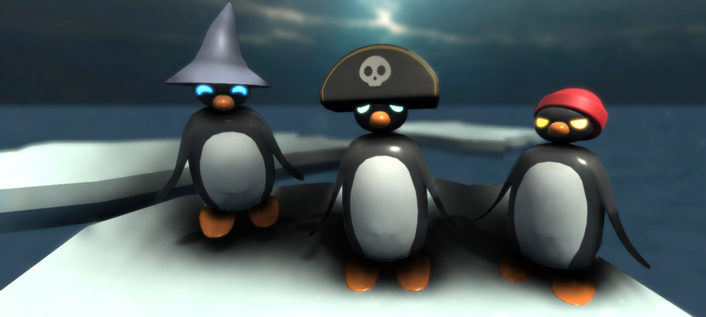

Emperor penguins
Emperor penguins are the tallest and heaviest penguins of all penguin species. But their weight also makes them a little bit slower, then the other species.
They are known as merciless slayers in the penguin world. But in reality, they are soft and gentle. They only started to fight because the other penguin species attacked first.

(More (real) information from wiki: https://en.wikipedia.org/wiki/Emperor_penguin)

Chinstrap penguins
The Chinstrap penguins are not the smartest out of all species. Sometimes they try to crack stones with their bald head. That’s why they are also called “Stonecracker penguins”.
Because of their lower intelligence they often get offended by other penguin species. They now want to make others pay for that.

(https://en.wikipedia.org/wiki/Chinstrap_penguin)

Rockhopper penguins
The Rockhopper penguins are much smaller than the other penguin species. But they compensate this with their intelligence.
They always plan their next move ahead. The other species hates to play chess against one of the rockhopper penguins (they always win).

(https://en.wikipedia.org/wiki/Rockhopper_penguin)

Jackass penguins
Normally just seen in South Africa, the jackass penguins had to move to the Antarctic.
They are called the “outsiders” and get hated, because they look such different than the other penguin species.
The jackass penguins just want to survive. Luckily, they love to shoot other animals (learned in South Africa). So just give them a nice big water cannon and they’re happy.

(https://en.wikipedia.org/wiki/African_penguin)

Characters based on 1 single rigged penguin model/race
Dual wielding penguin (run and shoot)
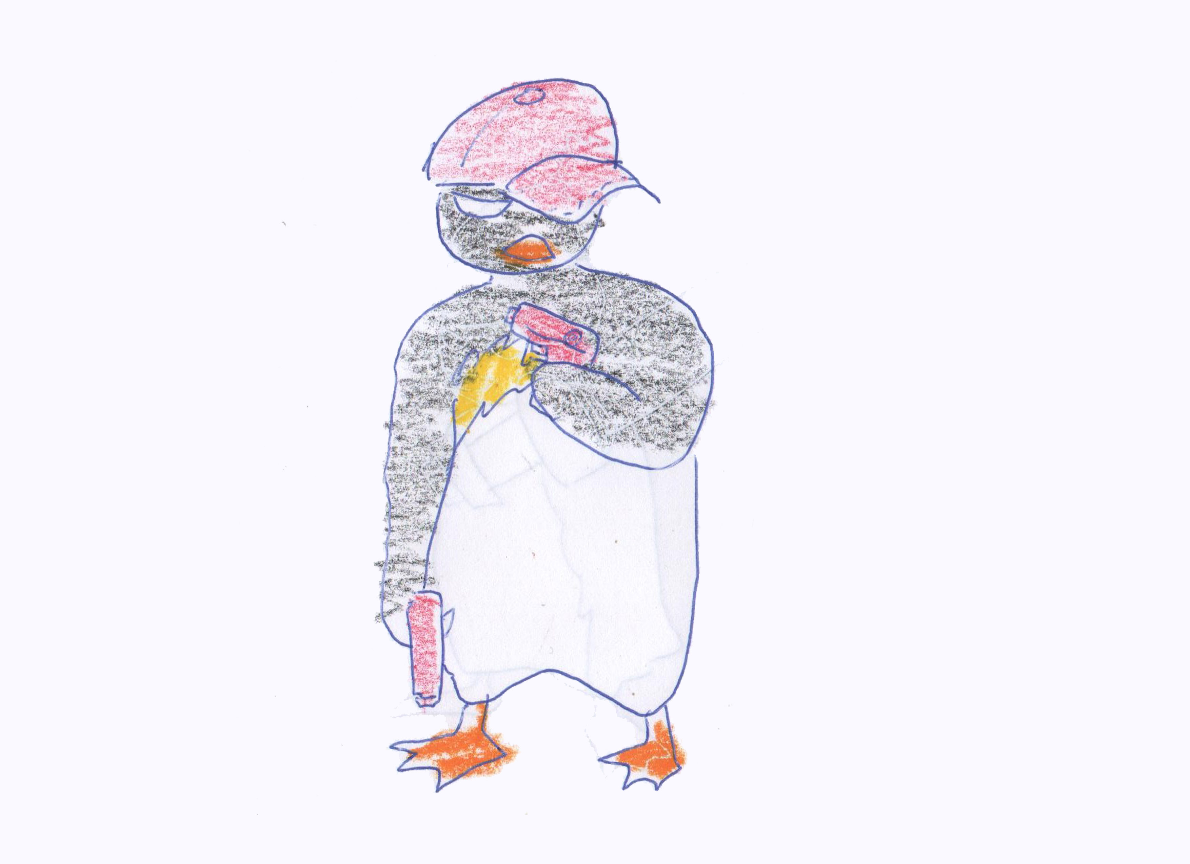
This penguin can run/jump and shoot at the same time. He wields two small water pistols which he can continously shoot while running, shooting in the direction he is running. This character thrives on his speed and his ability to constantly shoot small water projectiles. Every Pistol has 20 shots, which can be fired in rapid succession! If you simply press the trigger the pistols empty themselves in maybe 5 seconds. The weakness of the pistols are their lack of accuracy and range. The pistols are the only weapon that you can use while moving.

pirate penguin (stand to aim)
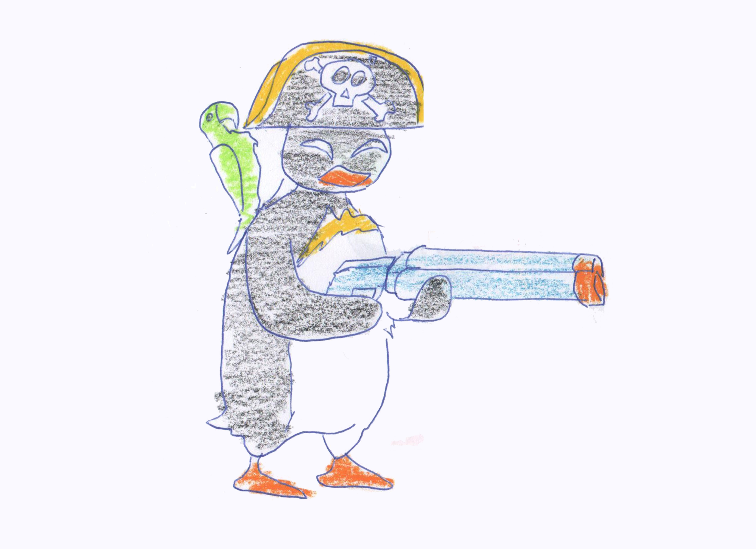
The pirate penguin has a water shotgun, which needs him to charge and then shoot. The shots can be charged while running, when you release the trigger you stand still automatically. The shotgun only has 2 shots, after which it must be reloaded. Every blast is powerful enough to knock any penguin of his soles! I imagine the aqua shotgun to shoot a strong beam of water. But because he only has 2 shots, he needs to reload often, so take good aim before shooting. Compared to the bazooka penguin, his shotgun recharges quickly in the water. 2 shot mode makes gameplay different here – its a one-hitter!

bazooka penguin (stand to aim)

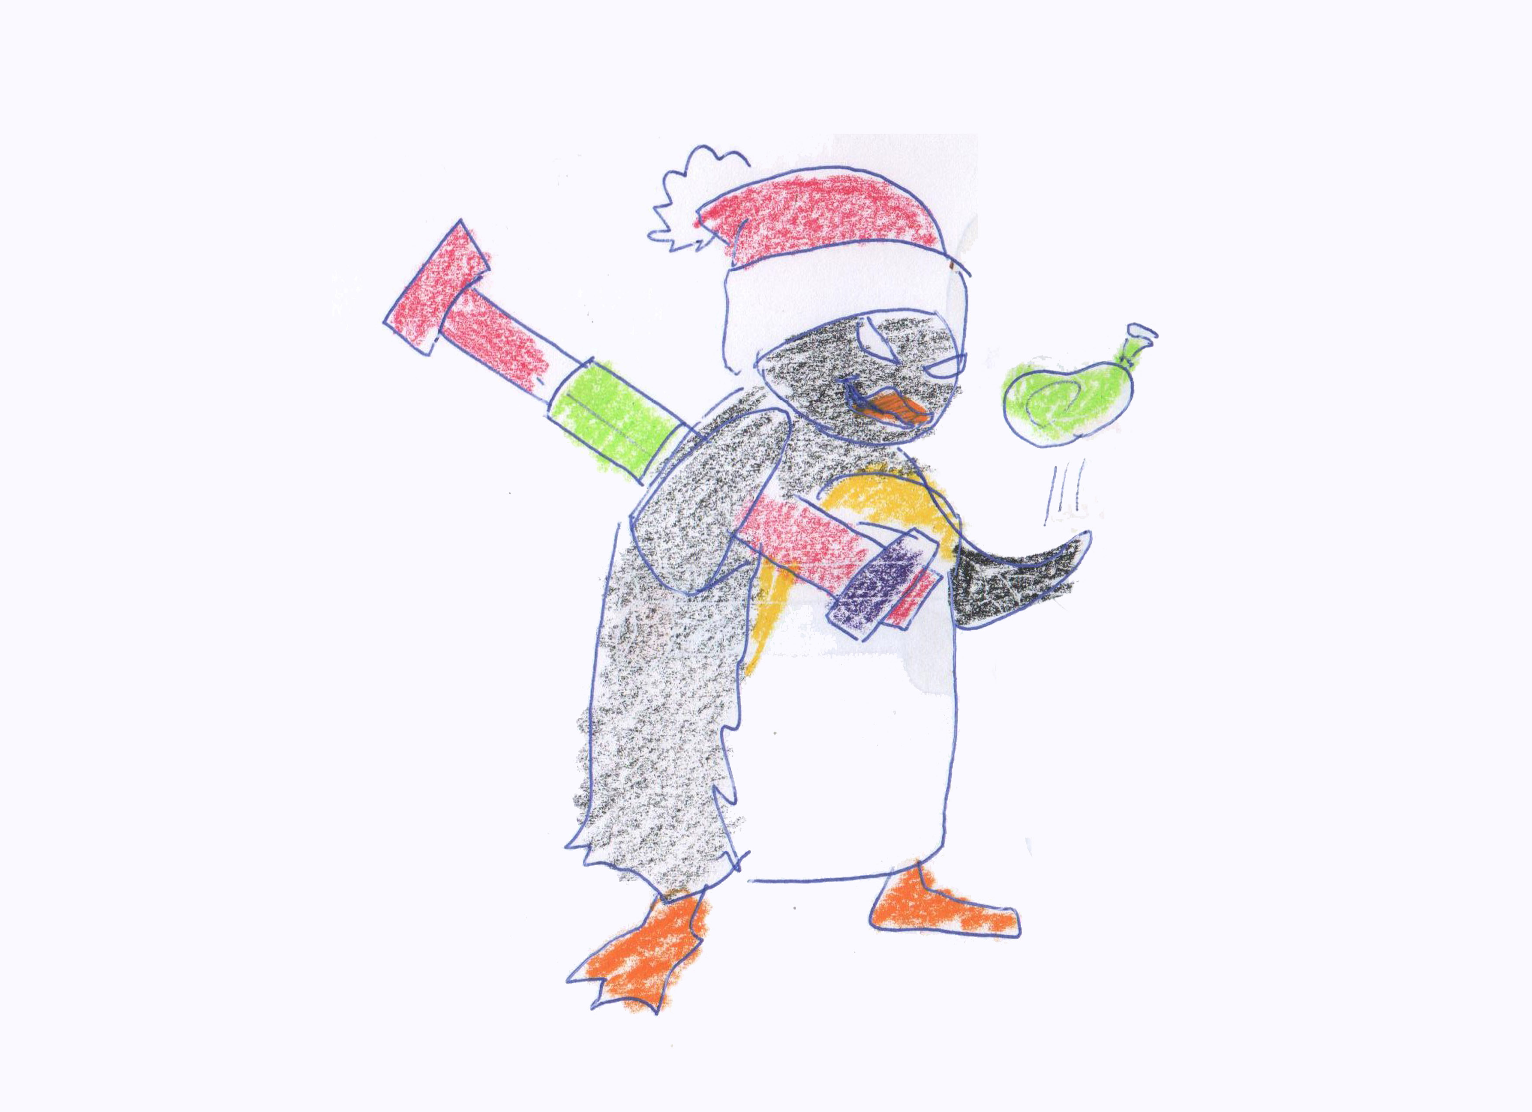
The bazooka penguin has a large balloon launching device which lobs ballistic waterballons on his enemies, which explode on impact. By aiming and charging the balloons will be fired at longer distance, similar to a grenade launcher. Aiming charging and shooting requires you to stand still. The bazooka penguin has 3 water balloons. After 3 balloons he needs to recharge his bazooka. The AoE of the splash effect becomes bigger the more you charged the weapon. With low charge the balloons have much less knockoff power than with full charge.

Rifle penguin (stand to aim)

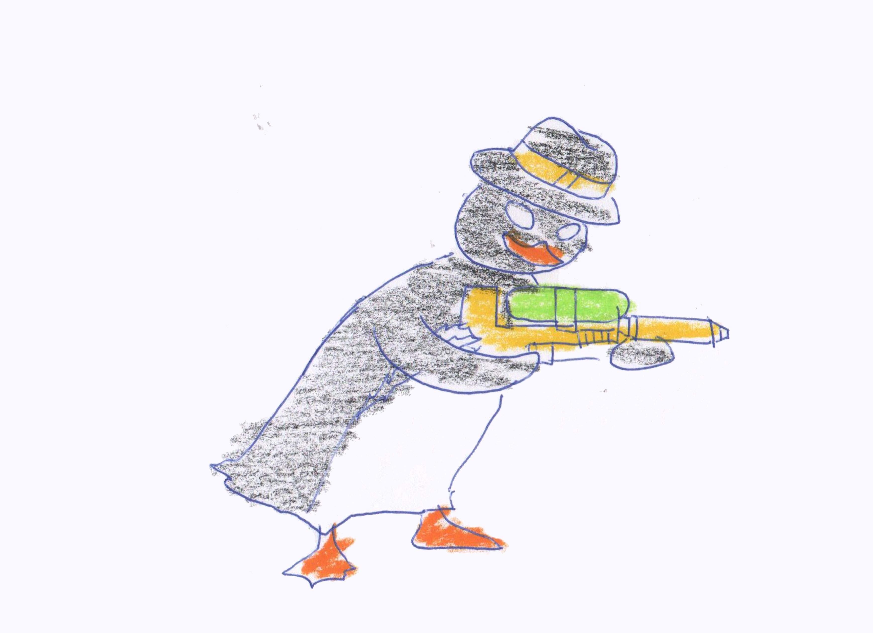
The water rifle can continously shoot small water projectiles/drops, as it has a large tank filled with water. So you have an amount of maybe 40, and by pressing the trigger button you will continously release waterparticles from the gun, until it is empty. The rifle penguin is easiest of all penguins to play. The rifle does not need to charge – every shot comes with same speed and power, just like with the pistol. So you can walk, then shoot (you automatically stand still), walk again, shoot, walk shoot.. Difference is that the rifle needs to stand to aim, but the ammo consumption is similar to the pistol. The rifle has greater accuracy though. It may empty itself in 8 seconds if pressed continously.

Game Elements

Penguin (Player)

Properties
- Position
- Direction
- Movement speed
- Water cannon charge time
- Aiming mechanisms[let us test a few to see what works best] maybe with degrees of arch for ballistics? See below weapons Balloon bazooka..
- Describe how the camera works. Apparently it is a multi target camera.

Behaviors
A player can move, rotate and jump freely on the map. While he is charging with his water cannon he can’t move and jump (only rotate to aim). See my input on weapons below – it would be more interesting, if lets say dual wielding waterpistols would NOT require aiming, you always have an aiming cone, and you can run and jump with em – the other weapon ideas from me, the aquazooka, watershotgun and waterrifle require you to stand to aim. These would functionally diversify the game expirience, while different penguin races need to be rigged, animated, and dont necessarily do much to gameplay and core mechanics.
If a player gets hit by the water cannon of another player, he is pushed away by the power and range of the water cannon.

Relationships
- Water cannon: equipped and usable
- Platforms: walkable/jumpable

Water cannon

Properties
- Power
- Range
- Impact area (by power and range)
- Timeout duration

Behaviors
A water cannon can be charged and fired. The greater the charge, the greater the power and range. After a shot is fired, the next shot is locked until a certain time (timeout duration).

Types of water guns
Water cannons could come in 4 types: small water pistols, which can be quickly recharged, and are dual wielded. Then a water rifle which is more powerful, a dual shot water-shotgun, and a big RPG-like Water Bazooka, which throws colorful waterballoons. Creating variety by making multiple weapons is far less effort than making muliple animated penguins. The amount of work for such models is minimal and takes only 1-3 workdays including texturing. By having different types of water guns, the penguins behave different. So the enemies also use the 3 water gun types. Here some examples:
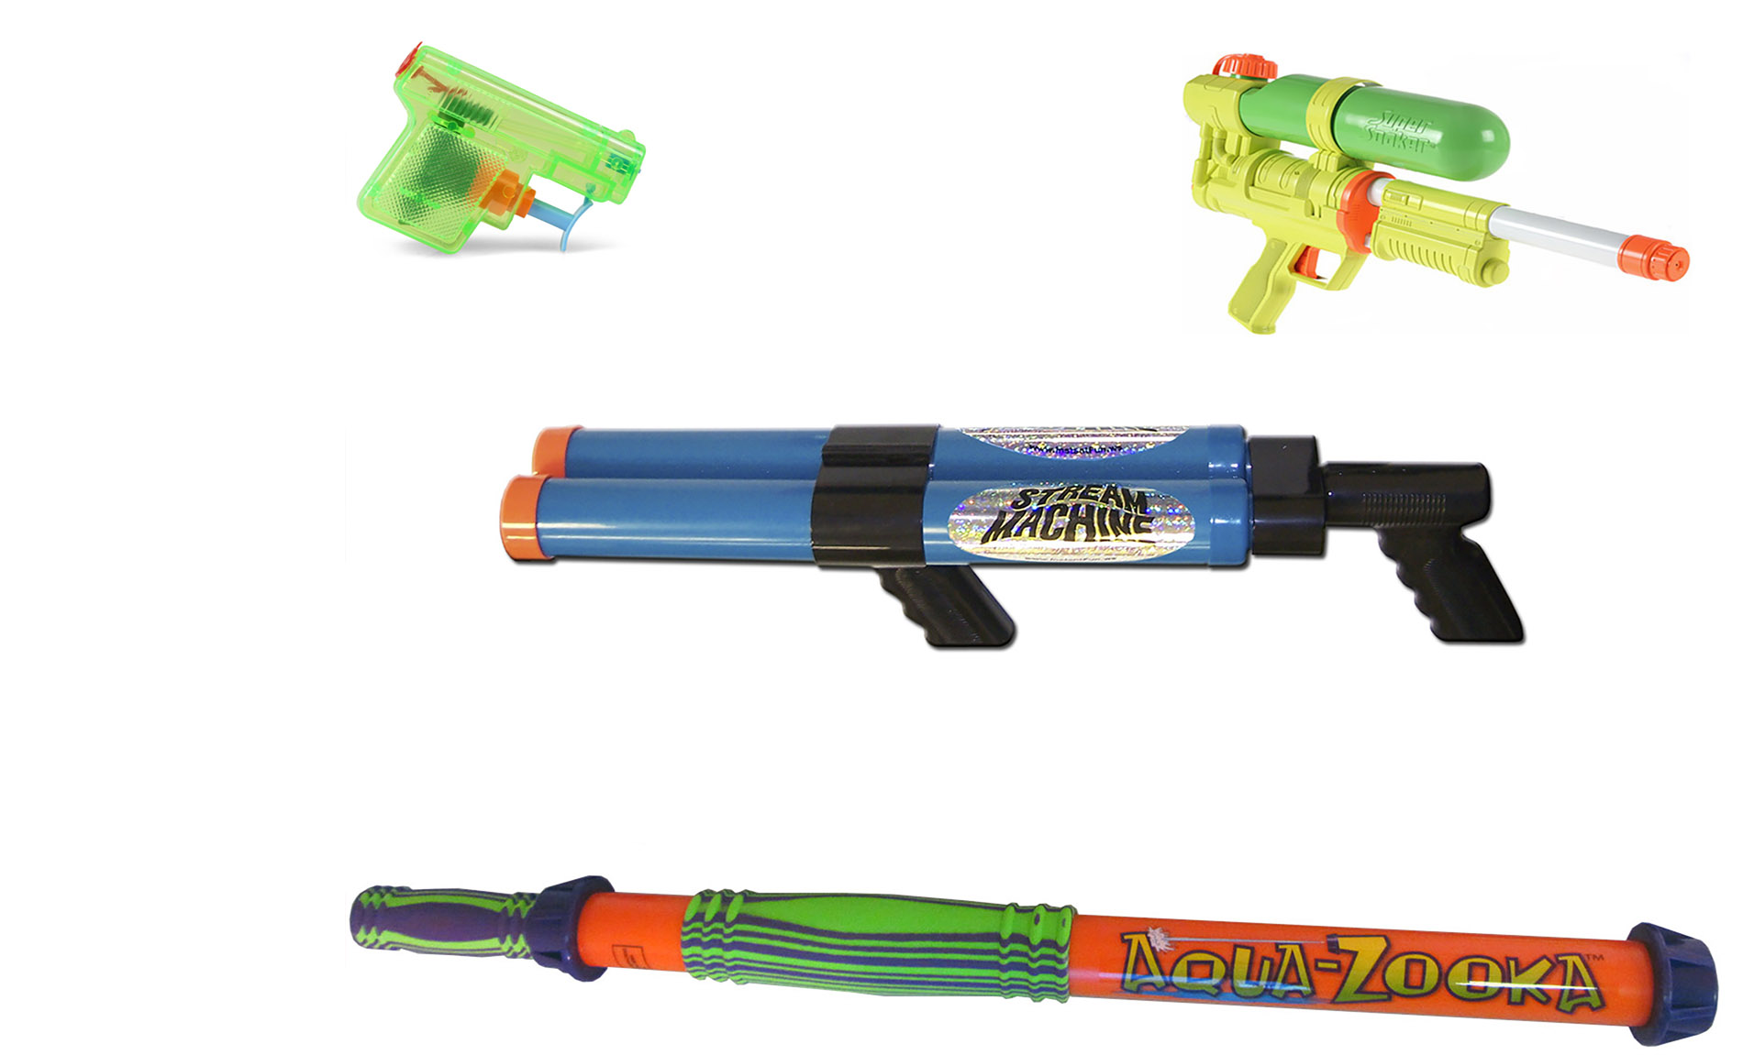
In the top left corner we have a small pistol for dual wielding, a water rifle (continous beam) on the top right, in the middle a water shotgun, and below an Aqua-Zooka. This thing could launch water balloons which explode on impact. So certain penguin characters / races have only small pistols, others big aquazookas.. Reload speed may also be an advantage – the shotgun and pistols are quickly reloaded. A penguin who reloads is an easy target ;D
item Dual Pistols Water Rifle Water Shotgun Aquazooka
push effect minor small medium big
weigth 300gr 700gr 1kg 3kg
capacity 3 dl 1liter 1 liter 2 liter
recharge time 5sec 10sec 3sec 10sec (3,3 for 1 balloon)
ammo 2*20 40 2 jets 3 balloons
It could also make sense to give different guns different aiming mechanisms – for example if you dual wield waterpistols, you dont need to aim to shoot, you can run around shooting, while a cone indicates your targeted area. So you can jump and run while shooting water! If you use the water rifle or water shotgun, you can only shoot standing (standart shooting). While the water rifle gives multiple water shots, the water shotgun only fires 2 very powerful water projectiles, and then you need to reload it. If you use the aquazooka, you can charge it. The aqua zooka fires waterballoons, so it fires in a ballistic arc. Maybe a degree indicator like in grenade launchers? These different weapons and their use would not pose a lot of work, but it would diversify the game expirience drastically, and it is far less effort than for example to make multiple penguin models. The amount of water, size and knockdown power of the different weapons would make the game more diverse. Also an aquazooka would take longer to reload than the shotgun, the dual pistols take less time to reload than shotgun and rifle.

Relationships
Each player has a water cannon equipped.

Destroyable ice platforms

Properties
- Position
- Range / Collision
- Timer

Behaviors
An ice platform has a fixed place on the map. After the timer is expired, the platform will glow, fibrate and make a sound (so the players are warned). After another 5 seconds the platform will be destroyed (falls into water).

Relationships
Players can move and jump on it, while not destroyed.

Mechanical platforms

Properties
- Start/End position
- Speed

Behaviors
Mechanical Platforms have a fixed start and end position on the map, in which they move in a certain speed.

If the ice platforms are physics based (or some of them), then it would be possible that they drift and move on their own, depending on if players jump and run on them – physics. Maybe one could even move the platform by shooting on it – if it is all force based! So you could isolate a player by shooting on his platform, as it gets pushed away too far to jump on another platform...

Relationships
Players can move and jump on it.

Items (Powerups)

Properties
- Position
- Spawn timer
- Effect duration
- Effect multiplier
- Effect type
  - Movement speed increasing
  - Jump power increasing
  - Water cannon power or range increasing
  - Water cannon reload speed increasing
  - Water cannon charge speed decreasing

Behaviors
After a certain amount of time, items will spawn at random positions (several positioning areas are defined on the map). The items can be collected by the player and will get activated directly. The different effects of this powerups are stackable (only one stack per effect). The effect will last for a certain amount of time.

Enemy Penguins

Here a proposed AI script for the enemies. Consider that the AI will take some time to develop. The enemies should be able to idle, to roam, to search for players (physics.Sphereoverlap method to use!). Then calculate the distance between enemy and player. If dist < followRange, then the enemy should approach his new target. If dist < shootingRange, the enemy penguin takes aim and squirts water!

In the game there is a plane (invisible) with a boxcollider on it, on the level of water. If any player or enemy collides with this plane, he looses. Enemy and players use the same weapon items. These are placed at the hand bone of the skeleton in Unity. Some of the enemies stats are determined by the equipped item, like ammo, speed maybe,...

EnemyPenguin.cs (this is only an example remove from gdd and place in txt file..)

int maxAmmo = 2 //the equipped item has maximal 2 shots.. for example..
int ammo = 2 //from the equipped weapon you update the amount of ammo you //have left to fire and at start function you get your maxAmmo..

int points // how many points did this penguin already make?
int aiState //idle, roam, search, follow, shoot and re-fill!
float attackRange = 25 //at this range i shoot at the target
float followRange = 50 //at this range i follow the player closest to me
Transform myTarget //this is the player i am currently locked on to. If he falls into the water //and this transform is = null, then i change into roam and search //mode...

float speed // maybe some penguins are less sporty than others?
NavmeshAgent agent // Do we use navmesh agents?
Float JumpDistance // at this distance i jump to another platform

float grounding //player also has this; Maybe if u get hit by water, you loose traction //with the ground and start to slide?
Animator myAnims //this is the animator to access animation in unity
Rigidbody myRigidbody //the rigidbody from this GO
Item myWeapon //see class item and the weapons derived from it
GameObject weapon //this is the weapon model
Collider coll //this is my collider – use to detect collision with waterplane!

Transform handbone //the right hand bone. Here the weapon will be spawned correctly

- Weapon.cs (place this on the weapon GO) just an example..
int maxAmmo = 2; //the equipped weapon fully loaded has 2 ammo
int Ammo = 2; //you cant have more ammo than maxammo
GameObject Projectile; //waterballoons, water projectiles etc..
float fireRate; //how fast can i empty the gun?
Float reloadTime; //how long to refill the watertank of the gun?
float chargeTime; //how long to charge
float timer; //timer for firerate (update, time.timedelta or sth) needed for //chargetime, fireRate and reloadTime.
Transform muzzle //from here the projectiles are being emitted!
Int weaponType //0=pistol, 1=shotgun, 2=rifle, 3= bazooka

void update () //mock method example
{
if (Ammo >= 1)
{
if (Input.GetKeyDown("fire01"))
{
print("you charge your weapon");
//charge the weapon now!
If (timer > chargeTime)
//this is fully charged now! Indicate it on UI
}
if (Input.GetKeyUp (“fire01”))
{
//Instantiate projectile as new
//place projectile prefab at muzzle of weapon
//give it speed etc. Rotate it so that it looks at Z!
//destroy projectile auto after 5 seconds maybe..
}
}
else
{ //you should refill your weapon
//display this ingame with a gauge?
If (distanceToWater < minDist)
{
if (Input.GetKey(“fire02”) && ammo <= maxAmmo)
{
//start refilling the water tank, display this on gauge //in UI. start timer, if greater than rechargeTime float
//the gun is refilled again..
Ammo ++;
}
} }
}

Maps

Map 1 (ice land)
This maps only consist of ice. But some of the ice areas getting destroyed after a recent time of play. At first, it’s easy to move around). After a while the map gets smaller and smaller.
Blue: Water
White: Ice
Red: Destroyable ice platforms (getting destroyed after 30, 60 or 180 seconds)
Brown: Mechanical platform areas-> moves in this area
Black: Obstacles
Grey: Research Factory
Yellow: Powerup spawn points
Green: Penguin (Player) size

Map 2 (research station factory)
This map is divided in four ice islands. Between these islands, there are different mechanical platforms from a research station, which brings the players on the other side.

Map 3 (Mixed)
This map is a mixture of ice areas and mechanical platforms. This map offers the most action.

Modes

Default
In the default mode, the players are choosing a map and fight until one player gets five points.

Speed mode
In the speed mode, everything gets faster: Players, water cannons and platforms.

Mixed map
In this mode, the map gets randomly changed after every round (not the same map twice).

2vs2
In this mode, 2 players fighting against 2 other players. The map can be selected.

Assets Needed

2D
- Textures
  - Menu & UI
  - Map textures

3D
- Characters
  - Emperor penguin
  - Chinstrap penguins
  - Rockhopper penguin
  - Jackass penguin
- Weapon
  - Water cannon
- Items
  - Powerup box (one is enough, effects will be random)
- Environmental
  - Mechanical platforms
  - Ice platforms
  - Obstacles (wooden/steel boxes)

Sound
- Ambient
  - Water
  - Wind
  - Destroyable ice platforms
  - Mechanical platforms
- Player sounds
  - Character Movement (move and jump)
  - Character hit by water cannon
  - Water cannon charging
  - Water cannon shoot
  - Character out of map (death)
- Menu
  - Change option
  - Select option
  - Select Penguin

Code
- Player Script
- Map Script
- Menu Script

Animation
- Environment Animations
  - Destroyable ice platforms
  - Mechanical platforms

- Character Animations (Penguin)
  - Move
  - Jump
  - Water cannon charge & shoot

Development milestones

Prototype
- Penguin movement
- Water cannon

First playable
- First map (without any effects)
- Powerups
- Timer
- Win-/Lose condition

Content
- Penguin model and animations
- Water cannon model und animations
- Enemy penguins with simple AI
- Map 2 and 3
- Destroyable ice platforms
- Mechanical platforms
- Obstacles

Beta
- Testing and optimization

Release
- Polish and release

