# ОТЧЕТ ПО ЛАБОРАТОРОНОЙ РАБОТЕ №4

### B-Tree индекс

-- B-дерево (B-tree): B-дерево является наиболее распространенным типом

-- индекса в PostgreSQL.

-- Он подходит для равенства и диапазонных запросов, а также для сортировки

-- данных.

-- B-дерево поддерживает эффективный поиск данных в порядке сортировки ключей -- и позволяет быстро находить значения в диапазоне.

1. Фильтрация данных в запросах с использованием предикатов
2. Простой

Пример 1

**EXPLAIN** (**ANALYZE**)

**SELECT** * **from** cargoes

**WHERE** weight = 120.0;

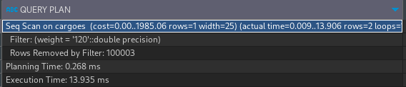

**CREATE** **INDEX** cargoes_weight_index **ON** cargoes **USING** btree(weight);

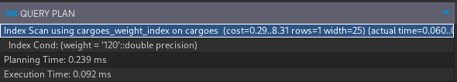

Пример 2

**EXPLAIN** (**ANALYZE**)

**SELECT** * **FROM** cargoes

**WHERE** weight **BETWEEN** 1 **AND** 11;

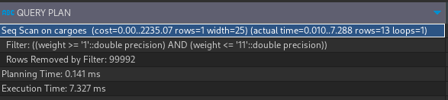

**CREATE** **INDEX** cargoes_weight_index **ON** cargoes **USING** btree(weight);

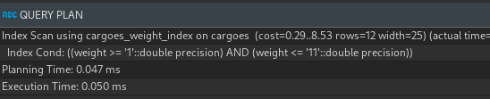

Пример 3

**EXPLAIN** (**ANALYZE**)

**SELECT** id, car_number, lifting_capacity, model

**FROM** vehicles

**WHERE** car_number **LIKE** 'зз%';

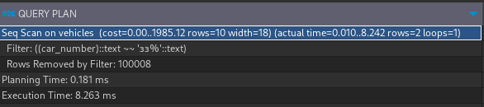

**CREATE** **INDEX** car_number_index **ON** vehicles **USING** btree(car_number varchar_pattern_ops);

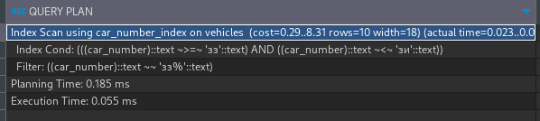

Пример 4

**EXPLAIN** (**ANALYZE**)

**SELECT** *

**FROM** requests

**WHERE** requests.**cost** **IN** (100, 500);

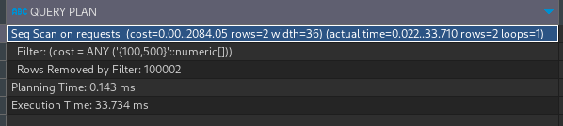

**CREATE** **INDEX** cost_index **ON** requests **USING** btree(**cost**);

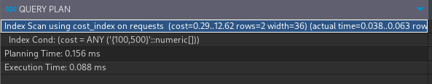

Пример 5

**EXPLAIN** (**ANALYZE**)

**SELECT** *

**FROM** requests

**WHERE** requests.**cost** > **ALL** (

**SELECT** **avg**(**cost**) **FROM** requests

);

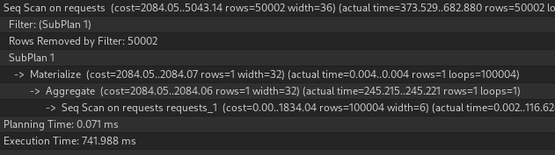

**CREATE** **INDEX** cost_index **ON** requests **USING** btree(**cost**);

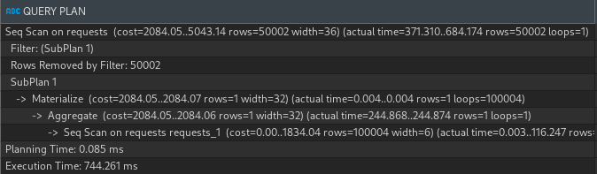

Пример 6

**EXPLAIN** (**ANALYZE**)

**SELECT** *

**FROM** requests

**WHERE** requests.**cost** > **ANY** (

**SELECT** **avg**(**cost**) **FROM** requests

);

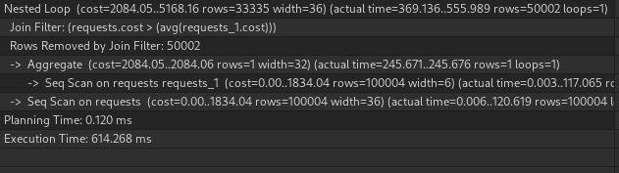

**CREATE** **INDEX** cost_index **ON** requests **USING** btree(**cost**);

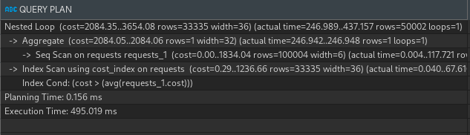

1. Составной

Пример 1

**EXPLAIN** (**ANALYZE**)

**SELECT** id, car_number, lifting_capacity, model

**FROM** vehicles

**WHERE** car_number **LIKE** 'зз%' **AND** lifting_capacity = 19;

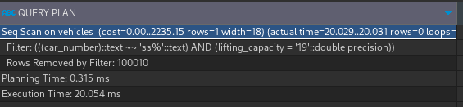

**CREATE** **INDEX** car_number_index **ON** vehicles **USING** btree(car_number varchar_pattern_ops, lifting_capacity);

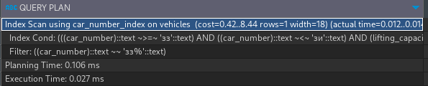

1. Уникальный

Пример 1

**EXPLAIN** (**ANALYZE**)

**SELECT** id, car_number, lifting_capacity, model

**FROM** vehicles

**WHERE** lifting_capacity = 19;

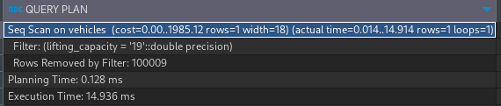

**CREATE** **UNIQUE** **INDEX** lifting_capacity_index **ON** vehicles **USING** btree(lifting_capacity);

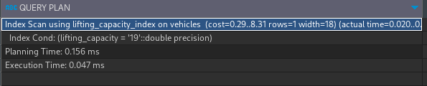

Пример 2

**EXPLAIN** (**ANALYZE**)

**SELECT** id, car_number, lifting_capacity, model

**FROM** vehicles

**WHERE** lifting_capacity **BETWEEN** 1 **AND** 19;

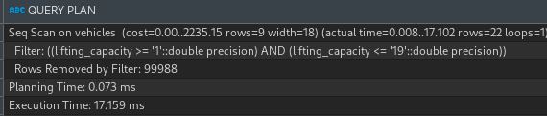

**CREATE** **UNIQUE** **INDEX** lifting_capacity_index **ON** vehicles **USING** btree(lifting_capacity);

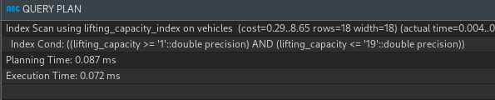

Пример 3

**EXPLAIN** (**ANALYZE**)

**SELECT** id, car_number, lifting_capacity, model

**FROM** vehicles

**WHERE** car_number **LIKE** 'зз%';

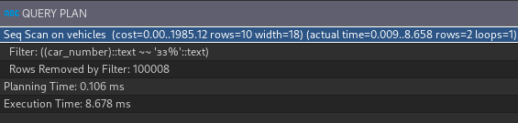

**CREATE** **UNIQUE** **INDEX** car_number_index **ON** vehicles **USING** btree(car_number varchar_pattern_ops);

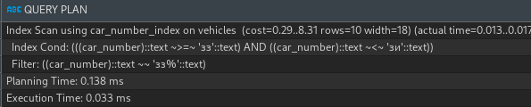

1. Покрывающий

Пример 1

**EXPLAIN** (**ANALYZE**)

**SELECT** lifting_capacity, model

**FROM** vehicles

**WHERE** lifting_capacity = 19;

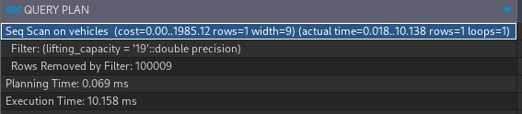

**CREATE** **INDEX** lifting_capacity_index **ON** vehicles(lifting_capacity) **INCLUDE** (model);

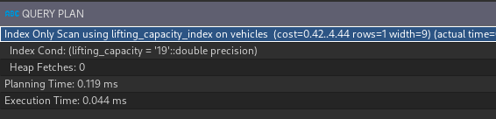

Пример 2

**EXPLAIN** (**ANALYZE**)

**SELECT** lifting_capacity, model

**FROM** vehicles

**WHERE** lifting_capacity **BETWEEN** 1 **AND** 19;

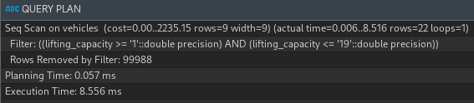

**CREATE** **INDEX** lifting_capacity_index **ON** vehicles(lifting_capacity) **INCLUDE** (model);

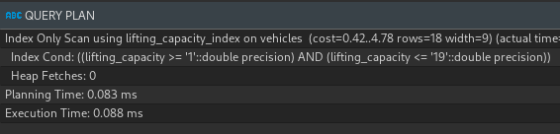

Пример 3

**EXPLAIN** (**ANALYZE**)

**SELECT** car_number, model

**FROM** vehicles

**WHERE** car_number **LIKE** 'зз%';

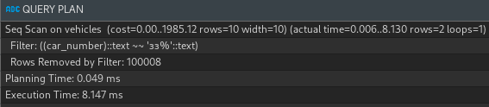

**CREATE** **INDEX** car_number_index **ON** vehicles(car_number varchar_pattern_ops) **INCLUDE** (model);

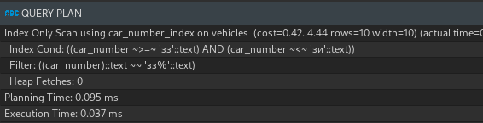

1. Частичный

Пример 1

**EXPLAIN** (**ANALYZE**)

**SELECT** **cost**, **name** **FROM** requests

**WHERE** **cost** = 2000;

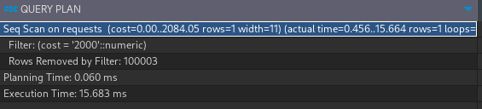

**CREATE** **INDEX** cost_index **ON** requests(**cost**) **WHERE** **cost** = 2000;

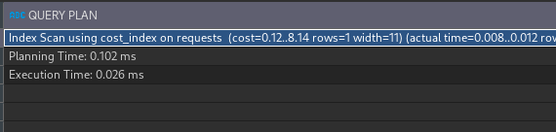

Пример 2

**EXPLAIN** (**ANALYZE**)

**SELECT** **cost**, **name** **FROM** requests

**WHERE** **cost** **BETWEEN** 3500 **AND** 3700;

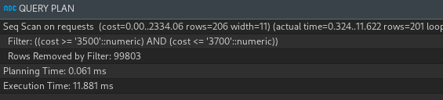

**CREATE** **INDEX** cost_index **ON** requests(**cost**) **WHERE** **cost** > 2000 **AND** **cost** < 4000;

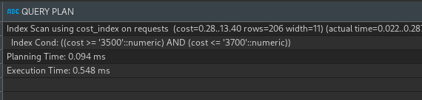

Пример 3

**EXPLAIN** (**ANALYZE**)

**SELECT** **cost**, **name** **FROM** requests

**WHERE** **cost** **BETWEEN** 6000 **AND** 7000;

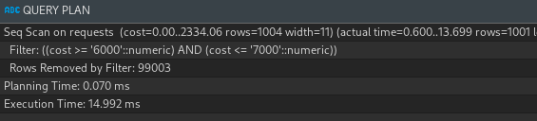

**CREATE** **INDEX** cost_index **ON** requests(**cost**) **WHERE** **cost** > 2000 **AND** **cost** < 4000;

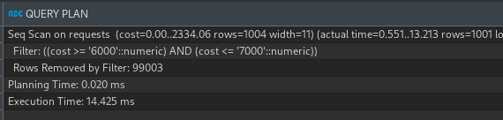

Пример 4

**EXPLAIN** (**ANALYZE**)

**SELECT** car_number, model

**FROM** vehicles

**WHERE** car_number **LIKE** 'зз%';

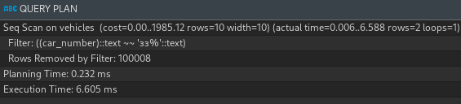

**CREATE** **INDEX** car_number_index **ON** vehicles(car_number varchar_pattern_ops) **WHERE** car_number **LIKE** 'зз%';

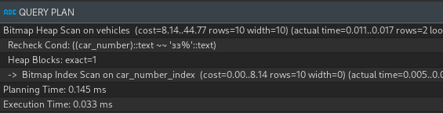

Пример 5

**EXPLAIN** (**ANALYZE**)

**SELECT** car_number, model

**FROM** vehicles

**WHERE** car_number **LIKE** 'eзeз%';

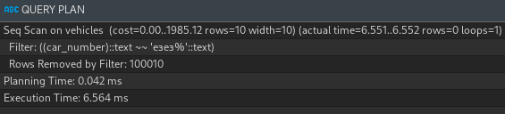

**CREATE** **INDEX** car_number_index **ON** vehicles(car_number varchar_pattern_ops) **WHERE** car_number **LIKE** 'зз%';

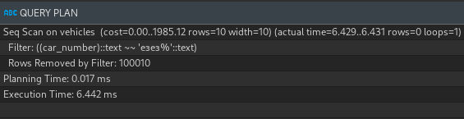

1. Запросы c использованием различных видов соединений
2. Простой

Пример 1

**EXPLAIN** (**ANALYZE**)

**SELECT** requests.**name**, requests.date_created, vehicles.car_number

**FROM** requests

**INNER** **JOIN** vehicles **ON** vehicles.id = requests.vehicle_id;

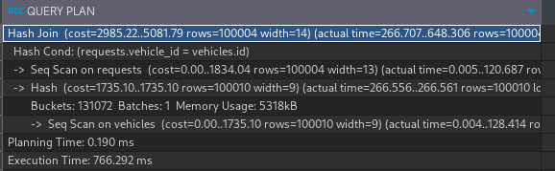

**CREATE** **INDEX** vehicles_id_index **ON** requests **USING** btree(vehicle_id);

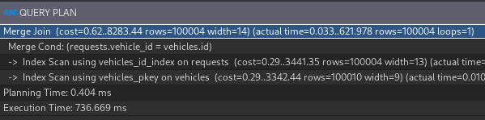

Пример 2

**EXPLAIN** (**ANALYZE**)

**SELECT** *

**FROM** vehicle_groups

**LEFT** **JOIN** vehicles **ON** vehicle_groups.group_name = vehicles.model;

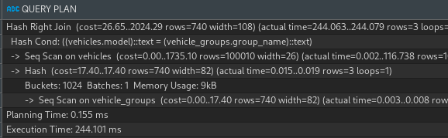

**CREATE** **INDEX** vehicle_car_index **ON** vehicles **USING** btree(model);

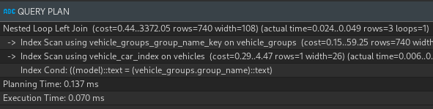

Пример 3

**EXPLAIN** (**ANALYZE**)

**SELECT** *

**FROM** vehicles

**RIGHT** **JOIN** vehicle_groups **ON** vehicle_groups.group_name = vehicles.model;

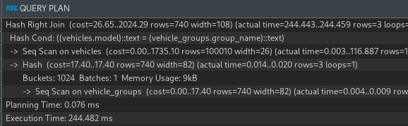

**CREATE** **INDEX** vehicle_car_index **ON** vehicles **USING** btree(model);

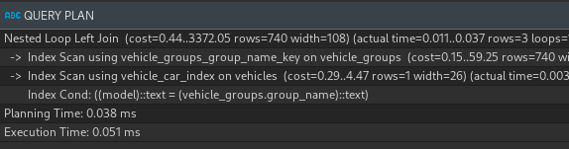

1. Составной

Пример 1

**EXPLAIN** (**ANALYZE**)

**SELECT** *

**FROM** vehicle_groups

**LEFT** **JOIN** vehicles **ON** vehicle_groups.group_name = vehicles.model

**AND** vehicle_groups.group_name = vehicles.car_number;

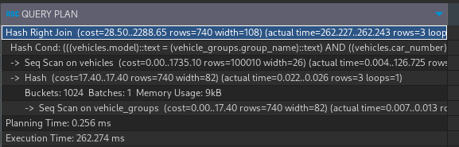

**CREATE** **INDEX** vehicle_car_index **ON** vehicles **USING** btree(model, car_number);

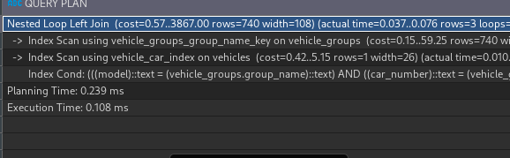

Пример 2

**EXPLAIN** (**ANALYZE**)

**SELECT** *

**FROM** vehicles

**RIGHT** **JOIN** vehicle_groups **ON** vehicle_groups.group_name = vehicles.model

**AND** vehicle_groups.group_name = vehicles.car_number;

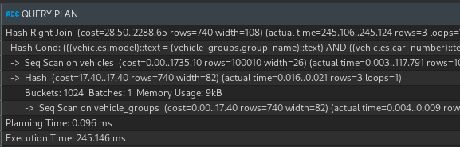

**CREATE** **INDEX** vehicle_car_index **ON** vehicles **USING** btree(model, car_number);

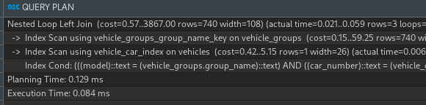

1. Уникальный

Пример 1

**EXPLAIN** (**ANALYZE**)

**SELECT** *

**FROM** vehicle_groups

**LEFT** **JOIN** vehicles **ON** vehicle_groups.group_name = vehicles.model;

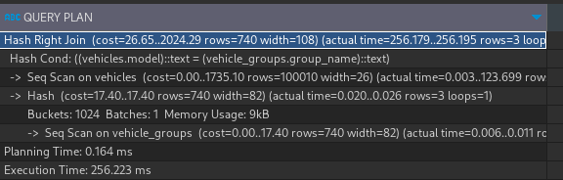

**CREATE** **UNIQUE** **INDEX** vehicle_car_index **ON** vehicles **USING** btree(model);

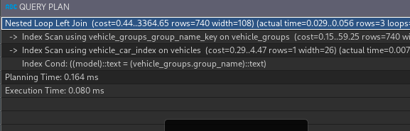

Пример 2

**EXPLAIN** (**ANALYZE**)

**SELECT** *

**FROM** vehicles

**RIGHT** **JOIN** vehicle_groups **ON** vehicle_groups.group_name = vehicles.model;

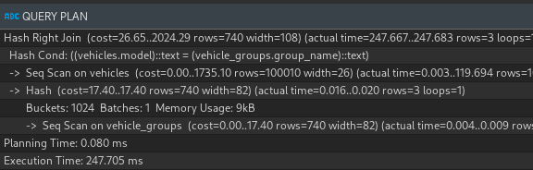

**CREATE** **UNIQUE** **INDEX** vehicle_car_index **ON** vehicles **USING** btree(model);

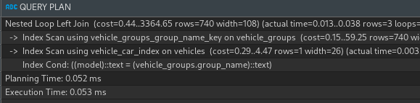

1. Покрывающий

Пример 1

**EXPLAIN** (**ANALYZE**)

**SELECT** car_number

**FROM** vehicle_groups

**LEFT** **JOIN** vehicles **ON** vehicle_groups.group_name = vehicles.model;

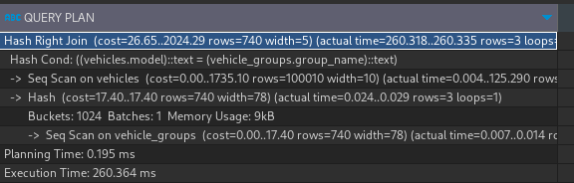

**CREATE** **INDEX** vehicle_car_index **ON** vehicles(model) **INCLUDE** (car_number);

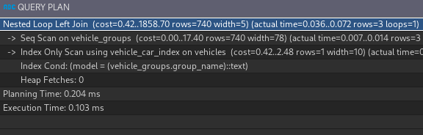

Пример 2

**EXPLAIN** (**ANALYZE**)

**SELECT** car_number

**FROM** vehicles

**RIGHT** **JOIN** vehicle_groups **ON** vehicle_groups.group_name = vehicles.model;

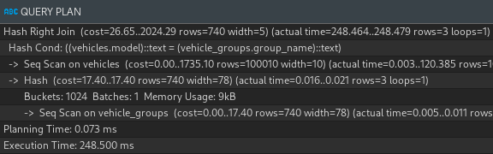

**CREATE** **INDEX** vehicle_car_index **ON** vehicles(model) **INCLUDE** (car_number);

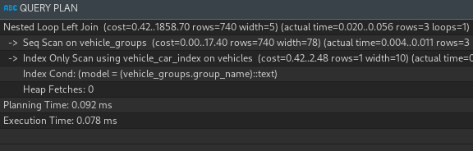

1. Частичный

Пример 1

**EXPLAIN** (**ANALYZE**)

**SELECT** car_number

**FROM** vehicle_groups

**LEFT** **JOIN** vehicles **ON** model **LIKE** 'Ла%' **AND** vehicle_groups.group_name = vehicles.model;

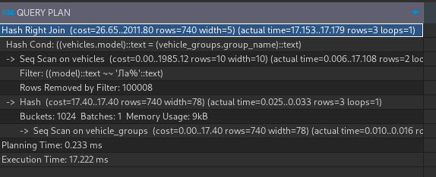

**CREATE** **INDEX** vehicle_car_index **ON** vehicles(model varchar_pattern_ops) **WHERE** model **LIKE** 'Ла%';

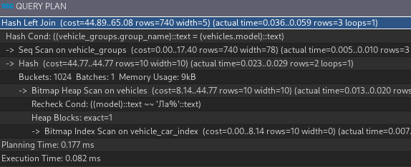

Пример 2

**EXPLAIN** (**ANALYZE**)

**SELECT** car_number

**FROM** vehicles

**RIGHT** **JOIN** vehicle_groups **ON** model **LIKE** 'Ла%' **AND** vehicle_groups.group_name = vehicles.model;

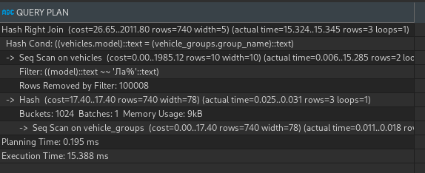

**CREATE** **INDEX** vehicle_car_index **ON** vehicles(model varchar_pattern_ops) **WHERE** model **LIKE** 'Ла%';

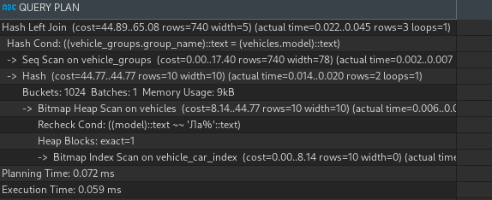

1. Запросы с использованием функций для работы со строками
2. Простой

**EXPLAIN** (**ANALYZE**)

**SELECT** id, **REPLACE** (**name**, 'Мешок картошки', 'Картоха') **AS** **name** **FROM** cargoes;

**EXPLAIN** (**ANALYZE**)

**SELECT** id, **substring** (**name**, 1, 3) **AS** **name** **FROM** cargoes;

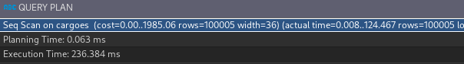

**CREATE** **INDEX** cargoes_name_index **ON** cargoes **USING** btree(**name**);



1. По выражению

Пример 1

**EXPLAIN** (**ANALYZE**)

**SELECT** * **FROM** cargoes **WHERE** **lower**(**name**) = 'мешок картошки';

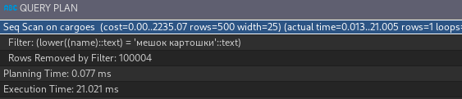

**CREATE** **INDEX** cargo_name_index **ON** cargoes (**lower**(**name**));

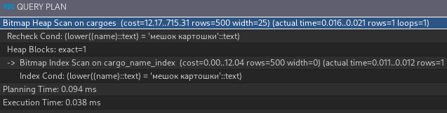

Пример 2

**EXPLAIN** (**ANALYZE**)

**SELECT** * **FROM** cargoes **WHERE** **overlay**(**name** **PLACING** '12 ' **FROM** 1 **FOR** 2) = '12 лки для дачи';

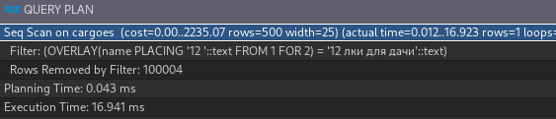

**CREATE** **INDEX** cargo_name_index **ON** cargoes (**overlay**(**name** **PLACING** '12 ' **FROM** 1 **FOR** 2));

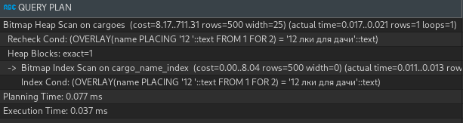

1. Запросы с использованием функций даты и времени

**CREATE** **INDEX** date_index **ON** requests **USING** btree(date_created);

**EXPLAIN** (**ANALYZE**)

**SELECT** id, **name**, date_created - **interval** '2 days' **AS** consideration_days, date_created **FROM** requests;

**DROP** **INDEX** date_index;

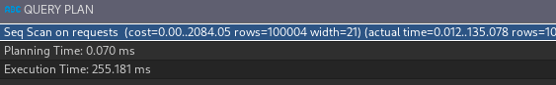

1. Запросы с использованием агрегатных функций, группировок ( GROUP BY ) и фильтрации групп ( HAVING )
2. Простой

Пример 1

**EXPLAIN** (**ANALYZE**)

**SELECT** requests.vehicle_id, **SUM** (requests.**cost**)

**FROM** requests

**GROUP** **BY** vehicle_id;

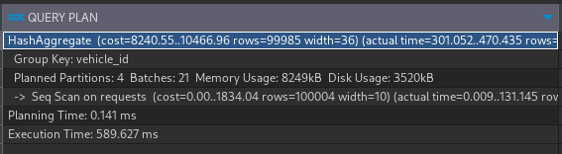

**CREATE** **INDEX** vehicle_id_index **ON** requests **USING** btree(vehicle_id);

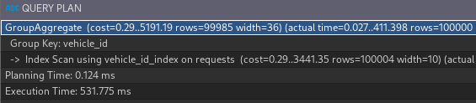

Пример 2

**EXPLAIN** (**ANALYZE**)

**SELECT** requests.vehicle_id, **SUM** (requests.**cost**)

**FROM** requests

**GROUP** **BY** vehicle_id

**HAVING** **SUM** (requests.**cost**) > 200;

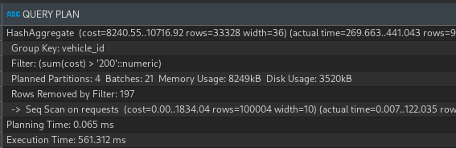

**CREATE** **INDEX** vehicle_id_index **ON** requests **USING** btree(vehicle_id);

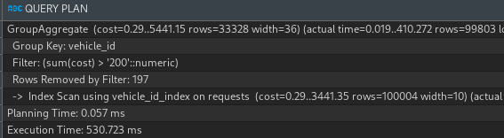

1. Составной

Пример 1

**EXPLAIN** (**ANALYZE**)

**SELECT** requests.vehicle_id, requests.**name**, **SUM** (requests.**cost**)

**FROM** requests

**GROUP** **BY** vehicle_id, requests.**name**;

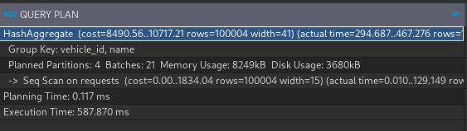

**CREATE** **INDEX** vehicle_id_name_index **ON** requests **USING** btree(vehicle_id, **name**);

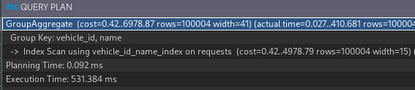

Пример 2

**EXPLAIN** (**ANALYZE**)

**SELECT** requests.vehicle_id, requests.**name**, **SUM** (requests.**cost**)

**FROM** requests

**GROUP** **BY** vehicle_id, requests.**name**

**HAVING** **SUM** (requests.**cost**) > 200;

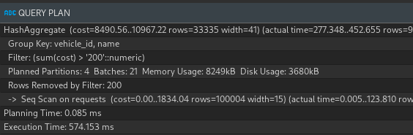

**CREATE** **INDEX** vehicle_id_name_index **ON** requests **USING** btree(vehicle_id, **name**);

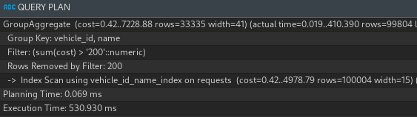

1. Уникальный

Пример 1

**EXPLAIN** (**ANALYZE**)

**SELECT** requests.**name**, **SUM** (requests.**cost**)

**FROM** requests

**GROUP** **BY** requests.**name**;

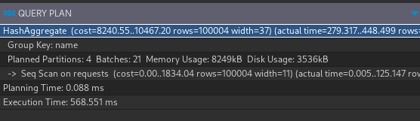

**CREATE** **UNIQUE** **INDEX** vehicle_name_index **ON** requests **USING** btree(**name**);

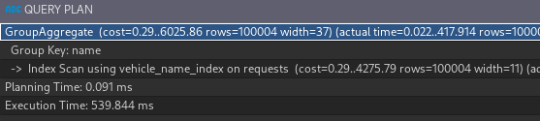

Пример 2

**EXPLAIN** (**ANALYZE**)

**SELECT** requests.**name**, **SUM** (requests.**cost**)

**FROM** requests

**GROUP** **BY** requests.**name**

**HAVING** **SUM** (requests.**cost**) > 200;

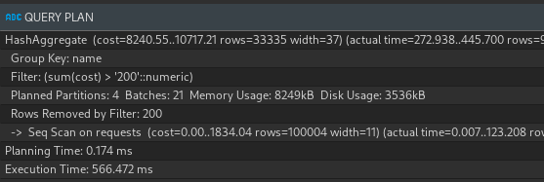

**CREATE** **UNIQUE** **INDEX** vehicle_name_index **ON** requests **USING** btree(**name**);

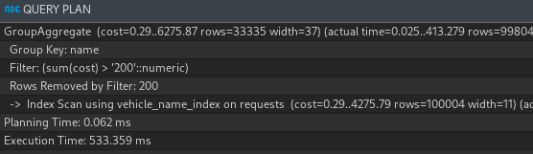

1. Покрывающий

Пример 1

**EXPLAIN** (**ANALYZE**)

**SELECT** requests.**name**, **SUM** (requests.**cost**)

**FROM** requests

**GROUP** **BY** requests.**name**;

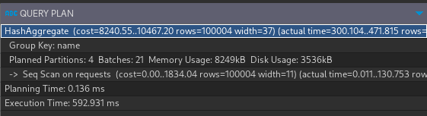

**CREATE** **INDEX** vehicle_car_index **ON** requests(**name**) **INCLUDE** (**cost**);

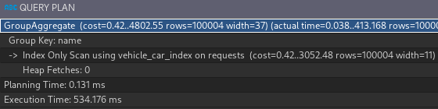

Пример 2

**EXPLAIN** (**ANALYZE**)

**SELECT** requests.**name**, **SUM** (requests.**cost**)

**FROM** requests

**GROUP** **BY** requests.**name**

**HAVING** **SUM** (requests.**cost**) > 200;

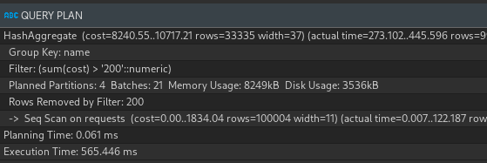

**CREATE** **INDEX** vehicle_car_index **ON** requests(**name**) **INCLUDE** (**cost**);

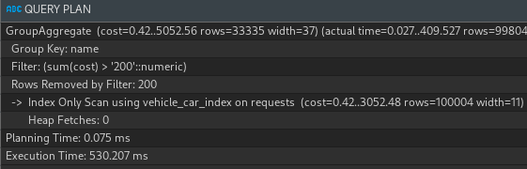

1. Частичный

Пример 1

**EXPLAIN** (**ANALYZE**)

**SELECT** requests.**name**, **SUM** (requests.**cost**)

**FROM** requests

**WHERE** **name** **LIKE** 'Пере%'

**GROUP** **BY** requests.**name**;

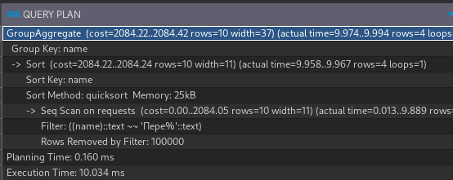

**CREATE** **INDEX** requests_index **ON** requests(**name** varchar_pattern_ops) **WHERE** **name** **LIKE** 'Пере%';

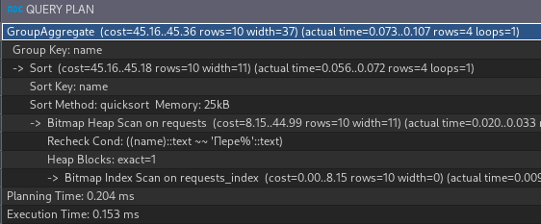

Пример 2

**EXPLAIN** (**ANALYZE**)

**SELECT** requests.**name**, **SUM** (requests.**cost**)

**FROM** requests

**WHERE** **name** **LIKE** 'Пере%'

**GROUP** **BY** requests.**name**

**HAVING** **SUM** (requests.**cost**) > 200;

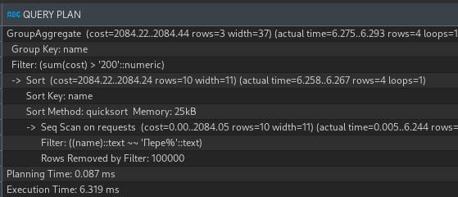

**CREATE** **INDEX** requests_index **ON** requests(**name** varchar_pattern_ops) **WHERE** **name** **LIKE** 'Пере%';

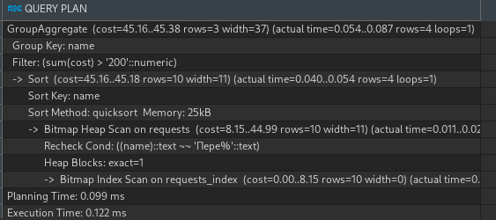

1. Вложенные запросы
2. Простой

Пример 1

**EXPLAIN** (**ANALYZE**)

**SELECT** *

**FROM** requests

**WHERE** requests.**cost** > **ALL** (

**SELECT** **avg**(**cost**) **FROM** requests

);

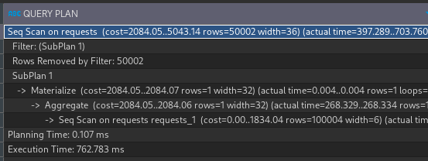

**CREATE** **INDEX** cost_index **ON** requests **USING** btree(**cost**);

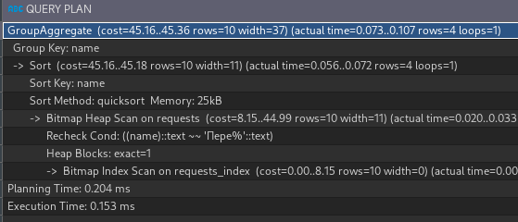

Пример 2

**EXPLAIN** (**ANALYZE**)

**SELECT** *

**FROM** requests

**WHERE** requests.**cost** > **ANY** (

**SELECT** **avg**(**cost**) **FROM** requests

);

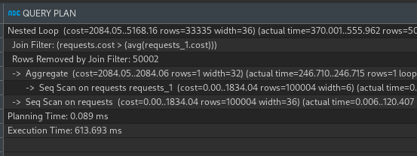

**CREATE** **INDEX** cost_index **ON** requests **USING** btree(**cost**);

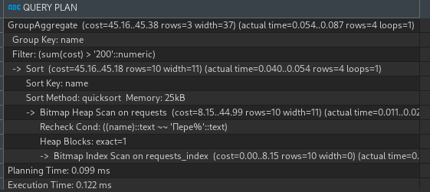

1. Составной

Пример 1

**EXPLAIN** (**ANALYZE**)

**SELECT** *

**FROM** requests

**WHERE** requests.**cost** > **ALL** (

**SELECT** **avg**(**cost**) **FROM** requests

) **AND** requests.**name** **LIKE** '1%';

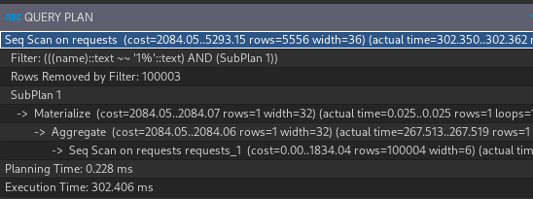

**CREATE** **INDEX** cost_index **ON** requests **USING** btree(**name** varchar_pattern_ops, **cost**);

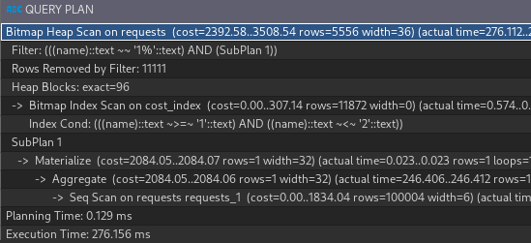

Пример 2

**EXPLAIN** (**ANALYZE**)

**SELECT** *

**FROM** requests

**WHERE** requests.**cost** > **ANY** (

**SELECT** **avg**(**cost**) **FROM** requests

) **AND** requests.**name** **LIKE** '1%';

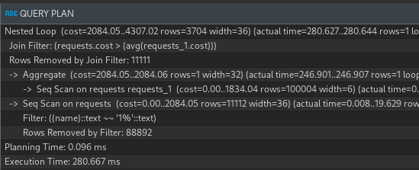

**CREATE** **INDEX** cost_index **ON** requests **USING** btree(**name** varchar_pattern_ops, **cost**);

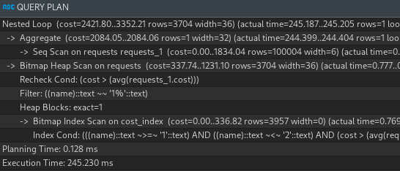

1. Уникальный

Пример 1

**EXPLAIN** (**ANALYZE**)

**SELECT** *

**FROM** requests

**WHERE** requests.**cost** > **ALL** (

**SELECT** **avg**(**cost**) **FROM** requests

);

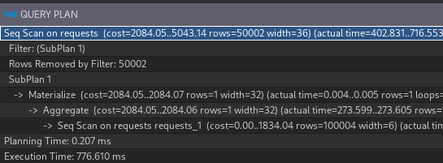

**CREATE** **UNIQUE** **INDEX** cost_index **ON** requests **USING** btree(**cost**);

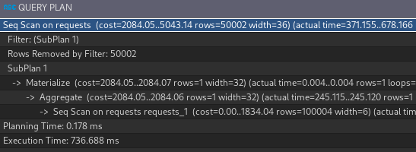

Пример 2

**EXPLAIN** (**ANALYZE**)

**SELECT** *

**FROM** requests

**WHERE** requests.**cost** > **ANY** (

**SELECT** **avg**(**cost**) **FROM** requests

);

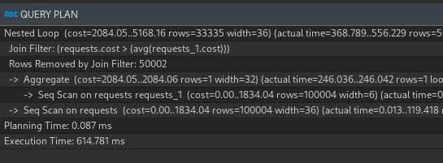

**CREATE** **UNIQUE** **INDEX** cost_index **ON** requests **USING** btree(**cost**);

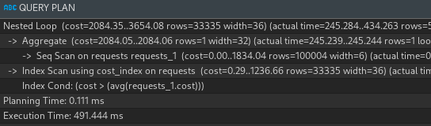

1. Покрывающий

Пример 1

**EXPLAIN** (**ANALYZE**)

**SELECT** requests.**name**

**FROM** requests

**WHERE** requests.**cost** > **ALL** (

**SELECT** **avg**(**cost**) **FROM** requests

);

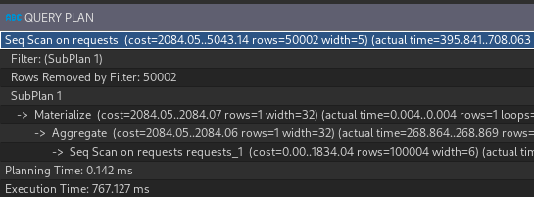

**CREATE** **INDEX** requests_cost_index **ON** requests(**cost**) **INCLUDE** (**name**);

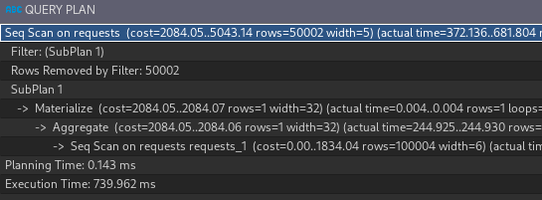

Пример 2

**EXPLAIN** (**ANALYZE**)

**SELECT** requests.**name**

**FROM** requests

**WHERE** requests.**cost** > **ANY** (

**SELECT** **avg**(**cost**) **FROM** requests

);

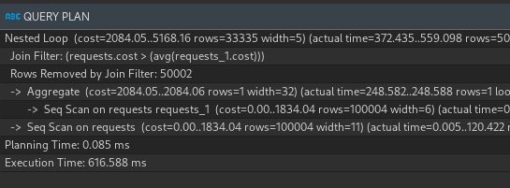

**CREATE** **INDEX** requests_cost_index **ON** requests(**cost**) **INCLUDE** (**name**);

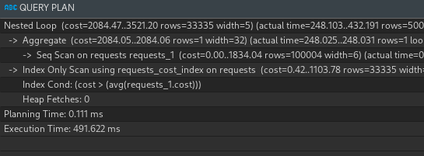

1. Частичный

Пример 1

**EXPLAIN** (**ANALYZE**)

**SELECT** requests.**name**

**FROM** requests

**WHERE** **cost** = 2000 **AND** requests.**cost** > **ALL** (

**SELECT** **avg**(**cost**) **FROM** requests

);

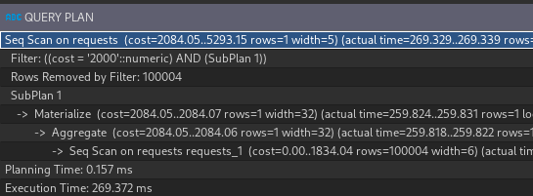

**CREATE** **INDEX** requests_cost_index **ON** requests(**cost**) **WHERE** **cost** = 2000;

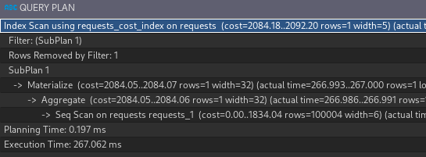

Пример 2

**EXPLAIN** (**ANALYZE**)

**SELECT** requests.**name**

**FROM** requests

**WHERE** **cost** = 2000 **AND** requests.**cost** > **ANY** (

**SELECT** **avg**(**cost**) **FROM** requests

);

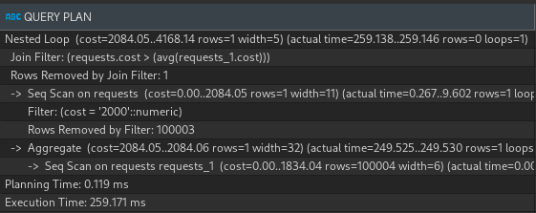

**CREATE** **INDEX** requests_cost_index **ON** requests(**cost**) **WHERE** **cost** = 2000;

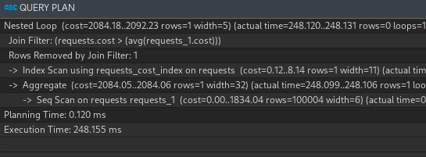

1. Запросы с использованием UNION и INTERSECT
2. Простой

Пример 1

**EXPLAIN** (**ANALYZE**)

**SELECT** weight **from** cargoes **WHERE** weight = 120.0

**UNION** **SELECT** **cost** **from** requests **WHERE** requests.**cost** = 10;

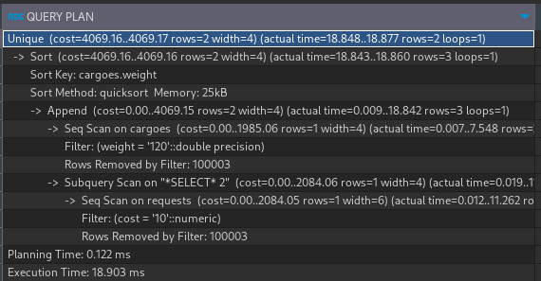

**CREATE** **INDEX** cargoes_weight_index **ON** cargoes **USING** btree(weight);

**CREATE** **INDEX** req_cost_index **ON** requests **USING** btree(**cost**);

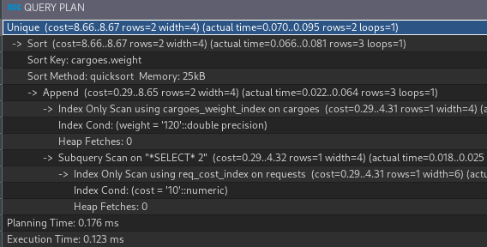

Пример 2

**EXPLAIN** (**ANALYZE**)

**SELECT** weight **from** cargoes **WHERE** weight = 120.0

**INTERSECT** **SELECT** **cost** **from** requests **WHERE** requests.**cost** = 10;

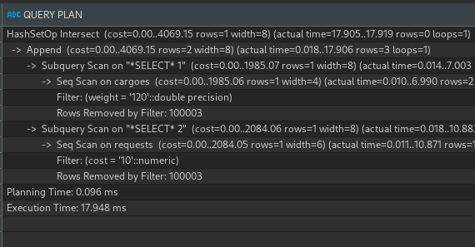

**CREATE** **INDEX** cargoes_weight_index **ON** cargoes **USING** btree(weight);

**CREATE** **INDEX** req_cost_index **ON** requests **USING** btree(**cost**);

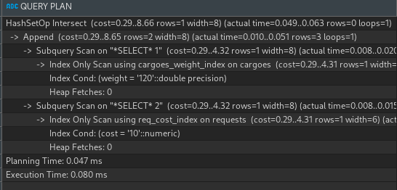

1. Составной

Пример 1

**EXPLAIN** (**ANALYZE**)

**SELECT** weight **from** cargoes **WHERE** weight = 120.0

**UNION** **SELECT** **cost** **from** requests **WHERE** requests.**cost** = 10 **AND** **name** **LIKE** '1%';

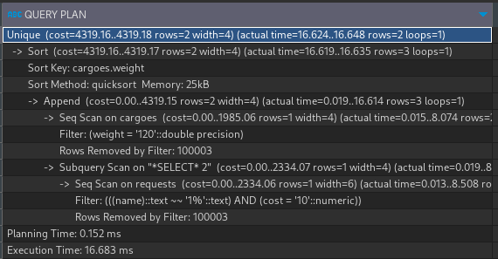

**CREATE** **INDEX** cargoes_weight_index **ON** cargoes **USING** btree(weight);

**CREATE** **INDEX** req_cost_name_index **ON** requests **USING** btree(**cost**, **name** varchar_pattern_ops);

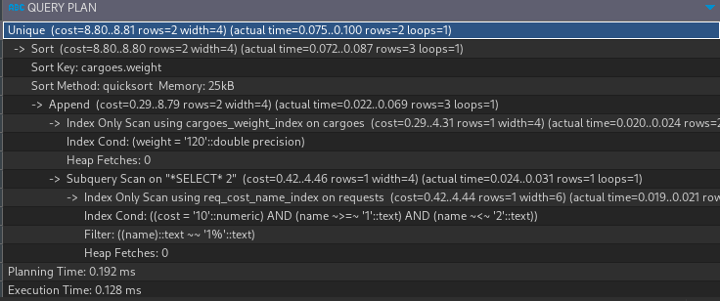

Пример 2

**EXPLAIN** (**ANALYZE**)

**SELECT** weight **from** cargoes **WHERE** weight = 120.0

**INTERSECT** **SELECT** **cost** **from** requests **WHERE** requests.**cost** = 10;

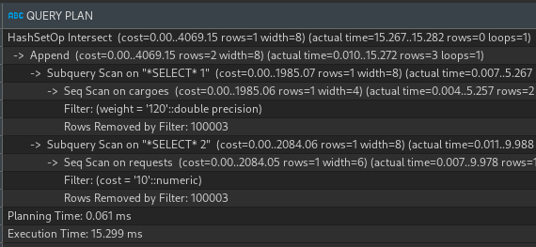

**CREATE** **INDEX** cargoes_weight_index **ON** cargoes **USING** btree(weight);

**CREATE** **INDEX** req_cost_name_index **ON** requests **USING** btree(**cost**, **name** varchar_pattern_ops);

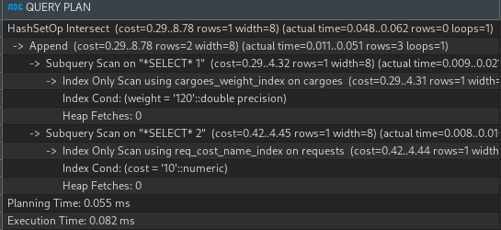

1. Уникальный

Пример 1

**EXPLAIN** (**ANALYZE**)

**SELECT** weight **from** cargoes **WHERE** weight = 120.0

**UNION** **SELECT** **cost** **from** requests **WHERE** requests.**cost** = 10;

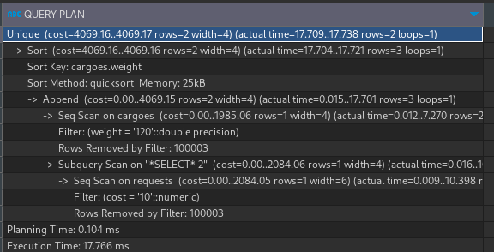

**CREATE** **INDEX** cargoes_weight_index **ON** cargoes **USING** btree(weight);

**CREATE** **UNIQUE** **INDEX** req_cost_index **ON** requests **USING** btree(**cost**);

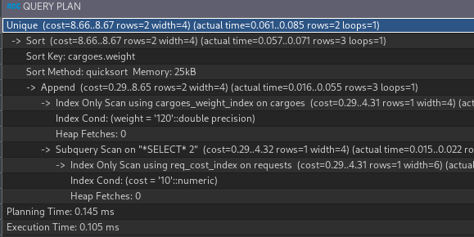

Пример 2

**EXPLAIN** (**ANALYZE**)

**SELECT** weight **from** cargoes **WHERE** weight = 120.0

**INTERSECT** **SELECT** **cost** **from** requests **WHERE** requests.**cost** = 10;

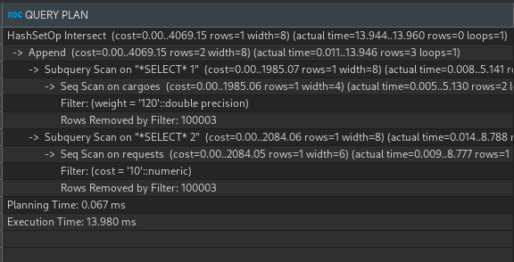

**CREATE** **INDEX** cargoes_weight_index **ON** cargoes **USING** btree(weight);

**CREATE** **UNIQUE** **INDEX** req_cost_index **ON** requests **USING** btree(**cost**);

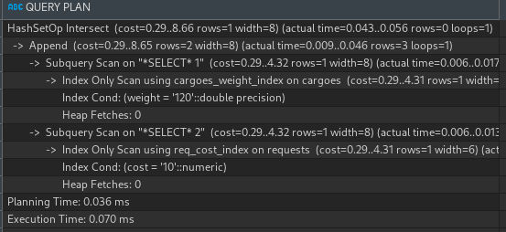

1. Покрывающий

Пример 1

**EXPLAIN** (**ANALYZE**)

**SELECT** weight **from** cargoes **WHERE** weight = 120.0

**UNION** **SELECT** **cost** **from** requests **WHERE** requests.**cost** = 10;

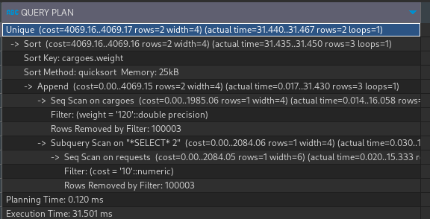

**CREATE** **INDEX** cargoes_weight_index **ON** cargoes(weight) **INCLUDE** (**name**);

**CREATE** **INDEX** req_cost_index **ON** requests(**cost**) **INCLUDE** (**name**);

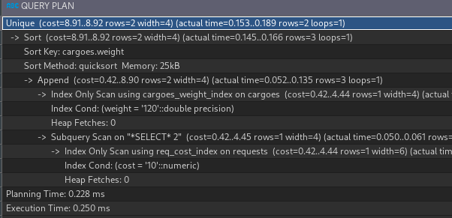

Пример 2

**EXPLAIN** (**ANALYZE**)

**SELECT** **name** **from** cargoes **WHERE** weight = 120.0

**INTERSECT** **SELECT** **name** **from** requests **WHERE** requests.**cost** = 10;

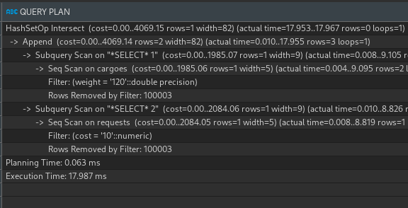

**CREATE** **INDEX** cargoes_weight_index **ON** cargoes(weight) **INCLUDE** (**name**);

**CREATE** **INDEX** req_cost_index **ON** requests(**cost**) **INCLUDE** (**name**);

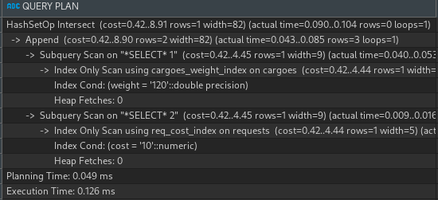

1. Частичный

Пример 1

**EXPLAIN** (**ANALYZE**)

**SELECT** weight **from** cargoes **WHERE** weight = 120

**UNION** **SELECT** **cost** **from** requests **WHERE** requests.**cost** = 10;

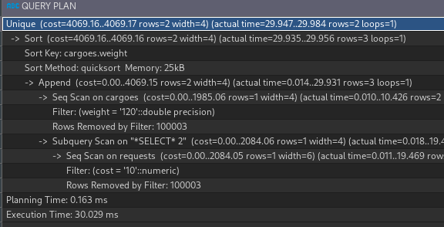

**CREATE** **INDEX** cargoes_weight_index **ON** cargoes(weight) **WHERE** weight < 2000;

**CREATE** **INDEX** req_cost_index **ON** requests(**cost**) **WHERE** **cost** < 2000;

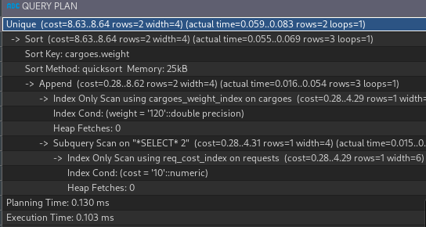

Пример 2

**EXPLAIN** (**ANALYZE**)

**SELECT** **name** **from** cargoes **WHERE** weight = 120

**INTERSECT** **SELECT** **name** **from** requests **WHERE** requests.**cost** = 10;

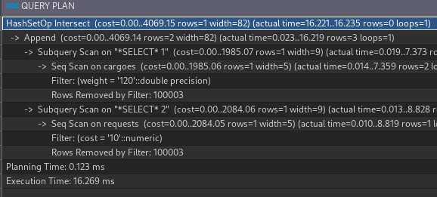

**CREATE** **INDEX** cargoes_weight_index **ON** cargoes(weight) **WHERE** weight < 2000;

**CREATE** **INDEX** req_cost_index **ON** requests(**cost**) **WHERE** **cost** < 2000;

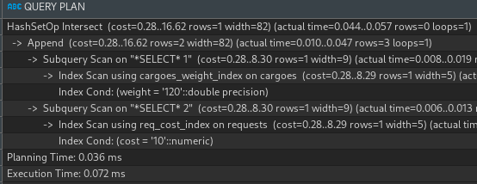

### Hash индекс

-- Хеш (hash): Индекс хеша используется для быстрого поиска по точному значению.

-- Он строит хеш-таблицу, где каждая запись имеет уникальный хеш-код, и поиск основан на хеш-значении.

-- Хеш-индекс подходит для точных поисковых запросов, но не поддерживает сортировку или диапазонные запросы.

**CREATE** **INDEX** weight_index **ON** cargoes **USING** hash(weight);

**EXPLAIN** (**ANALYZE**)

**SELECT** * **FROM** cargoes

**WHERE** weight = 10;

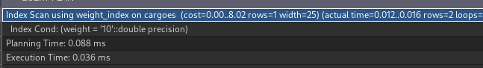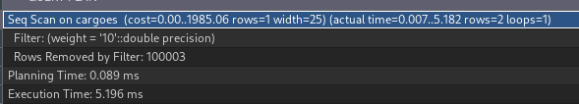

**EXPLAIN** (**ANALYZE**) -- не даёт преимущества

**SELECT** * **FROM** cargoes

**WHERE** weight **BETWEEN** 10 **AND** 100;

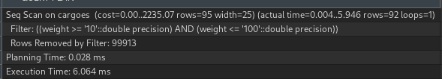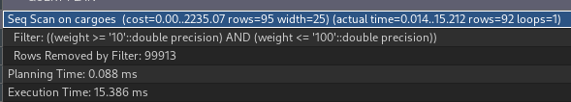

**DROP** **INDEX** weight_index;

**CREATE** **INDEX** name_index **ON** cargoes **USING** hash(**name**);

**EXPLAIN** (**ANALYZE**)

**SELECT** * **FROM** cargoes

**WHERE** **name** = 'Улей';

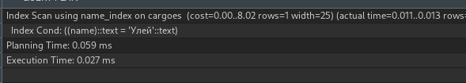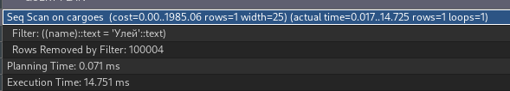

**EXPLAIN** (**ANALYZE**) -- не даёт преимущества

**SELECT** * **FROM** cargoes

**WHERE** **name** **LIKE** 'Ул%';

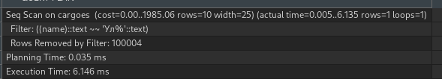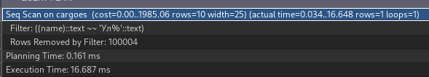

**DROP** **INDEX** name_index;

### Кластерный индекс

-- PostgreSQL не имеет прямой реализации индекса CLUSTER, как Microsoft SQL Server.

-- После создания первичного ключа таблицы или любого другого индекса вы можете

-- выполнить команду CLUSTER, указав имя этого индекса, чтобы добиться физического порядка данных таблицы.

-- Когда таблица кластеризована, ее порядок физически переупорядочивается на основе информации об индексе.

-- Кластеризация — это однократная операция: при последующем обновлении таблицы изменения не кластеризуются.

-- То есть не предпринимается никаких попыток сохранить новые или обновленные строки в соответствии с порядком их индекса.

**CREATE** **INDEX** car_num_index

**ON** vehicles (car_number varchar_pattern_ops);

**CLUSTER** vehicles **USING** car_num_index;

**EXPLAIN** (**ANALYZE**)

**SELECT** id, car_number, lifting_capacity, model

**FROM** vehicles

**WHERE** car_number **LIKE** 'зз%' **AND** lifting_capacity = 19;

**EXPLAIN** (**ANALYZE**)

**SELECT** car_number

**FROM** vehicle_groups

**LEFT** **JOIN** vehicles **ON** car_number **LIKE** 'зз%' **AND** vehicle_groups.group_name = vehicles.model;

**DROP** **INDEX** car_num_index;

