UPTIME GIZMO
Color Guidelines
Brand palette, semantic colors, accessibility and implementation tokens
Gizmo Gold | Deep Navy | Signal Blue
“Uptime is money, friend!”
Design reference
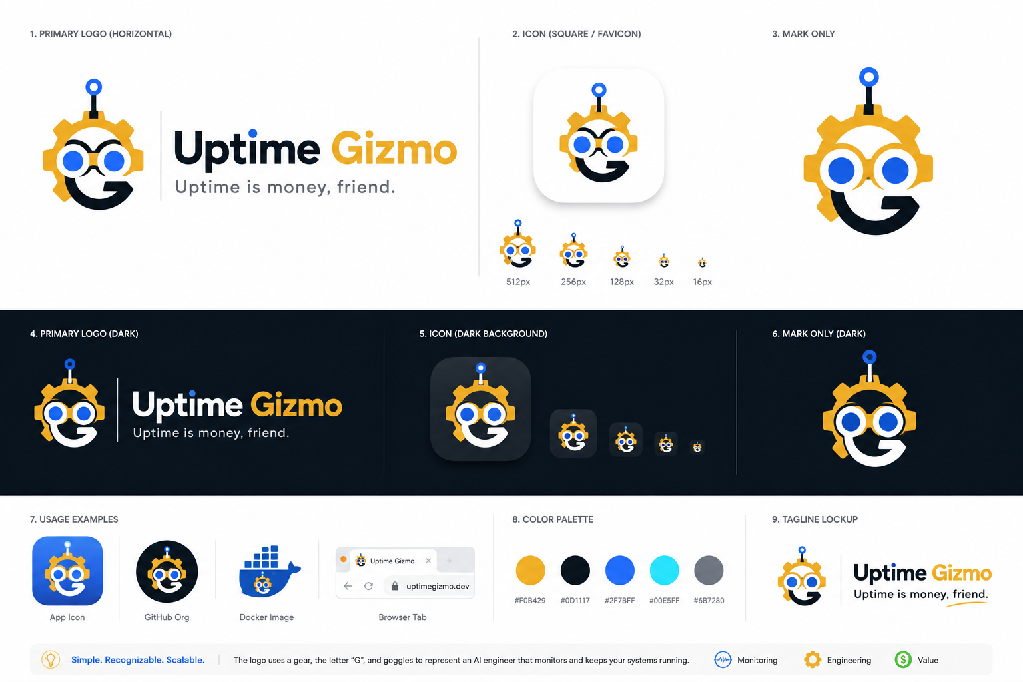

1. Core Brand Palette
The palette is derived from the current flat Uptime Gizmo identity. Gold carries the character and engineering personality, Navy anchors the developer/infrastructure aesthetic, and Blue represents monitoring intelligence and AI interaction.
Swatch | Token | HEX | RGB | Primary use
 | Gizmo Gold | #ECAB24 | 236, 171, 36 | Primary brand accent; gear, mascot highlights, key CTAs
 | Deep Navy | #0A151E | 10, 21, 30 | Primary dark neutral; wordmark, dark surfaces, high-contrast text
 | Signal Blue | #1E64E7 | 30, 100, 231 | AI/monitoring accent; goggles, links, active and informational UI
 | Cloud White | #FCFCFC | 252, 252, 252 | Primary light surface and page background
 | Utility Gray | #575D64 | 87, 93, 100 | Secondary text, subdued labels, disabled/supporting UI
 | Soft Gray | #A2A4A7 | 162, 164, 167 | Borders, dividers, tertiary metadata; use sparingly
Recommended visual balance
For product UI and marketing surfaces, keep the identity calm and infrastructure-focused. A good default is 60% Navy/White surfaces, 25% Gold brand elements, 10% Signal Blue interaction/AI accents, and no more than 5% high-energy supporting color.

2. Usage Rules
Gold = brand, not status
Use Gizmo Gold for the logo, mascot details, branded highlights and selected primary CTAs. Avoid using Gold as the default “warning” state; monitoring status colors need to remain semantically unambiguous.
Blue = intelligence and interaction
Use Signal Blue for AI actions, selected controls, links, live/interactive states and information. It should feel technical rather than decorative.
Navy = foundation
Deep Navy is the preferred dark background and strong text color. It gives Uptime Gizmo a developer-tool character without relying on pure black.
Keep surfaces restrained
Use Cloud White and neutral grays for most layout surfaces. The mascot can be expressive; the interface and logo should remain simple.

3. Monitoring Status Colors
Status colors are functional tokens rather than brand colors. They should remain conventional so users can understand service health immediately.
 | Status | HEX | Use
 | Operational | #22C55E | Healthy / online / passed
 | Degraded | #F59E0B | Warning / degraded performance
 | Incident | #EF4444 | Down / failed / incident
 | Maintenance | #8B5CF6 | Scheduled maintenance / paused
 | Unknown | #6B7280 | Unknown / no data / disabled

4. Light and Dark Mode
Light mode  Primary text · Secondary text  Signal / AI interaction  Gizmo Gold | Dark mode  Primary text · Secondary text  Signal / AI interaction  Gizmo Gold
Contrast guidance
- Use Deep Navy on Cloud White for primary body text and navigation.
- Use Cloud White on Deep Navy for dark-mode text.
- Do not use Gizmo Gold for small body text on white; reserve it for larger labels, icons, badges and filled elements.
- Do not communicate monitoring state with color alone. Pair color with text, icons, or shape/status labels.

5. Design Tokens
Recommended baseline tokens for web implementation:
--gizmo-gold: #ECAB24;
--gizmo-navy: #0A151E;
--gizmo-blue: #1E64E7;
--gizmo-white: #FCFCFC;
--gizmo-gray-600: #575D64;
--gizmo-gray-400: #A2A4A7;
--status-up: #22C55E;
--status-degraded: #F59E0B;
--status-down: #EF4444;
--status-maintenance: #8B5CF6;
--status-unknown: #6B7280;

6. Quick Brand Checklist
- Use Gold + Navy as the dominant brand pairing.
- Use Signal Blue to communicate AI, monitoring intelligence and interaction.
- Keep the logo flat and readable at favicon size; avoid heavy glow and realistic lighting in the core mark.
- Keep semantic status colors separate from the primary brand palette.
- Maintain the same token values across README assets, website, dashboard and social graphics.
- Prefer the flat mascot/logo treatment for product UI; reserve the 3D Gizmo character for hero artwork and campaigns.
Uptime Gizmo · Color Guidelines · v0.1

