
JMJ MARIST BROTHERS
NOTRE DAME OF DADIANGAS UNIVERSTITY
MARIST AVENUE, GENERAL SANTOS CITY

“A Web-Based Institutional Repository System for Archiving and Accessing Academic Outputs in CEAT – NDDU”

By
Justin Dhyll B. Mansueto
Timm Kennedy B. Sta.Rita
Marc Ethan P. Lumagod

CHAPTER I
INTRODUCTION

The Problem and its Setting
Limited shelves and overcrowding with hardbound copies and manuscripts are current prevailing issues when it comes to physical repositories. They often delay retrievals and are prone to document damages (Kamalia & Putra, 2025). These factors often lead to page tearing, crushing and inefficient indexing due to the disordered and cramped environment. According to Lucchi et al (2023), high humidity affects the papers’ fibers by weakening their bindings, causing the inks on the pages to bleed, thus making each paper stick to each other. They have also found fluctuating temperatures to cause molds and discoloration to the paper which affects readability.

Additionally, a study by Henriques & Domingos (2022), conducted in Angola, surveyed 23 education institutions and revealed that only 26% had their own Institutional Repository, with another 4% participating in a shared repository. The remaining 74% reported not having any Institutional Repository at all, which highlights a significant gap in adopting IRs. This highlights the occurring issue in many Global South countries, Institutional Repositories are underutilized despite their value in increasing research visibility, and digital preservation.

Adam and Kaur (2021) examined Institutional Repository (IR) usage in African universities through OpenDOAR. Their research highlighted countries such as South Africa, Nigeria, Kenya, and Egypt demonstrated high repository performance in terms of access, usability, and content curation. The study found that IRs highly contribute to global academic visibility while fostering regional knowledge equity. Though some countries are behind in implementation due to lack of funds and policy gaps, the overall trend suggests that IRs are highly viewed as important to digital knowledge preservation.

The same issue is also present in the Philippines, as they have found that some hardbound thesis, manuscripts, and optical-disc copies were difficult to track and had delayed retrievals, while some copies were not returned at all. Universities that have not yet taken action to transfer their record management system from a paper based, cabinet system (Perante & Barnaba 2024).
The shift toward digital academic repositories is steadily gaining momentum. Schools like UP and ADMU have implemented institutional repository systems that archive student thesis and other manuscripts in digital form. But despite all this, many institutions still rely on physical repositories, which are prone to misplacement, damage, and delayed retrieval. CHED has initiated partnerships to promote digitalization across higher education services, including academic records and student documentation (GMA News, 2023).

Moreover, an intensive 3-day training workshop was conducted in Henry Luce III
Library, Central Philippine University (2021), training librarians and IT staff to implement their IR using DSpace, an open-source institutional repository system that allows preservation of digital content. Topics included meta management, system policies, and digitization (OCR), signaling institutional commitment toward sustainable digital archiving.

Locally, academic manuscripts are mainly stored in physical repositories, such as filing cabinets, or library shelves, which often struggle from limited capacity, misplacement, and lack of proper environmental control. With these prevailing issues, retrieval and access to these academic works are slow and inefficient, particularly for students, professors and faculty seeking references for ongoing research or project development. While this initiative is grounded within a single college, it addresses challenges that reflect broader issues across many higher education institutions in the Philippines, especially those with limited access to digital transformation.

Literature Review

Institutional Repository

A study from Susilowati et al. (2021) claims that they have developed a web based archival system for a local village government in Indonesia using interviews, observation and user acceptance tests. The system supported file uploads of multiple types, database structure implementation, and interface layout design. Subiyakto et al (2021) also found that interface usability impacts repository adoption and recommend testing with real users. Their findings emphasized the importance of intuitive design, accessibility and user-centered development, especially for institutions with limited technical literacy among users.

Demetres et al. (2020) emphasized that modern repositories must accommodate a variety of academic outputs, such as videos and artworks. It is essential to have a repository to preserve diverse academic materials. Okon et al (2020) designed a web-based repository obliging images and multimedia for scholarly content. Additionally, Imoro and Saurombe (2024) found that Ghanaian universities host varied content like videos, and presentations to enhance repository value while González‑Pérez et al. (2021) highlighted user demand for repositories that support non-text objects.

Role Based Access Control

González‑Pérez et al. (2021) conducted a study on IRs and found significant gaps in system design, especially role clarity and interface design. One of the study’s core recommendations was the implementation of strict Role-based access controls (RBAC) to enhance workflow transparency and reduce confusion. They emphasized the need to distinguish user responsibilities, such as content submission, metadata curation, approval, and system administration so that users (students, faculty, and admins) clearly understand their scope of action.

A research by Kumar et al (2022) highlights how RBAC enhances data security by restricting access based on predefined user roles (students, faculty, librarians), thereby preventing unauthorized modifications and ensuring compliance with institutional policies. Similarly, Lee et al. (2023) further explains RBAC’s effectiveness in improving workflow efficiency, showing how role-based permissions clarify processes like thesis submissions, reviews, and metadata management. Moreover, Smith & Johnson (2021) shows that RBAC supports digital preservation in university repositories by controlling permissions for uploading, editing, and deleting content, which is important for maintaining access to scholarly materials.

Additionally, Martinez & Brown (2020) explains RBAC’s importance in ensuring compliance with data privacy regulations (GDPR, FERPA), as it restricts access to sensitive research data and student records. Similarly, a study from Zhang et al. (2021) reveals that over 70% of universities adopt RBAC in their repositories, citing its benefits in security, access management, and regulatory adherence.

Intellectual Property

The integration of Institutional Repositories in higher education brings a critical discussion on Intellectual Property (IP) rights, especially concerning student owned works such as thesis and capstones. Cullen and Chawner (2021) examined the complexities surrounding institutional repositories and copyright ownership. In their study, they explained the importance of setting consent and licensing frameworks, such as CC (Creative Commons), to protect both the institution’s right to archive works and the student’s right to be recognized as authors. This is because works are made publicly online through open access archiving.

de Beer, Oguamanam, and Rizk (2021) build up on this by highlighting the issues faced
by academic institutions in the Global South. Their study revealed that restrictive Intellectual Property laws and lack of awareness often hinder research dissemination. They suggested that institutions adopt open licensing practices to promote fair sharing while securing the author’s rights. Similarly, a 2022 joint report by the Creative Commons and SPARC emphasized how students can retain full ownership of their academic work while granting non-exclusive licenses to universities for publishing their work digitally.

However, Troll Covey (2020) found that students often misunderstand their Intellectual Property rights, especially when submitting work to Institutional Repositories. The study suggested that universities should actively teach students about copyright, authorship, and reuse policies, especially in the context of digital storage. The Intellectual Property Office of the
Philippines (IPOPHL, 2023) responded to these concerns by issuing an Intellectual Property Policy Guidebook for Higher Education Institutions, which mandates schools to adopt formal IP policies that address student works.

Synthesis of the Reviewed Literature

The reviewed studies collectively underscore the importance of institutional repositories in promoting open access to diverse academic materials, as well as the need for usability and accessibility in system design. Researchers consistently emphasize that repositories must not only accommodate multiple media types but also ensure secure and well-structured access through role-based permissions. Furthermore, the literature highlights the growing concern for Intellectual Property management to safeguard authors’ rights and institutional responsibilities.
However, despite the extensive research on repository usability, RBAC frameworks, and intellectual property policies, few studies integrate all three dimensions into a single system—particularly within the context of Philippine higher education institutions. There remains a gap in developing a comprehensive academic repository system that combines user-centered design, RBAC for secure data handling, and built-in IP compliance mechanisms tailored to local institutional needs. This study seeks to address that gap by designing and evaluating a web-based academic repository system for CEAT that integrates these critical components.

Conceptual Framework
The study adopts the Input–Process–Output (IPO) model to illustrate the flow of activities in developing the CEAT Digital Repository System for Academic Outputs. The input phase involves the key functions of the system, including the submission and borrowing of materials, the approval of submitted works, and the publishing of approved materials. These serve as the foundation of the repository’s workflow.
The process phase covers the activities carried out during system development, which include the use of the Agile Methodology, User Acceptance Testing (UAT), and interviews with target users to ensure that the system meets the needs of its intended users. The output phase results in a web-based digital repository system that provides a structured, accessible, and secure platform for storing and managing academic outputs within the College of Engineering, Architecture, and Technology (CEAT).

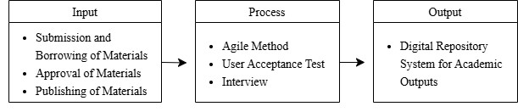

Figure 1. Conceptual Framework

Statement of the Problem
This study aims to develop and implement a web-based institutional repository system for the College of Engineering, Architecture, and Technology (CEAT) at Notre Dame of Dadiangas University (NDDU). The system is designed to improve the collection, organization, preservation, and access of academic document outputs such as theses, capstone projects, and research papers produced by CEAT students and faculty.
The proposed system addresses the limitations of traditional paper-based archiving practices such as manual cataloging, physical storage constraints, and restricted accessibility by introducing a centralized digital platform that enables secure, role-based submission, review, and publication of academic works within CEAT.
Specifically, the research project will aim to answer the following questions:
- What are the current practices and policies used in CEAT for collecting, storing, and accessing student academic outputs?

- What system features and access control mechanisms will be necessary for a webbased institutional repository tailored to CEAT?

- What compliance measures and intellectual property considerations must be incorporated into the repository to ensure data security, authorship integrity, and regulatory adherence?

- How will the proposed CEAT Repository System be evaluated by its users in terms of:
  - System Design and Architecture
  - Functionality and Features
  - Usability and User Experience
  - Overall Acceptability within the CEAT academic community

Scope and Delimitation

This study focuses on the design and development of a Web-Based Institutional
Repository System for the College of Engineering, Architecture, and Technology (CEAT) at Notre Dame of Dadiangas University (NDDU). The system serves as a digital platform for storing, organizing, and accessing academic outputs such as theses, capstone projects, research papers, and other scholarly works of CEAT students and faculty.
The system allows authorized users to upload, manage, publishing, and borrowing of digital documents through a secure, browser-based interface. It includes key features such as user authentication, metadata tagging, search and filter tools, file uploads, librarian approval, and borrowing management. All files are stored locally on the CEAT campus server, ensuring data security and fast access within the university’s internal network.
The scope of this study is limited only to CEAT and does not include other colleges within NDDU or external institutions. The system focuses on academic archiving and access and does not cover features such as student grading, plagiarism detection, or peer review. This repository is developed to support digital preservation, easy access, and organized management of CEAT’s academic documents within the college.
The study assumes consistent network connectivity, user cooperation during data gathering and testing, and the availability of accurate academic records from the CEAT department. It is also limited by the scope of technologies used (local server hosting and web-based deployment) and the time constraints of the academic calendar. Future enhancements may include system integration with other NDDU colleges, cloud-based storage, or advanced plagiarism and analytics features.

Significance of the Study

The result of the study will give advantage to the following:
To the Institution. The system will enhance the college’s capacity to preserve, manage, and showcase student outputs. It will support institutional efforts in documentation for accreditation, improve internal archiving practices, and align with NDDU’s long-term goals for digital innovation, academic excellence, and sustainability. It will also help address specific archiving limitations caused by CEAT’s geographical distance from the main campus.
To the IT Staff and System Administrators. This project empowers the university’s technical personnel by offering hands-on experience in the development, deployment, and maintenance of a live academic repository system. It promotes internal capacity building and enables future scalability to other colleges within the university.
To the Faculty Members. Teachers and research advisers will benefit from easy access to previous student outputs, aiding them in providing more informed guidance and improving the quality of student research. It also streamlines evaluation processes and reduces reliance on printed or manually filed archives.
To the Researchers and Evaluators. The repository serves as a rich reference base for current and future research. Evaluators, panelists, and academic committees can retrieve required materials efficiently for review, helping to maintain academic integrity and continuity in research themes.
To the Students. Students will have access to a searchable archive of previous theses, capstone projects, and creative works. This will help them gain insights, avoid redundancy, and improve the quality of their outputs. It also eliminates the inconvenience of submitting multiple physical copies and promotes digital literacy.
To the Future Researchers. This study provides a foundation for future research on academic repositories, digital preservation systems, or institutional database design. It opens opportunities for future enhancements such as plagiarism detection, AI-based document sorting, or full-scale university-wide implementation. Future capstone developers and scholars can build upon this work to improve academic systems further.

CHAPTER II
METHODOLOGY
This chapter will discuss the research method and procedure that will be used in conducting the study. It includes research design, selection of respondents, the method for collecting data, the research instrument, and the ethical consideration of the study

Research Design
This study uses a quantitative research design to evaluate the functionality, performance, and user satisfaction of the developed web-based institutional repository system for the College of Engineering, Architecture, and Technology (CEAT) at Notre Dame of Dadiangas University. The quantitative approach is chosen because it provides measurable and objective data that can be analyzed statistically to determine the system’s effectiveness.
Data are gathered from librarians, faculty members, and students through structured survey questionnaires. The collected responses are analyzed using statistical tools such as the mean and standard deviation to determine the overall level of satisfaction and system performance based on user feedback.
According to Creswell (2014), quantitative research emphasizes numerical measurement and statistical analysis to identify patterns and draw objective conclusions. Following this principle, the study ensures that findings are evidence-based, measurable, and verifiable, providing a clear assessment of how well the repository system meets user expectations and institutional requirements.
System Development Process
The development of the Digital Repository System for Academic Outputs followed a structured and iterative development process aligned with the Agile methodology. This approach allowed the researchers to continuously refine system functionalities based on user feedback and evaluation results from each cycle.
The process began with requirements gathering, where the team conducted interviews and observations with CEAT personnel to identify system needs such as material submission, approval workflow, publishing access levels, and the need to store academic outputs securely in a database. After gathering requirements, the team proceeded to the system design phase, creating diagrams including the IPO diagram, data flow diagrams, database schema, and wireframes to visualize system functionality and layout. Once the design was approved, the coding and development phase started. During this phase, modules were developed incrementally—starting from login and role-based access control, proceeding to submission and approval of materials, and lastly publishing and borrowing functions.

Each iteration ended with the testing phase, where functions underwent User Acceptance Testing (UAT). Feedback gathered from respondents—librarians, faculty, and student users—was analyzed and served as the basis for enhancement. Issues such as interface layout adjustments, approval notification improvements, and upload validation were addressed immediately before proceeding to the next iteration. This cycle continued until the system reached stability and met all functional requirements.
Throughout the development, various tools and technologies were utilized to ensure efficiency. Visual Studio Code served as the primary code editor, while PHP, JavaScript, HTML, and CSS (Bootstrap framework) were used for system development. The system was hosted using XAMPP with Apache Server, and MySQL served as the database management system to store academic materials and user data. Version control and backup were handled using GitHub during the development phase.

Selection of Respondents
The study uses purposive sampling to select respondents who are directly involved in the development, use, and management of the CEAT Institutional Repository System. This sampling method is chosen because it allows the researchers to focus on individuals who have relevant experience and knowledge about the system’s functions and implementation.
A total of 38 respondents participates in the study. These include 30 students, 4 faculty members, 2 IT personnel, and 1 librarian from the College of Engineering, Architecture, and Technology (CEAT) of Notre Dame of Dadiangas University.
The students are selected because they serve as the primary users of the system, responsible for uploading and accessing academic materials. The faculty members act as research advisers and evaluators, providing feedback on the system’s usefulness for academic supervision. The IT personnel assist in evaluating the technical performance and system stability, while the librarian assesses the organization and management of uploaded research materials.
All respondents are from the Glamang Campus of NDDU, where the system is designed and implemented. The study focuses solely on CEAT to ensure that the evaluation reflects the needs and experiences of its intended users.

Locale of the Study
The study will be conducted at Notre Dame of Dadiangas University – Glamang Campus, located in Polomolok, South Cotabato, Philippines. This campus serves as the academic base for the College of Engineering, Architecture, and Technology (CEAT).
The research will focus exclusively on this college, as it operates independently from the university’s main campus, which may influence access to and management of academic records. By concentrating on CEAT, the study aims to address localized challenges in academic archiving and propose a system tailored to its unique operational and instructional needs.
This study will not cover other colleges within NDDU such as the College of Education, Arts and Sciences (CEAS), College of Health Sciences (CHS), or the Business College (BC), nor will it include institutions outside NDDU.

Research Instrument
This study uses a structured questionnaire as the main research instrument to collect quantitative data from respondents. The questionnaire is designed to measure user perceptions of the usability, accessibility, functionality, and overall effectiveness of the web-based institutional repository system for the College of Engineering, Architecture, and Technology (CEAT) at Notre Dame of Dadiangas University.
The instrument consists of 15 to 20 items using a 5-point Likert scale, with responses ranging from “Strongly Disagree” (1) to “Strongly Agree” (5). The items are grouped according to thematic categories that correspond to the study’s objectives, such as system features, ease of use, accessibility, and user satisfaction.
The questionnaire items are developed based on existing literature and validated survey instruments used in related studies on academic repository and information systems. To ensure validity, the instrument is reviewed by faculty experts in information systems and educational research. A pilot test is conducted among a small sample of CEAT students to evaluate the clarity, reliability, and structure of the questionnaire. Feedback from the pilot test is used to revise the final version before it is administered digitally through Google Forms.

Data Gathering Procedure
The study uses a quantitative approach in collecting data to evaluate the effectiveness of the CEAT Institutional Repository System. A structured questionnaire is the primary instrument used to gather numerical data from respondents, including students, faculty members, librarians, and IT personnel from the College of Engineering, Architecture, and Technology (CEAT).
Before data collection, the researchers secure permission from the college and obtain the consent of all participants. The validated questionnaire is distributed digitally through Google Forms to ensure accessibility and efficiency in data collection. Respondents are instructed to answer all items honestly based on their actual experience in using the system.
After the questionnaires are completed, all responses are collected and organized for statistical analysis. The data are encoded and processed using appropriate statistical tools to determine the level of user satisfaction, functionality, and overall performance of the system.

Software Process Model
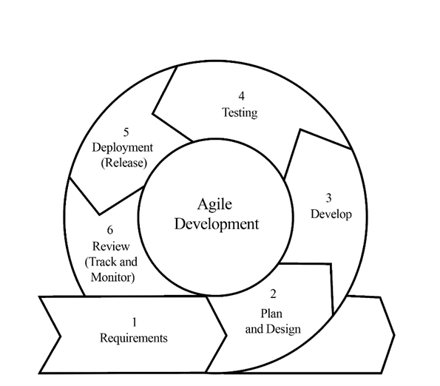
Figure 2. Agile Methodology
The development of the Web-Based Institutional Repository System for the College of
Engineering, Architecture, and Technology (CEAT) at Notre Dame of Dadiangas University (NDDU) will adopt the Agile Development Model. This model supports a flexible and adaptive approach, allowing continuous improvement and collaboration with stakeholders throughout the development cycle.

The phases in the Agile Development Cycle include:

1. Requirements
The process begins with gathering and defining the system requirements. Input is collected from CEAT faculty members, IT personnel, librarians, and student researchers to identify essential system features such as file upload, search functionality, metadata tagging, and user access control. These requirements form the initial product backlog that guides subsequent development activities.

2. Plan and Design
After defining the requirements, the development team creates a sprint plan and designs the system architecture. User stories are divided into smaller, manageable tasks, and a sprint roadmap is established. Wireframes, data flow diagrams, and the entity-relationship diagram (ERD) are developed to visualize the workflow and guide implementation.

3. Develop
The system is developed in small, incremental sprints, each lasting about two to five days. Developers implement and integrate features gradually, ensuring that each module functions correctly before proceeding to the next. Continuous integration practices are applied to maintain system stability and prevent regression.

4. Testing
Testing is conducted throughout the development cycle. Each completed module undergoes unit testing, functional testing, and user acceptance testing to ensure accuracy, reliability, and usability. Errors or inconsistencies are corrected immediately within the sprint to maintain quality.

5. Deployment (Release)
After successful testing, the functional increment is deployed to a local or staging environment. CEAT stakeholders are invited to test and evaluate the released version. Their feedback is recorded and used to assess performance, usability, and compliance with user requirements.

6. Review (Track & Monitor)
The development team collects feedback from stakeholders, including CEAT students, faculty, librarians, and IT staff, to assess the system’s usability and efficiency. Based on the feedback, the team updates the product backlog, refines priorities, and begins the next iteration.
This iterative cycle continues until all core functionalities are completed, tested, and approved. The final version is deployed to CEAT’s local server for institutional use. The Agile approach ensures that the system remains user-centered, adaptable, and aligned with CEAT’s operational needs.

Data Analysis
In applying statistical tools for the analysis of data, it utilized the following method while analyzing the data gathered from the survey:
Percentage Frequency. This was employed to assess the result obtained from the questionnaires that were distributed to the respondents.
Frequency = (f x w)
Wherein: f = Number of responses for a particular option w
= Weight (value of the rating: 5, 4, 3, 2, 1)
Mean Formula. To gauge the general perception of both the implemented system and the User Acceptance Test, the mean was utilized with Likert Scale.
Weighted Mean = Xˉ=∑w∑(wx) Wherein:
∑ (f x w) = summation of all responses
N = Total number of respondents
Range | Program Design | Content and Features | Usability | Acceptability
4.21 – 5.00 | Very Acceptable | Very Acceptable | Very Acceptable | Very Acceptable
3.41 – 4.20 | Acceptable | Acceptable | Acceptable | Acceptable
2.61 – 3.40 | Fairly  Acceptable | Fairly  Acceptable | Fairly  Acceptable | Fairly  Acceptable
1.81 – 2.60 | Unacceptable | Unacceptable | Unacceptable | Unacceptable
1.00 – 1.80 | Very  Unacceptable | Very  Unacceptable | Very  Unacceptable | Very  Unacceptable

Where:
Excellent, Very Usable, Very Reliable (4.21 – 5.00) – The Web-Based Institutional Repository
System as a whole is functioning excellently in terms of functionality, suitability, usability, and reliability.
Very Good, Usable, Reliable (3.41 – 4.20) – The Web-Based Institutional Repository System as a whole is functioning well, but the features are moderately good in terms of the functionality, suitability, usability, and reliability.
Good Fairly Usable, Fairly Reliable (2.61 – 3.41) – The Web-Based Institutional Repository System as a whole is functioning well, but the features are moderately good in terms of the functionality, suitability, usability, and reliability.
Fair, Unusable, Unreliable (1.81 – 2.60) – The Web-Based Institutional Repository System as a
whole is functioning unfairly in terms of the functionality, suitability, usability, and reliability.
Poor, Very Unusable, Very Unreliable (1.00 – 1.80) – The Web-Based Institutional Repository System as a whole is functioning poorly, and the features are limited in terms of the functionality, suitability, usability, and reliability.

Sentiment Score
The Sentiment Score is a number that is derived by getting the average of each question listed on the Likert Scale. A passing score falls within the 2.61 – 3.40 range, indicating a good, fairly usable, and fairly reliable sentiment. Meanwhile, the highest passing score ranges from 4.21 –
5.00, signifying an interpretation of excellent, very usable, and very reliable.

Ethical Considerations
Informed Consent. Before participants interact with the system, they were provided with clear information about the purpose of the study and the nature of their participation. Informed consent was obtained from all users, ensuring they understood how their data will be used and their right to withdraw from the study at any time without consequence.
Confidentiality and Privacy. User interactions with the system are stored securely, and any personally identifiable information (PII) is anonymized to protect user privacy. Data encryption and secure storage practices are employed to safeguard sensitive information. Access to data is restricted to authorized personnel only, ensuring compliance with relevant data protection regulations, such as GDPR or local data privacy laws.
Data Use. The data collected from user interactions were used exclusively for research purposes. Aggregated and anonymized data were analyzed to assess the performance of the system and to improve its functionality. Individual user data are not disclosed or used for any purpose other than those specified in the research.
Feedback and Improvement. Users were encouraged to provide feedback on their experience with the system. This feedback was used to make iterative improvements to the system. Users are informed that their feedback will be used to enhance the system’s performance and were assured that their input will be handled respectfully and confidentially.
Conflict of Interest. The research team declared that there are no conflicts of interest that could influence the study’s outcomes or the interpretation of the data.

CHAPTER III
RESULTS & DISCUSSION

Presentation of Data
Before the development of the CEAT Digital Repository System, the process of handling academic outputs relied on manual, paper-based submission and physical document storage. Students printed multiple manuscript copies of their theses or capstone papers and submitted them to the Dean’s office for review. Once approved, the documents were physically endorsed to the CEAT Library for cataloging and storage. Retrieval of these records required face-to-face inquiries and browsing through filing cabinets or shelves. Accessing a material required approval from the Dean or the Librarian, and borrowing was logged manually. This process resulted in limited accessibility, slower retrieval times, potential document misplacement, storage congestion, and lack of backup mechanisms, making academic archiving inefficient and prone to data loss.
The analysis of the existing workflow identified several inefficiencies, which are presented in the As-Is Process diagram and problem summary below.
Figure 1. As-Is Manual Repository Workflow
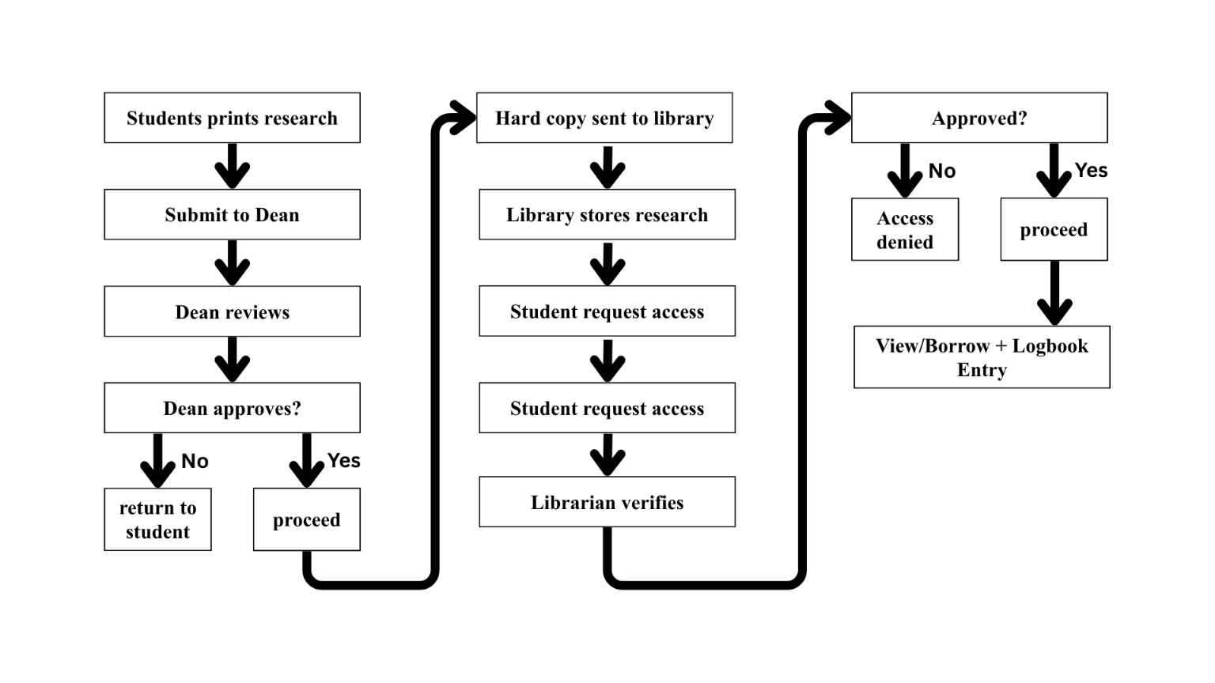
Problem | Description | Impact
Manual submission | Only printed documents accepted | Costly, time-consuming, environmentally unstainable
Physical storage only | No digital backup | Risk of document damage, loss, or detoriation
Manual retrival | Searching done through shelves and logbooks | Slow document location and retrieval
Limited access | On-site access only, requires approval | Delays research, limits availability
No centralized tracking | No system dashboard history log | Poor monitoring and low transparency
No standardized metadata | Inconsistent catalog labels | Difficulty search and refreshing

To address these issues, the CEAT Digital Repository System was developed to transform the process into a structured, secure, and digital workflow. The proposed system enables students and faculty to upload academic documents electronically through a web-based platform. Submissions undergo a digital approval process managed by the Dean and final publishing by the Librarian. Materials are categorized using standardized metadata (course, year, author, document type) to support accurate filtering and retrieval. Role-Based Access Control (RBAC) ensures secure document handling, while the access request feature allows students to request restricted materials digitally instead of transacting manually. The To-Be process shown below illustrates the improved workflow.
Figure 2. To-Be Digital Repository Workflow 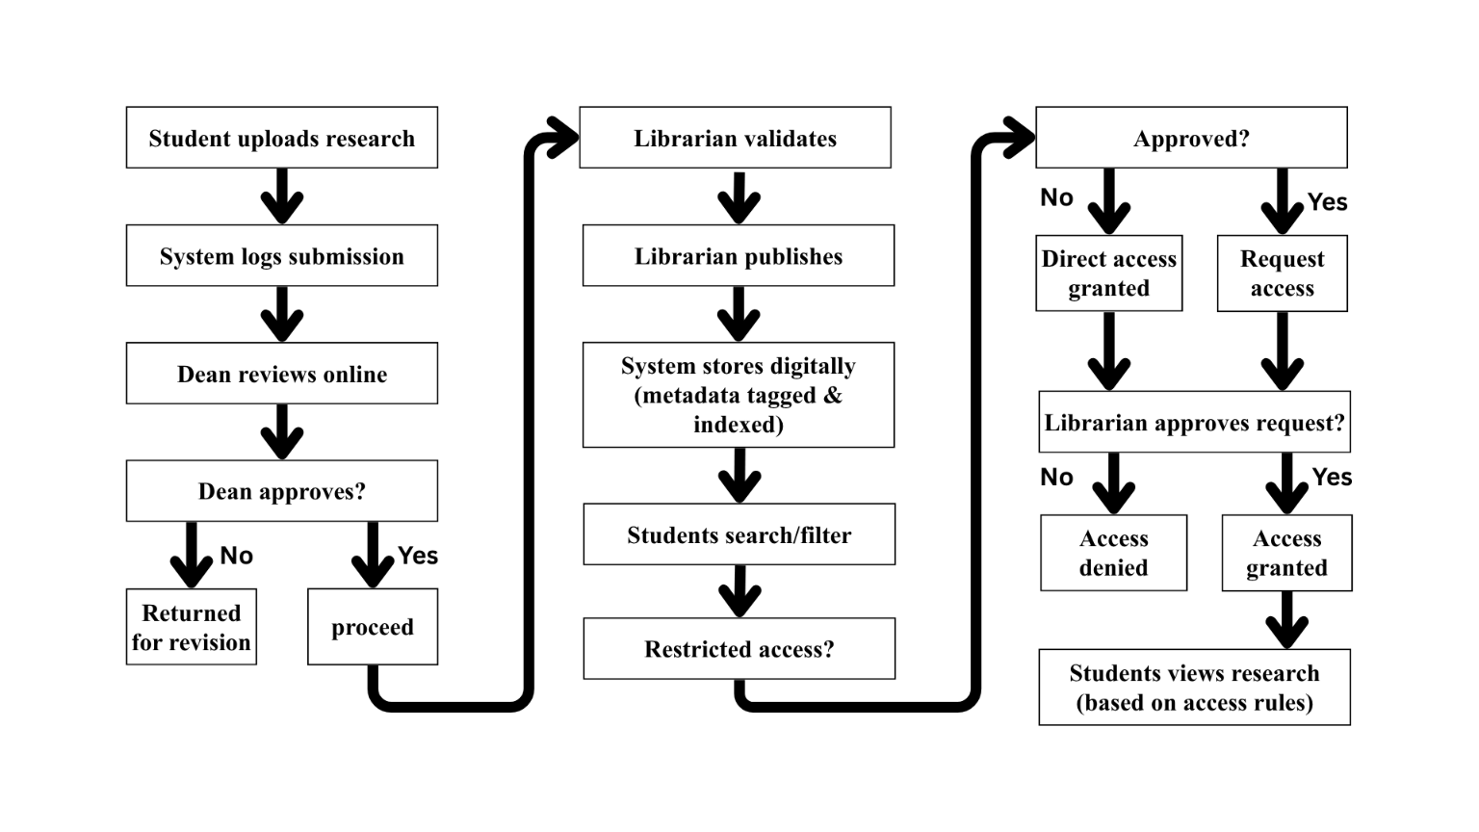
The implementation of the system significantly improves the management of academic outputs by digitizing submission, approval, storage, and retrieval processes. The system eliminates dependency on physical document handling, reduces processing time, improves document traceability, and allows faster academic referencing through structured metadata search. With secured role-based access, automated dashboards, and enhanced organization, the system provides a sustainable and scalable solution for CEAT’s academic archiving needs. These improvements demonstrate that the proposed system effectively addresses the limitations of the traditional repository process while promoting greater accessibility, efficiency, and data security.

System Overview
The institutional repository system is a web-based application developed using PHP and MySQL. It is designed to serve as a centralized platform for storing, organizing, and retrieving academic documents within the College of Engineering, Architecture, and Technology (CEAT) at Notre Dame of Dadiangas University (NDDU). The system focuses on managing document-based outputs such as theses, capstone projects, and research papers submitted by CEAT students and faculty.
The repository is accessible through a web browser within the university’s local network. Authorized users can upload, review, and access academic materials based on their assigned roles in the system. According to Susilowati et al. (2022), web-based repositories improve accessibility and organization of academic files through structured metadata tagging and digital storage.
The system is hosted on a local server located within the Glamang Campus to ensure controlled access and secure data management. It implements role-based user authentication, allowing each role to perform specific actions such as material submission, approval, publication, and access request management. The repository includes core functions such as document categorization, search and filter options, and an approval process that ensures submitted materials are reviewed before being published, the system aims to streamline the process of submitting, approving, and accessing academic documents within CEAT.

System Objectives
The CEAT Repository System is developed to enhance the management, accessibility, and preservation of academic outputs produced within the College of Engineering, Architecture, and Technology (CEAT) at Notre Dame of Dadiangas University (NDDU). It supports the institution’s efforts toward digital transformation while addressing local challenges in document organization, retrieval, and access. The main objectives of the system are described below.

1. Improve the Current Practices of Storing Academic Outputs
The current practice in CEAT is collecting students’ academic outputs in printed forms which are submitted after their defense and paper revisions. These materials are then initially cataloged and stored manually in the Dean’s office and later endorsed in the Library through Dean’s approval. Access is restricted to on-site users as they require permission from the Dean or the Librarian.
Although this approach ensures physical safekeeping and administrative documentation, it also presents several challenges, including limited accessibility, storage constraints, and risks of document misplacement or physical deterioration. The CEAT Repository System addresses these limitations by providing a centralized, web-based platform for digital storage and retrieval of academic documents

2. Support Metadata Tagging and Course-Based Categorization
Each uploaded academic document in the system is tagged with relevant metadata, including the course, year, author, and type of work (e.g., thesis, capstone, research paper). This structured categorization ensures consistency in organization and improves the accuracy of the system’s search and filtering functions. By enabling metadata tagging, the system enhances the discoverability of materials, supports efficient academic referencing, and helps reduce topic redundancy during research proposal development.

3. Enable Secure, Role-Based Access for CEAT Users
The system integrates a secure login mechanism with Role-Based Access Control (RBAC) to manage user permissions and ensure proper segregation of functions. This structure allows users to interact only with the modules and data relevant to their assigned responsibilities. The main user roles include Student, Dean, Librarian, and System Administrator (Super Admin) each performing distinct functions within the repository.
- Students can upload and submit their academic documents (such as theses and capstone projects) for review. Once submitted, the material enters a verification and approval process. Students can also view their submission history and the status of their uploaded materials (e.g., Pending, Approved, Published, or Denied). Additionally, students may request access to already published works; however, these requests require librarian approval before access is granted.
- Deans are responsible for managing and approving student submission requests within their respective colleges. Through the system, they can view all submitted materials from students under their college, review the submission details, and update the approval status (e.g., Approved, Denied, Pending). Once a submission is approved, it automatically becomes available for the Librarian to verify and publish.
- Librarians manage the final review, classification, and publication of approved materials. They determine which submissions are ready for public access and oversee borrowing or access requests made by students. Librarians can approve, deny, or mark these requests as completed, maintaining full control over material access within the repository.
- System Administrators (Super Admins) oversee the technical and operational management of the system. They handle database maintenance, user role assignments, and access permissions to ensure that all functions and stored data remain secure and reliable. The Super Admin also monitors system-wide activities to ensure smooth operation and policy compliance.
This hierarchical access control structure ensures security, accountability, and efficient workflow management within the repository. Each role operates within defined boundaries, preventing unauthorized access and maintaining the integrity of the institution’s academic archives.

4. Establish a Foundation for Sustainable Digital Archiving
While the current version of the system is focused solely on managing CEAT’s document-based academic outputs, it is designed with a modular structure that allows future enhancement and scalability. This includes potential integration of additional CEAT programs or system expansion to other university colleges if required by institutional policy. This design approach ensures that the system remains adaptable and relevant to the long-term digital archiving needs of the college.

System Scope & Limitations Scope
The proposed system is a web-based institutional repository specifically developed for the College of Engineering, Architecture, and Technology (CEAT) at Notre Dame of Dadiangas University (NDDU). It serves as a centralized digital platform for storing, organizing, reviewing, and retrieving academic document outputs such as theses, capstone projects, research papers, and journals produced by CEAT students and faculty.
The system is developed using PHP for server-side processing and MySQL for database management. It is hosted on a local server located within the Glamang Campus and can be accessed through the university’s internal Wi-Fi network. This setup allows users to access the repository through a web browser while connected to the institutional network.
Key features include:

1. User Role Management and Authentication
The system employs a secure login mechanism with role-based access control (RBAC) to manage user permissions effectively. Users are classified into the following roles: Super Administrator, Dean, Librarian, Faculty, and Student. Each role is assigned specific functions based on institutional responsibilities.
- Students can submit materials and request access to published works.
- Dean’s review and approve material submissions.
- Librarians publish approved materials and manage access or borrowing requests.
- The Super Administrator oversees user accounts, system configurations, and database integrity.

2. Material Submission and Approval Workflow
The repository follows a structured process for material verification and approval. Each academic document undergoes the following workflow:
Submitted → Dean Review → Librarian Publication → Published (Accessible). This ensures that only validated and institutionally approved materials are published in the system.

3. Document Upload and Categorization
Authorized users can upload academic document files, primarily in PDF format. Each file is categorized according to course, academic year, and material type (such as thesis, capstone, research paper, or journal). Metadata such as the title, author, course, and description are required for each upload to maintain consistency and facilitate efficient document retrieval.

4. Borrowing and Access Request Management
The system allows students to request access to published academic materials. The Librarian reviews each request and can either approve or deny access. Approved requests grant the user time-limited access to the material. Once the access period expires, the material automatically becomes available again for other users to request.

5. Search and Filtering Tools
The repository provides an integrated search and filtering feature that enables users to locate materials efficiently using keywords such as title, author, course, material type, or status. This enhances the accessibility and usability of the repository as a research and reference tool.

6. Admin Dashboard and Activity Monitoring
Administrative users specifically the Super Administrator, Dean, and Librarian have access to dashboard features that display essential information, including the total number of submissions, published materials, pending requests, and basic user activity summaries. This feature supports transparency, effective monitoring, and smooth repository operations.

Limit
The repository is intended exclusively for the CEAT college and is limited to archiving academic outputs produced by CEAT students and faculty. It does not handle files or user roles from other university colleges and does not manage academic grading, enrollment, or administrative records outside of the repository’s scope.
System Limitations:

1. Limited to CEAT College
The system is exclusively designed for the College of Engineering, Architecture, and Technology (CEAT) of Notre Dame of Dadiangas University. It does not accommodate submissions or access from other colleges or colleges within the university unless future expansions are implemented.

2. Document-Based Repository Only
The system currently supports document-type academic outputs such as theses, capstone projects, research papers, and journals. It does not support multimedia files, including videos, images, design blueprints, or interactive formats, to ensure efficient file handling and manageable database storage.

3. Local Network Accessibility
The repository is hosted on a local server within the university campus and can only be accessed through the institution’s Wi-Fi or internal network. Offcampus access requires network configuration or administrative approval, as no cloud hosting or external web access is implemented.

4. Manual Metadata Entry
The system relies on manual input for metadata such as title, author name, course, and material type. This approach may lead to inconsistencies or input errors if data is entered incorrectly by users.

5. No Automated Plagiarism Detection or Similarity Checking
The system does not include automated plagiarism detection or content similarity comparison tools. Verification of academic integrity remains under the responsibility of faculty reviewers or the Dean.

6. Absence of Automated Notifications
The current system does not automatically send email or in-app notifications for submission approvals, denials, or borrowing request updates.
Users must manually check their dashboards for updates.

Architectural Designs

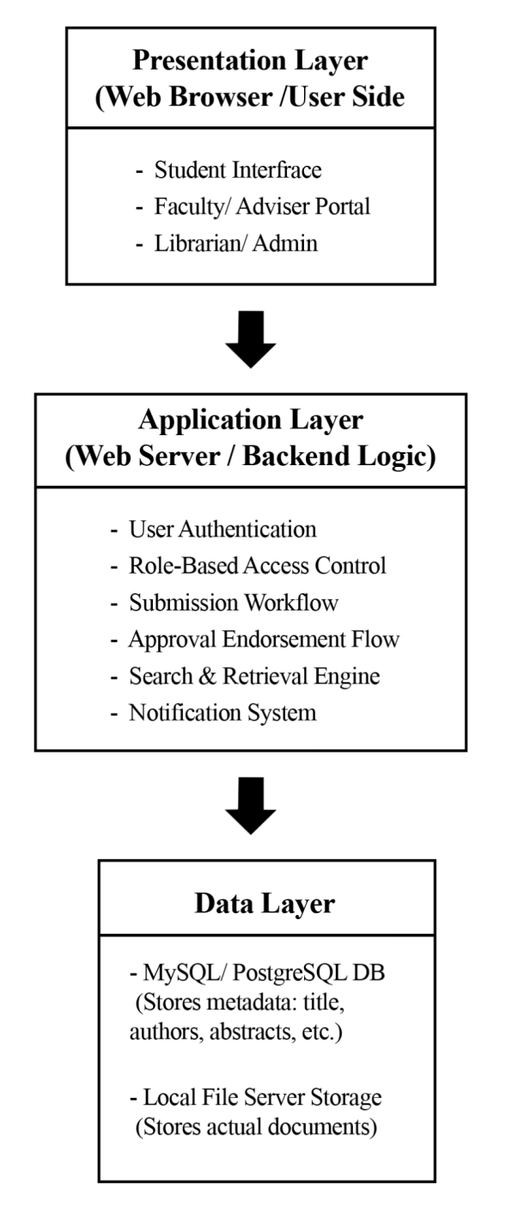
Figure 3. System Architectural Design
The proposed Web-Based Institutional Repository System for the College of Engineering, Architecture, and Technology (CEAT) at Notre Dame of Dadiangas University (NDDU) will follow a three-tier architecture, which will include the Presentation Layer, Application Layer, and Data Layer. This structure will help define the flow and separation of system components for user interaction, processing, and data storage.
The Presentation Layer will serve as the user interface accessible through a web browser. It will consist of separate modules or portals for different user roles, including student users, faculty or research advisers, and librarians or administrators. These interfaces will be designed to facilitate specific tasks such as document submission, review, and access management.
The Application Layer will handle the backend processes and business logic of the system. It is expected to include user authentication, role-based access control, document submission workflows, approval and endorsement procedures, search and retrieval functionalities, and basic notification features. This layer will manage how data flows between the interface and the storage system and will be developed using suitable server-side technologies.
The Data Layer will include a relational database management system (e.g., MySQL or PostgreSQL) that will be used to store metadata such as titles, authors, and abstracts.
Additionally, a local file server may be utilized to store the actual academic documents in digital format.

System Functions
The CEAT Repository System is a web-based platform developed to support the digital archiving, access, and retrieval of academic outputs within the College of Engineering, Architecture, and Technology (CEAT) at Notre Dame of Dadiangas University (NDDU). Built using PHP and MySQL, the system is hosted on a university-managed server and features browser-based access for users with active internet connections. It combines metadata-driven organization, role-based access control, and a secure document access workflow to support CEAT’s academic and research activities.

Role-Based Access Control and User Authentication
The system implements a secure login mechanism and role-based access to regulate functionalities available to different users:
○ Students and Faculty can upload their academic outputs for review and select whether the document will be public or restricted. They can also view approved works that are marked as public. If a document is restricted, they may submit an access request, which will be reviewed by the librarian.

○ Dean can review and endorse student submissions. They may also upload their own academic work or assist students with uploads when necessary. Like Students and Faculty, Dean can choose the access level (public or restricted) of the documents. Final endorsement is still required before archiving.
○ Librarians are responsible for reviewing endorsed submissions, managing access requests, overseeing metadata consistency, and ensuring documents align with institutional guidelines. This structure maintains control while respecting the uploader’s access preferences.
o System Administrator is responsible for managing users, roles, material types, colleges and courses. This ensures the maintenance and proper functioning, security and integrity of the digital repository.

Document Access Request and Library-Based Viewing
When a student wishes to access the full content of a research document beyond the abstract, the system provides an integrated access request feature. Students may submit a request which is reviewed by the Admin. Upon approval, the student is notified and is permitted to view the full document physically at the CEAT library, rather than accessing the complete file online. This controlled workflow ensures academic security and compliance with the institution’s content handling policies.

Web-Based Access for Faculty and Student Users
The system allows Faculty and Student users to access the platform via internetconnected devices. This remote accessibility enables flexible research engagement and submission management.

Document Upload and Metadata Tagging
Faculty and Admin users can upload documents to the repository and assign key metadata attributes, such as course, academic year, project type, and author. This structured tagging system supports organized storage and enhances the accuracy of retrieval during searches.

Search and Filtering Tools
The system includes a built-in search engine and advanced filtering options, enabling users to locate documents using keywords, course titles, author names, and academic years. These tools support academic referencing and streamline the research process for both faculty and students.

Admin Dashboard and Monitoring (Local Access Only)
Admin users are equipped with a dashboard to manage user activity, document submissions, and request approvals. Access to the Admin interface is limited to users connected to the university’s local area network (LAN) or authorized internal systems to maintain control over system-critical operations.

Local Server Deployment with Internet-Enabled Accessibility
The system is hosted on a server located at the CEAT Glamang Campus. While the Admin interface is restricted to local use, Faculty and Student pages are accessible via the internet, allowing broader reach for document viewing and upload functions without relying on third-party cloud providers. This ensures institutional control and data sovereignty.

Physical Environment & Resources
The initial development of the Institutional Repository prototype will take place in each of the members’ homes. Each member will use a personal computer for coding, UI design, and local testing of the system. A stable internet connection is needed for collaboration and communication. Since the initial phase is home based, there's no need for a physical server at this stage. Localhost will be used to simulate the repository system. No centralized development space is required, but regular coordination will be done through virtual meetings and communication tools. File sharing, and documentation will rely on cloud-based platforms. While environmental conditions such as power reliability and workspace setup may vary across individual homes, the team is advised to follow best practices such as maintaining clean, well ventilated work areas and using surge protectors where necessary.

Software and Hardware Resources for Developers
Software:
- Development Environment: Visual Studio Code
- Backend: PHP, MySQL
- Frontend: HTML5, CSS3, JavaScript
Hardware:
- Processor: Intel core i3
- RAM: 8GB Minimum
- Storage: 500GB
- Internet: 50MBps minimum speed

Software and Hardware Resources for End Users

Software:
- Web Browser: Google chrome, Microsoft edge - Operating System: Windows, MAC, Linux Hardware:
- Device: PC, Mobile phone - Processor:
- RAM: 4GB Minimum
- Internet: Stable connection

Development Cost
Box 1:
Software cost
Software / API | Cost
Visual Studio Code/JavaScript/HTML/CSS | Free
MySQL, PHP | Free
Web hosting | Free
Server | Free
This table lists the tools that will be used in developing the system, along with their corresponding costs. All the software and services used are open source and provided at no cost. For the frontend development, we will use VSC for the code editor along with the standard web technologies such as HTML, CSS, and JavaScript, all of which are open source. For the backend, we will utilize MySQL and PHP for the database and server side scripting, both are also open source and free of cost. Lastly, the web hosting and server resources will be provided by the school, which supports the implementation.
Box 2:
Hardware cost
Hardware | Cost
Developer PC | P70,000
Internet Plan | P3,897
This table outlines the physical resources that will be utilized in making the system. The developer PC, which is owned separately by the 3 members, is valued at approximately ₱70,000 in total. This serves as the main machine for coding, testing, and running the application. Additionally, the internet plan costs around ₱3,897 and will be used to facilitate research, collaboration, remote access, and deployment tasks. These hardware related expenses were essential in ensuring continuous and efficient system development throughout the project.

References:
Kamalia, & Putra (2025). A study of the archival system: Enhancing archive management.
Journal of Commerce Management and Tourism Studies, 4(1), 107–119. Retrieved from:
https://www.researchgate.net/publication/390414948_A_study_of_the_archival_system_Enhanci
ng_archive_management

Lucchi, E., Tabasso, M., Zendri, E., Calzavara, F., & Zarrella, A. (2023). Thermal behavior of a historic building housing books across past and future climate scenarios. Heritage, 7(12), 3660– 3683. Retrieved from: https://doi.org/10.3390/heritage7120320
GMA News. (2023, May 27). CHED, DICT ink MOU to push digitalization in higher education. Retrieved from: https://www.gmanetwork.com/news/topstories/nation/871563/ched-dict-inkmou-to-push-digitali zation-in-higher-education/story/
Susilowati, M., Kurniawan, Y., & Wilujeng, L. L. (2022). Implementation of a web-based digital repository information system at the Office of Sumbersekar Village. Journal of Community Practice and Social Welfare, 2(1), 11–23. Retrieved from:
https://doi.org/10.33479/jacips.2022.2.1.11-23
repository.upy.ac.id+10researchgate.net+10jacips.machung.ac.id+10
Subiyakto, A., Rahmi, Y., Kumaladewi, N., Huda, M. Q., Hasanati, N., & Haryanto, T. (2021, April 2). Investigating quality of institutional repository website design using usability testing framework. AIP Conference Proceedings, 2331(1), Article 060016. Retrieved from: https://doi.org/10.1063/5.0041677
Demetres, M., Delgado, D., & Wright, D. (2020, April) The impact of institutional repositories: a systematic review. Journal of Academic Libraries and Archives, 10(2), 45–60. Retrieved from: https://www.researchgate.net/publication/340368195_The_impact_of_institutional_repositories_ a_systematic_review
Henriques, M., & Domingos, N. (2022). Challenges and opportunities for institutional repositories in Angolan higher education institutions. Scientometrics, 127(6), 3253–3271. Retrieved from: https://doi.org/10.1007/s11192-022-04410-w
Henry Luce III Library. (2021, January 27). Three-day IR training-workshop for CPU librarians and IT staff. Central Philippine University Library News.
Retrieved from: https://library.cpu.edu.ph/ir-librarians-training/

Cuyugan, C., Roguel, F. K., Bulanadi, H. G., Gabuya, R. N., & Cerenado, K. (2023). View of The Effect of Artificial Intelligence Tools Usage to the Perceived Learning of 2nd Year Communication Students at Far Eastern University-Manila, Academic Year 2023-2024. Ijci.net; International Journal of Curriculum and Instruction.
Retrieved from: https://ijci.net/index.php/IJCI/article/view/1498/741?fbclid=IwY2xjawI-qilleHRuA2FlbQIxMA ABHW00E5xZ4FoX3KCVT9msdNhQqzRRdj34V5Xz6oZFgra242csXHuXH2Q4NQ_aem__xu egvH1gTBhuYdhsN6n0Q

Ponto, J. (2015). Understanding and evaluating survey research. Journal of the Advanced Practitioner in Oncology, 6(2), 168–171.
Retrieved from: https://www.ncbi.nlm.nih.gov/pmc/articles/PMC4601897/

González‑Pérez, C., García-Barriocanal, E., Sicilia, M.‑Á., & Sánchez-Alonso, S. (2021). Improving institutional repository systems through user-centered design: A case study. Future Internet, 13(11), 282. Retrieved from: https://doi.org/10.3390/fi13110282

Okon, S. O., Ogar, G. N., & Iwatt, G. E. (2020). A web-based digital repository for scholarly publication. Journal of Software Engineering and Applications, 13(3), 93–105. Retrieved from:
https://doi.org/10.4236/jsea.2020.133007

González-Pérez, C., Carrillo-Ramos, A., & García-Peñalvo, F. J. (2021). A user-centered institutional repository design. In F. J. García-Peñalvo (Ed.), Interaction in Digital Education
(pp. 55–70). Springer. Retrieved from: https://doi.org/10.1007/978-3-658-38703-7_4

Imoro, O., & Saurombe, A. (2024). Investigating the infrastructural and operational sustainability of institutional repositories in Ghanaian public universities. Collection and
Curation, 43(2), 87–99. Retrieved from: https://doi.org/10.1108/CC-11-2022-0038

Appendix A
Entity Relationship Diagram

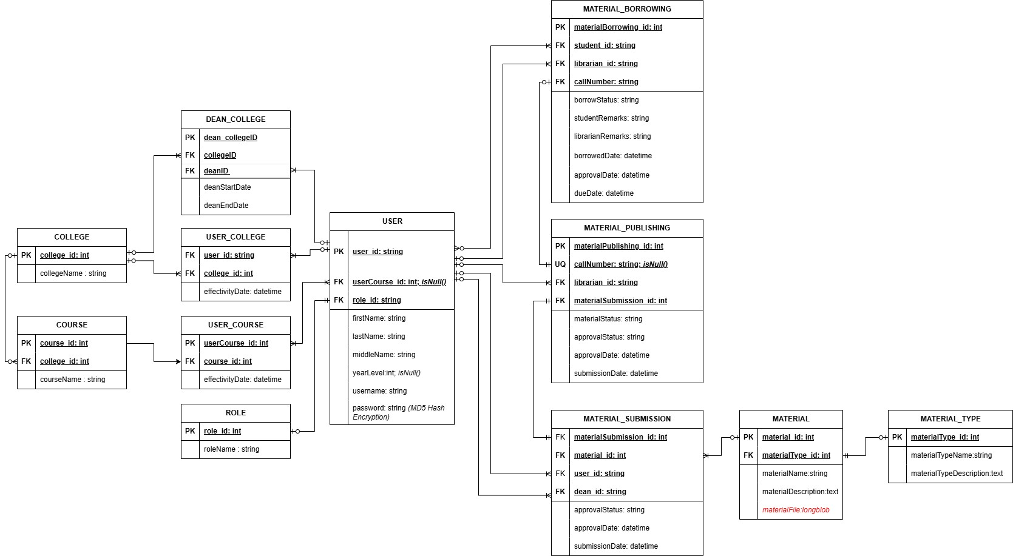

Appendix A

Data Flow Diagram
