Integration guide

Step 1: Get Access Token

Url : https://b2c-ext.nexdev.net/api/auth
Content-Type : application/json
Method : Post
Input data type : JSON
Input Parameter :
{
"username":"",
"password":""
}

UserName | Pasword

OutPut result: json object
{
"access_token": "eyJhbGciOiJkaXIiLCJlbmMiOiJBMjU2Q0JDLUhTNTEyIiwidHlwIjoiSldUIiwiY3R5IjoiSldUIn0..SYCCPXw_XQBEM_kkGYje8A.DNby1tniQS62bepdQfmCuiMHSSpC1PQXEmOMr6jsIFr_yMQAsbOZBm0G10immZiuvbRAPeoEG5bMs8UNaB4ArTgI5x4dMsLSXKsnB5vsB9WZh4pW4D0BI9tVG5v_Le7lRlH5UNI_F-A2uBP-vy8qXvnHOdQJDIpR_xcSCo8LQPZHJV9CcVSjPjLtIm3BtG1KjVugkZ31wmfZhcvtDOLcb__qmAKvECdvhhsVEt_TAN4BMmaFWU1e811xJNA2LhUFKXiiGeYv1RcTXEWc3W_7YC8YD3_KUZMAzS1LXFTvjTOSOiY0ao7swIY8OCKS88UW.Ux0GUnKQ4gqB8r3lGivzQqlrwh4C7kwmV5F2cSti7Fw",
"token_type": null,
"expires_in": 0
}

Whitelist IP : The authentication service restricts access by IP . Therefore, you need to contact to administrator to enable your outgoing IP.

Sample code:

using (var client = new HttpClient())
{

using (var postContent = new StringContent(JsonConvert.SerializeObject(new
{
UserName = "SiteName",
password = "xxxxx"
})
))
{
postContent.Headers.ContentType = new MediaTypeHeaderValue("application/json");
var request = await client.PostAsync("https://b2c-ext.nexdev.net/api/auth", postContent).ConfigureAwait(false);
request.EnsureSuccessStatusCode();
if (request.StatusCode == HttpStatusCode.OK)
{
var token = JsonConvert.DeserializeObject<Token>(await request.Content.ReadAsStringAsync());
Console.WriteLine(token.AccessToken);

}
else
{
Console.WriteLine($"StatusCode={request.StatusCode},Msg={await request.Content.ReadAsStringAsync()}");
}
}
}
Step 2 : Build query URL
- Query Affiliate Info
URL : https://b2c-ext.nexdev.net/api/AffInfo
Method : POST
Query Parameters:
Name | Required | Data type | Description
access_token | yes | text | The access token value will expire after 30 minutes

Body parameters:
Name | Required | Data type | Description
PlayerName | yes | text | Name of player account
MonthDate | yes | date | Revenue sharing date  format:MM-dd-yyyy  timeZone:GMT+8
BaseCurrencyName | no | text | - Only support:  + USD, MYR, THB, IDR, CNY for N88. Default value is USD  + VND, USD for N8B and N8G. Default value is VND
LicenseeCode | no | text | - Only Support: N88, N8B, N8G  - Default value is N88
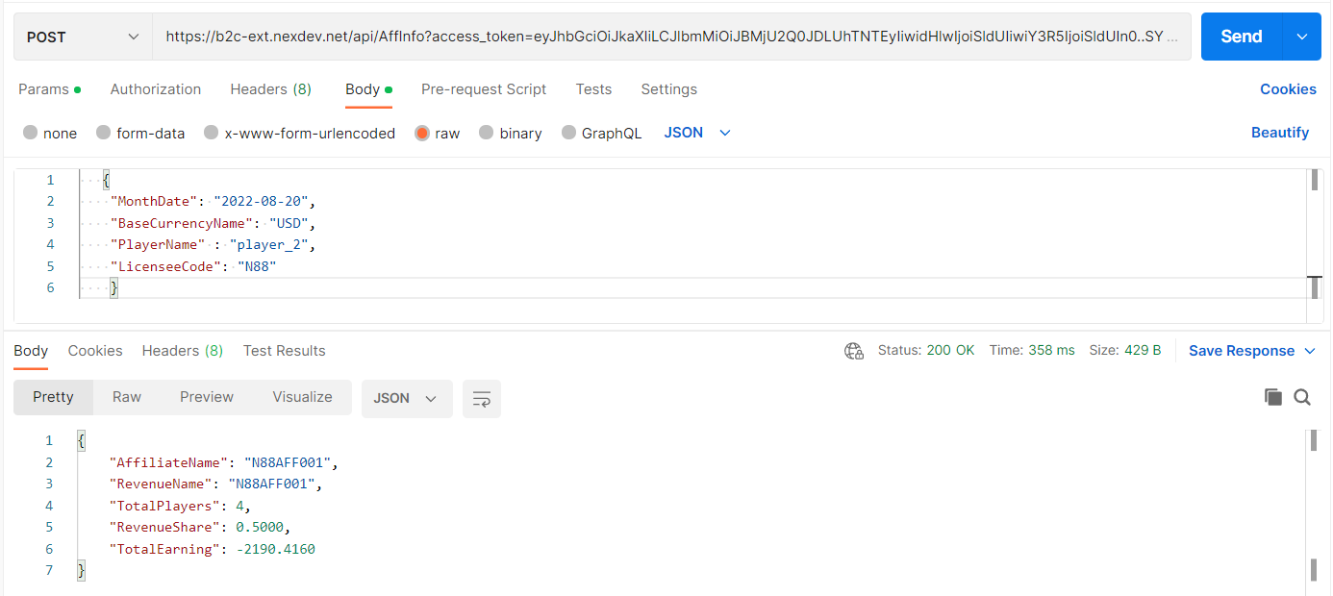
Sample:
https://b2c-ext.nexdev.net/api/AffInfo?access_token=eyJhbGciOiJkaXIiLCJlbmMiOiJBMjU2Q0JDLUhTNTEyIiwidHlwIjoiSldUIiwiY3R5IjoiSldUIn0..SYCCPXw_XQBEM_kkGYje8A.DNby1tniQS62bepdQfmCuiMHSSpC1PQXEmOMr6jsIFr_yMQAsbOZBm0G10immZiuvbRAPeoEG5bMs8UNaB4ArTgI5x4dMsLSXKsnB5vsB9WZh4pW4D0BI9tVG5v_Le7lRlH5UNI_F-A2uBP-vy8qXvnHOdQJDIpR_xcSCo8LQPZHJV9CcVSjPjLtIm3BtG1KjVugkZ31wmfZhcvtDOLcb__qmAKvECdvhhsVEt_TAN4BMmaFWU1e811xJNA2LhUFKXiiGeYv1RcTXEWc3W_7YC8YD3_KUZMAzS1LXFTvjTOSOiY0ao7swIY8OCKS88UW.Ux0GUnKQ4gqB8r3lGivzQqlrwh4C7kwmV5F2cSti7Fw

