Step 1:
Please copy all file to the new folder, name it → [Payroll System]
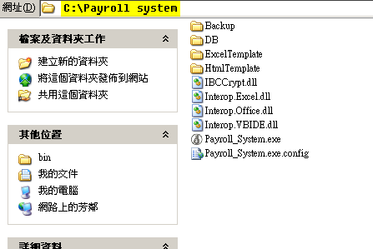

Folder description:
[ExcelTemplate]: use by import / output excel file.
[HtmlTemplate]: use by send out payslip mail.
[Backup] : use by backup function
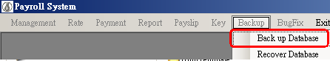
As this:
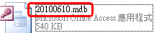
It setting on [Payroll_System.exe.config]
[DB] : your pay roll database , only one. (唯一操作的真正資料庫)

Step 2:
Please copy pat`s [Payroll.mdb] to your [DB] folder! very important.
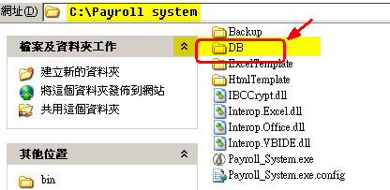

Step 3:
Set the file [Payroll_System.exe.config] and let key word [DBAbsolutePath] value is empty.
As this:

And system will get database from [DB] (default)

