System Combo Parlay
High Level Requirement Specification

Version: 1.12
Date: Jun.20 2016

Document Information
Document Title: System Combo Parlay High Level Requirement Specification
File Name: | System Combo Parlay High Level Requirement Specification
Author(s): | Jacky, Tony, Ryan

Document Acceptance
Reviewed By
[Name]
Designation:  [Designation]  [Department] | Designation: | Designation: | Designation:
Date: | Date: | Date: | Date:

Approved By
[Name]
Designation:  [Designation]  [Department] | Designation: | Designation: | Designation:
Date: | Date: | Date: | Date:
Document Revision History
Date | Version | Author | Description
Mar 25, 2016 | 1.0 | Jacky | Initial document
Mar 28, 2016 | 1.01 | Ryan | Update customer setting
Mar.29, 2016 | 1.02 | Jacky | Add Stake Per Bet on bet slip
Mar 31, 2016 | 1.03 | Jacky | Update fields in [bettrans] table
Apr 08, 2016 | 1.04 | Jacky | Update max match rule
Apr 12, 2016 | 1.05 | Jacky | Update admin mockup
Apr 19, 2016 | 1.06 | Jacky | Update web betslip mockup
Apr 26, 2016 | 1.07 | Jacky | Update final Mockup & add indo oddstype rule
May 10, 2016 | 1.08 | Jacky | Licensee ref.betsetting change rule & admin Last 30 stake no need add combo parlay
May 24, 2016 | 1.09 | Jacky | - Admin remove Mix parlay monitor & system parlay monitor & parlay completed report link1  - Update Mockup for Betlist & Statement about lucky
May 25, 2016 | 1.10 | Jacky | Key Stake per bet expand all and highling total stake
May 27, 2016 | 1.11 | Jacky | Remove indo account can’t bet lucky
Jun 20, 2016 | 1.12 | Jacky | Update lucky bet display on betlist
Jul 06, 2016 | 1.13 | Jacky | - Update new smart betlist detail mockup

Table of Contents

1 Project Overview and Objectives 1
2 Key Details in Scope 1
3 Functional Requirements 2
4 Non Functional Requirements 7
5 Out of Scope 8
6 Appendix 9

Project Overview and Objectives

Key Details in Scope

Areas | Details
Target Market | All
Currencies | All currencies
Languages | All languages
Business Model  (Cash/Credit) | - Credite  - Licensee
Commercial Terms
Product | - Sportsbook

Functional Requirements

Req. Ref. | Description | MoSCoW
1 | Customer Setting:
1.1 | Commission Setting:  - Credit:  Other Sports group commission applied to Mix Parlay and System Parlay  - Licensee:  No Commission
1.2 | Bet Setting:  - For Credit customers bet Combo Parlay of Soccer: Use Sportsbook Soccer bet setting  - For Credit customers bet Combo Parlay of other Sports: Use Sportsbook Mix Sports Parlay bet setting  - For Licensee customers bet Combo Parlay of Soccer: Use Sport_Bettype_Reference_Setting sport 1and bettype 99  - For Licensee customers bet Combo Parlay of other Sports: Use Sportsbook Mix Sports Parlay bet setting
1.3 | PT Setting  - For Credit customers bet Combo Parlay of Soccer: follow Mix Parlay of Soccer setting.  - For Credit customers bet Combo Parlay of other Sports: follow Sportsbook Mix Sports Parlay setting.  - For Licensee customers bet Combo Parlay of Soccer: follow Mix Parlay of Soccer setting.  - For Licensee customers bet Combo Parlay of other Sports: follow Sportsbook Mix Sports Parlay setting.
2 | Member Site/Mobile:  - Parlay Bet Slip add System Combo Options.  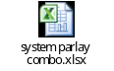  - Most 20 matchs can bet on System Combo  - only “System Combo- 1 bet” need to show odds on betslip  - If Bet on “System Combo- 1 bet” bet trans will store bettype 29, others store bettype 29 with new betteam, hdp1 & hdp 2 values  hdp1 : stored 1 or 0 , if bet on system parlay will store 0  hdp2 : change from "bitmap value" to "total no. of selections/matches"  betteam : stoerd reversed bitmap (BINARY) to dec  betcheck : Bitmap (BINARY) change to dec; over 20 matchs always store 1048576  - All System Combo need to show Max bet .  - For Soccer only Doubles Maxbet: Compare {2 Combo Payout/Max Odds} with Customer Soccer bet setting then get small bet  - For Mix sport Doubles Maxbet: Compare {2 Combo Payout/Max Odds} with Customer Mix Sports Parlay bet setting then get small bet  - For Soccer Only Trebles Maxbet: Compare {3 Combo Payout/Max Odds} with Customer Soccer bet setting then get small bet  - For Mix sport Trebles Maxbet: Compare {3 Combo Payout/Max Odds} with Customer Mix Sports Parlay bet setting then get small bet  - For Soccer only 4-fold & up Maxbet: Compare {4Up Combo Payout/Max Odds} with Customer Soccer bet setting then get small bet  - For Mix Sport 4-fold & up Maxbet: Compare {4Up Combo Payout/Max Odds} with Customer Mix Sports Parlay bet setting then get small bet  - For Soccer only System parlay Maxbet: Compare { System Parlay Max Payout /Max Odds} with Customer Soccer bet setting then get small bet  - For Mix Sport System parlay Maxbet: Compare { System Parlay Max Payout /Max Odds} with Customer Mix Sports Parlay bet setting then get small bet  - For Soccer only Lucky{X} Maxbet: Compare { System Parlay Max Payout /Max Odds} with Customer Soccer bet setting and each match max bet then get small bet  - For Mix Sport Lucky{X} Maxbet: Compare { System Parlay Max Payout /Max Odds} with Customer Sports bet setting and each match max bet then get small bet  - For Soccer only Lucky{X} Min bet: Compare Currency min bet with Customer Soccer min bet setting then get small bet  - For Mix Sport Lucky{X} Min bet: Compare Currency min bet with Customer Sports min bet setting then get small bet  - BetList & statement need modification (collapse feature and betteam display)  - Add Total Bets  - That always tick off 1 bet Combo parlay and shrink other combo  - Betslip combo parlay background color highlight when key the stake  - One combo = one bet trans tickets; ex. Lucky 255 = one Goliath ticket(247 bets) +8 single tickets  - Add Live System parlay  - Highlight the selection when input the stake value  - Highlight the Total Bets/ Total Stake/ Max Payout/ Min & Max Bet when value have to change  - Add Stake Per Bet  - System to automatically input stake on all combo selection and highlight the selection but exculed Lucky{x} & system parlay selection  - Automatically input mini maxbet on all stake per bet combo selection when max bet over one of maxbet  XIIII. Process bet Popup alert need to show all combo selection & total stake  - Betlist & Statement event column default hide parlay events info and when click system parlay link show all parlay events info  - Auto bookie need include Doubles & Trebles combo, the system parlay aslo still use old ruls  - Max selection are 100 matchs and over 20 matchs [betcheck] always store 1048576  - Only Indo odds type account can’t see lucky  - Key Stake per bet then expand the combo with stak and highlight total stake.  - Bet list after bettype name add en: (Via Lucky) ; ch: (來自幸運選擇); cs: (来自幸运选择) when bet form lucky
2.1 | MockUp  - BetSlip  ~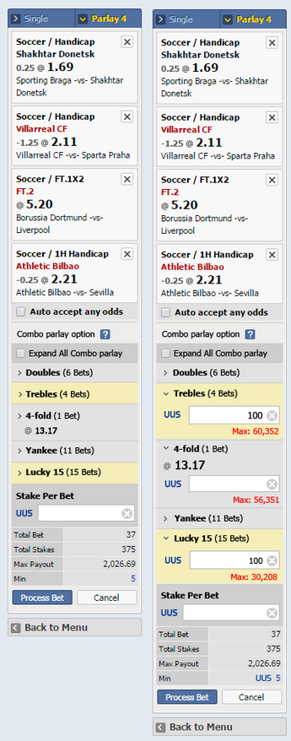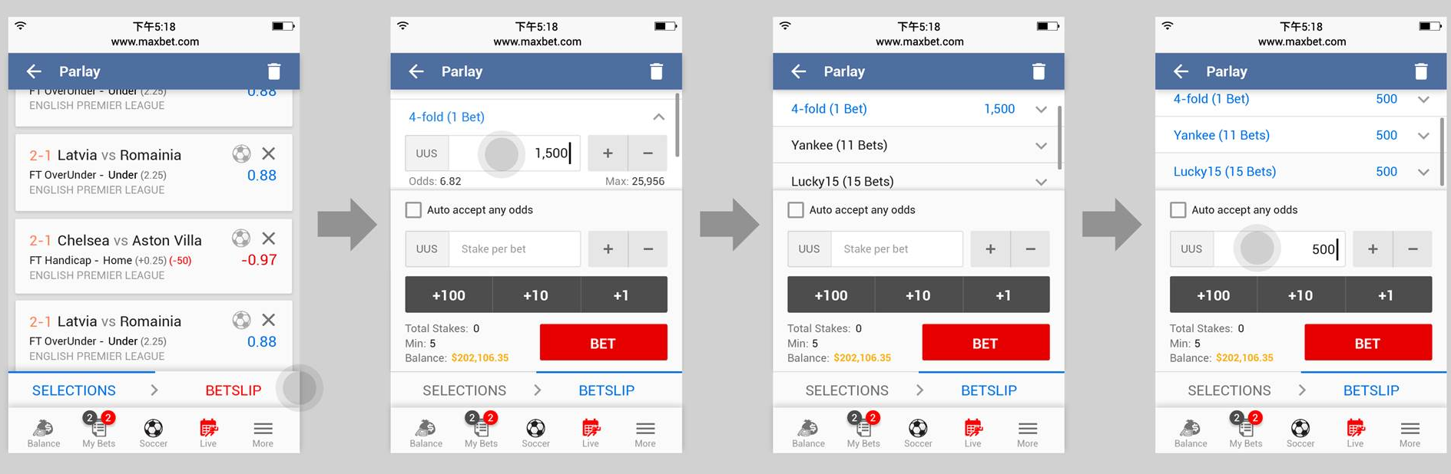  - BetList  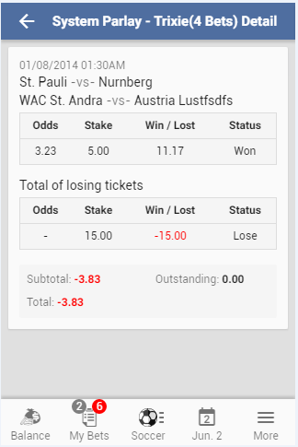  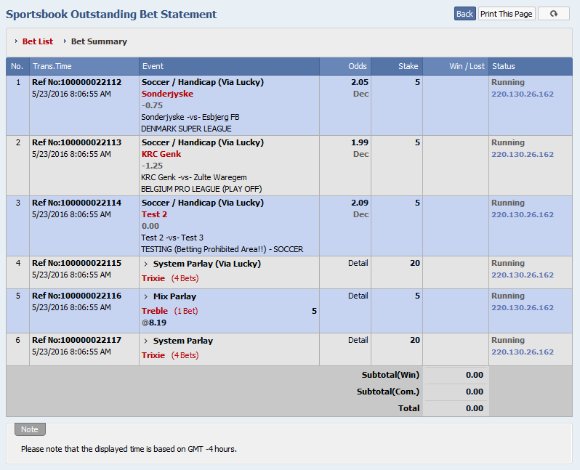  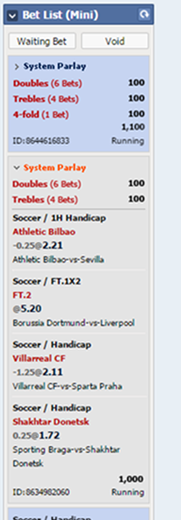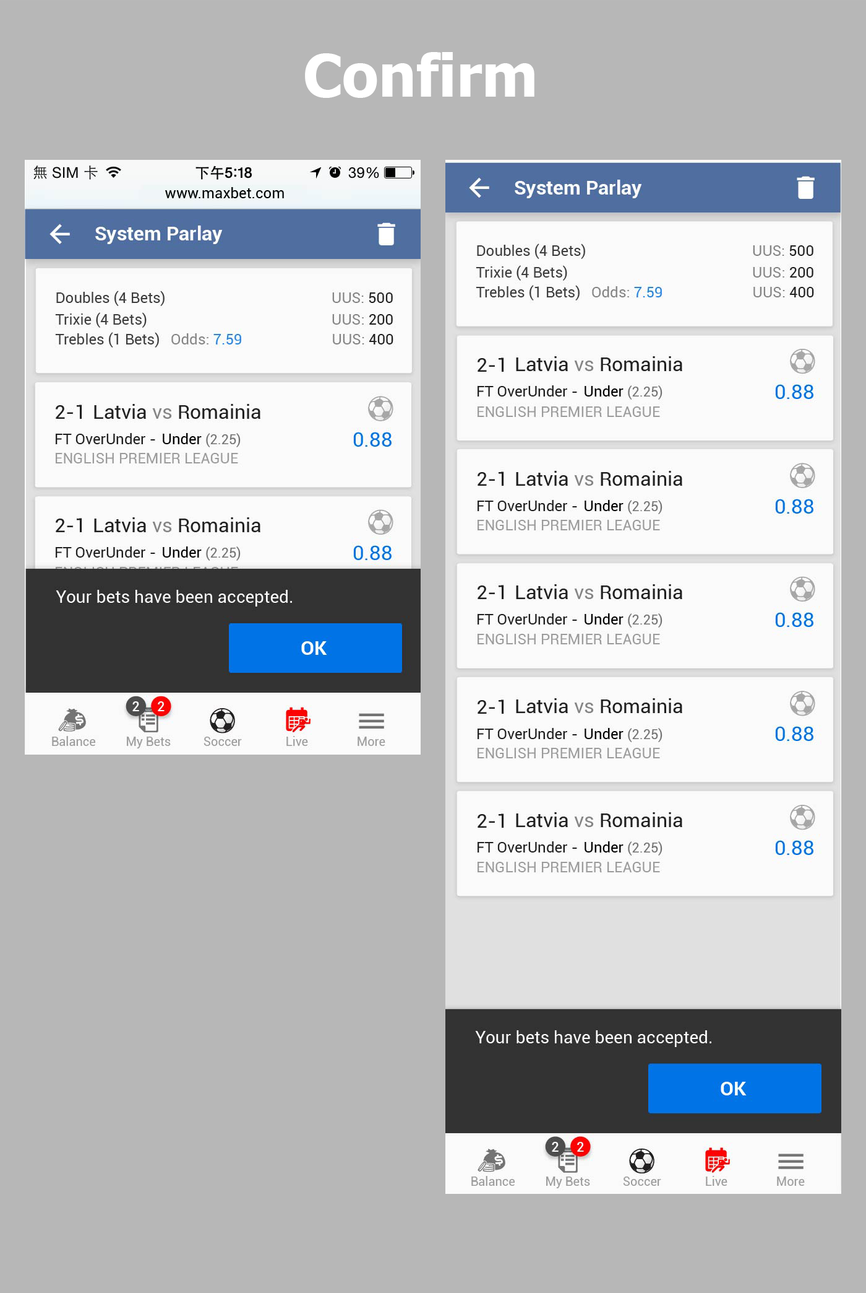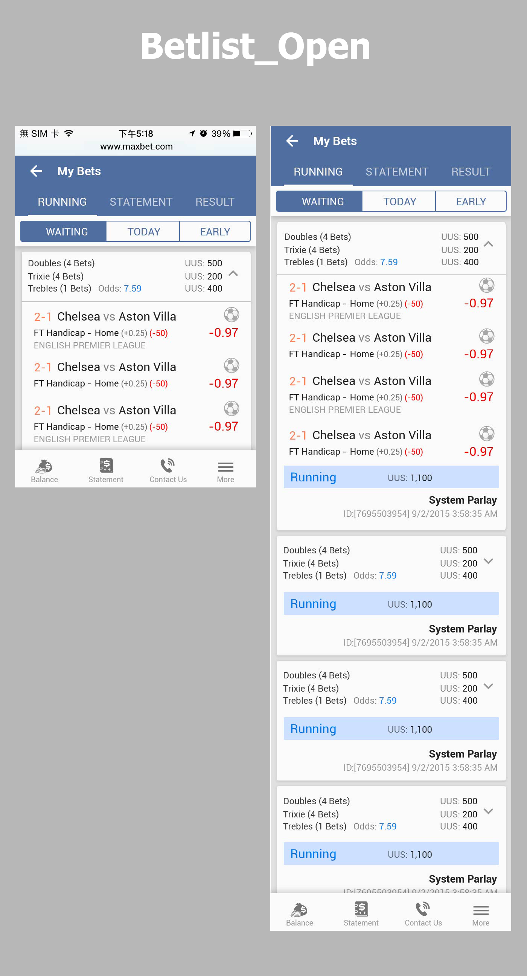  Process bet alert- 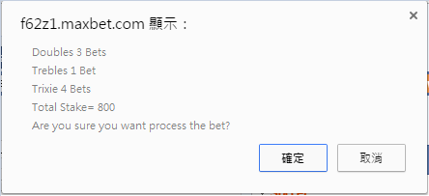
2.2 | System parlay Help page  - Add Singles, combos and lucky explanation  
3 | Admin  - System parlay Monitor add Combo parlay  - Mix Parlay Monitor add Combo Parlay  - Last 30 bet add Combo parlay  - Last 30 stake no need add combo parlay(Request by Jacky Ting)  IV. Add Live System Parlay
3.1 | Mix parlay Monitor Mock up: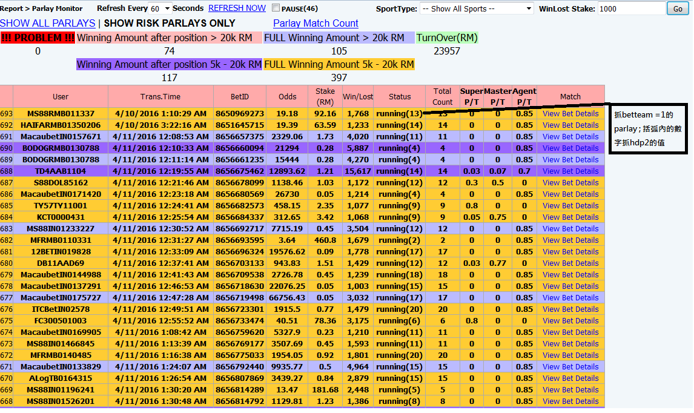  System parlay monitor mockup: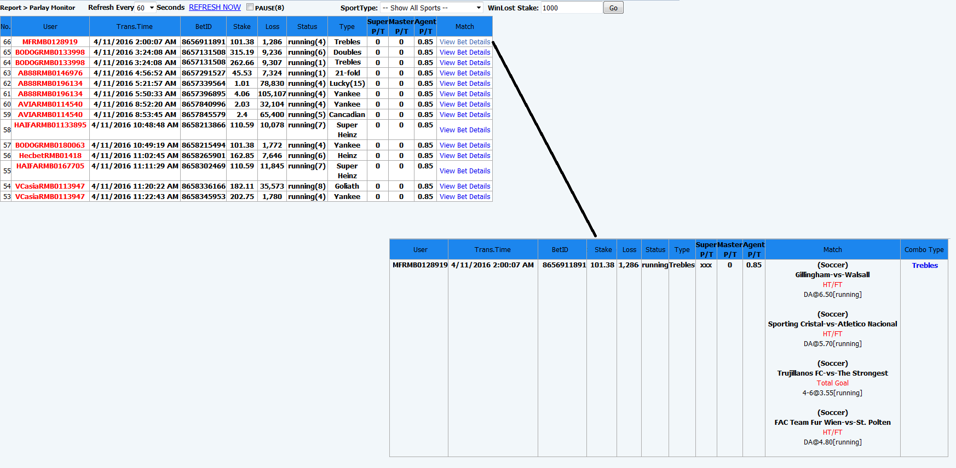
4. | Alpha [Web/Mobile]  - Bet List: modified to be able to show Combo Parlay.  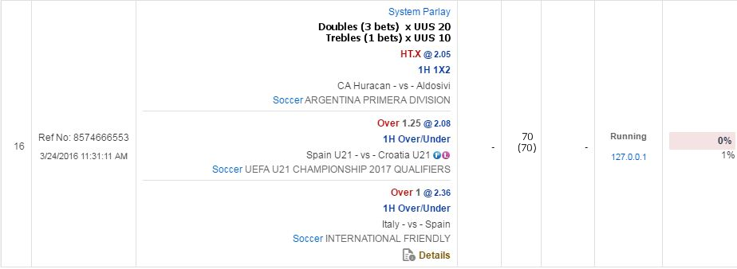  - Bet List details: modified to be able to show Combo Parlay.  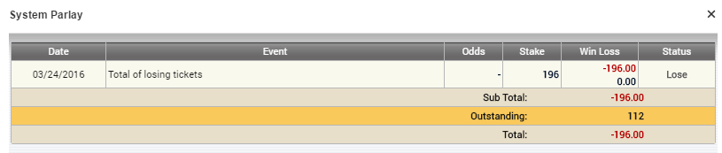
5. | LRF  - Bet List: modified to be able to show Combo Parlay.
6. | NAP Settlement:  - Calculate MP: modified to be able to calculate Combo Parlay.  - Refund Parlay HT/FT/All: modified to be able to calculate Combo Parlay.
7. | NAP:  - Bet List: modified to be able to show Combo Parlay.  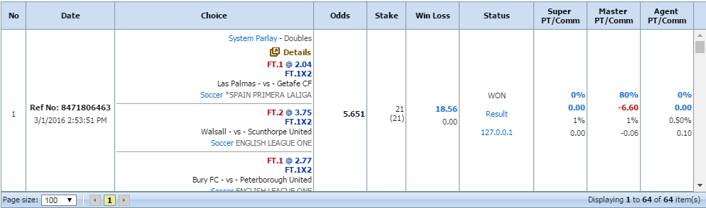  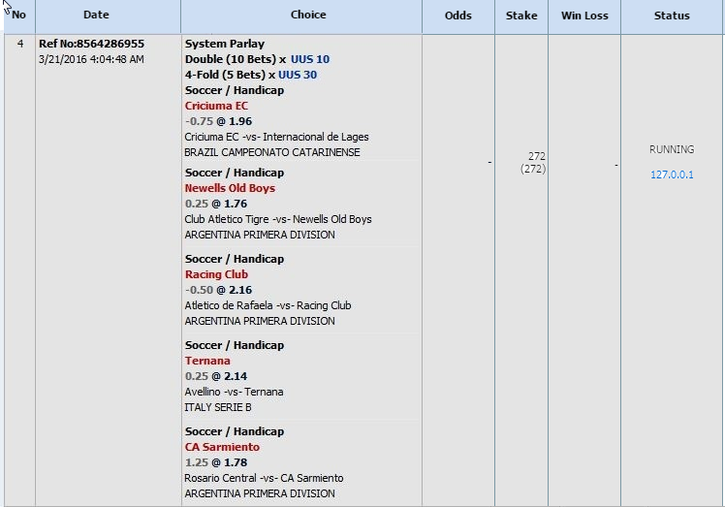  - Bet List details: modified to be able to show Combo Parlay  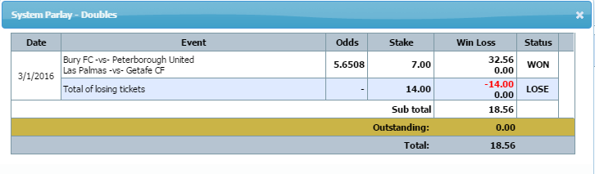  - Bet List Combination details: modified to be able to show all Combo Parlay  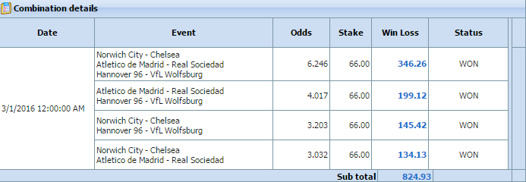
8. | NAP Special Delete:  - Void Parlay Bet: modified to be able to void Combo Parlay.  - Void Early KO Bet: modified to be able to void ticket of Combo Parlay.
9. | Parlay RMS:  Modified to be able to support Combo Parlay.  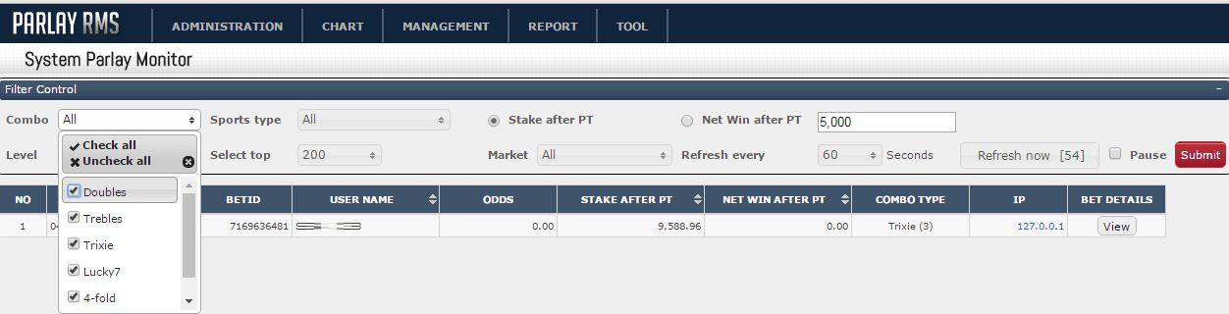
10. | NAP Reports  Modified to be able to support Combo Parlay.
11. | DW Reports:  Modified to be able to support Combo Parlay.
12. | DB  Table: [bettrans]  [hdp1] : 0 ,1 ; bet system parlay store 0  [hdp2]: total bets value  [betcheck]: Bitmap (BINARY) change to dec  [betteam]: Reversed Bitmap (BINARY) change to dec

Non Functional Requirements

Req. Ref. | Description | Priority
NF1 |  | M
NF2 |  | M

Out of Scope

N/A

Appendix

N/A

