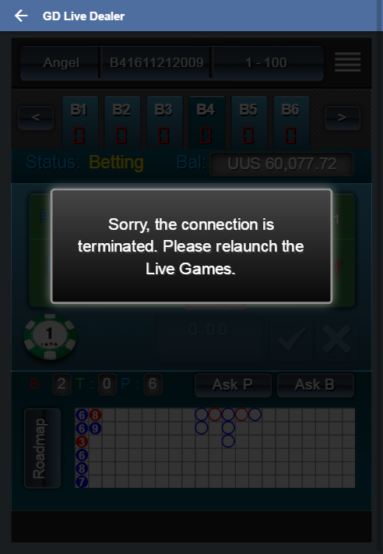
================ GD Call Debit Time : 2016-11-21 06:20:03 762, transactionId : 161121182003BHI4v3QHaqkceLnuFtZB================
GD Input :
Debit-Request userId : 14242461
Debit-Request gameId : B41611212009
Debit-Request gameType : 6
Debit-Request transactionId : 161121182003BHI4v3QHaqkceLnuFtZB
Debit-Request amount : 1.00
Debit-Request currency : UUS
Debit-Request ipAddress : 61.221.35.49

2016/11/21 06:20:03 Thread:94 GDWebAPI.GDWebAPI.Debit(String userId, String gameId, String gameType, String transactionId, Decimal amount, String currency, String ipAddress) in c:\Projects\3rdIntegration\trunk\CoreTeam Frontend\GDWebAPI\GDWebAPI\SOAP\GDWebAPI.asmx.cs Line:231
Request bettype= 1701 BStakeLevel = 50 RStakeLevel =227

2016/11/21 06:20:03 Thread:94 GDWebAPI.GDWebAPI.Debit(String userId, String gameId, String gameType, String transactionId, Decimal amount, String currency, String ipAddress) in c:\Projects\3rdIntegration\trunk\CoreTeam Frontend\GDWebAPI\GDWebAPI\SOAP\GDWebAPI.asmx.cs Line:313
Check Is User Online :
UserOnlineKey : UserOnLine14242461

2016/11/21 06:20:03 Thread:94 GDWebAPI.GDWebAPI.Debit(String userId, String gameId, String gameType, String transactionId, Decimal amount, String currency, String ipAddress) in c:\Projects\3rdIntegration\trunk\CoreTeam Frontend\GDWebAPI\GDWebAPI\SOAP\GDWebAPI.asmx.cs Line:327
Check User Online From Redis : Null

2016/11/21 06:20:03 Thread:94 GDWebAPI.GDWebAPI.buildXml(String custid) in c:\Projects\3rdIntegration\trunk\CoreTeam Frontend\GDWebAPI\GDWebAPI\SOAP\GDWebAPI.asmx.cs Line:733
Building XML :
<Request>
<Header>
<Method>cLogoutPlayer</Method>
<MerchantID>maxbet</MerchantID>
<MessageID>L161121062003P0636</MessageID>
</Header>
<Param>
<UserID>14242461</UserID>
</Param>
</Request>

2016/11/21 06:20:03 Thread:94 GDWebAPI.GDWebAPI.LogoutVendor(XDocument xml) in c:\Projects\3rdIntegration\trunk\CoreTeam Frontend\GDWebAPI\GDWebAPI\SOAP\GDWebAPI.asmx.cs Line:802
Vender Logout :
<?xml version="1.0"?><Reply><Header><Method>cLogoutPlayer</Method><ErrorCode>0</ErrorCode><MerchantID>maxbet</MerchantID><MessageID>L161121062003P0636</MessageID></Header><Param><UserID>14242461</UserID><ErrorDesc></ErrorDesc></Param></Reply>

2016/11/21 06:20:03 Thread:94 GDWebAPI.GDWebAPI.buildXmlTest(String custid) in c:\Projects\3rdIntegration\trunk\CoreTeam Frontend\GDWebAPI\GDWebAPI\SOAP\GDWebAPI.asmx.cs Line:762
Building XML :
<Request>
<Header>
<Method>cLogoutPlayer</Method>
<MerchantID>maxbettest</MerchantID>
<MessageID>L161121062003P0637</MessageID>
</Header>
<Param>
<UserID>14242461</UserID>
</Param>
</Request>

2016/11/21 06:20:03 Thread:94 GDWebAPI.GDWebAPI.LogoutVendor(XDocument xml) in c:\Projects\3rdIntegration\trunk\CoreTeam Frontend\GDWebAPI\GDWebAPI\SOAP\GDWebAPI.asmx.cs Line:802
Vender Logout :
<?xml version="1.0"?><Reply><Header><Method>cLogoutPlayer</Method><ErrorCode>0</ErrorCode><MerchantID>maxbettest</MerchantID><MessageID>L161121062003P0637</MessageID></Header><Param><UserID>14242461</UserID><ErrorDesc></ErrorDesc></Param></Reply>

2016/11/21 06:20:03 Thread:94 SunplusBettingLibrary.VendorGame.GetUserCredit(VendorGameTicket& Ticket)
ConnInfo=DataSource=10.40.40.17,Database=bodb02
SP=Dot_Member_VendorGame_GetFinalBalance_cust
@custid=14242461,
@isLicensee=0

2016/11/21 06:20:03 Thread:94 SunplusBettingLibrary.VendorGame.GetUserCredit(VendorGameTicket& Ticket)
SP=Dot_Member_VendorGame_GetFinalBalance_cust
Return Data:
finalbalance=10077.7167,

2016/11/21 06:20:03 Thread:94 SunplusBettingLibrary.VendorGame.GetUserCredit(VendorGameTicket& Ticket)
ConnInfo=DataSource=10.40.40.191,Database=CustDB
SP=Dot_customerinfo_mini_Cust
@custid=14242461,
@Balance=0,
@OutStanding=0

2016/11/21 06:20:03 Thread:94 SunplusBettingLibrary.VendorGame.GetUserCredit(VendorGameTicket& Ticket)
SP=Dot_customerinfo_mini_Cust
Return Data:
OuSTxn=0.0000,Total=0.0000,cdttotal=50000.0000,

2016/11/21 06:20:03 Thread:94 GDWebAPI.GDWebAPI.GetUserBalance(Int32 custid, String siteid, Int32& err) in c:\Projects\3rdIntegration\trunk\CoreTeam Frontend\GDWebAPI\GDWebAPI\SOAP\GDWebAPI.asmx.cs Line:137
balance :60077.7167

2016/11/21 06:20:03 Thread:94 GDWebAPI.GDWebAPI.Debit(String userId, String gameId, String gameType, String transactionId, Decimal amount, String currency, String ipAddress) in c:\Projects\3rdIntegration\trunk\CoreTeam Frontend\GDWebAPI\GDWebAPI\SOAP\GDWebAPI.asmx.cs Line:345
Debit-Response :
Debit-StatusCode : -1
Debit-UserBalance : 60077.7167
================ GD Call Debit End Time : 2016-11-21 06:20:03 949, transactionId : 161121182003BHI4v3QHaqkceLnuFtZB================

