IBC Database Description

- Server structure:

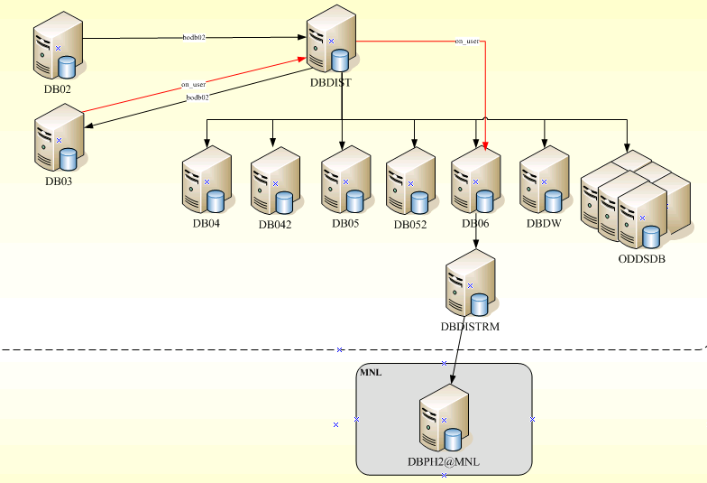

IBC DB server:
- DB02 : main db, data publisher
- DB03 : user login
- DBIP : get user IP come from country
- DB042 : admin site
- DB052 : account and agent site
- DB05: backup of DB052.
- DB06 : report and archive data
- DB07 : message
- DBODDS Group (six servers) : display odds

- ER-Diagram:

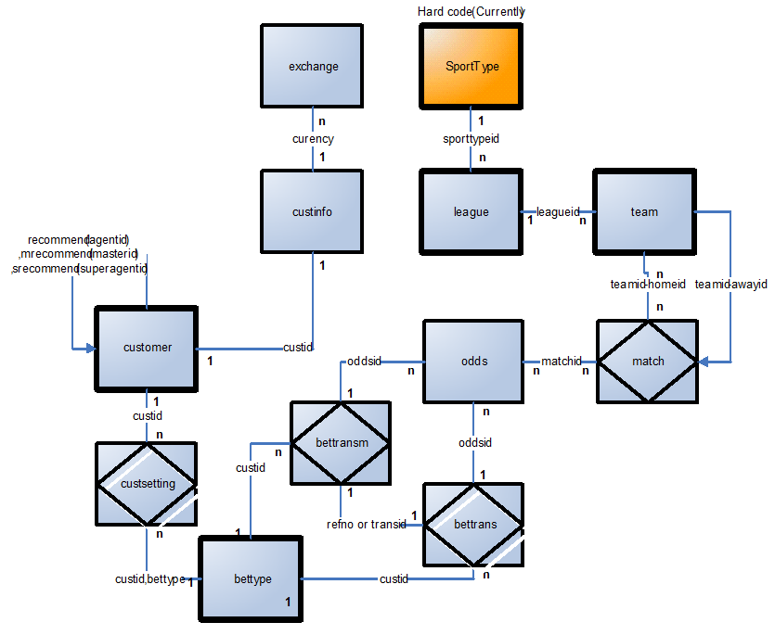

- Main tables structure:

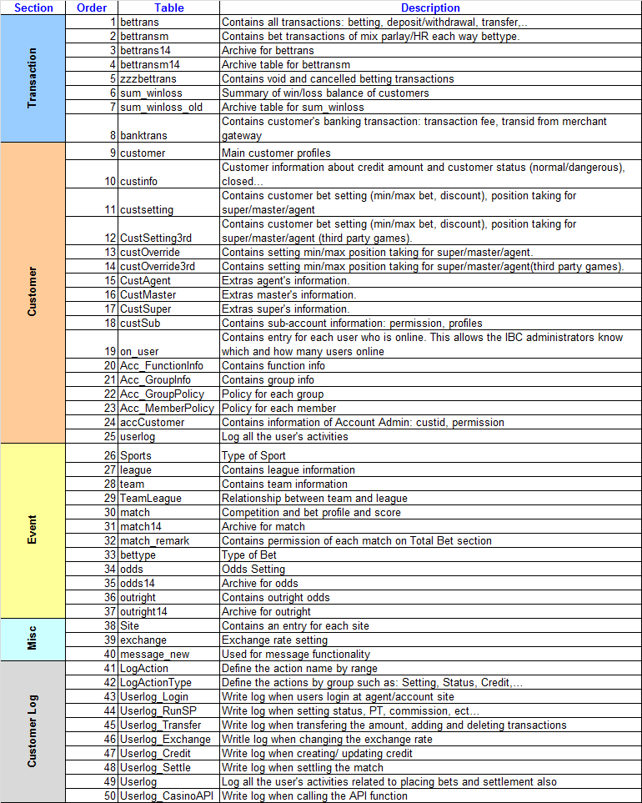

- Archive data:
a. Move [active] tables to [14] tables:
odds odds14
match match14
outright => outright14
bettrans bettrans14
bettransm bettransm14
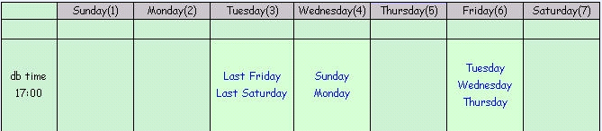

b. Move [14] tables to [archive]:
    - Run every Thursday night.
    - Every Friday DB downtime => insert openning balance into bettrans(bettype = 100)

- Examples:
a. Bettrans/bettrans14: Get tickets under the member “SRM397”

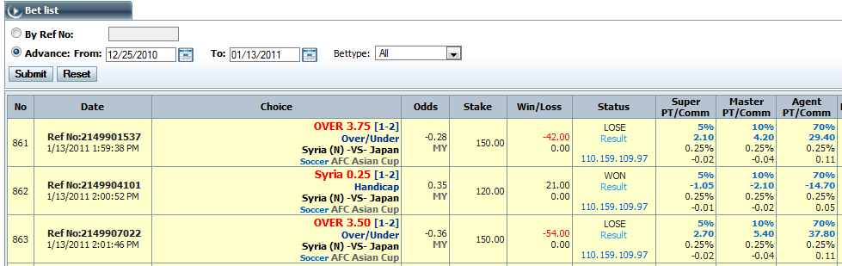

select
transid, transdate, h.teamname as home, a.teamname away, hdp1,hdp2,
b.livehomescore, b.liveawayscore,
betteam,odds,stake,winlost-actual_stake winlost, status,
spositiontaking, swinlost, sdiscount, scomm - acomm supercomm,
mpositiontaking, mwinlost, adiscount, acomm - comm mastercomm,
apositiontaking, awinlost, discount, comm - playercomm agcomm
from bettrans b (nolock)
inner join match m (nolock) on b.matchid = m.matchid
inner join team h (nolock) on m.homeid = h.teamid
inner join team a (nolocK) on m.awayid = a.teamid
where transid = 2149901537

b. Bettransm / bettransm14:

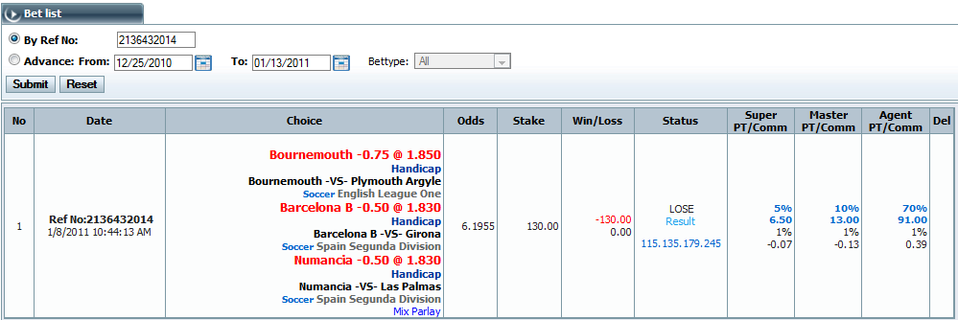

select
transid, transdate, refno,
odds,stake,winlost-actual_stake, status,
spositiontaking, swinlost, sdiscount, scomm - acomm supercomm,
mpositiontaking, mwinlost, adiscount, acomm - comm mastercomm,
apositiontaking, awinlost, discount, comm - playercomm agcomm
from bettrans14 b (nolocK)
where transid = 2136432014

select
bm.transid, bm.transdate, bettype,h.teamname as home, a.teamname away, bm.hdp1,bm.hdp2,
bm.livehomescore, bm.liveawayscore,
bm.betteam,bm.odds,bm.stake, bm.status
from bettransm14 bm(nolock)
inner join match14 m (nolock) on bm.matchid = m.matchid
inner join team h (nolock) on m.homeid = h.teamid
inner join team a (nolocK) on m.awayid = a.teamid
where refno = 100107431755

    - Customer:
      - Position taking:
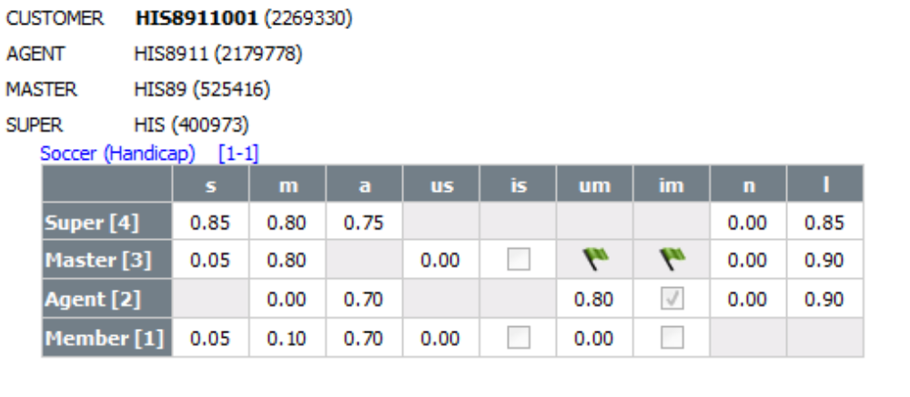
--member
select
apositiontaking, mpositiontaking, spositiontaking, isautopositiontaking, autopositiontaking,
autompositiontaking, isautompositiontaking
from custsetting (nolock)
where custid = 2269330 and sporttype = 1 and bettype = 1
--agent
select
apositiontaking, mpositiontaking, spositiontaking,
isautopositiontaking, autopositiontaking,
autompositiontaking, isautompositiontaking
from custsetting (nolock)
where custid = 2179778 and sporttype = 1 and bettype = 1
--master
select
apositiontaking, mpositiontaking, spositiontaking,
isautopositiontaking, autopositiontaking,
autompositiontaking, isautompositiontaking
from custsetting (nolock)
where custid = 525416 and sporttype = 1 and bettype = 1
--super
select apositiontaking, mpositiontaking, spositiontaking, isautopositiontaking, autopositiontaking,
autompositiontaking, isautompositiontaking
from custsetting (nolock) where custid = 400973 and sporttype = 1 and bettype = 1
--agent
select
minpositiontaking, maxpositiontaking
from custoverride (nolock)
where custid = 2179778 and sporttype = 1 and bettype = 1
--master
select
minpositiontaking, maxpositiontaking
from custoverride (nolock)
where custid = 525416 and sporttype = 1 and bettype = 1
--super
select
minpositiontaking, maxpositiontaking
from custoverride (nolock)
where custid = 400973 and sporttype = 1 and bettype = 1

      - Commission:

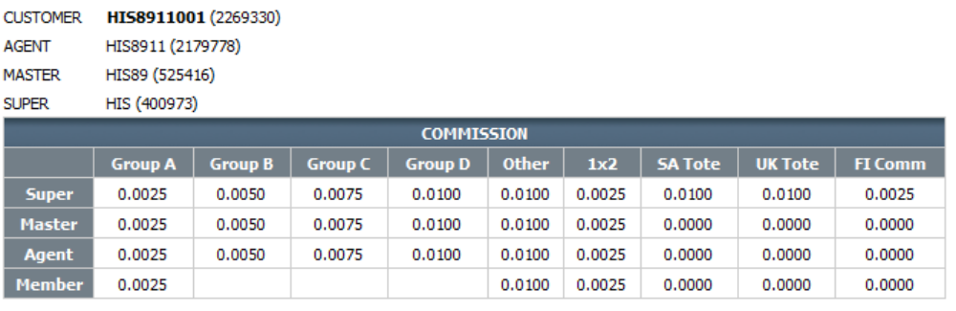
--super
select
max(groupa) groupa,max(groupb) groupb,max(groupc) groupc,max(groupd) groupd,
max(case when sporttype = 1 and bettype = 4 then sdiscount else null end) sdiscount,
max(case when sporttype = 1 and bettype = 5 then sdiscount else null end) com1x2
from custsetting cs(nolocK)
where custid = 400973
--master
select
max(groupa) groupa,max(groupb) groupb,max(groupc) groupc,max(groupd) groupd,
max(case when sporttype = 1 and bettype = 4 then adiscount else null end) sdiscount,
max(case when sporttype = 1 and bettype = 5 then adiscount else null end) com1x2
from custsetting cs(nolocK)
where custid = 525416

--agent
select
max(groupa) groupa,max(groupb) groupb,max(groupc) groupc,max(groupd) groupd,
max(case when sporttype = 1 and bettype = 4 then discount else null end) sdiscount,
max(case when sporttype = 1 and bettype = 5 then discount else null end) com1x2
from custsetting cs(nolocK)
where custid = 2179778
--member
select
max(case when sporttype = 1 and bettype = 1 then playerdiscount else null end) comm,
max(case when sporttype = 1 and bettype = 4 then playerdiscount else null end) othercomm,
max(case when sporttype = 1 and bettype = 5 then playerdiscount else null end) com1x2
from custsetting cs(nolocK)
where custid = 2269330

