- History
- Huy@20091231: more dangerous level 7 and 8
- Overview:
Requirement of More Danger Levels
- Design:
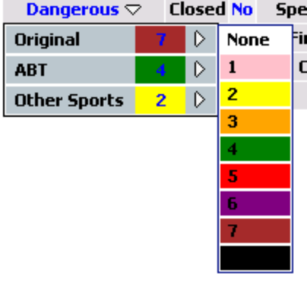
- Solution:
- 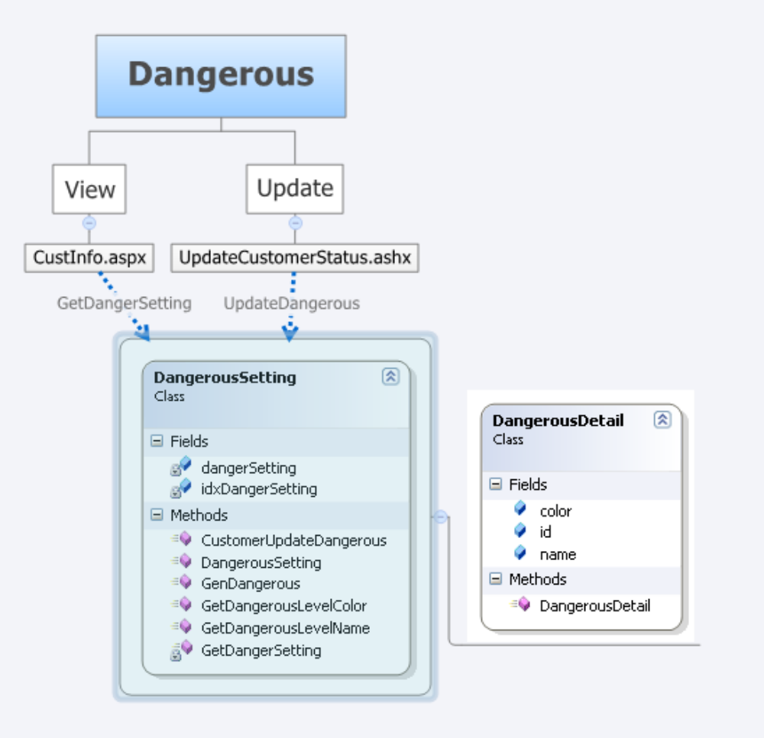Class Diagram
- App_Data\DangerousSetting.xml
- App_Code\BLL\CustInfo\DangerousSetting.cs
- Handlers\UpdateCustomerStatus.ashx
- CustInfo.aspx

