- History
- @Simon:20100120 - Created
- Overview
- Setting Casino PT.
- Design:
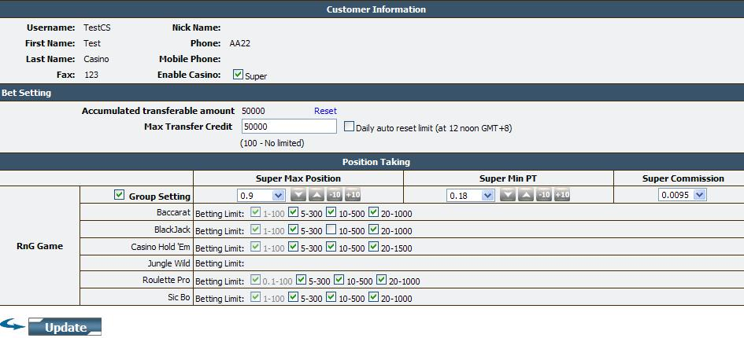
- Solution:
- Bin\CasinoLibrary.dll
- App_dll\CasinoLibrary.dll
- App_Code\DAL\APIClient\IBCLibProvider.cs
- App_Code\DAL\APIClient\APICasinoProvider.cs
- App_Code\DAL\CSCustomerDetail.cs
- App_Code\BLL\CasinoManager.cs
- Handlers\SynCasino.ashx
- Handlers\UpdateCustInfo.ashx
- Handlers\ResetMaxTransfer.ashx
- Customer\PositionTakingCS.aspx.cs
- Customer\PositionTakingCS.aspx
- js\PT\Casino\BettingLimit.js
- App_Themes\PTSetting\casino.css
- App_GlobalResources\Language.resx


