- History
@KhoaTran:20091231 - Created
- Overview
- Move site for Super or Direct Master and their downlines
- Design:
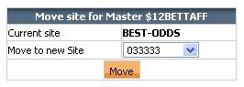
- Solution:
- Customer\ChangeSite.aspx.cs
- Customer\ChangeSite.aspx
- App_Code\DAL\Provider\CustSetting\CustSettingProvider.cs
- App_Code\DAL\AdoNet\SqlServer\CustSetting\CustSettingProviderClient.cs
- App_Code\BLL\CustSetting\CustSettingMoveSite.cs
- Handlers\UpdateMoveSite.ashx
- App_Templates\Customer\ChangeSite.htm
- App_Code\TplCore\App_Templates\Customer\ChangeSite.htm.cs


