- History
- Overview:
- Get settlement log
- Need to filter data by Date, MatchCode
- Output Data: logid, logdate, custid, username, matchid, ActionNameEN, finalhomescore, finalawayscore, hthomescore, htawayscore, GoalRecord, betstatus, Remark, IP
- Design:
- Present data in HTML table
- Paging for large data
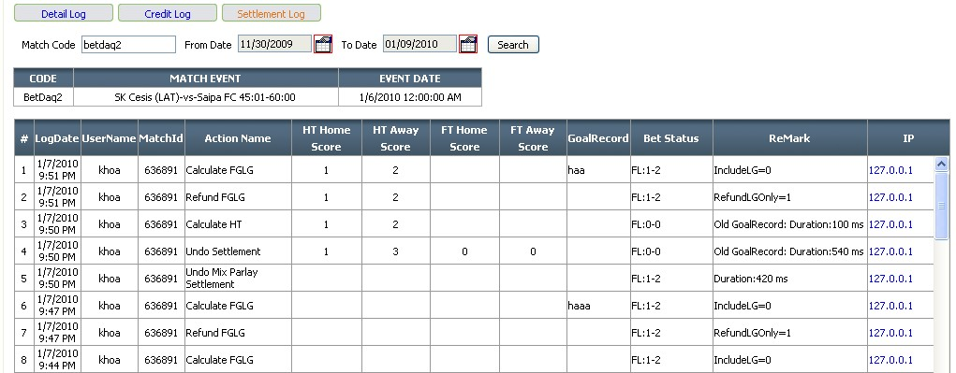
- Solution:
- Database
- Class Diagram


