**Introduction to Robot Modeling - Project 2**

**Hardware based Pick & Place Operation using UR5**

Venkata Tej Kiran

Dhinesh Rajasekaran

Arshad Shaik

**Team Members:**

1. Tej Kiran:

UID - 119197066

Linkedin - <https://linkedin.com/in/tej-kiran-379719218>

1. Dhinesh Rajasekaran:

UID - 119400241

Linkedin - <https://www.linkedin.com/in/dr24/>

GITHUB: <https://github.com/stark-2000>

1. Arshad Shaik:

UID - 118438832

Linkedin - <https://linkedin.com/in/arshad-shaik-b10b5044>

GITHUB: <https://github.com/Arshad-Engineer>

**Introduction:**

The main objective of this project is to implement an application based on basic pick and place operation using the Universal UR5 manipulator in the Robot Realisation Laboratory.

This proposal is organized into the following sections:

* Motivation
* Robot Description
* Robot Appropriateness for the task
* Scope Description
* Scope Appropriateness
* Model Assumptions
* Approach to performing the work
* Milestones with timeline
* Validation Plan

**Motivation:**

Utilising the core concepts from the ‘Introduction to Robot Modeling’ course, it is agreed among the team members to explore these concepts in a real-world hardware application. Upon several discussions with Prof.Reza Monfaredi and evaluating different available options at the University of Maryland labs, it is narrowed down to utilise Universal Robot’s UR5 manipulator, a flexible robotic arm, to implement ‘pick and place’ application.

**Robot Description:**

The UR5 is a lightweight, adaptable collaborative industrial robot that tackles medium-duty applications with ultimate flexibility. The UR5 is designed for seamless integration into a wide range of applications. UR5 is also offered as an [OEM robot system](https://www.universal-robots.com/products/oem-robots/) and with a [3-Position teach pendant](https://www.universal-robots.com/products/3pe/).

Main Technical Specifications:

Payload Capacity: Up to 5 kg

Max Reach: 850 mm

Footprint: 149 mm

Weight: 20.56 kg

I/O Power Supply Voltage: 12/24 V

The Degrees of Freedom of UR5 is calculated as follows:

DoF

Number of Links N = 6

Number of Joints J = 5

DOF in 3-D space m = 6

DoF = 6(6-1-5) + 5 * 1 = 5

**Robot Appropriateness for the task:**

UR5 is selected for the application, for the following reasons:

* Easy programming: Quickly set up and operate with intuitive, 3D visualization
* Collaborative and Safe: As this is our primitive project on robot modeling, UR5 being compliant to safety standards as per TUV(The German Technical Inspection Association), would be ideal for our project.
* Flexible Deployment: Easy to re-deploy to multiple applications, creating opportunity to further explore the possibilities in the upcoming course of robotic studies.
* Availability: The robot is expected to be available for the implementation and explore tasks associated with the project.
* ROS Package: compatible with ROS and official ROS package is available for UR5 which may be used during the hardware implementation phase. The ROS package that we developed will be used for demonstration in Gazebo and while deploying in actual hardware, for safety reasons the official package may be used.

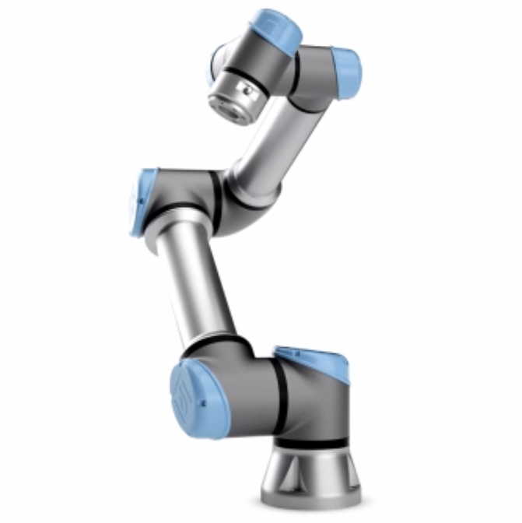

Fig 1: Universal Robots - UR5

**Scope Description:**

* The scope of the project is to implement an application based on pick and place operation using the UR5 robotic arm, utilising the concepts of forward kinematics, inverse kinematics, and the tools such as Solidworks, Gazebo and ROS.
* Here the inverse kinematic and forward kinematics of the robot may be studied and explored. Gazebo implementation of pick and place may be performed using SOLIDWORKS model and our own ROS package.
* Deploy the parameters derived for IK and FK on the official ROS package on real hardware UR5 in RRL.

**Ambitious Goal:**

1. Check availability of the end effector and move the robot arm to desired waypoints in the 3-D space, to perform an operation such as pick and place, hook etc
2. Final application is still debatable as it depends on end effector availability at that time as it might be engaged with other lab members. In the event of its availability, basic pick and place of some objects placed in given waypoints may be performed or any other application based on prof recommendation.
3. The object location and its desired end location will be given, UR5 will reach the initial location, grab the object and place it in the given desired location.

**Fall Back Goals:**

1. Simulation of UR5 in gazebo world with custom designed world in Gazebo with our own ROS package.
2. Implement basic movement of UR5 hardware in RRL where the robot may reach a given start location from any random arbitrary location and then move to a given end/desired location without any pick and place of objects.

**Scope Appropriateness:**

The rationale for the appropriateness of the this project is evaluated based on the following factors:

* Utilization of some of the core concepts taught in the class - Forward Kinematics, Inverse Kinematics, D-H Parameters, Jacobians, etc.
* Expected timeline of the project
* Using the real-world hardware, rather than relying only on simulation
* Skill level of the project resources
* Ability to program and utilize industrial grade robots.

**Model Assumptions:**

As it is proposed to reuse the existing UR5 model, currently (at the time of project proposal), there aren’t any known assumptions. However, they will be mentioned, as we come to realize of any, during the project execution

**Approach to performing work:**

The following is the proposed approach to the project:

* Build / Reuse UR5 CAD model in SOLIDWORKS
* Import model to Gazebo and add transmissions & controllers
* Create ROS package and implement FK
  + Basic working (reach desired loc – angles given – just move as per angles)
* Same package, implement IK
  + Basic working (reach desired loc – desired loc given – calc angles & move)
  + Move between initial and final location given those locations from a random arbitrary location/point
* Implement Move IT for basic pick and place applications
* Design neat and good-looking Gazebo world (if Move IT works)
* Import official UR5 package and test IK/FK from above on HW UR5
* Check availability of end effector and try pick & place of basic objects using move IT or UR5 official package.
* Ambitious Goal: Final application (based on prof recommendation or our own application – opening a door, switching off knobs)
* Fallback Goal: Move the robot arm to desired waypoints in the 3-D space

**External Dependencies (as of now - during proposal):**

UR5 Cad Model: <https://grabcad.com/library/ur5-5>

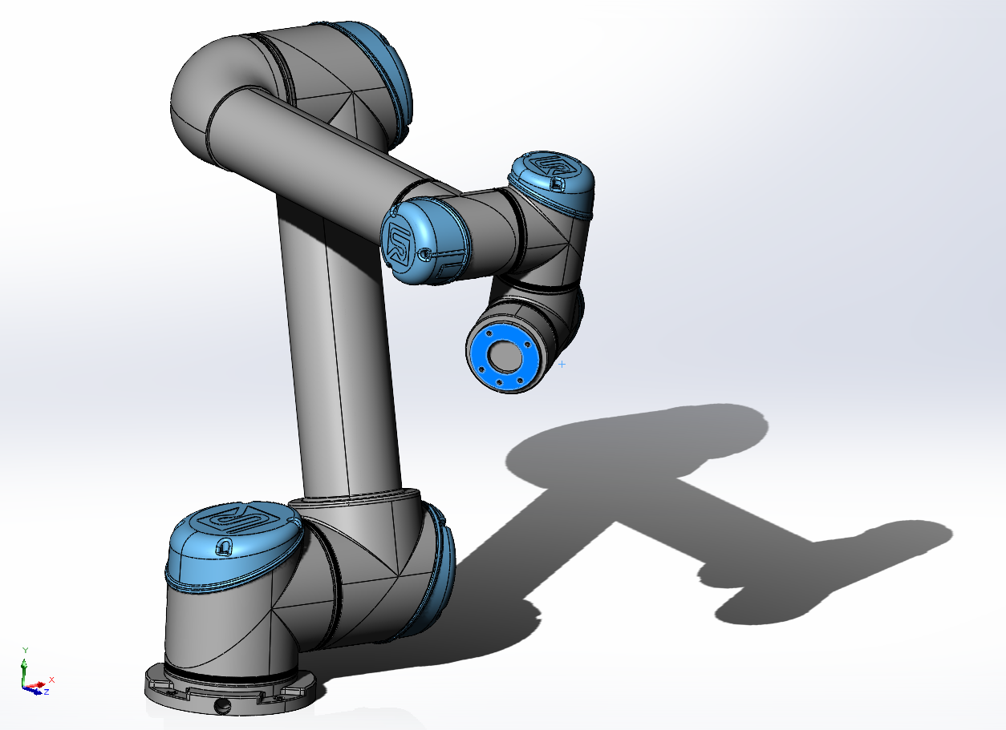

Fig 2: UR5 Model - SOLIDWORKS

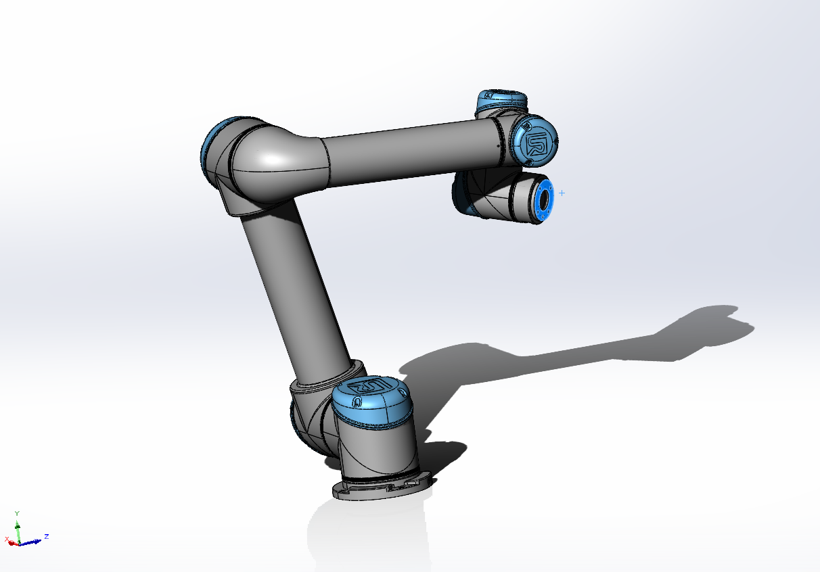

Fig 3: UR5 Model - SOLIDWORKS

**Milestones with Timeline:**

| **SN** | **Phase** | **Milestone** | **Time (2022)** |
| --- | --- | --- | --- |
| 1 | Proposal | Project Proposal | Nov 6 |
| 2 | Design & Implementation | Solidworks Model | Nov 7 - Nov13 |
| 3 | Design & Implementation | Simulation in Gazebo world  (Add transmissions & controllers, Gazebo World) | Nov 7 - Nov13 |
| 4 | Design & Implementation | Create ROS package and implement FK | Nov 7 - Nov13 |
| 5 | Design & Implementation | ROS Package and IK | Nov 7 - Nov13 |
| 6 | Design & Implementation | Implement MoveIt | Nov 14 - Nov 21 |
| 7 | Test and Validation | Test IK/FK from above on HW UR5 | Nov 14 - Nov 21 |
| 8 | Project Delivery | Final Project Submission (report + Presentation) | Dec 5 |

**Validation Plan:**

The robotic arm is driven to the desired configuration and will be checked for the position of the end-effector, against the given value.

Further, possibly a ‘Pick and Place operation’ at the desired location will be evaluated. The above tasks will be carried out in the following phases.

Phase 1: Simulation based validation in Gazebo

Phase 2: Hardware based validation

More details regarding the validation will be added as the project progresses.