Umpire Buddy Lab #1
CS449

Lab Assignment

The purpose of this lab assignment is to help you get started with Android programming. It will introduce you to the syntax and semantics of Android/Java along with the mechanics of using Android Studio with the Android plugin.

The lab assignment is to create an Android application that can function as a ball-strike counter an umpire might use during a baseball game to keep track of the count for a batter.

For now, the application only needs to keep track of balls and strikes for a single batter. In a future assignment, I may have you extend it to keep track of outs and/or innings. (If you want to add extra features during assignment #1, have at it.)

If the count reaches 3 strikes first, your application should display a dialog box announcing the batter is “Out!” If the count reaches 4 balls first, your application should display a dialog box announcing “Walk!” After either one, the count should be reset for the next batter.

The final result should look something like:

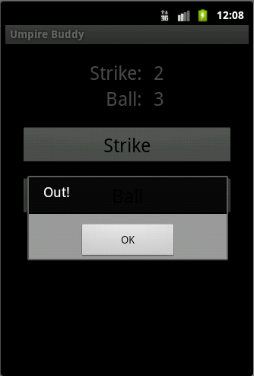
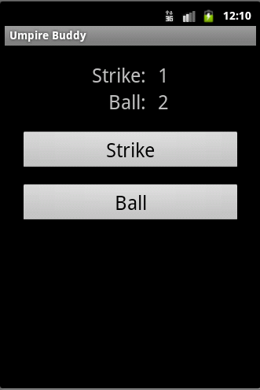

Question: What, if anything, is created for you when you enter the following as a value in an .xml layout?
android:id="@+id/strike_button"

What about when you enter:
android:text="@string/strike_button_label"

Explain.
android:id="@+id/strike_button" creates an id to link the button to use in java.

android:text="@string/strike_button_label" the app is going to find the value of the string in the resources file.

