Arduino Nano Beginner
Embedded Reverse Engineering CTF

1. Introduction
This tutorial teaches you how to reverse engineer firmware from an Arduino Nano (ATmega328P) board. Everything is done on Windows 10/11 using only HxD, avr-objdump, avrdude, Notepad, and Arduino IDE. No Ghidra, no Python, no strings.exe required. Every step has been tested on real hardware.

💡 Windows OS
This tutorial is fully tested on Windows 10/11. All commands, paths, and tools are Windows-specific. Linux/Mac users will need to adjust paths and port names.

2. Requirements

2.1 Hardware
Item | Details
Arduino Nano | ATmega328P chip — onboard LED on pin 13
Micro USB Cable | Data transfer capable — not charge-only!
Windows PC | Windows 10 / 11

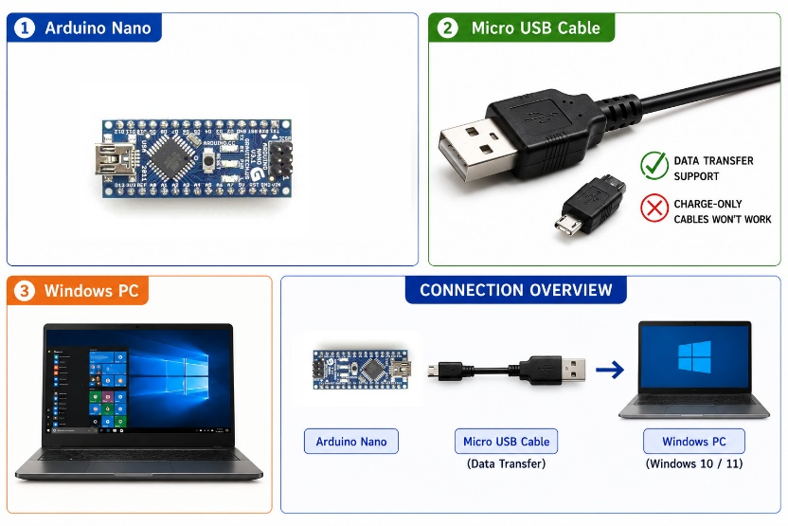

2.2 Software
Tool | Source | Purpose
Arduino IDE | arduino.cc/en/software | avr-objdump + avrdude + Serial Monitor
HxD Hex Editor | mh-nexus.de/en/hxd | Hex view + patch bytes
Notepad | Windows built-in | Read disassembly.txt
BAT files | Included in challenge package | Extract, disassemble, flash — ready to run

💡 BAT Files Provided
The challenge package includes all required .bat files: extract_new.bat, extract_old.bat, backup.bat, disassembly.bat, flash_new.bat, flash_old.bat. No manual command typing needed!

3. ATmega328P Flash Memory — Theory
Before patching, let's understand how flash memory works. This is the most important theoretical foundation of this tutorial.

💡 Harvard Architecture
AVR uses a Harvard architecture, meaning program memory (flash) and data memory (SRAM) are completely separate address spaces. Flash stores your code and initial data values. SRAM is where variables live at runtime. This is why the same address number (e.g. 0x0100) can refer to a flash location and a SRAM location simultaneously — they are different physical memories.

3.1 Flash Memory — Everything is Raw Bytes
Inside the ATmega328P flash memory, everything is ultimately stored as raw bytes. The same bytes can mean completely different things depending on how a tool interprets them:

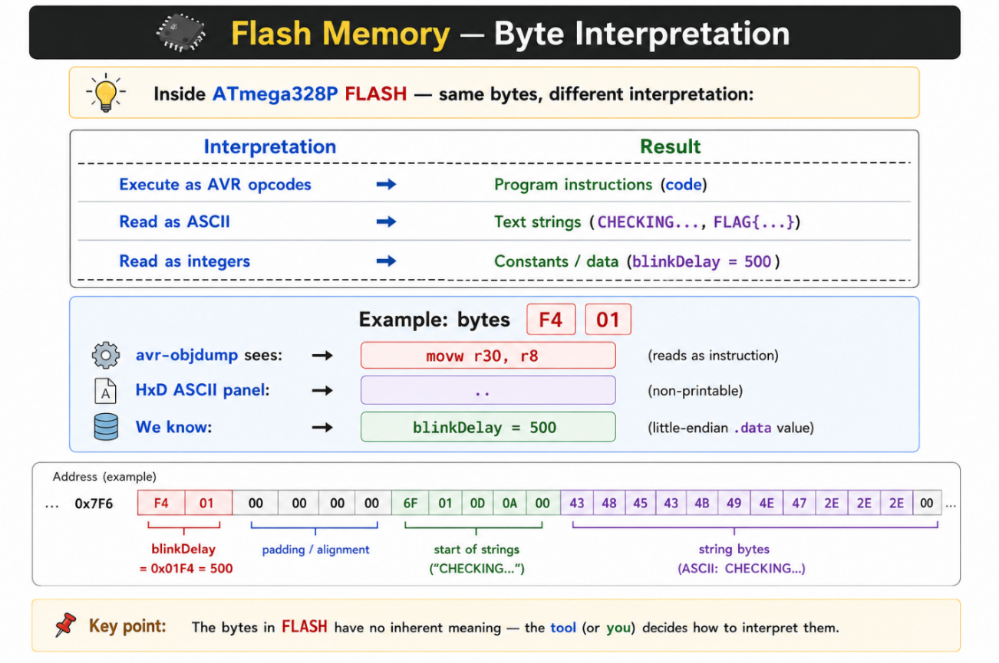
🎓 Same Bytes, Different Meaning
The bytes F4 01 at flash offset 0x7F6 — avr-objdump decodes them as 'movw r30, r8' instruction, but they are actually blinkDelay = 500 stored as data! Knowing whether you are in a code section or .data section is critical before patching.

3.2 Arduino .hex File — Contents
When Arduino IDE compiles a sketch it generates a .hex file containing these sections:

Section | Purpose | Flash Location
.text | AVR machine code (program instructions) | Flash start 0x0000
.rodata | Read-only constants (PROGMEM strings) | Flash — after .text
initial .data | RAM variable initial values (blinkDelay lives here!) | Flash — .data section
Interrupt vectors | Hardware interrupt jump table | Flash 0x0000 area

💡 initial .data Section
volatile int blinkDelay = 500 is stored in the initial .data section. The initial values for .data variables are stored in flash memory. During boot, AVR startup code copies those values into SRAM, where the variables actually live and are accessed during execution. The flash copy is read-only source — the SRAM copy is what your code reads and writes. That is why patching flash offset 0x7F6 changes the blinkDelay value in SRAM at boot time.

3.3 HEX vs BIN Format
avrdude can save firmware as HEX or BIN. We use BIN because:

Feature | HEX Format | BIN Format
File type | Text (ASCII readable) | Raw bytes (binary)
Contains | Addresses + checksums + data | Pure binary data only
File size | Larger | Smaller
HxD analysis | Addresses confuse the view | Direct byte view ✅
Patch friendly | Complex | Simple — offset = exact byte ✅
Our choice | — | ✅ We use BIN

🎓 Why BIN over HEX?
BIN format is pure raw bytes. Offset 0x7F6 in the file = exactly byte 2038. You can jump directly in HxD using Ctrl+G. HEX format mixes in text addresses and checksums which makes direct patching complex. Always read flash as BIN using: -U flash:r:firmware.bin:r

3.4 Flash Read — What Gets Included?
Region | Included? | Notes
Application firmware | YES ✅ | Your compiled Arduino sketch
.data section (blinkDelay, strings) | YES ✅ | All RAM variable initial values
Bootloader (Optiboot) | MAYBE ⚠️ | Included only on full flash read
Interrupt vectors | YES ✅ | Flash 0x0000 area

💡 Bootloader Note
Whether the bootloader is included in a flash read depends on the read size and fuse configuration. avrdude can read the full 32KB flash region regardless of what is stored there. Arduino IDE normally uploads only to the application section, leaving the bootloader intact. When you read back flash with avrdude, you may receive the full image including the Optiboot bootloader at 0x7E00 — or only the application section depending on your read command parameters.

4. Firmware Source Code
Challenge firmware (embedded_CTF_arduino_nano_0.ino):

Arduino Sketch
#define LED_PIN 13

volatile int blinkDelay = 500; // stored as F4 01 at flash .data offset 0x7F6
boolean doneFlag = false;

void setup() {
pinMode(LED_PIN, OUTPUT);
Serial.begin(9600);
Serial.println("CHECKING...");
}

void loop() {
digitalWrite(LED_PIN, HIGH);
delay(blinkDelay);

digitalWrite(LED_PIN, LOW);
delay(blinkDelay);

if (blinkDelay == 100) { // flag trigger condition
if (!doneFlag) {
Serial.println("FLAG{patched_the_firmware}");
}
doneFlag = true;
} else {
Serial.println("SYSTEM LOCKED");
}
}

Code | Purpose
volatile int blinkDelay = 500 | RAM variable — stored as F4 01 in flash .data at 0x7F6
boolean doneFlag = false | Ensures flag prints only once
Serial.println("CHECKING...") | Printed once at boot via Serial Monitor
delay(blinkDelay) | LED ON/OFF timing — uses RAM value
if (blinkDelay == 100) | Flag trigger — prints flag if value is 100
Serial.println("SYSTEM LOCKED") | Printed every loop when blinkDelay != 100

💡 delay() Uses Milliseconds The delay() function takes milliseconds as its argument. So delay(500) = 0.5 seconds per blink phase and delay(100) = 0.1 seconds per blink phase. At 500ms the LED blinks visibly slowly. At 100ms it blinks noticeably fast — a clear visual confirmation that your patch worked.

5. volatile Keyword — Why It Matters
Without volatile, the compiler can treat blinkDelay as a compile-time constant.This allows the optimizer to eliminate the condition if(500 == 100) as always false, and remove the associated code block as unreachable.The FLAG string is also typically removed as a side effect but the primary issue is the condition elimination, not the string.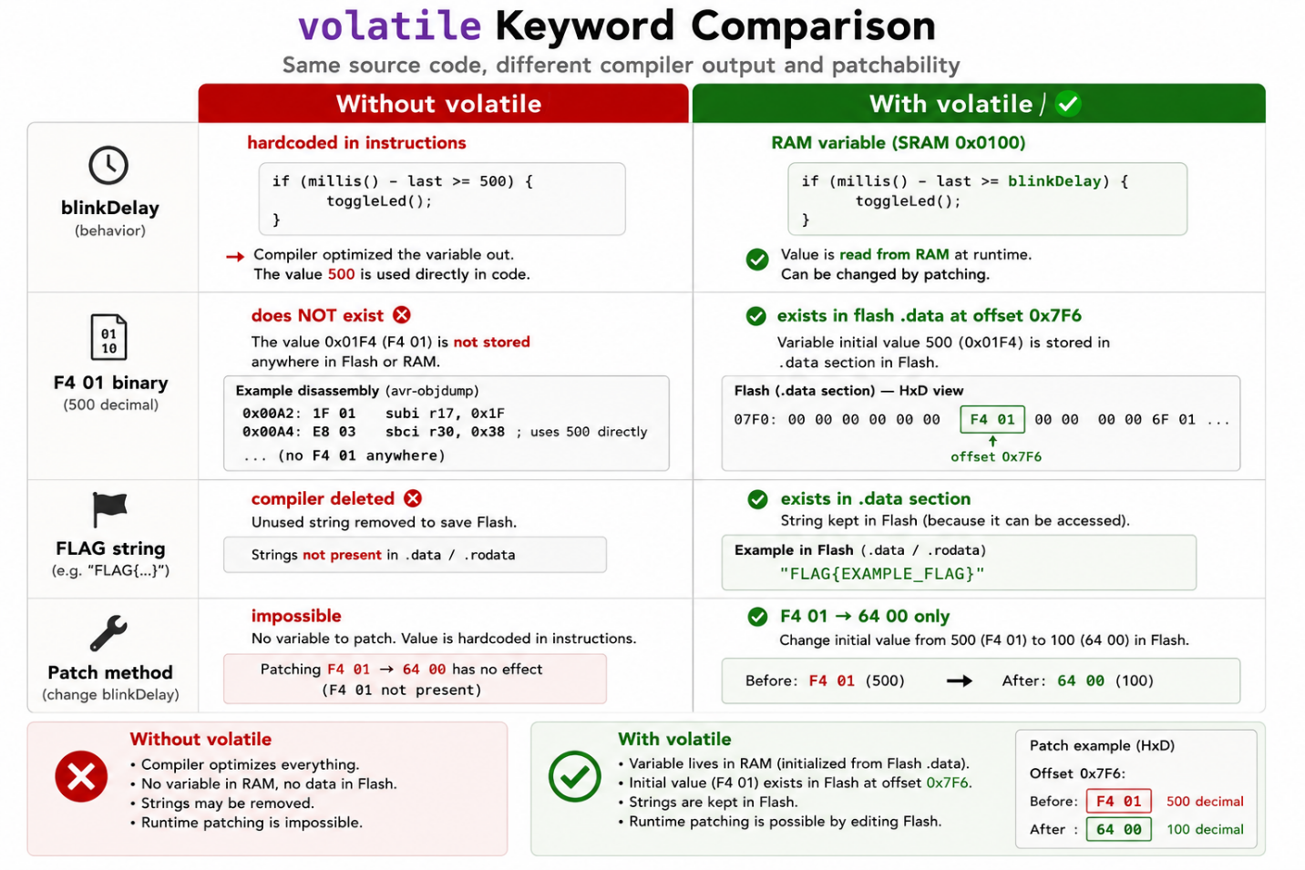

💡 Arduino Compiler Optimization Arduino IDE typically compiles with optimization enabled (-Os), which aggressively removes dead code, unreachable branches, and unused data. This is why the compiler eliminates the entire if(blinkDelay==100) block when blinkDelay is not volatile — the optimizer proves the condition can never be true and removes it completely.

⚠️ Without volatile
Without the volatile keyword, no amount of binary patching can trigger the flag — because the flag condition and FLAG string were completely removed by the compiler optimizer. volatile is what makes this challenge patchable.

6. Challenge Overview

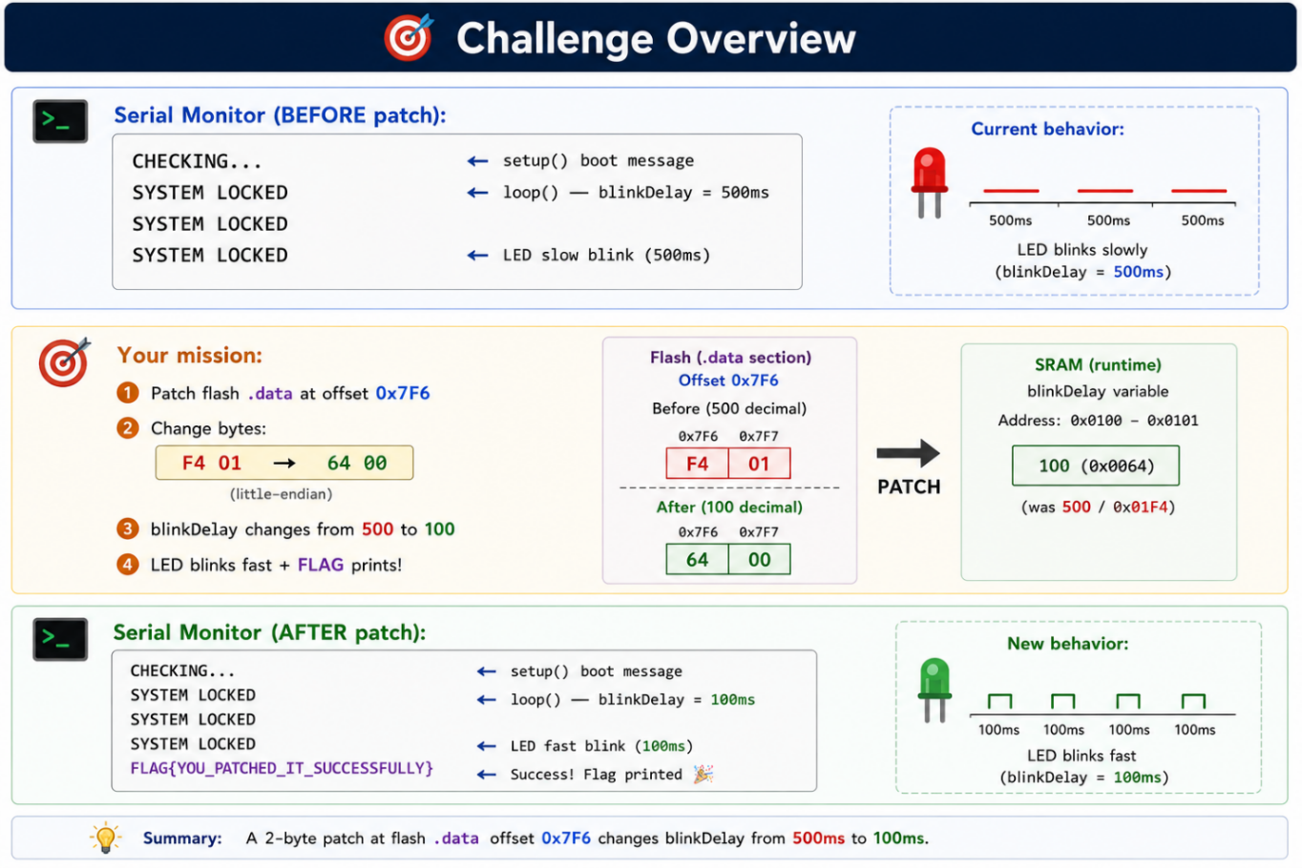
✅ AFTER Patch — Expected Result
CHECKING... (boot) FLAG{patched_the_firmware} (100ms blink, printed once)

7. What is an Offset? — Binary Street Analogy
Understanding offsets is critical for patching. Think of a binary file as a long street. Every byte has a house number — that is its offset.

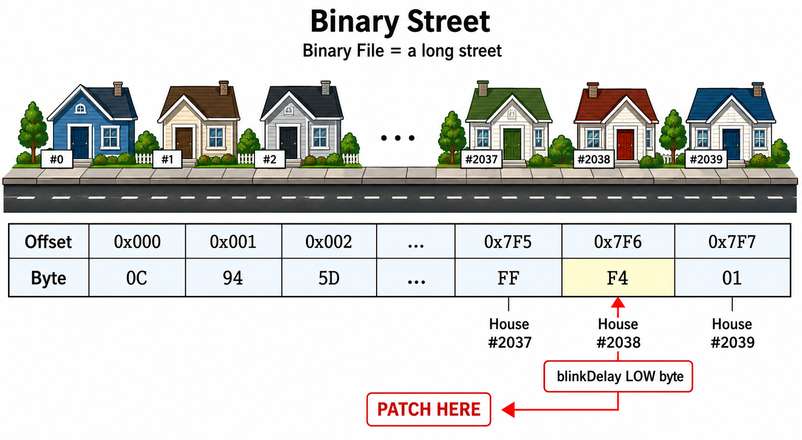

7.1 Decoding 0x7F6
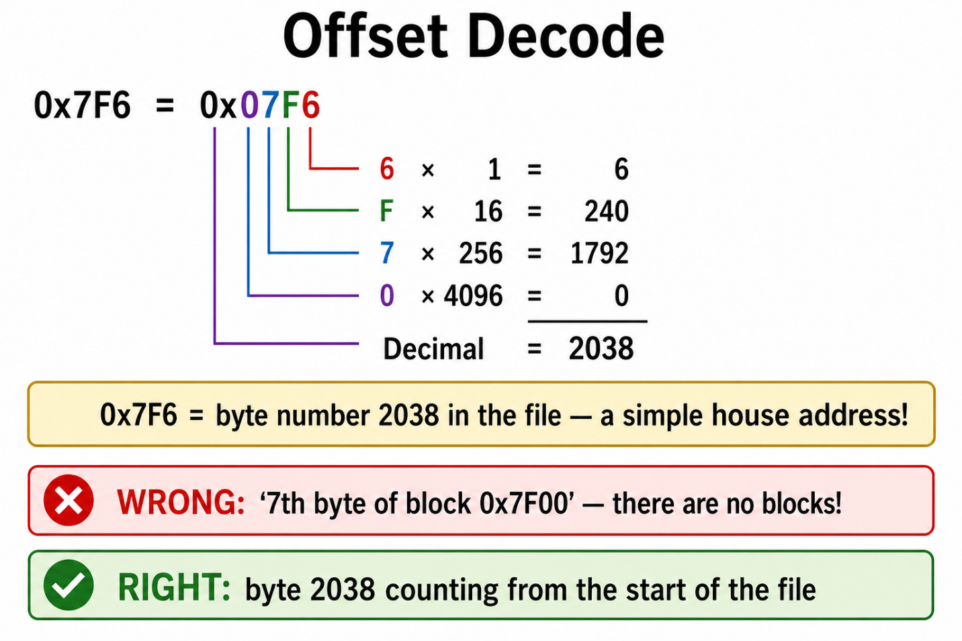
💡 Offset = Linear Address
Binary file offsets are linear — just sequential numbers. 0x7F0 = byte 2032, 0x7F6 = byte 2038. HxD Ctrl+G → 7F6 jumps directly to byte 2038. No blocks, no sections — pure linear addressing.

8. Extracting Firmware — avrdude

8.1 Set Up Working Folder
- Create a folder called CTF on your Desktop.
- Extract the challenge package into the CTF folder.

8.2 avrdude — Every Flag Explained
Full anatomy of the avrdude read command:

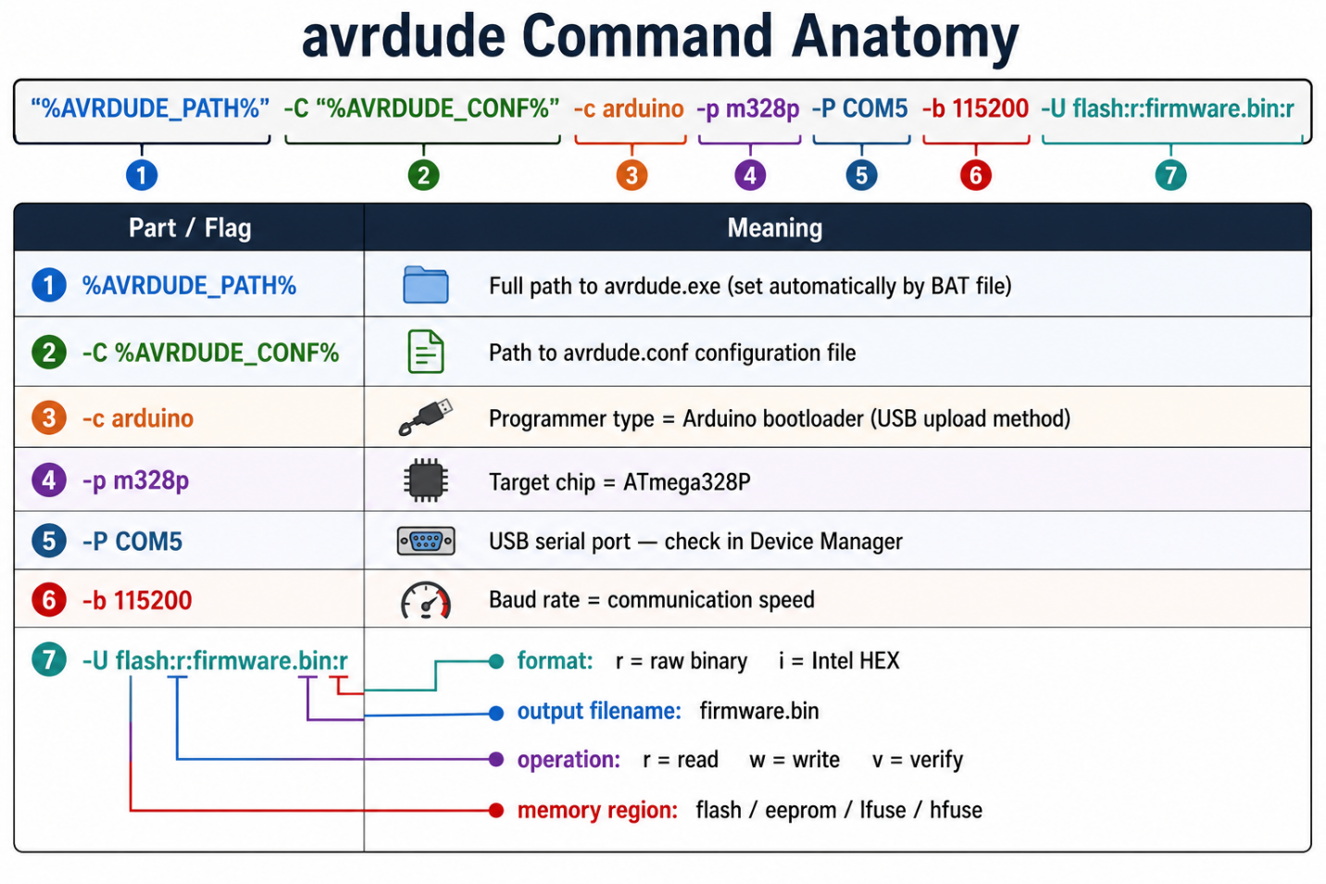
⚠ Arduino IDE Tools Path
All BAT files use tools installed by Arduino IDE 1.8 .xx — avrdude and avr-objdump are NOT separate downloads. Arduino IDE must be installed first. The default tool path is:
C:\Users\<username>\AppData\Local\Arduino15\packages\arduino\tools\
Change <username>

8.3 Bootloader Versions — Baud Rate
The correct baud rate depends on which bootloader is on your Arduino Nano:

Bootloader | Baud Rate | BAT File
New bootloader (CH340 chip) | 115200 | extract_new.bat
Old bootloader (FT232 chip) | 57600 | extract_old.bat

⚠️ Baud Rate — Both Tested
115200 (new bootloader) and 57600 (old bootloader) are both tested and confirmed working. If the upload fails with a timeout error, switch to the other baud rate BAT file.

8.4 BAT Files for Extract and Backup
The challenge package includes ready-made BAT files:
extract_new.bat
extract_new.bat — New bootloader (115200 baud)
──────────────────────────────────────────────────────────────
@echo off
set AVRDUDE_DIR=C:\Users\<username>\AppData\Local\Arduino15\packages\arduino\tools\avrdude

for /d %%D in ("%AVRDUDE_DIR%\*") do set AVRDUDE_PATH=%%D\bin\avrdude.exe & set AVRDUDE_CONF=%%D\etc\avrdude.conf

"%AVRDUDE_PATH%" -C "%AVRDUDE_CONF%" -c arduino -p m328p -P COM5 -b 115200 -U flash:r:embedded_CTF_arduino_nano_0_ino.bin:r

echo Done! embedded_CTF_arduino_nano_0_ino.bin saved.

pause

extract_old.bat
extract_old.bat — Old bootloader (57600 baud)
──────────────────────────────────────────────────────────────
@echo off
set AVRDUDE_DIR=C:\Users\<username>\AppData\Local\Arduino15\packages\arduino\tools\avrdude

for /d %%D in ("%AVRDUDE_DIR%\*") do set AVRDUDE_PATH=%%D\bin\avrdude.exe & set AVRDUDE_CONF=%%D\etc\avrdude.conf

"%AVRDUDE_PATH%" -C "%AVRDUDE_CONF%" -c arduino -p m328p -P COM5 -b 57600 -U flash:r:embedded_CTF_arduino_nano_0_ino.bin:r

echo Done! embedded_CTF_arduino_nano_0_ino.bin saved.

pause
pause

backup.bat
backup.bat — Save a safe copy of original firmware
──────────────────────────────────────────────────────────────
@echo off
copy embedded_CTF_arduino_nano_0_ino.bin embedded_CTF_arduino_nano_0_ino.bin _backup.bin
echo Backup saved as embedded_CTF_arduino_nano_0_ino.bin_backup.bin
pause

💡 COM Port
Change COM5 to your actual port. Open Device Manager → Ports (COM & LPT) → plug and unplug the Arduino to identify which port appears and disappears.

9. HxD — Viewing Strings and Binary
Opening firmware.bin in HxD shows hex bytes on the left and ASCII characters on the right simultaneously. Scrolling to the bottom reveals readable strings in the ASCII panel — no separate tool needed.

9.1 Open and Scroll
- Open HxD.
- File → Open → firmware.bin.
- Press Ctrl+End to scroll to the bottom.
- ASCII panel on the right shows readable strings.

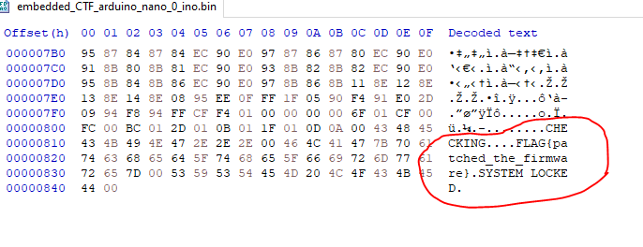
🎓 HxD = Hex Editor + String Viewer
No strings.exe needed. Opening firmware.bin in HxD and scrolling to the bottom immediately shows CHECKING..., SYSTEM LOCKED, and FLAG{patched_the_firmware} in the ASCII panel on the right side.

10. avr-objdump — Generating Disassembly

10.1 disassembly.bat
The challenge package includes disassembly.bat:

disassembly.bat
disassembly.bat
──────────────────────────────────────────────────────────────────
@echo off
setlocal

set GCC=C:\Users\<username>\AppData\Local\Arduino15\packages\arduino\tools\avr-gcc\5.4.0-atmel3.6.1-arduino2\bin

set PATH=%GCC%;

avr-objdump -b binary -m avr5 -D --adjust-vma=0 embedded_CTF_arduino_nano_0_ino.bin > disassembly.txt
pause

Flag | Meaning
-b binary | Input file format = raw binary (not ELF or Intel HEX)
-m avr5 | Machine architecture = AVR5 (ATmega328P belongs to this family)
-D | Disassemble ALL sections including .data — not just code
--adjust-vma=0 | Set virtual memory start address to 0x0000 (matches ATmega328P flash start)
> disassembly.txt | Redirect output to a file instead of printing to screen

💡 Why --adjust-vma=0?
ATmega328P flash starts at address 0x0000. Using --adjust-vma=0 ensures offsets shown in disassembly.txt exactly match offsets in HxD. When Notepad shows offset 7f6, you type exactly 7f6 in HxD Ctrl+G — they always match!

- Double-click disassembly.bat.
- disassembly.txt is generated in the CTF folder.
- Open disassembly.txt in Notepad.

11. Reading disassembly.txt — The Loop Logic
In Notepad press Ctrl+F and search for 0x0100. You will find where the loop() function loads blinkDelay from RAM:
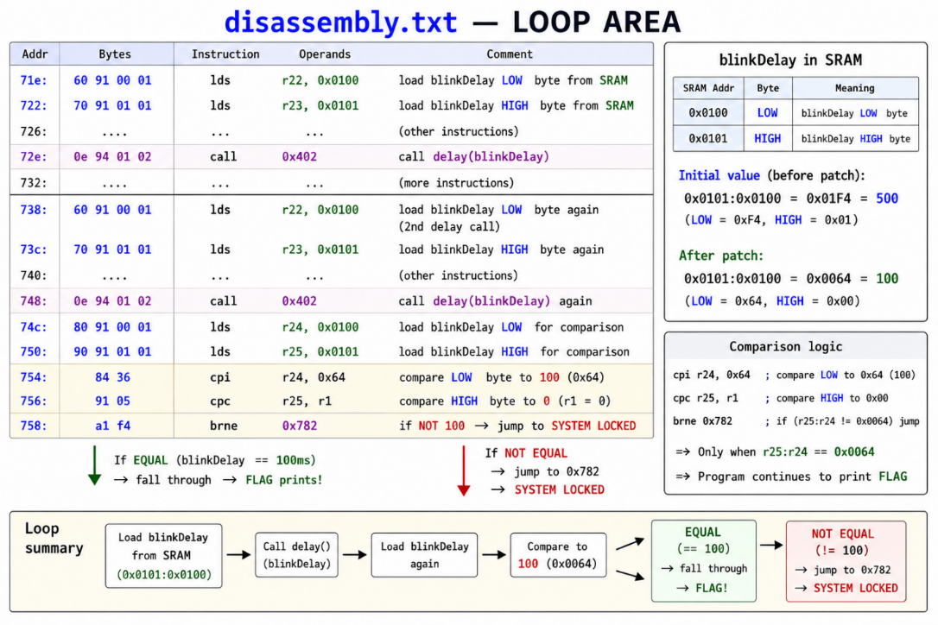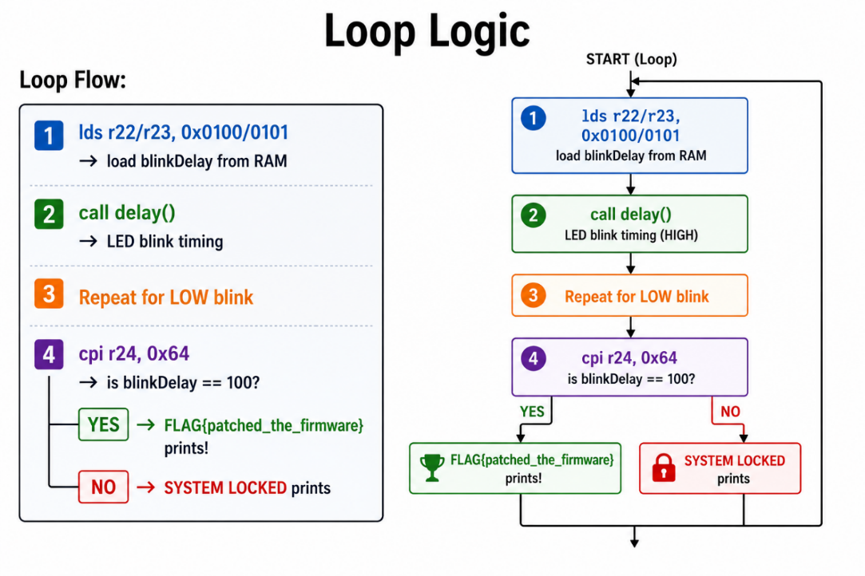

🎓 lds Instruction — volatile Forces RAM Read
Because of the volatile keyword, the compiler generates lds (Load from SRAM) instructions every loop iteration. blinkDelay is always read fresh from SRAM 0x0100. No caching, no optimization. If we change the RAM value at boot (by patching .data), every loop reads the new value.

12. cpi Instruction — Comparing to 100
The comparison if(blinkDelay == 100) becomes these AVR instructions:

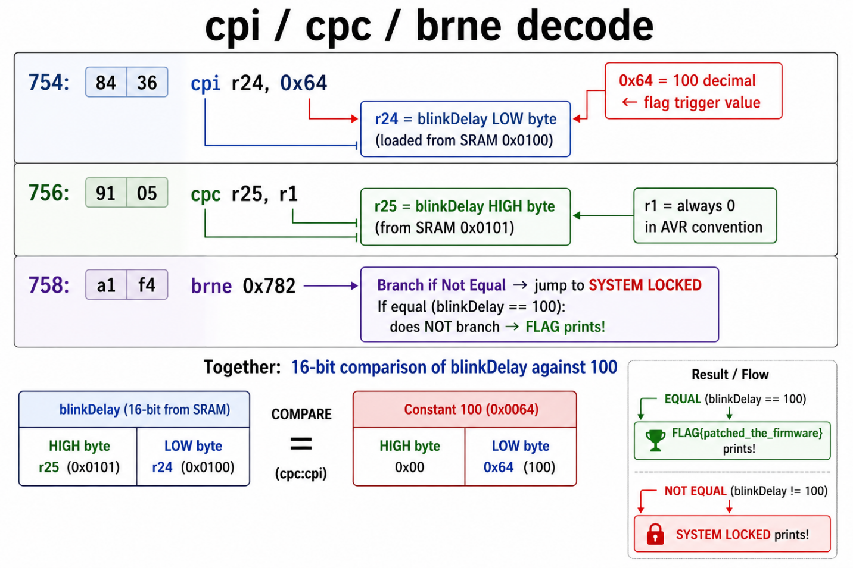
🎓 100 in Hex
100 decimal = 0x64 hex. The cpi instruction compares blinkDelay low byte directly to 0x64. If blinkDelay is 100 (0x0064), both cpi and cpc set the zero flag, brne does NOT branch, and execution falls through to the FLAG print.

13. The .data Section — How blinkDelay is Stored in Flash
At boot time, the AVR startup code copies the .data section from flash to SRAM:

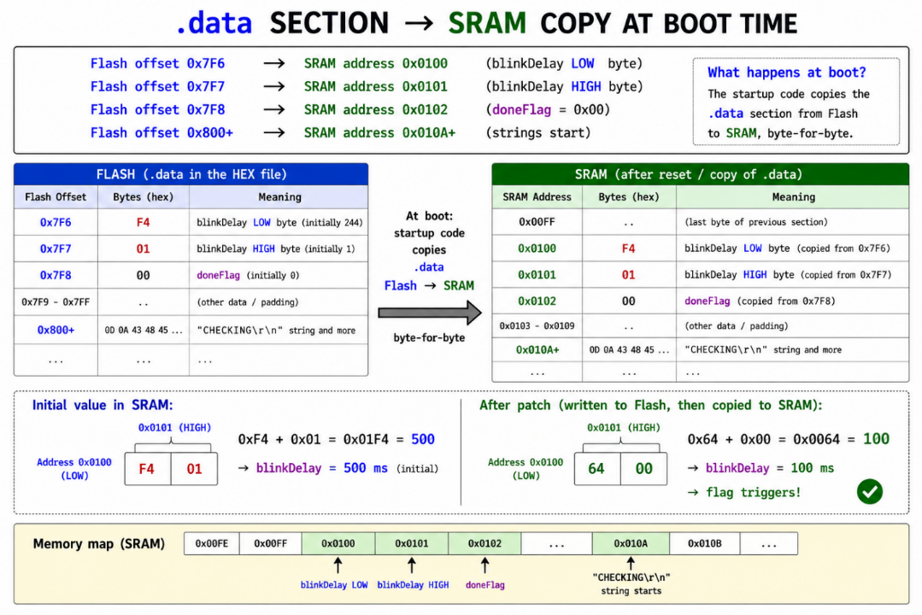

💡 Why is the SRAM offset not 1:1? The .data section copy is sequential — flash bytes map to SRAM in order starting at 0x0100. blinkDelay takes bytes 0x0100–0x0101, doneFlag takes 0x0102, then padding fills a few bytes before strings begin at 0x010A. The gap exists because of variable alignment and additional runtime variables inserted by the Arduino framework.

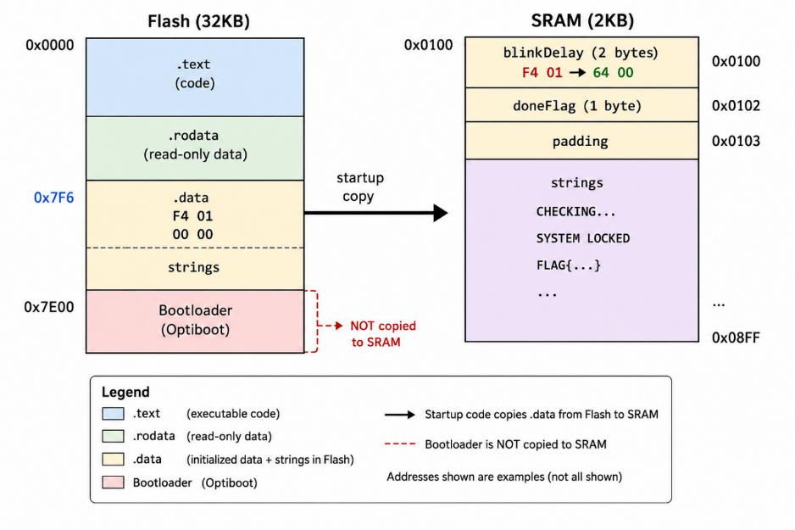

14. avr-objdump .data Confusion — Important Understanding
avr-objdump with -D disassembles the entire binary as code — including the .data section. This causes confusing output at the end of the file:

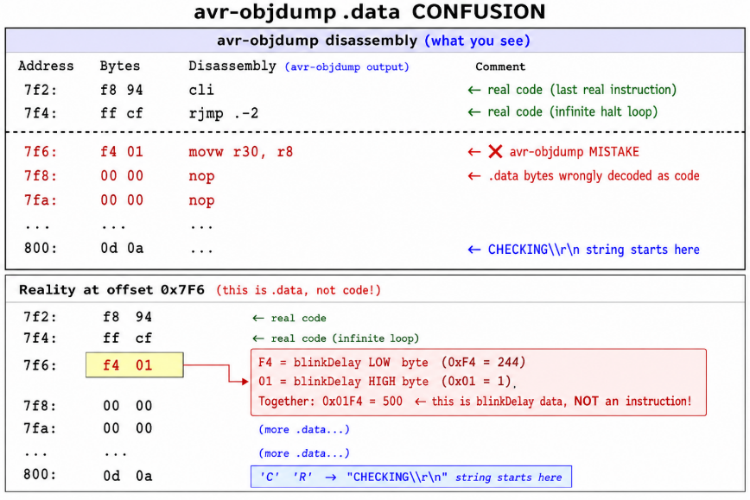
🎓 avr-objdump -D Limitation
avr-objdump -D decodes the entire binary file as AVR instructions — including the .data section at the end. The bytes F4 01 at offset 0x7F6 appear as 'movw r30, r8' but they are actually blinkDelay = 500 stored as data. We use Notepad only to confirm the offset 0x7F6, then use HxD to do the actual patching.
Same bytes — HxD view vs avr-objdump view:

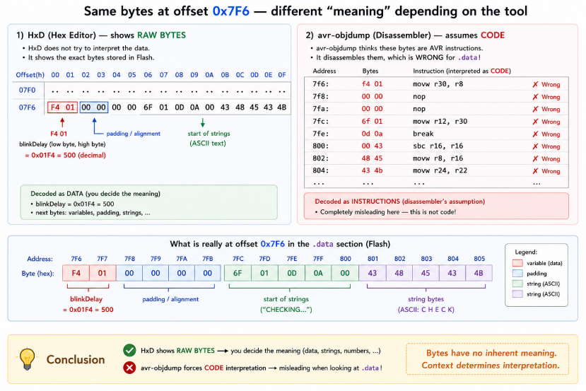
🎓 False Disassembly What avr-objdump produces at offset 0x7F6 is sometimes called a false disassembly — a valid decoding of bytes that are actually data rather than code. The bytes F4 01 form a legal AVR instruction encoding (movw r30, r8), so the disassembler decodes them confidently — but incorrectly in context. False disassembly is a common challenge in embedded RE and also appears in ARM and x86 analysis. Recognising it requires knowing where code ends and data begins in the binary layout.

15. Hex Conversion and Little-Endian
Decimal | Hex | Little-Endian Bytes in Flash/RAM
500 | 0x01F4 | F4 01 (low byte F4 first, high byte 01 second)
100 | 0x0064 | 64 00 (low byte 64 first, high byte 00 second)

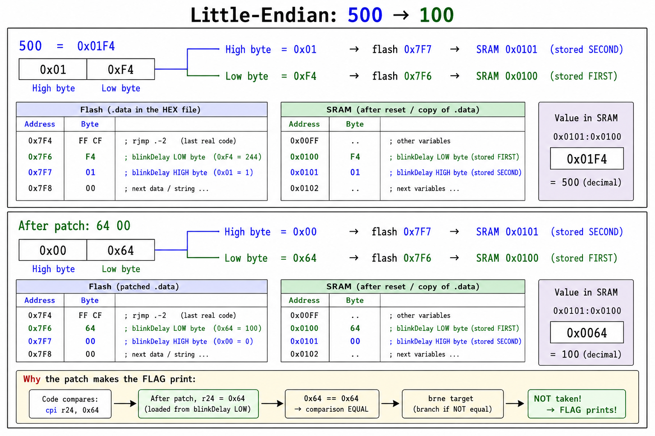
💡 Quick Example
0x1278 stored little-endian → 78 12 (low byte 78 first, high byte 12 second). AVR uses little-endian throughout — flash .data, SRAM, and 16-bit registers all follow this convention.

16. Notepad + HxD — Finding Offset and Patching

16.1 Step 1 — Confirm Offset in Notepad
- Open disassembly.txt in Notepad.
- Press Ctrl+F, type 7f6, click Find Next.

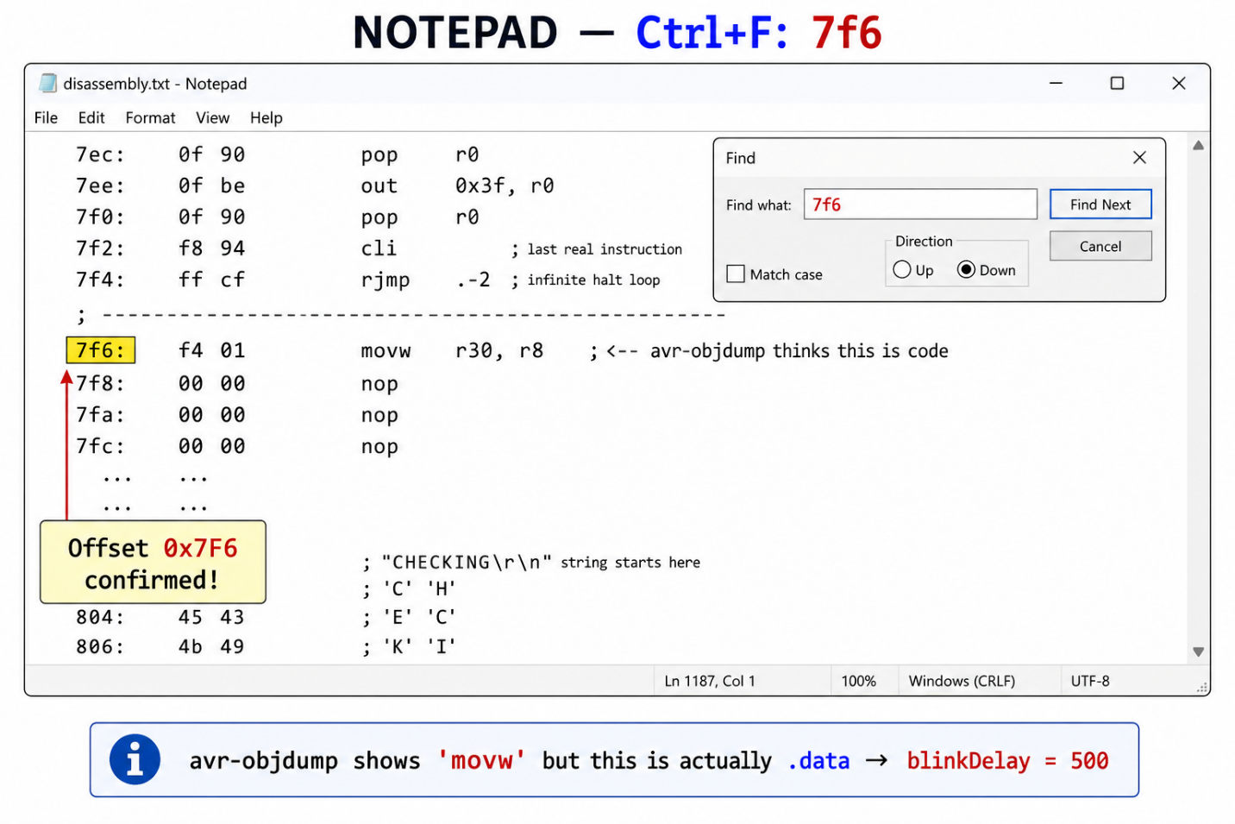
[ Notepad — disassembly.txt open. Ctrl+F search for '7f6'. Line '7f6: f4 01 movw r30, r8' highlighted. ]

16.2 Step 2 — Jump to Offset in HxD
- Open firmware.bin in HxD.
- Press Ctrl+G (Go to Offset).
- Type 7f6 (no 0x prefix needed) and press Enter.
- HxD cursor jumps to offset 0x7F6.
- You will see: F4 01 at that position.

HxD at offset 0x7F6
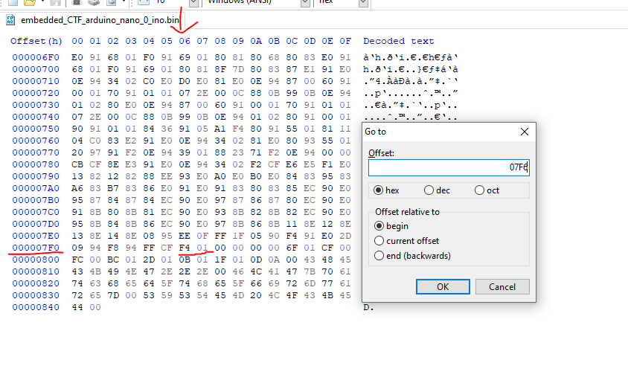
[ HxD — Ctrl+G → 7F6 → Enter. Cursor on F4 byte. F4 01 bytes clearly visible at offset 0x7F6. ]

16.3 Step 3 — Patch the Bytes
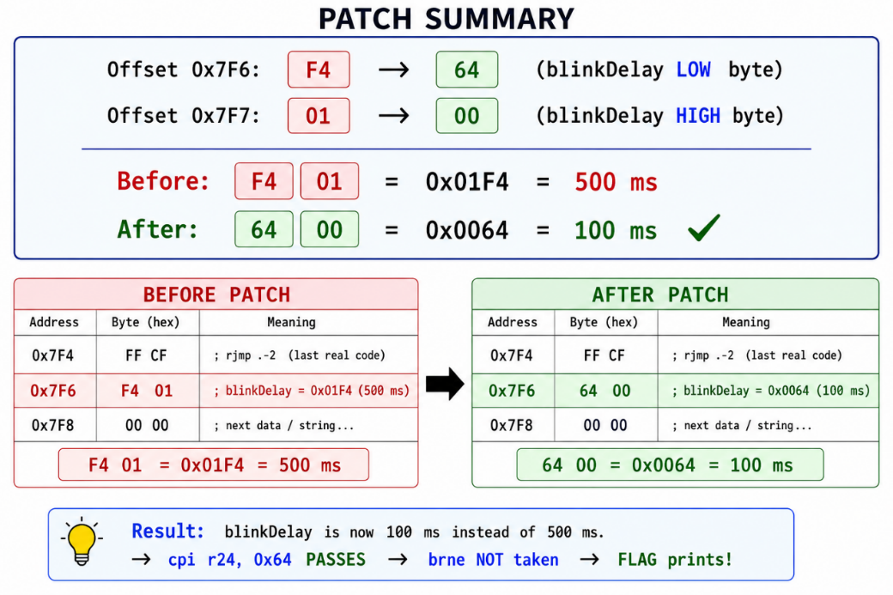
- Click on the F4 byte at offset 0x7F6.
- Type 64 — F4 changes to 64.
- Click on the 01 byte at offset 0x7F7.
- Type 00 — 01 changes to 00.

⚠️ Overwrite Mode!
Check HxD status bar shows 'OVR' (Overwrite mode). If it shows 'INS' (Insert), press the Insert key to switch. In Insert mode, typing adds new bytes and changes the file size — the patch will fail!
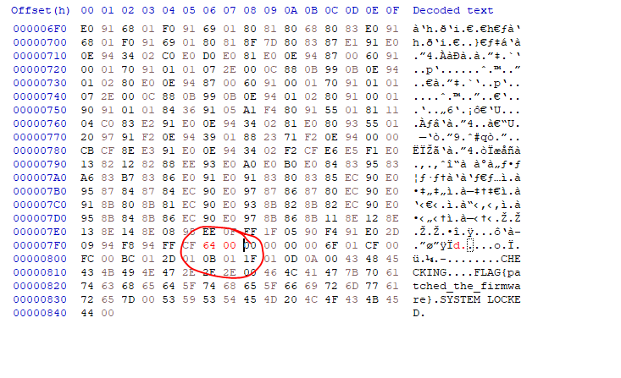
[ HxD — offset 0x7F6: F4→64, offset 0x7F7: 01→00 patched. Modified bytes highlighted in different color. ]

16.4 Step 4 — Save
- File → Save As.
- Save as patched.bin.
- Keep the original firmware.bin safe as your backup!

17. Flashing Patched Firmware

17.1 Flash BAT Files
Use the correct BAT file for your board:

flash_new.bat
flash_new.bat — New bootloader (115200 baud)
──────────────────────────────────────────────────────────────────
@echo off
set AVRDUDE_DIR=C:\Users\<username>\AppData\Local\Arduino15\packages\arduino\tools\avrdude

for /d %%D in ("%AVRDUDE_DIR%\*") do set AVRDUDE_PATH=%%D\bin\avrdude.exe & set AVRDUDE_CONF=%%D\etc\avrdude.conf

"%AVRDUDE_PATH%" -C "%AVRDUDE_CONF%" -c arduino -p m328p -P COM5 -b 115200 -U flash:w:embedded_CTF_arduino_nano_0_ino.bin:r echo Done!
pause

flash_old.bat
flash_old.bat — Old bootloader (57600 baud)
──────────────────────────────────────────────────────────────────
@echo off
set AVRDUDE_DIR=C:\Users\<username>\AppData\Local\Arduino15\packages\arduino\tools\avrdude

for /d %%D in ("%AVRDUDE_DIR%\*") do set AVRDUDE_PATH=%%D\bin\avrdude.exe & set AVRDUDE_CONF=%%D\etc\avrdude.conf

"%AVRDUDE_PATH%" -C "%AVRDUDE_CONF%" -c arduino -p m328p -P COM5 -b 57600 -U flash:w:embedded_CTF_arduino_nano_0_ino.bin:r
echo Done!
pause

17.2 The -U Write Flag Explained
Part | Meaning
flash | Memory region to write to
w | Operation = write
patched.bin | Source file to write
r | File format = raw binary (BIN)

17.3 Expected Output
Successful flash output
avrdude: writing flash (2009 bytes):
avrdude: 2009 bytes of flash written
avrdude: verifying flash memory against patched.bin:
avrdude: 2009 bytes of flash verified
avrdude done. Thank you.

💡 Bootloader is Safe
The Arduino bootloader upload method only overwrites the application flash region. The bootloader section (starting at 0x7E00) is automatically protected and will not be erased.

18. Serial Monitor — Before and After

18.1 Before Patch
- Arduino IDE → Tools → Serial Monitor.
- Set baud rate to 9600 (bottom right dropdown).
- Press the Reset button on the Arduino Nano.

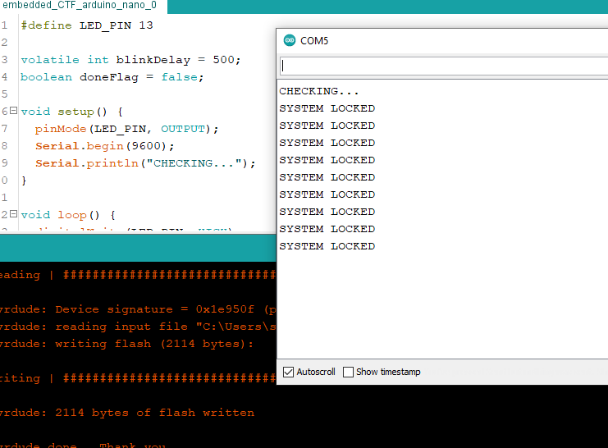

18.2 After Patch
- Flash patched.bin using the correct BAT file.
- Open Serial Monitor → 9600 baud → press Reset.

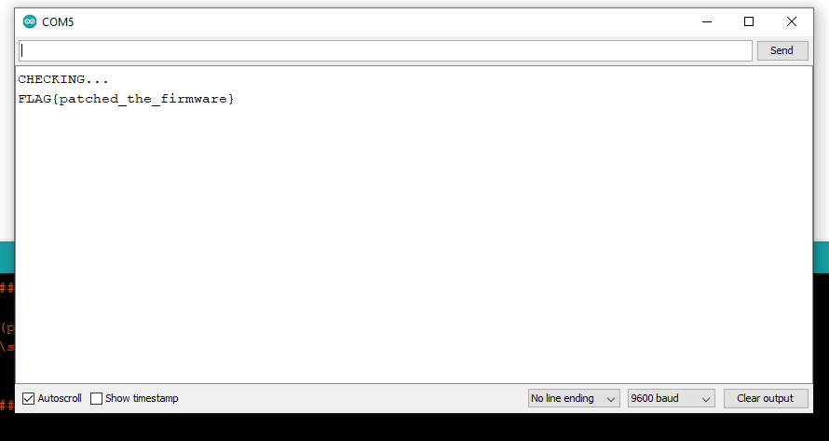
✅ Challenge Complete!
LED blinks fast at 100ms. FLAG{patched_the_firmware} appears in Serial Monitor. The doneFlag variable ensures the flag prints only once.

19. Complete Workflow — Quick Reference

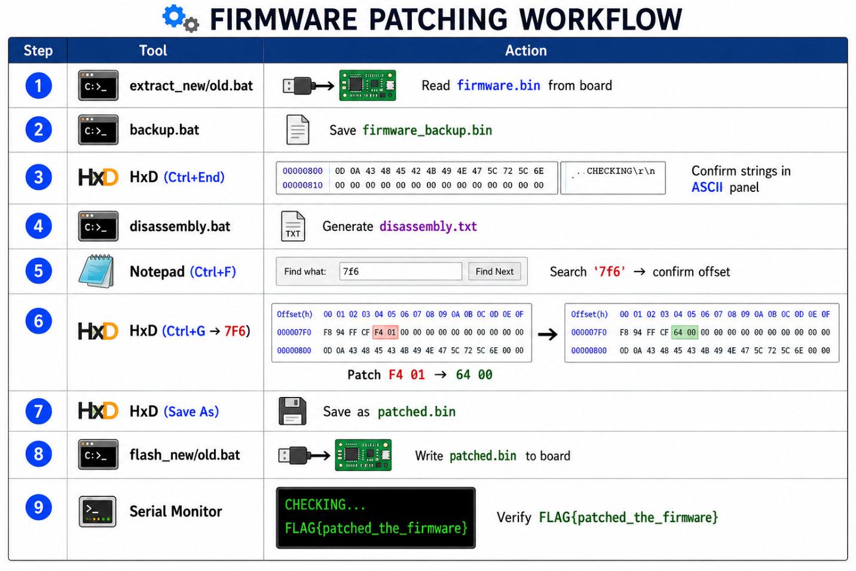
🎓 What You Actually Changed
It is worth noting precisely what this patch did and did not do:
We did NOT modify any executable code. The AVR instructions in the .text section are completely untouched.
We modified initialized program data — specifically the initial value of blinkDelay stored in the .data section at flash offset 0x7F6. At boot, the startup code copied our patched value (100) into SRAM instead of the original (500). Every subsequent RAM read by the loop() function then saw 100, satisfying the flag condition.
This is a key embedded RE insight: you do not always need to patch code to change program behavior. Patching program state (data) can be equally or more effective.

20. Key Lessons
🎓 Lesson 1 — Same Bytes, Different Meaning
Flash memory stores everything as raw bytes. The same bytes F4 01 can be an AVR instruction (as avr-objdump decodes), a little-endian integer (blinkDelay = 500), or something else entirely. Context — knowing whether you are in a code section or .data section — determines the correct interpretation.

🎓 Lesson 2 — volatile = Patchable Firmware
Without volatile, the compiler optimizer removes the entire if(blinkDelay==100) block as dead code. The FLAG string does not exist in the binary. No patching is possible. With volatile, blinkDelay is stored in RAM, F4 01 exists in the .data section, and the flag is reachable with just 2 bytes patched.

🎓 Lesson 3 — BIN is Better Than HEX for Analysis
BIN format is pure raw bytes. Offsets are linear and match directly between avr-objdump output and HxD. HEX format adds text encoding, addresses, and checksums which complicates direct patching. Always extract firmware as BIN using -U flash:r:firmware.bin:r

🎓 Lesson 4 — Offset = Linear File Address
0x7F6 is simply byte number 2038 in the file — counted from the very beginning. There are no blocks or segments to navigate. The same offset number from Notepad (disassembly.txt) goes directly into HxD Ctrl+G when --adjust-vma=0 is used.

🎓 Lesson 5 — avr-objdump .data Confusion
avr-objdump -D disassembles the entire binary including the .data section at the end. Bytes F4 01 at 0x7F6 appear as 'movw r30, r8' — a real-looking AVR instruction. But this is DATA not code. We use disassembly.txt only to confirm the offset number, then use HxD for the actual patch.

🎓 Lesson 6 — Little-Endian Byte Order
AVR stores 16-bit values low byte first (little-endian). 500 = 0x01F4 → stored as F4 01. 100 = 0x0064 → stored as 64 00. Patching F4→64 and 01→00 at offset 0x7F6 changes blinkDelay from 500 to 100 in flash, which then gets copied to SRAM at boot.

🎓 Lesson 7 — Visible Behavior vs Program Logic
Patching the delay() instructions would make the LED blink faster but would NOT trigger the flag. The flag condition checks the RAM value of blinkDelay. Patching the .data section (flash 0x7F6) changes the RAM value at boot — that is what triggers the flag. Visual behavior and program logic are two separate things.

🎓 Lesson 8 — Baud Rate Matters
New Arduino Nano boards use 115200 baud. Old boards use 57600 baud. Using the wrong baud rate causes avrdude to time out. Both values are tested and confirmed working. If one fails, try the other BAT file.

21. Alternative Patch Targets (Advanced)
This challenge has more than one patchable location. Understanding why different patches produce different results is valuable RE training.
Patch Target | Location | Effect | Type
.data blinkDelay value | Flash 0x7F6 — F4 01 → 64 00 | blinkDelay = 100 at boot → flag triggers | Data patch ✅
delay() instructions | Flash 0x700, 0x712 | LED blinks faster — flag does NOT trigger | Cosmetic patch
cpi comparison value | Flash 0x754 — 0x64 → 0xF4 | Changes what value triggers the flag | Logic patch

🎓 Three Types of Patching
Cosmetic patching changes visible behavior only — LED speed, print frequency — without affecting program logic. Behavioral patching changes what the code compares or branches on — modifying the cpi instruction changes the trigger condition. Data patching changes program state before execution begins — modifying .data changes what value blinkDelay has from the very first loop iteration. In this challenge, only the data patch triggers the flag as intended. Understanding which type of patch achieves your goal is a core embedded RE skill

Arduino Nano Embedded RE CTF — Tutorial | English | Windows OS

