CEC322 - Section 2
Lab 9 – Displaying New Characters on the LCD Glass
Lab start date: 03/27/19
Report data: 04/03/19
Tyler Wise

Introduction:
The purpose of this lab is to utilize and extend the API’s provided for developers to utilize to display text to the LCD screen on the microprocessor. It also gives a preview of how other APIs will function to handle other tasks, such as interfacing with the microphone on the board, and how to extend the basic functionalities of these APIs.

Discussion:
Most of this lab relies on modifying the pre-built code provided to the students. By following along with the instructions in the lab manual, it is extremely easy to continually expand the capabilities of the LCD screen to display a large number of characters in a variety of different ways. This same approach can then be taken to modify other APIs independently to extend and modify the capability of the microprocessor.

Artifacts:

Task 1:
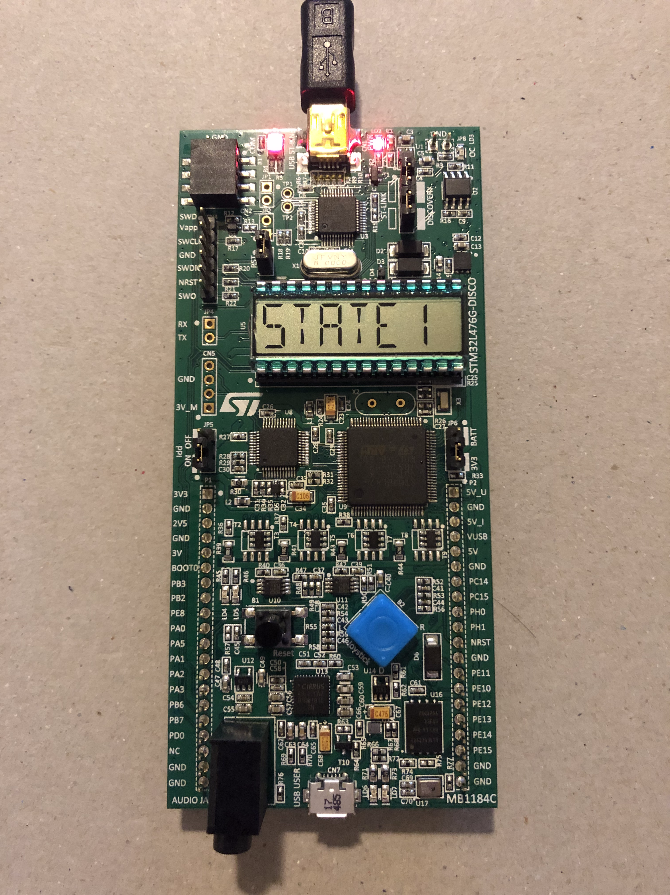
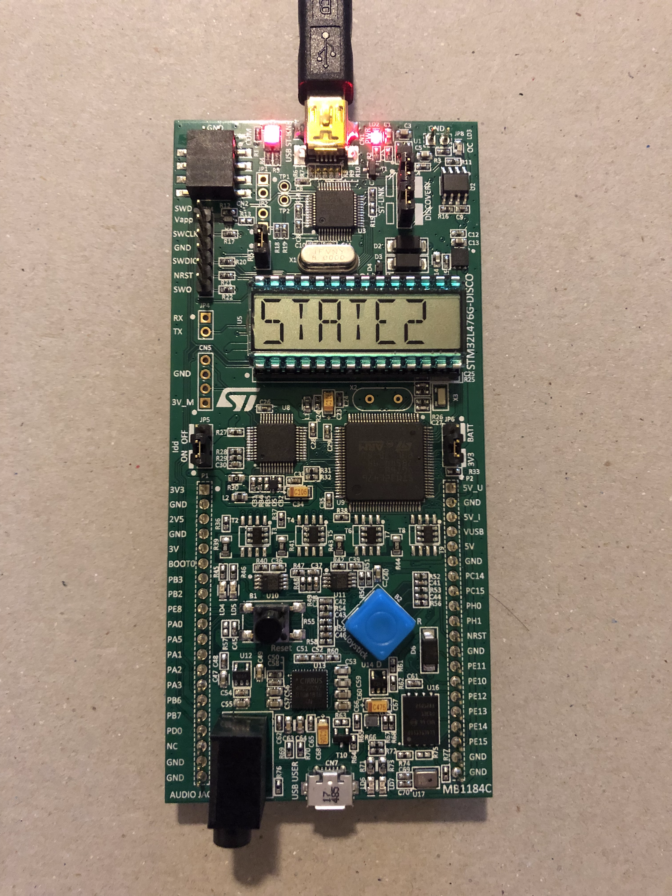

Task 2:
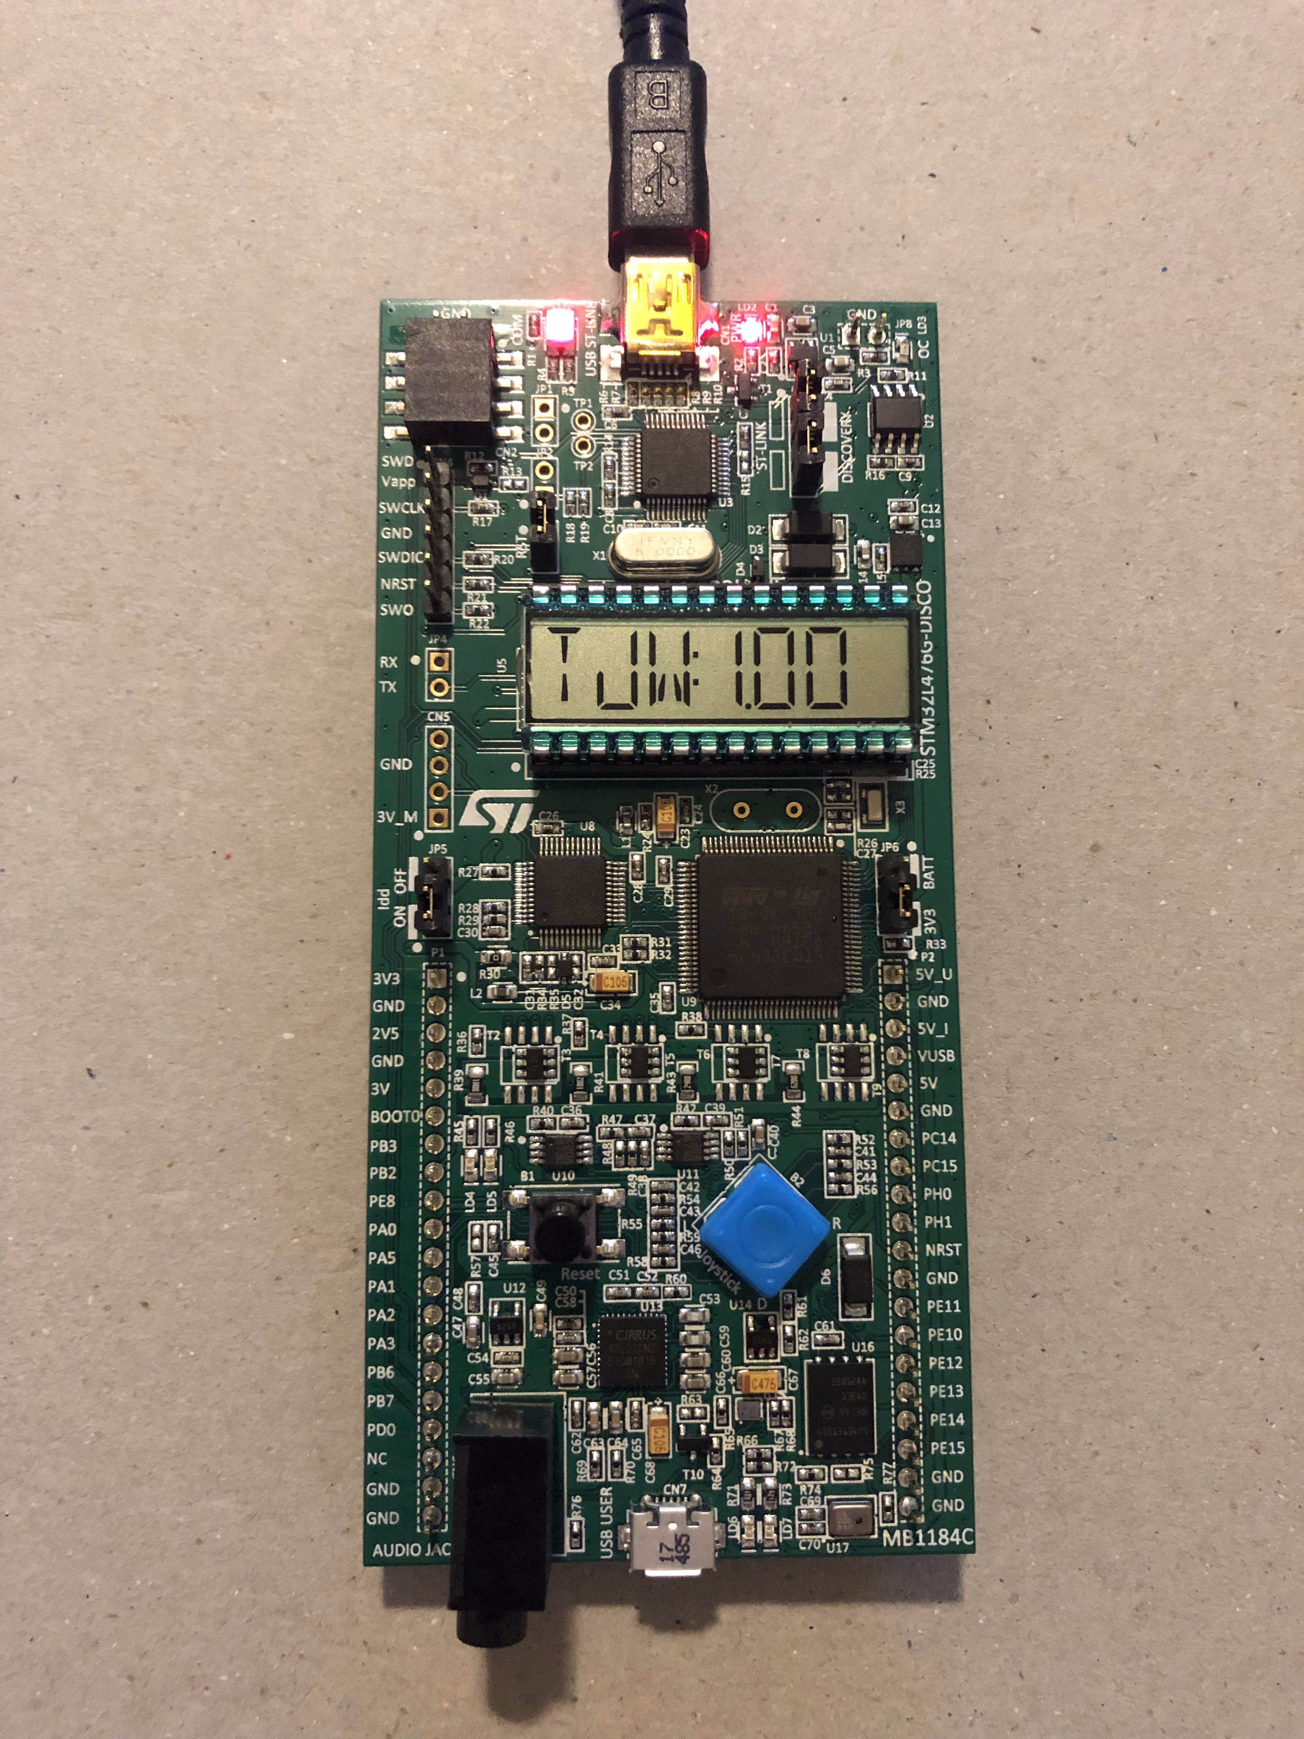

Task 3:
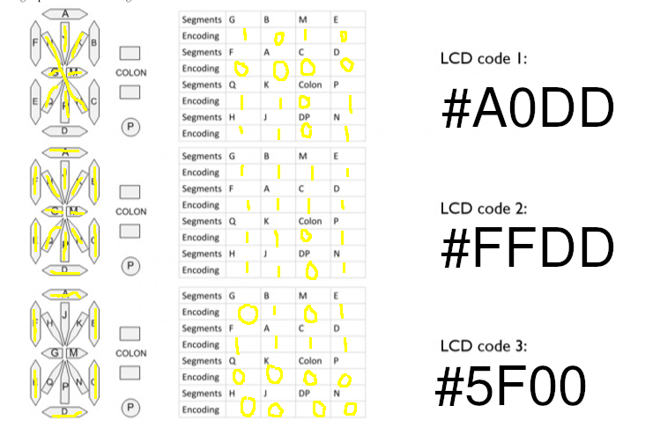

Task 4:


