**Adiabatic Processes: Sensor Calibration, Work and the Adiabatic Index**

**Cameron Stark**

Barbara De Figueiredo

Cristian D. Abades

Zachary Chuang

*PS 253 Section 12, Benedict Pineyro*

*Department of Physical Sciences,*

*Embry-Riddle Aeronautical University, Daytona Beach, FL.*

October, 2018

**Section I: Background**

To perform this experiment to determine and measure the Volume, Pressure and Temperature of the two main phases of the adiabatic process which are the compression phase and the expansion phase. To get these values an Adiabatic Compression Apparatus, which is connected to the capstone software via the Pasco Interface box, with three different sensors plugged in. The objective of the experiment was to determine the relationship between the Volume, Pressure and Temperature during the compression and expansion phases of the adiabatic process.

**Section II: Theory and Procedure**

The experiment was performed with an Adiabatic Compression Apparatus that would create and measure the adiabatic reaction that is desired. There are two phases to the adiabatic process, the compression phase which will be recorded while the compressor will be in the process of being pushed down, this will be done a total of three runs, the second phase is the expansion phase which will be the process of the pulling up thereby increasing the volume, and will be recorded during that process and also ran for three runs. To perform and record the for the compression phase begin with setting the recording rate 500Hz and begin pressing the piston down, taking about 0.4 to 0.8 seconds to complete the compression. After it is completely compressed wait 10 seconds and then release, after fully decompressed wait another 10 seconds and then stop recording data, this serving as one run, repeat two more times. For the expansion phase, the data concerning the point after the release of the piston.

**Section III: Results**

The results for the 3 runs, split up into two phases each with 3 datasets.

**Compression Run #1**

The compression phase took a total of .464 seconds with the following Min, Max and Average values.

|  |  |  |  |
| --- | --- | --- | --- |
|  | V | P | T |
| Min | 128.8 | 83.74 | 295.34 |
| Max | 181.9 | 128.99 | 325.06 |
| Avg | 156.49 | 103.03 | 308.37 |

Table Data Values For Compression Run #1

The graphs below represent the data trends with Volume Vs Pressure and Volume Vs Temperature.

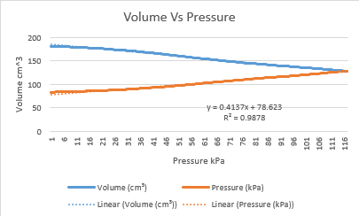

Table Volume Vs Pressure Graph for Compression Run #1

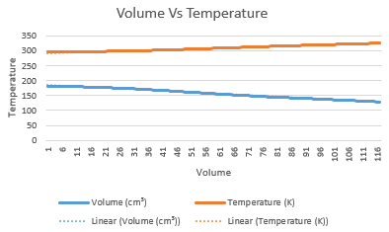

Table Volume Vs Temperature Graph for Compression run #1

The Volume vs Pressure Graph for compression run 1, shows a trend of the volume decreasing while the pressure is increasing and at the end of the compression phase meeting at the same point. The Volume vs temperature graph shows that the as the volume decreases the temperature increases at a slower rate than the volume.

**Compression Run #2**

The compression phase took a total of .276 seconds for the second run with the following min, max and average values.

|  |  |  |  |
| --- | --- | --- | --- |
|  | V | P | T |
| Min | 128.86 | 83.77 | 295.61 |
| Max | 181.92 | 130.26 | 326.27 |
| Avg | 157.09 | 103.192 | 307.99 |

Table Values for the Compression Run #2

The graphs below show the relationship between the Volume and Pressure and Volume and Temperature.

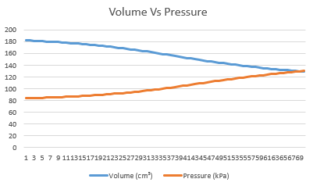

Table Volume vs Pressure Graph for Compression Run #2

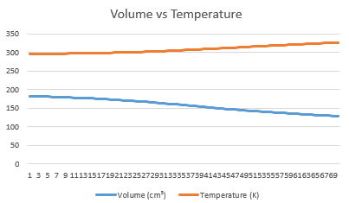

Table Volume vs Temperature graph for Compression Run #2

The Volume vs Pressure graph shows the same relationship in run 2 as it did in run 1, with the volume decreasing and the pressure increasing as compression occurs. The Volume vs Temperature graph also shows the same relationship in that the temperature is increasing and the volume is decreasing as the compression occurs.

**Compression Run #3**

The compression phase took a total of .324 seconds for the third run with the following min, max and average values.

|  |  |  |  |
| --- | --- | --- | --- |
|  | V | P | T |
| Min | 128.88 | 83.63 | 295.46 |
| Max | 181.97 | 129.86 | 326.42 |
| Avg | 157.21 | 103.00 | 308.01 |

Table Values for the Compression Run #3

The graphs below show the relationship between the Volume Vs Pressure and Volume Vs Temperature.

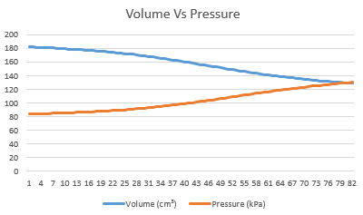

Table Volume vs Pressure graph for Compression Run #3

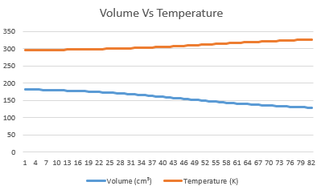

Table Volume vs Temperature graph for Compression Run #3

The Volume Vs Pressure graph shows the same relationship as the previous two runs in that the volume is decreasing and the pressure is increasing as the compression occurs. The Volume Vs Temperature graph shows the same relationship as the previous two runs in that the temperature is increasing and the volume is decreasing as the compression occurs.

**Expansion Run #1**

The expansion phase took a total of .244 seconds for the first run with the following min, max and average values.

|  |  |  |  |
| --- | --- | --- | --- |
|  | V | P | T |
| Min | 129.1 | 74.92 | 274.09 |
| Max | 183.06 | 176.92 | 295.02 |
| Avg | 155.26 | 93.79 | 283.82 |

Table Values for Expansion Run #1

The graphs below show the relationship between the Volume, Pressure and Temperature during the first Expansion phase.

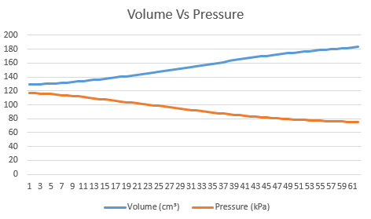

Table Volume vs Pressure graph for Expansion Run #1

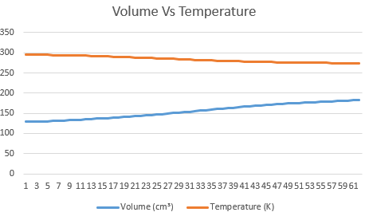

Table Volume vs Temperature graph for Expansion Run #2

The Volume Vs Pressure graph shows the relationship between them during the expansion which is that as the expansion occurs the volume increases as the pressure decreases. The Volume vs Temperature graph shows that as the volume increase the temperature decreases.

**Expansion Run #2**

Expansion run 2 took a total of .728 seconds, with following min, max and average values.

|  |  |  |  |
| --- | --- | --- | --- |
|  | V | P | T |
| Min | 129.04 | 76.69 | 276.23 |
| Max | 183.08 | 117.06 | 295.09 |
| Avg | 155.61 | 94.24 | 283.70 |

The below graphs show the relationship between the Volume, Pressure and Temperature as the expansion occurs.



Table Volume vs Pressure graph for Expansion run #2

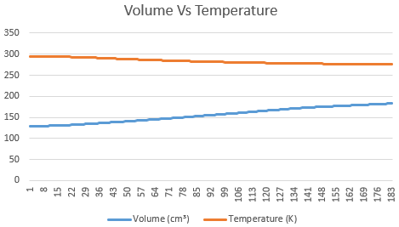

Table Volume vs Temperature for Expansion Run #2

The above graphs for Expansion phase for run two, depict the relationship between the Volume vs Pressure which shows that the volume is increasing and the pressure is decreasing during the expansion and the Volume vs Temperature graph shows that the volume is increasing and the temperature is decreasing.

**Expansion Run #3**

The total time for the third run of the expansion phase is .468 seconds with the following values.

|  |  |  |  |
| --- | --- | --- | --- |
|  | V | P | T |
| Min | 129.1 | 75.93 | 275.11 |
| Max | 183.21 | 116.88 | 295.03 |
| Avg | 157.08 | 92.70 | 282.83 |

The below graphs show the relationship between Volume, Pressure and Temperature.

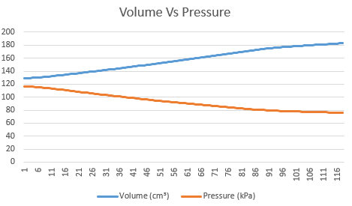

Table Volume Vs Pressure graph for Expansion run #3

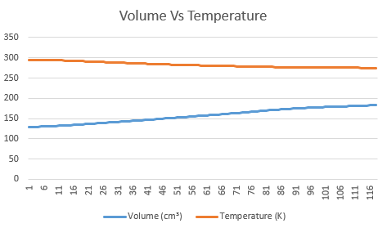

Table Volume vs Termperature graph for Expansion run #3

The Volume vs Pressure graph shows a relationship in that as the volume increases the pressure decreases during the expansion process, and the Volume vs Temperature graph shows a relationship where as the volume increases the temperature decreases.