**Pendulum: Discovering What Variables Affect a Pendulum’s Period**

**Cameron Stark**

Barbara De Figueiredo

Cristian D. Abades

Zachary Chuang

*PS -253 Section 12, Benedict Pineyro*

*Department of Physical Sciences,*

*Embry-Riddle Aeronautical University, Daytona Beach, FL.*

September, 2018

Pendulums are a periodic motion contraption that when released from a certain height will follow oscillate at the same period that is dependent upon the weight of the mass at the end of the pendulum and the length of the pendulum, and will theoretically continue for a very long time unless acted upon by an outside force. The purpose of this experiment was to find out what factors affect the period of a pendulum and how they affect the pendulum. The method of determining what factors affected the period were broken up into three sections, the first, where the drop angle was changed on each trial, the second, where the pendulum length was changed, and the third, where the weight changed, for each of these we let the pendulum go through 19 oscillations to get a mean period for each method. The first method we discovered that with changing the degree at which the mass was dropped did not affect the period of the pendulum, with a mean period of 2.04 seconds, performed with the large weight of 494.5g. The Second method we discovered that changing the length of the pendulum did have an effect of the period, with every change in length a drop in a tenth of a second occurred for each trial, with the large weight. The third method the weight was changed and the length stayed constant, it was discovered that changing the weight did not affect the period of the pendulum.

**Section I: Background**

To preform this experiment we used a pendulum, a string of negligible mass, three weights of masses 494.5g, 187.2g, and 91.1g, and a photogate to accurately time the pendulums period. The experiments objective was to fined what changes to the system would affect the period of the pendulum in a noticeable way. All these items were used to perform 13 runs all with 19 oscillations.

**Section II: Theory and Procedure**

The experiment was performed with a crossbar that had a string attached to it with a weight and the end of the string which as a whole it created the pendulum. The pendulum would oscillate through a photogate that was connected to the computer and through the capstone program would track the period of the pendulum with much higher accuracy then someone with a stopwatch. For all pendulum length measurements, they were based from the bottom of the crossbar to the end of the string plus the length from the top of the mass to the center.

Method 1, for finding which factor affected period was the changing of the initial angle the pendulum was started from and keeping the weight and the length of the pendulum the same. We ran the test for 5 instances, with 19 trials each, each with different degree of drop, by which we calculated the x-displacement based on the degrees and pendulum length.

(1) [1]

Method 2, for finding which factor influenced the period of the pendulum was the changing of the length, L, of the pendulum and not changing the drop angle of 5 degrees and the weight 494.5g. We ran the test for 5 instances, with 19 trials each, each with a different pendulum length which affected the x displacement for 5 degrees, for every change in L a new x displacement had to be found using equation 1.

Method 3, for finding which factor had an influence was to change the weight at the end of the pendulum without changing the length or the drop degree. The method was ran a total 3 times, with 19 trials each, where each time the weight was changed.

Once all of the values were collected after a total of 13 runs, the next goal was to use the experimental values we collected to find the gravity acceleration, g, and to compare that to the reference value for Daytona which is 9.79265 m/s^2 [1].

**Section III: Results**

The measurements and results for the total 13 runs, for method 1, 2 and 3 are as follows. We found the constants variables to be the following.

|  |  |
| --- | --- |
| Mass | Weight (g) |
| Large | 494.5 |
| Medium | 187.2 |
| Small | 91.1 |

**Method 1 Measurements & Values**

To begin Method 1, the 5 x-displacements needed to be found with equation 1 and are as follows.

|  |  |  |
| --- | --- | --- |
| Trial | Equation | X |
| 1 | 104.5 * sin(0.0872) | 9.107 |
| 2 | 104.5 * sin(0.1745) | 18.146 |
| 3 | 104.5 * sin(0.2617) | 27.046 |
| 4 | 104.5 * sin(0.3490) | 35.741 |
| 5 | 104.5 * sin(0.4363) | 44.163 |

Once this information was found each trial was ran so that 19 oscillations could occur and then the mean was recorded. The means of the 5 trials are as follows.

|  |  |
| --- | --- |
| Trial | Period, T |
| 1 | 2.04 |
| 2 | 2.04 |
| 3 | 2.0426 |
| 4 | 2.0526 |
| 5 | 2.06 |

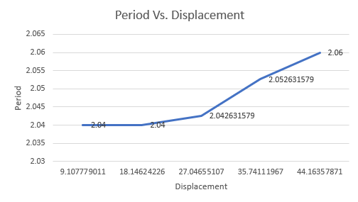

From these values we can draw the conclusion that the period of a pendulum is not affected by the degree and/or height the pendulum is released from, because period is not dependent on displacement, but the velocity is dependent on that, so the pendulum just moves faster to cover more distance in the same amount of time. The small changes in the period over the 5 trials is more then likely due to human error, as in the drops were probably not entirely accurate to the x-displacement that was needed, and the inconsistency that comes with physical dropping the pendulum.

**Method 2 Measurements & Values**

For method 2, the length of the pendulum changed for a total of 5 trials with 19 oscillations for each trial. The periods and pendulum lengths are as follows.

|  |  |  |
| --- | --- | --- |
| Trial | Length, L | Period, T |
| 1 | 101.5 | 2.02 |
| 2 | 92.5 | 1.96 |
| 3 | 83.2 | 1.85 |
| 4 | 74.5 | 1.76 |
| 5 | 69 | 1.69 |

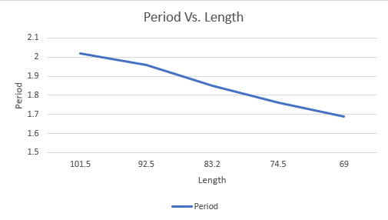

For the final results of the experiment the natural log of the above values is needed and are as follows.

|  |  |  |
| --- | --- | --- |
| Trial | ln(Length) | ln(Period) |
| 1 | 4.620 | 0.703 |
| 2 | 4.527 | 0.672 |
| 3 | 4.421 | 0.615 |
| 4 | 4.311 | 0.565 |
| 5 | 4.234 | 0.524 |

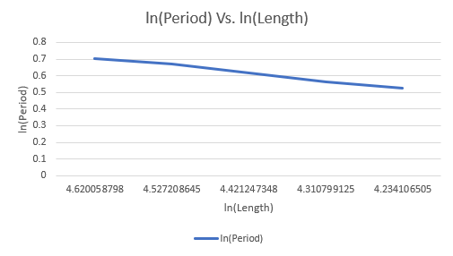

From these values we can draw that changing length of the pendulum does have a direct effect on the period of a pendulum because the period of a pendulum is based on length and gravity.

**Method 3 Measurements & Values**

For method 3, the weight of the pendulum was changed for a total of 3 trials all performed for 19 oscillations at the same length and drop degree/x-displacement. The found periods are as follows.

|  |  |  |
| --- | --- | --- |
| Trial | Weight | Period |
| 1 | 494.5 | 2.04 |
| 2 | 187.2 | 2.03 |
| 3 | 91.1 | 2.02 |

From these values we can draw the weight does not have a major direct influence on the period of the pendulum and these .01 second changes among the periods is probably a result of human error as in they were not dropped the same way or dropped from not the exact same height.

The main purpose of the experiment was to find what factors and variables can influence the change of the period of a pendulum, it was found that changing the initial drop degree did not affect the period, changing the weight did not change the period, but changing the length of the pendulum had fairly drastic change on the pendulum. With this information the task was to find the experimental gravitational acceleration from the values that were found in the experiment and compare to the reference value for the Daytona area. The values and percent difference are as follows.

From this percent difference we can confirm the experimental values were accurate to that of reference value for the gravity with less than half a percent of difference.

**Section IV: References**

[1] Department of Physical Sciences. “Pendulum Tests – Discovering What Variables Affect a Pendulum’s Period.” Daytona Beach: Embry-Riddle Aeronautical University, 2016. PDF File

**Section V: Lab Work**

