**Determining Planck’s Constant Using Light Emitting Diodes (LED’s)**

**Cameron Stark**

Barabara De Figueriedo

Cristian D. Abades

Zachary Chaung

*PS 253 Section 12, Benedict Pineyro*

*Department of Physical Sciences,*

*Embry-Riddle Aeronautical University, Daytona Beach, FL*

November 2018

**Section I: Background**

Planck’s method states that it can determine the type and quantity of energy emitted by all objects because of that objects temperature. The different colors observed during this experiment were a result of the electrons changing levels in the atom, which releases amounts of energy which in using Planck’s Constant and the frequency of the light coming off of it can be determined. The experiment is designed around trying to measure the value of Planck’s constant by using known values for wavelength, electron charge and the speed of light. The experiment consists of six LED’s where the frequency is increasing going from blue, green, yellow, bright red, red and Infrared, with the following wavelengths respectively, 428 nm, 560 nm, 593 nm, 635 nm, 660nm and 940 nm.

**Section II: Theory and Procedure**

The process of the experiment to measure the value of Planck’s constant, is to build a circuit consisting of the power source, current probe, ammeter, and led, where the current can be slowed increased and the current and voltage can be recorded and tracked on the capstone program.

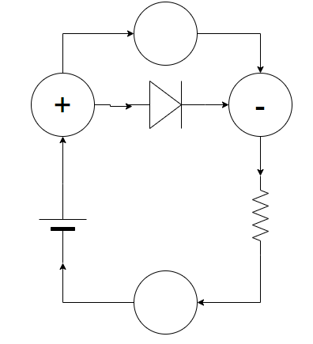 Each run will consist of the circuit slowing be brought up to a maximum of 18 mA of current as to not burn out the LED’s, while tracking the voltage on the capstone program, once the voltage keeps steady the recording is stopped and the current slowly turned down, as to not burn out the LED’s. Once the data is collected for the 6 runs at 6 different wavelengths, the voltages are found for each of the LED’s and are organized so that the mathematical portion can be done. Starting off with the finding of the energy of the LED, with the following equation.

(1) [1]

Once the energy found the next step is to find the frequency of the LED’s which can be done with this equation.

(2) [1]

Where v is the frequency, c is the speed of light and the wavelength. Once this is found the value for the Planck’s Constant can be determined.

Once the measured value for Planck’s Constant is found the percent difference is calculated.

**Section III: Results**

The results for runs as following show a trend that as the current increases the voltage increases until the voltage for the LED is reached.

**Run 1: 428 nm Blue LED**

This run is concerned with the 428nm wavelength LED, which has a voltage of approximately 4.05 Volts, for the light to be produced by the component which in this case is Blue.

|  |  |
| --- | --- |
| Voltage | 4.05 |
| Energy |  |
| Frequency |  |
| Measured Planck |  |
| % Difference | 200% |

From the calculations it can be concluded that for run 1, the data was 200% off from the expected value for planck’s constant.

**Run 2: 560 nm Green LED**

This run is concerned with the 560nm wavelength LED, which has a measure voltage of 2.2 Volts, for the light to be produced by the component which in this case is Green.

|  |  |
| --- | --- |
| Voltage | 2.20 |
| Energy |  |
| Frequency |  |
| Measured Planck |  |
| % Difference | 200% |

From the calculations it can be concluded that for this run aswell, the expected value and the measured value are off by 200%.

**Run 3: 593 nm Yellow LED**

This run is concerned with the 593nm wavelength LED, which has a voltage of 1.972, for the light to be produced by the component which in this case is yellow.

|  |  |
| --- | --- |
| Voltage | 1.972 |
| Energy |  |
| Frequency |  |
| Measured Planck |  |
| % Difference | 200% |

From the calculations it can be concluded that for this run, the expected value and the measured value for Planck’s Constant are off by 200%.

**Run 4: 635 nm Bright Red LED**

This is concerned with the 635nm wavelength LED, which has a voltage of 2.054, for the light to be produced by the component which in this case is bright red.

|  |  |
| --- | --- |
| Voltage | 2.054 |
| Energy |  |
| Frequency |  |
| Measured Planck |  |
| % Difference | 200% |

From the calculations it can be concluded that the expected and measure Planck’s Constants are off by 200%