**RC Circuits**

**Cameron Stark**

Barbara De Figueiredo

Cristian D. Abades

Zachary Chaung

*PS 253 Section 12, Benedict Pineyro*

*Department of Physical Sciences,*

*Embry-Riddle Aeronautical University, Daytona Beach, FL*

November, 2018

**Section I: Background**

An RC circuit is a type of electrical circuit consisting of any number of 1 or more Resistors and Capacitators in either series or parallel. A resistor is a circuit component that can very in value of resistivity which is measured in ohms, and the use of the component is to provide a point of resistance in the circuit. A capacitator is another type of circuit component which typically consists of two metal plates with separation between them, which when a current is passed through the component the charge of the plates become opposite which creates an electric field between the two plates, which allows the capacitator to be charged up and de-charged. Capacitators are measured by their capacitance which is the amount they can be charged up. A circuit in series means the flow of electrons passes through every single component and has only a single route to take to complete the circuit, whereas a parallel circuit the electrons have multiple paths to take to complete the circuit and don’t go through every component. The combination of resistor and capacitator in either series, parallel or both, change the rate of charge and discharge of capacitator because of the electrons travel through the circuit, which will demonstrate by the experiment.

**Section II: Theory and Procedure**

The purpose of the experiment is to compare the expected time constant for the discharging of various capacitators in different scenarios, being by itself, in series with another capacitator and in parallel with another capacitator. The variation in the circuits provide different cases where the charge and discharge of capacitor occur differently because of the properties that being series or parallel can have on a component in a circuit.

The process for each circuit is the same, the circuit will be gradually brought up to the voltage level of 4.8 V, once there the recording of the voltage was started and then the circuit was disconnected from the power supply where the data will be recorded until it reaches the time constant, which for the voltage level the experiment is done at, is at 1.656 V remaining which is about 63% discharged. The time constant is a calculated value for the amount of time for the charge of a capacitator to be reduced 63% from the max or initial value.

**Situation I: 1 Capacitor and Resistor**

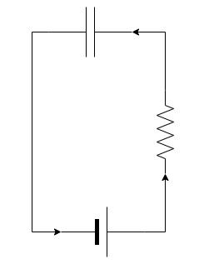

This Situation has the Resistor and Capacitor in series. The capacitance is measured at .0000033 and the resistor value is 21800 Ohms.

**Situation II: 2 Capacitors and 1 Resistor**

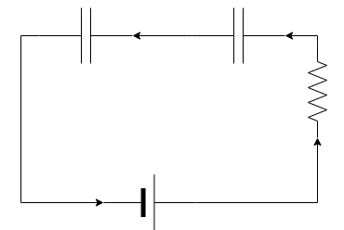

This Situation has the resistor and the 2 capacitors in series with each other. The equivalent capacitance for the two capacitors is .0000065 and the resistance is still 21800.

The equation for finding equivalent capacitance in series is the following.

$C_{eq}=\frac{1}{\left(\frac{1}{C_{1}}\right)+\left(\frac{1}{C_{2}}\right)+(\frac{1}{C_{n}})}$ [1]

**Situation III: 2 Capacitors and 1 Resistor**

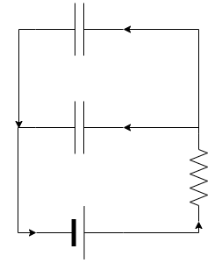

This situation consists of two capacitors both in series with the resistor but in parallel to each other. The equivalent capacitance for a circuit in parallel is .0000066 and the resistance is the same.

The equation for the finding the equivalent capacitance in parallel is the following.

$$C_{eq}= C_{1}+ C_{2}+ C_{n}$$

**Section III: Results**

The results for the three situations are as follows.

The first situation is a single capacitor and resistor in series, with the following values.

|  |  |
| --- | --- |
| **Name** | **Value** |
| Resistor | 21800 |
| Capacitance | .0000033 |
| Expected Time Constant | .07194 |
| Measured Time Constant | .07 |
| Percent Difference | 2.77% |

|  |  |
| --- | --- |
| **Time (s)** | **Voltage (V)** |
| 3.9 | 4.454 |
| 3.905 | 4.438 |
| 3.91 | 4.419 |
| 3.915 | 4.383 |
| 3.92 | 4.111 |
| 3.925 | 3.807 |
| 3.93 | 3.568 |
| 3.935 | 3.348 |
| 3.94 | 3.099 |
| 3.945 | 2.891 |
| 3.95 | 2.726 |
| 3.955 | 2.528 |
| 3.96 | 2.341 |
| 3.965 | 2.211 |
| 3.97 | 2.066 |
| 3.975 | 1.899 |
| 3.98 | 1.788 |
| 3.985 | 1.686 |

|  |  |
| --- | --- |
| **Time (s)** | **Ln(V/Vint)** |
| 3.9 | 0 |
| 3.905 | -0.0035987 |
| 3.91 | -0.0078891 |
| 3.915 | -0.0160691 |
| 3.92 | -0.0801363 |
| 3.925 | -0.1569611 |
| 3.93 | -0.2217974 |
| 3.935 | -0.2854394 |
| 3.94 | -0.3627231 |
| 3.945 | -0.4322001 |
| 3.95 | -0.4909672 |
| 3.955 | -0.5663741 |
| 3.96 | -0.6432244 |
| 3.965 | -0.7003577 |
| 3.97 | -0.7681882 |
| 3.975 | -0.8524751 |
| 3.98 | -0.9127049 |
| 3.985 | -0.9714437 |

From the above two tables a decaying trend for the data which is what is expected due the removal of the power source the charge in the capacitor will decrease as it goes through the circuit.

The two graphs support the discharging of the capacitor over time. To test the accuracy of the data collected the following equation can be used to the get the capacitance using the slope of the graph.

$C= \frac{-1}{Slope * R}$ [1]

|  |  |
| --- | --- |
| **Name** | **Value** |
| Measured Capacitance | .0000033 |
| Calculated Capacitance | .0000036 |
| Percent Difference | 9.7% |

The second situation is two capacitors and a resistor all in series, with the following values.

|  |  |
| --- | --- |
| **Name** | **Value** |
| Resistor | 21800 |
| Capacitance | .00000165 |
| Expected Time Constant | .03597 |
| Measured Time Constant | .042 |
| Percent Difference | 14.35% |

|  |  |
| --- | --- |
| **Time (s)** | **Voltage (V)** |
| 13.85 | 4.522 |
| 13.855 | 4.408 |
| 13.86 | 3.902 |
| 13.865 | 3.435 |
| 13.87 | 2.99 |
| 13.875 | 2.59 |
| 13.88 | 2.287 |
| 13.885 | 2.003 |
| 13.89 | 1.72 |
| 13.895 | 1.514 |

|  |  |
| --- | --- |
| **Time (s)** | **Voltage (V)** |
| 13.85 | 0 |
| 13.855 | -0.0255333 |
| 13.86 | -0.14746513 |
| 13.865 | -0.27493745 |
| 13.87 | -0.41368099 |
| 13.875 | -0.5572965 |
| 13.88 | -0.68171346 |
| 13.885 | -0.81430832 |
| 13.89 | -0.96663008 |
| 13.895 | -1.09419922 |

To test the accuracy of this data we need to use same previous equation using slope and resistor.

|  |  |
| --- | --- |
| **Name** | **Value** |
| Measured Capacitance | .0000033 |
| Calculated Capacitance | .0000018 |
| Percent Difference | 7.8% |
|  |  |

The third situation is two capacitors each in series with the resistor but in parallel to each other, with the following values.

|  |  |
| --- | --- |
| **Name** | **Value** |
| Resistor | 21800 |
| Capacitance | .0000066 |
| Expected Time Constant | .14388 |
| Measured Time Constant | .14 |
| Percent Difference | 2.77% |

|  |  |
| --- | --- |
| **Time (s)** | **Voltage (V)** |
|  |  |
|  |  |
|  |  |
|  |  |
|  |  |
|  |  |
|  |  |
|  |  |
|  |  |
|  |  |
|  |  |
|  |  |
|  |  |
|  |  |
|  |  |
|  |  |
|  |  |
|  |  |
|  |  |
|  |  |
|  |  |
|  |  |
|  |  |