**Radioactivity: Random Decay Processes and Shielding Application**

**Cameron Stark**

Barbara De Figueiredo

Cristian D. Abades

Zachary Chuang

*PS 253 Section 12, Benedict Pineyro*

*Department of Physical Sciences,*

*Embry-Riddle Aeronautical University, Daytona Beach, FL.*

October, 2018

**Section I: Background**

The purpose of this experiment was to measure the effectivity of two different materials being lead and aluminum, and varying amounts of them to see how much radiation is absorbed from the two samples, being Co-60 and Sr-90. The experiment will consist of a Geiger tube connected to the computer for recording the random decays that are occurring during the set time period. Provided there is a sample of Cobalt 60 and Strontium 90, to serve as the radioactive sources, and to serve as the absorbent material there is lead plates and layers of aluminum foil.

**Section II: Theory and Procedure**

The experiment will have a total of 15 runs, the first being a 25 min measurement set to a measurement per 5 seconds, the next 7 runs are using the Co-60 source and incrementally adding more lead plates between the source and the detector to test of the absorption rate of lead, the next 6 runs are using the Sr-90 source and incrementally adding more aluminum foil layers on to determine the absorption effectiveness of the aluminum. The 7 runs with Co-60 are each 3 mins, with a reading per minute, and foreach run a lead plate is added to the stack except for the last two runs where two plates are added each time, totaling 8 plates. For the 6 runs with Sr-90, each run is 3 minutes with a reading per minute, each run the layers of aluminum will increase, with 1, 5, 10, 20, 25, 30, consisting of preset layer amounts in sealed packages. To find the final answer for the whole experiment can be found with the following equation where N is the number of decays, and µ is the absorption constant for a material and x is the thickness of the absorbing material.

Lead is .405 cm^-1 and Aluminum is .075 cm^-1.

[1]

**Section III: Results**

The results for the first run with the Co-60 sample, and 25 min scanning period with a reading every 5 seconds the data formed a normal distribution as expected, because the decay process is a random process.

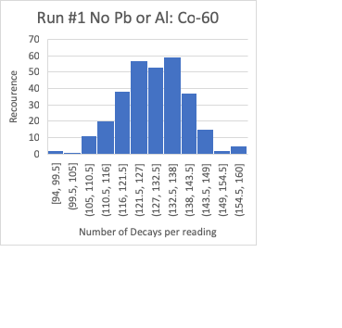

The next data set is the 7 runs with Co-60 and the incremental adding of lead plates between the source and the Geiger counter. The dimensions of the lead are as follows.

|  |
| --- |
| Lead Plates cm |
| .15 |
| .1 |
| .2 |
| .175 |
| .175 |
| .175 |
| .252 |

The data for the runs are collected, over 3 minutes and a reading every 1 minute.

|  |  |
| --- | --- |
|  | LN(N) |
| Plate 1 | 5.65 |
| Plate 1,2 | 5.91 |
| Plate 1,2,3 | 5.56 |
| Plate 1,2,3,4 | 5.42 |
| Plate 1,2,3,4,5,6 | 5.21 |
| Plate 1,2,3,4,5,6,7,8 | 4.82 |
|  |  |

The following data shows that as more plates are added between the source of radiation and the sensor, the amount of radioactive particles making it to the sensor is decreasing each run, therefore stating that the lead is effective at absorbing the radiation from the Co-60 source.

[1]

The blocking effectiveness of the Pb sheet is 95%.

The Sr-90 tests consists of 6 runs, each a total of three minutes with a reading for every minute that passes. The difference is the chosen material to serve as the absorbing material, in this case is various layers of aluminum foil, with the dimensions as follows.

|  |
| --- |
| Al Foil Dimensions |
| .0000013 |
| .0000065 |
| .000013 |
| .000026 |
| .0000325 |
| .000039 |