SE 320

Assignment 4

Cameron Stark

2.)

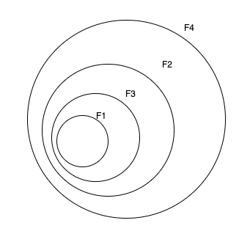

3.) The myCircle.radius will cause an error because it is a private value, therefore cannot be accessed without a defined getter method for the circle class.

4.)