SE320

Assignment 5

Cameron Stark

1.) Precondition: List must contain only same types or types that can be compared directly to each other, and duplicates must be next to each other, therefore list must be pre-sorted

2.)

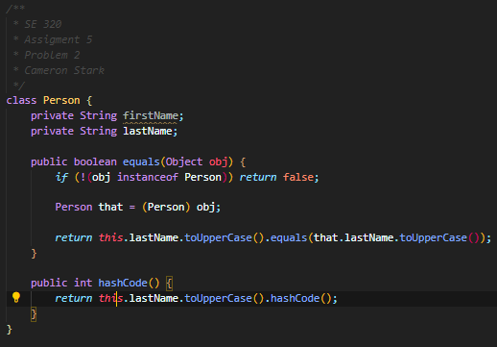

3.)

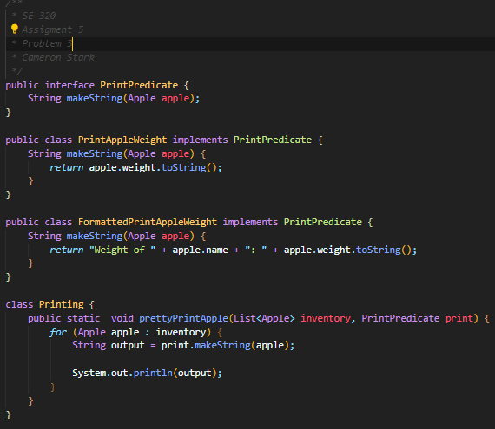

4.)

A functional interface is an interface with at most and at least 1 abstract method that can implemented on each implementation of the interface. They are useful when working lambdas because since the method is already defined in terms of types the compiler can type check the lambda expression for type errors

5.)

A functional descriptor is the information of what goes in and out of the method, such as

(String a, String b) -> a + b

(T t) -> t.isEmpty()

With the left side being the parameters/inputs and the left being the return types