Homework 4

Name Cameron Stark

**Problem 1(15 Points)**: Consider relations R(A, B, C) with n tuples, and relation S(C,D,E) with m tuples. What arethe relation **schema** for T1 and T2

1. T1= R **X** S

T1 = (A, B, R.C, S.C, D, E)

1. T2 = R **⋈** S

T2 = (A, B, C, D, E)

**Problem2 (15 Points)**: Given the following NBA game relation Game(Home, Guest, Home_Score, Guest_Score)

|  |  |  |  |
| --- | --- | --- | --- |
| Home | Guest | Home_Score | Guest_Score |
| Lakers | Rockets | 110 | 96 |
| Magic | Thunder | 98 | 88 |
| Heat | Clippers | 89 | 99 |
| Bulls | Spurs | 87 | 89 |
| Warriors | Nets | 108 | 100 |

Write a SQL query to return all home teams that win the game.

SELECT

Home,

Home_Score AS WinningScore

FROM Game

WHERE Home_Score > Guest Score

**Problem3 (25 Points)**: Below is an employee relation, named Employees. The data type of IdNum and JobCode is int, and the data type of LName, FName, JobCode, Phone are varchar(100). Based on the employees relation, write **one** sql query to query tuples of employee with the following requirements

1. The query results should only contain attributes LName, FName, JobCode
2. LName and FName need to be renamed as Last_Name and First_Name respectively
3. The query should only return employees whose Phone contain ‘58

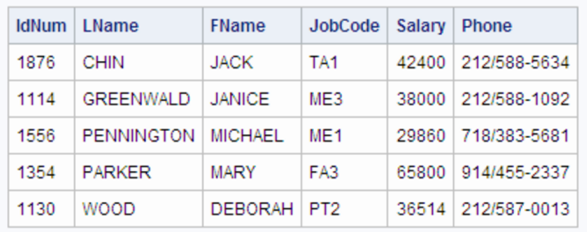

SELECT

LName AS Last_Name,

FName AS First_Name,

JobCode

FROM Employees

WHERE Phone = ‘%588%’

**Problem4 (25 Points)**: The table Scores(Team, Day, Opponent, Runs) gives the scores in the Baseball League for two consecutive days. The data in this table is as follows:

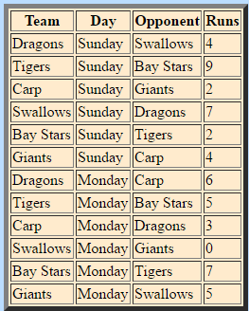

Write an SQL query to find all teams that have more runs in Sunday than Monday.

SELECT

*

FROM

Scores s1,

Scores s2,

WHERE

**Problem5 (20 Points)**: Given the following relations:

tudents(sid, first_name, last_name, major, department)

Departments(id, name, college)

Note: department in Students is the department id, not name.

Write a SQL query using **IN** operator to find all students in the department of ECSSE and AE