CS-317 Lab 1

Cameron Stark

**Task 1:**

CREATE TABLE Product (

ProductID INT PRIMARY KEY,

Name VARCHAR(255),

Price REAL,

Description VARCHAR(255),

Category INT,

Manufacturer VARCHAR(255)

);

CREATE TABLE Category (

CategoryID INT PRIMARY KEY,

MainCategory VARCHAR(255),

SubCategory VARCHAR(255)

);

CREATE TABLE Review (

ReviewID INT PRIMARY KEY,

Product INT,

Customer INT,

ReviewDate DATE,

Rating INT,

Details VARCHAR(255)

);

CREATE TABLE Customer (

CustomerID INT PRIMARY KEY,

Username VARCHAR(255),

email VARCHAR(255),

address VARCHAR(255)

);

**Task 2:**

**Step 1:**

SELECT * FROM Product

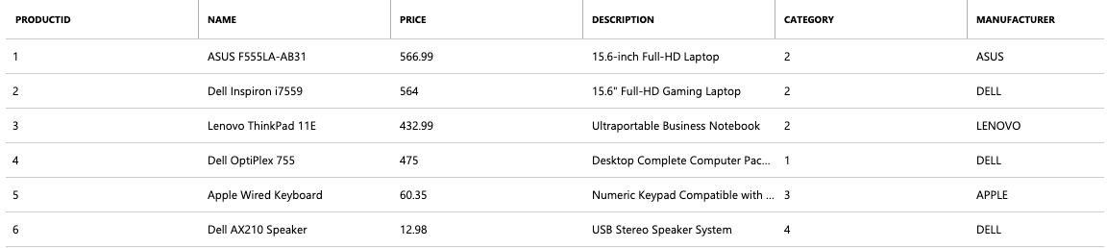

SELECT * FROM Category

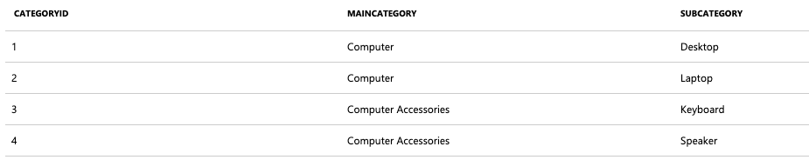

SELECT * FROM Review



SELECT * FROM Customer

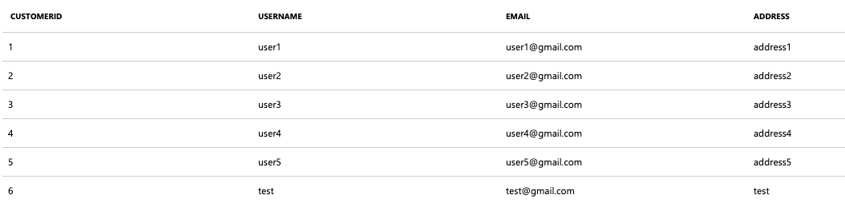

**Step 2:**

SELECT

Username

FROM Customer

WHERE CustomerId IN (

SELECT

Customer

FROM Review

WHERE ReviewDate IS NULL

);

**Step 3:**

UPDATE Review

SET ReviewDate = CAST('2019-02-25' AS DATE)

WHERE ReviewDate IS NULL

**Step 4:**

SELECT

Product.Name,

AVG(Review.rating)

FROM

Product,

Review

WHERE Product.ProductID = Review.Product

Group BY Product.Name

**Task 3:**

DELETE FROM Customer

WHERE Username = 'test';

**Task 4:**