SE-310 Exam 1 Review Guide

**Use Case Model**

Actors (Noun)

* Not part of the System
* Exchange Info with the system
* Provide info to the system
* Receive info from the system

Use Case (Verb)

* What Happens in the system when an actor interacts with it

Relationships

* Association
  + Describes how actors interact
* Extension
  + A role that is common in other Actors or Use Cases
* Include
  + A common use between multiple Use Cases
  + Points to where it includes
* Extend
  + An optional Use Case that can follow the Associated Use Case
  + Points to what it extends from

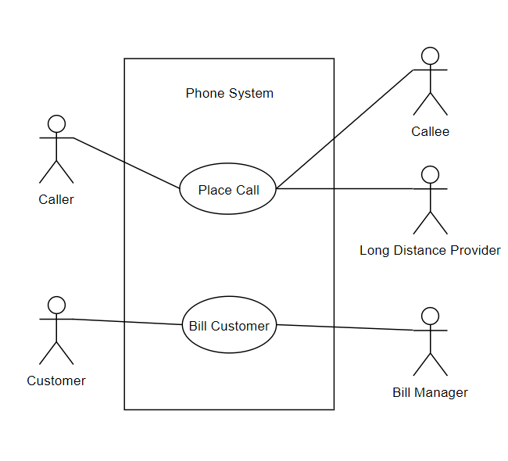

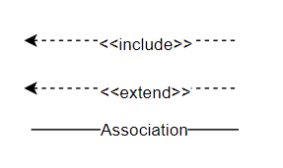

**Use Case Scenario**

Elements

* Scenario Identification (Use Case Name)
* Description
* Actors
* Pre-Condition (What must be true before entering the scenario)
* Trigger Condition (What initiates the Scenario)
* Flow Of Events (Steps Within the Scenario)

Sample

Scenario 1: Purchase

Description: The customer purchases an item from the system.

Actors: Customer, Shipping Company, Warehouse, Payment Company

Precondition: The customer has browsed items from the system and decided to make a purchase

Trigger Condition: The customer has selected the purchase option

Steps:

1. Include <<Validate User>> (ALT 1)
2. The system displays the shopping cart view
3. The customer selects to proceed to checkout (ALT 2)
4. The system requests shipping information
5. The customer provides the shipping information
6. The system validates the shipping information
7. ….

ALT 1: Step 1

* 1. The system is unable to find the user
  2. Extends <<Register>>
  3. Continue at Step 1

**State Transition Model**

States

* Initial State
  + Where the system begins
* State (A point in the system) – Rounded Rectangle
  + Entry – Activity that occurs upon entering state
  + Do – Activity that execute/occur while in state
  + Exit – Activity that occurs on exiting the state
* Transition (How it goes from one state to the next)
  + Event – An occurrence the triggers a state change
  + Condition – Evaluate to true for the transition to occur
  + Action – Computation to be made when the transition is made
* Final State (The end state of the program)

Substate – A State that is nested in another state

Composite State – A state that has substates

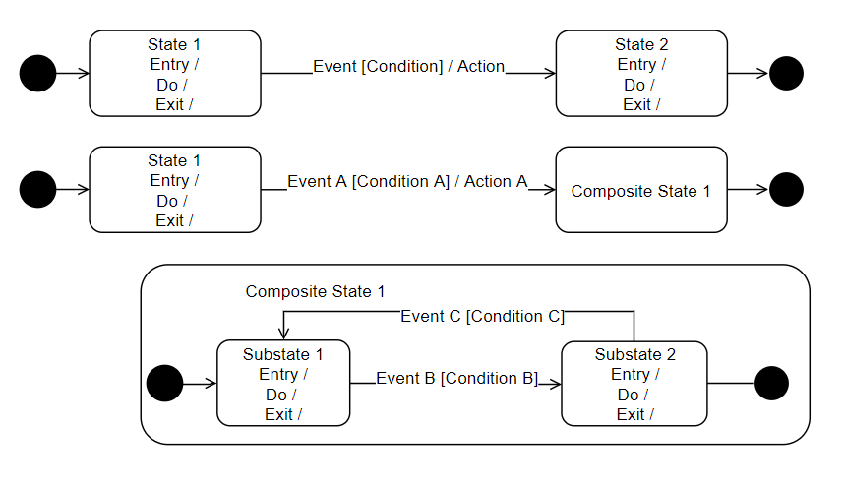

**Data Flow Diagram**

Views

* Input – Data Flowing into the system
* Process – Processing elements transform data to resultant data
* Output – Resultant data flowing out of the system

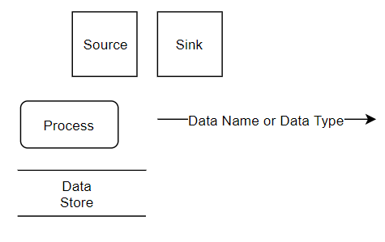

Diagrams

* Source (Noun)
  + Producer of Data
* Sink (Noun)
  + Consumer of Data
* Process (Verb Phrase)
  + Transform Data
  + At least one input and one output
* Data Flow (Noun)
  + Connect Processes
  + Represent intermediate Data
  + Types
    - Copy – duplicate data
    - Split – reduce complexity of data
    - Aggregation – combine data
* Data Store (Noun)
  + Two Operations
    - Store
    - Retrieve

