CS 455 – Artificial Intelligence

Module 1 Homework – Search Algorithms

Cameron Stark

1.1 Search path: 1 2 3 5 6 7 8 9 10 11 12 14 15 16 17 G

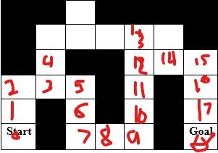

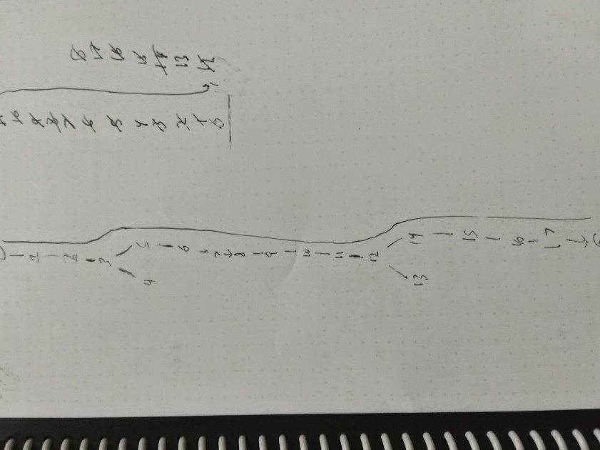

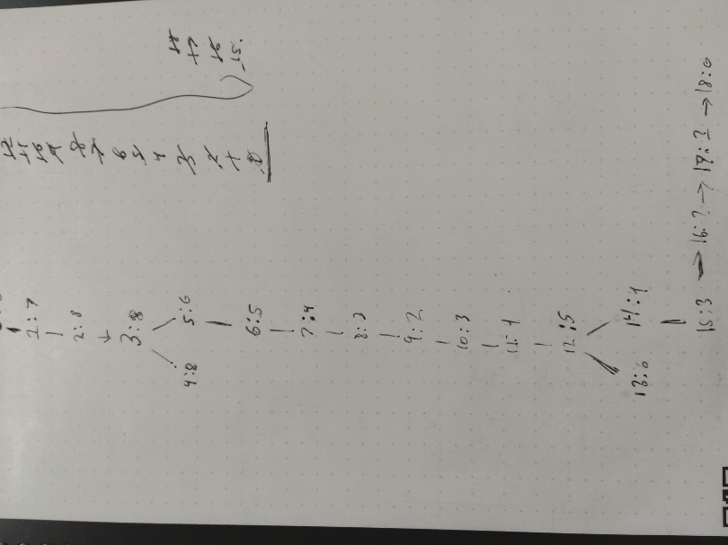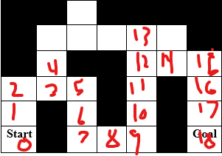

* 1. Search Path: 1 2 3 5 6 7 8 9 10 11 12 14 15 16 17 18

1.3

2.1